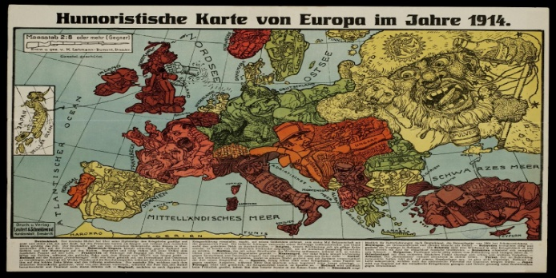
(http://historiana.eu/sources/show/humoristische-karte-1914)

Using sources as evidence: What does this satirical map reveal about the causes of War in 1914?

Teaching context
Students find the causation of World War One challenging to understand. They can connect with the story of the assassination of Franz Ferdinand - the so-called ‘trigger’ of the outbreak of war. They can also understand the alliance system and how, in the summer of 1914, the countries of Europe got involved in war because of their alliances. They find it much harder to understand the atmosphere of Europe in 1914 and why there was so much tension between the Great Powers. This is hardly surprising, as the causes stretch back over the preceding century and beyond. However, our role as history teachers is to help them understand the different interpretations of these longer term causes and this source is a good place to start.

Resources needed:
A colour copy of the map for pairs of students (paper or online) and this text to help you ask questions and point out the meaning of details.

How to use the map in class:
You can use this map to start your students learning about the underlying causes of World War One. Students love looking at this map and it gives them a chance to do some close observation work and to understand the atmosphere of Europe in 1914 without using too many written words. Here is a suggested approach to using this satirical map.

Opening questions | Response to be drawn out, teacher help with interpretation
Where does the map come from? | The German language should give them the clue.
What is significant about the date? | It’s the year the First World War starts.
What is the purpose of the map? | It’s not for hiking! It is a map to present opinions about the countries of Europe in 1914.
Where might this map have been published? | Perhaps in a magazine or political paper.

Studying the detail of the source:
Close observation of sources is a key historical skill and students can be encouraged by teacher questioning to look deeper and deeper at the interpretation of European countries that this source presents. Students need a good quality colour copy, either in print form or online. If they are using a printed version, you might like to provide magnifying glasses so that they can investigate details. The following table presents some initial ideas for teachers about interpreting the map by using some of the countries as examples.

Country | Thoughts about the interpretation
Germany | Presented as a wily, sneaky, tough guy. Clearly strong, virile and trying to expand both east and west.
Austria | Presented as a 19th century soldier very concerned with the threat of Russia.
Poland | Presented as a dog chained to Russia and being hassled by Russia.
Russia | Presented as a huge, scary, wild and woolly bear-like figure that is unpredictable and drinks too much vodka.
Turkey | Presented as laid back and careless of its capacity to cause Russia to explode into action (see the candle flame close to the gunpowder around the Russian’s neck).
Italy | Presented as hiding in its boot waiting to see what happens before getting out and drawing attention to itself.
France | Presented as a barefoot citizen soldier that is quite easy to push around.
Ireland | Presented as trying to cut the chain connecting it with the UK.
United Kingdom | Presented as an old boxer taking a punch from the sea, that is nevertheless wily (see the snake) and very rich (see the bags of money).

You could ask questions such as these to help your students use the source as evidence:
- Question: How useful is this map for historians?
- Teacher’s note: it shows one interpretation from Germany about the state of relations between the European countries in 1914. We need quite a lot of contextual knowledge to make it useful. We would want to use other sources to compare them to this interpretation. However, it does show that there were definite and stereotypical perspectives being taken about ‘foreign nation states’ in 1914.

- Question: What do you want to know as a result of studying this map?
- Teacher’s note: you could ask students what questions they would like answering about the presentation of the countries e.g.: Why is Russia presented a wild and woolly bear? Why is the UK being punched from the sea? Why is Poland chained to Russia?

- Question: What hypothesis can you make about Europe in 1914 from this map?
- Teacher’s note: a hypothesis is a working theory that needs to be further tested with evidence. Students are likely to create a hypothesis such as: ‘Europe was made up of nations who were suspicious of each other and that Germany was seeking to expand.’

- Question: How can you test your hypothesis?
- Teacher’s note: you might direct them to their textbook, or ask them to do some research online. The idea is that this map stimulates interest about Europe in 1914 and invites further questions.

Where do you go from here?
- Idea 1: If you want to study the underlying causes of War in Europe in 1914…
- You can use the hypothesis as the start of an enquiry in which small groups of students research the hopes, fears, aims and grievances of each of the European countries in 1914. Students can then present their position to their class colleagues. They could present in a number of ways, and one way could be to present the map of Europe from the perspective of their country. The aim is for the class to build up an understanding of the reasons for the tensions and alliances in 1914 which were triggered by the assassination in Sarajevo, and thus to understand in more depth the causes of World War One.

- Idea 2: If you want to continue using satirical maps as evidence then…
- You can use more of the satirical maps from the same collection on historiana.eu this time from the point of view of other countries. You can use maps across time from the 19th century and into the years of the First World War itself.

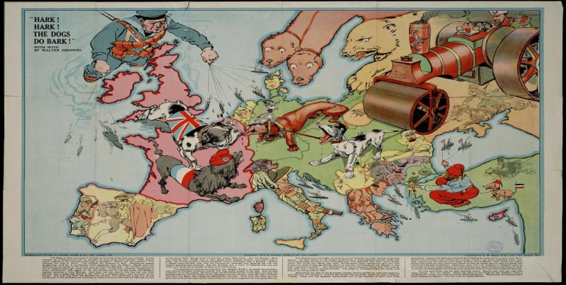
(http://historiana.eu/sources/show/hark-hark-bark)

This map is produced in the UK after the declaration of war in 1914. It was later printed in Germany as an example of British anti-German propaganda.

Ask your students to compare this map with the previous one.

- Question: How similarly or differently are the European countries are presented?
Country | Thoughts about the interpretation
Germany | Presented as a dachshund, leashed to Austria-Hungary and barking wildly at France and Britain (in France).
Austria | Presented as a mongrel dog, leashed to Germany and barking wildly in the direction of France, but set backwards.
Poland | Has been squashed by Russia, with just one paw left showing.
Russia | Presented as a steamroller on the move and being driven by Tsar Nicholas II.
Turkey | Presented as actively manipulating the shipping in and out of the Black Sea.
Italy | Presented as wary, weapon ready and keeping an eye on its eastern side, but not yet engaged.
France | Presented as a dandified French poodle, engaged against Germany, but not actually fighting.
Ireland | Is just portrayed as part of the UK.
UK | Presented as a powerful, watchful Bulldog biting the nose of Germany after having arrived in northern France. The large British navy is still on a leash and being led towards Europe.

- Question: How far does the interpretation of this map support the ideas about the hopes, fears, aims and grievances of each of the European countries in 1914 from the previous map?

- Question: Can students suggest reasons for differences between the two maps? (This is likely to focus upon the map being British, rather than German, and also the impact of the outbreak of the war)

Ask students to look at the map collection at http://historiana.eu/collection/satirical-maps and select another map to add to the two maps already used (some help points for you are presented below.)

Students should use the same close observation skills and be prepared to return to the class ready to:

1. Describe the origin of their chosen map how countries are presented on this map.
2. Comment upon how the map is similar and/or different from the other maps.
3. Suggest reasons for these differences.
4. Give their views about the extent of change and continuity of attitudes between European countries that these maps suggest.

Discuss as a class what historical research is required in order to contextualise and explain these maps. Ask students what questions the maps raise and then use this as the basis for further historical enquiry via research.

