The Second World War – A ________ war.
North America  North American soldiers fought in other areas- there was no conflict on the mainland.  However, they did become involved in battles to gain control of the sea and air.  The US Naval base at Pearl Harbour was attacked by Japanese forces in December 1941. The Battle of the Atlantic occurred between 1941 and 1945. It involved German U-boats and Italian submarines attempted to disrupt the Allied supply of oil and other material. | Europe  There was significant fighting on the Eastern and Southern fronts which impacted the entire continent. All fronts involved Allied forces pushing back German and Axis forces from the height of the German Empire in November 1942. The Eastern front was the most unforgiving of theses fronts with losses of life extending over 30 million. | The Middle East  The region was quiet for the first few months of the war, until Italy declared war against France and Britain June 1940. It remained a major theatre for two and a half years.
Caribbean  The Islands were involved in fighting in many other theaters of war as part of British Empire forces, but there was no conflict on the mainland.  The Battle of the Caribbean refers to a naval campaign waged during World War II that was part of the Battle of the Atlantic, from 1941 to 1945. | 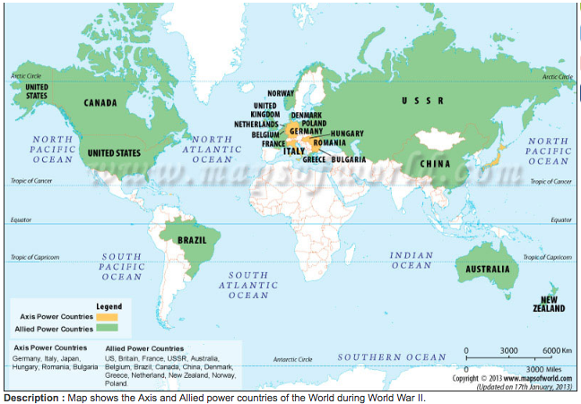 | Asia  Became the main location for the war between America and Japan (who were aided by Thailand).  The war ended when America dropped atomic bombs on the Japanese cities of Hiroshima and Nagasaki, These bombs targeted civilians. Across the two cities, between 120, 000 and 230,000 people are believed to have died.  Japan surrendered on 15 August 1945.  The South-East Asian Theatre of World War II was the name given to the campaigns of the Pacific War in Burma, Ceylon, India, Thailand, the Philippines, Indochina, Malaya and Singapore.
Challenge:  Using a black felt tip or similar, try to mark and label the theatres of war on your map from last lesson. | Africa  This theatre, also known as the Abyssinian campaign, took place mostly between Italian forces (who had colonised parts of East Africa) and Allied (mainly British) troops.  It is considered to be the first significant Allies victory, with Italian troops pushed back throughout 1941.  Small groups continued fighting British troops until 1943 in the form of smaller guerilla wars. | Australasia  Considerable Australian military resources were devoted to protecting the seas from Axis submarines and warships. A high proportion of Australian operational squadrons were used to protect shipping at various times.

The Second World War – A ________ war.
North America  North American soldiers fought in other areas- there was no conflict on the _________.  However, they did become involved in battles to gain control of the sea and air.  The US Naval base at _____ _________ was attacked by Japanese forces in December ____. The Battle of the Atlantic occurred between 1941 and 1945. It involved German U-boats and Italian submarines attempted to disrupt the Allied supply of ___ and other material. | Europe  There was significant fighting on the Eastern and Southern fronts which impacted the entire continent. All fronts involved Allied soldiers pushing back German and Axis soldiers from the height of the German Empire in November 1942. The Eastern front was the most unforgiving of theses fronts with losses of life extending ____ __ _______. | The Middle East  The region was quiet for the first few months of the war, until _____ declared war against France and Britain in June 1940. It remained a major theatre for two and a half years.
Caribbean  The Islands were involved in fighting in many other theaters of war as part of ________ Empire forces, but there was no conflict on the mainland.  The Battle of the Caribbean refers to a naval campaign during World War II that was part of the Battle of the ________ from 1941 to 1945. |  | Asia  Became the main location for the war between America and _____ (who were aided by Thailand).  The war ended when America dropped atomic bombs on the Japanese cities of __________ and Nagasaki, These bombs targeted civilians. Across the two cities, between 120, 000 and 230,000 people are believed to have died.  Japan surrendered on 15 August 1945.  The South-East Asian Theatre of World War II was the name given to the campaigns of the Pacific War in Burma, Ceylon, India, Thailand, the Philippines, Indochina, Malaya and Singapore.
Challenge:  Using a black felt tip or similar, try to mark and label the theatres of war on your map from last lesson. | Africa  This theatre, also known as the Abyssinian campaign, took place mostly between Italian forces (who had colonised parts of East Africa) and Allied (mainly ________ ) troops.  It is considered to be the first significant Allies victory, with Italian troops pushed back throughout 1941.  Small groups continued fighting British troops until 1943 in the form of smaller ________ wars. | Australasia  Considerable Australian military resources were devoted to protecting the seas from Axis submarines and warships. A high proportion of Australian operational squadrons were used to protect shipping at various times.

