TALLIS THRESHOLDS

KS3 ASSESSMENT WITHOUT LEVELS

THOMAS TALLIS SCHOOL

- Introduction and context

“What we want is a model of ability based on each child being capable of anything and us looking progressively, through assessment, at what ideas a child has understood.”

― Tim Oates, Cambridge Assessment

Attainment targets and levels were introduced with the national curriculum in 1988. In May 2013, the Secretary of State announced: ‘as part of our reforms to the national curriculum, the current system of ‘levels’ used to report children’s attainment and progress will be removed. It will not be replaced.’ This policy decision followed recommendations from the national curriculum Expert Panel (DfE: 2011) chaired by Tim Oates. ‘Reforming assessment and accountability for primary schools’ stated ‘schools should have the freedom to decide how to teach their curriculum and how to track the progress that pupils make’ (DfE, 2014: p4). These announcements made it clear that central government was no longer going to dictate how schools should record and report progress between statutory tests. From September 2015, National Curriculum levels will no longer be used for statutory assessments. Although attainment targets remain in the national curriculum orders, they now refer explicitly to ensuring all pupils know, apply and understand the matters, skills and processes specified in the relevant programme of study.

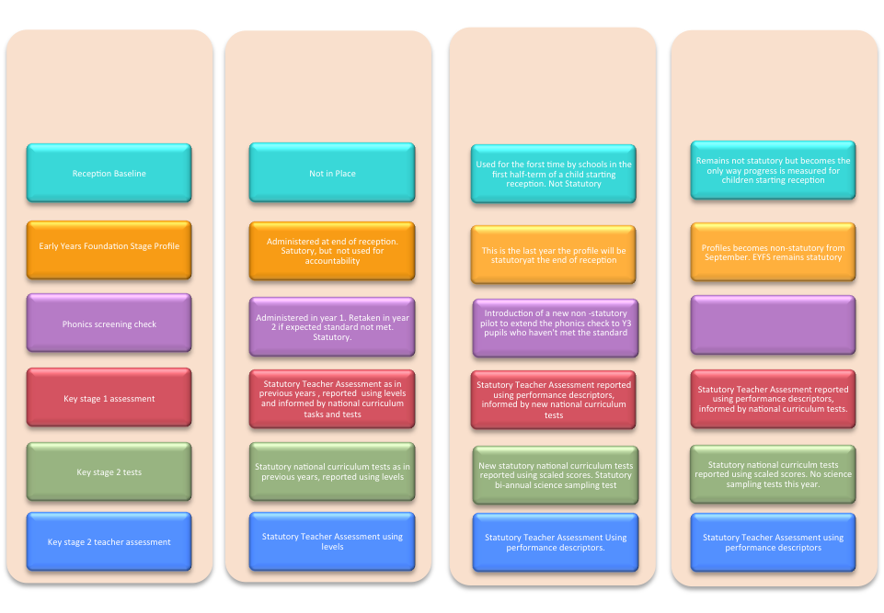
Academic year 2016/17

Academic year 2015/16

Academic year 2014/15
Assessment
The removal of National Curriculum Levels at KS3 means that schools have been tasked with developing their own way of assessing children’s progress. This represents an extraordinary opportunity to design an assessment system that is ‘the servant, not the master, of the learning’. (Dylan Wiliam) Over the last academic year, the school has been engaged in nuanced thinking about assessment that underpins the design of our new model: knowing the limitations of types of assessment and the impact these have on the inferences we make; defining what we will assess and the purpose for which we will use the data; how we will collect, share and/or record it; and, critically, how we can design an assessment system that first and foremost supports teaching and learning. This booklet outlines that new system.

- The rationale for the removal of levels

“A culture shift regarding the nature, range and purposes of assessment needs to take place, in recognition of the new opportunities provided both by the new curriculum and the removal of levels.”

― NCTL Research Report, September 2014

In order to get to grips with our new system of assessment without levels, it is first of all necessary to understand why National Curriculum levels have been removed in the first place. The key problems with levels as identified by the National Curriculum Expert panel and the Commission on Assessment without Levels may be summarised as follows:

- Accuracy and consistency of assessment

Levels mean different things. The various models used to aggregate test scores, APP and the use of sub-levels by schools make them unreliable. In some instances they are marks on a test, or APP work best matched to a descriptor or ‘just in….’ Although levels were intended to be used to assess pupils against the whole programme of study, the results of almost any assessment were translated into a level or sublevel and used as a measure of overall attainment.

Undue pace. The temptation to move up levels quickly in the name of “progress” is at odds with our desire to secure a deeper understanding of the big ideas, not just isolated content, and to allow more time for mastery of fundamental knowledge and skills.

- Impact on teaching and learning

Levels dominated lesson planning. Teachers planned lessons to allow pupils to learn or demonstrate the requirements for specific levels. Instead of using classroom assessments to identify strengths and gaps in pupils’ knowledge and understanding of the programmes of study, teachers were simply tracking pupils’ progress towards target levels.

Never meant to be a label. Although originally intended to provide information on progress, there is a danger they have become a label that discourages a common intellectual mission and perpetuates a fixed mindset. “Joe is a level 5″ or worse still “I’m a level 5.”

- Assessing knowledge and understanding of the new national curriculum

Levels did not lend themselves to assessing the underpinning knowledge of a concept. For example, using certain vocabulary in written work was indicative of a level, but did not necessarily provide evidence of conceptual understanding. The changes to the new national curriculum now provide the basis for a different, more secure assessment based on deeper learning.

- Successful nations don’t use them

High performing school systems don’t use levels. Nations with successful educational systems, such as Singapore, Finland and Hong Kong, believe that children are capable of anything because of the effort they put in…not because they are level 4, 5 etc. This is consistent with Carol Dweck’s work on Growth Mindset.

- Assessment Principles

In April 2014, the DfE provided a set of core principles to help all schools as they implement arrangements for assessing pupils’ progress against their school curriculum.

According to these principles, effective assessment systems:
- Give reliable information to parents about how their child, and their child’s school, is performing
- Help drive improvement for pupils and teachers
- Make sure the school is keeping up with external best practice and innovation

We therefore need our assessment system to enable us:

- To use assessment both formatively and summatively; to provide accurate assessment of learning as well as to plan future learning and provision
- To respond appropriately to the changes in KS3 National Curriculum programmes of study from September 2014
- To dovetail with the change in labelling system that is coming in 2015/16 when GCSE grades will change from letters to numbers
- To measure progress accurately
- To allow for simple, meaningful reporting to parents and carers

Additionally, as a school we agreed on the following desired outcomes of our new assessment system:

- Smooth transition through key stages (designed backwards & delivered forwards)
- To allow a “growth mindset” focused on progress more than attainment
- To provide an increased emphasis on effort and to develop our ‘habits’
- To provide real stretch and challenge at all levels
- To be simple to understand for all

In order to meet these principles, the following actions have taken place across the course of the academic year 2014/15:

- Consultation with primary feeder schools through the RGTSA Transition Assessment Group
- Regular and frequent ongoing research in current thinking about assessment
- Curriculum working group
- Consultation with curriculum leaders and departments
- Consultation with governors
- Consultation with parents
- Consultation with students

- The Model

At a glance:

A dual system:
- Effort towards Tallis Habits reported 3 times a year
- Progress in subject specific competencies reported twice a year

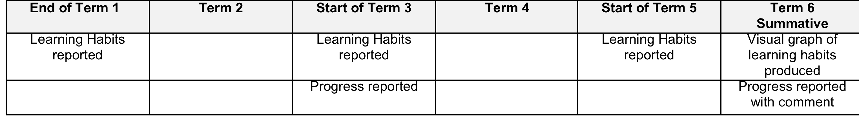
- Habits of Mind

At Key Stage 3 all students will be assessed based on the amount of effort they make in developing their Habits of Mind.

The following chart defines the high standard we want all students to aim for. We believe that great learning happens when students challenge themselves to work hard and aim high. We want all students to be able to develop, refine and use the Tallis Habits every day so that they can understand the world and change it for the better.

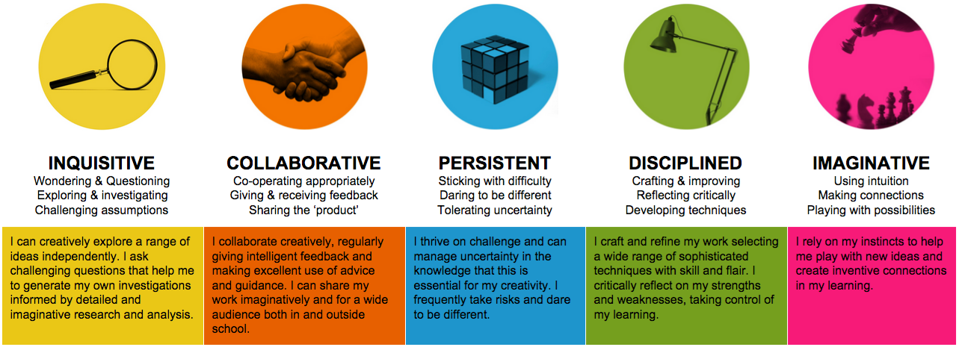
Each term, teachers will be assessing the amount of effort students are making towards developing their Habits of Mind. This replaces the existing system of reporting on Attitude to Learning, Behaviour, Meeting Deadlines and Quality of Homework. Progress will therefore be measured by how hard the student is working towards this high standard of competency. In this sense, every student would be working towards this high level, reinforcing the notion of stretch and challenge for all. This is a more authentic process of assessment that puts the focus on personal progress and effort rather than making comparative judgements between learners.

“Effort is one of those things that gives meaning to life. Effort means you care about something, that something is important to you and you are willing to work for it.”

― Carol Dweck

In terms of reporting to students and parents, teachers will enter one of 4 numbers per habit, per pupil:

1. X is making excellent effort and working as hard as possible in _______
2. X is making good effort and could work even harder in ________
3. X is making some effort and must continue to work harder in ________
4. X is making very little effort and must work considerably harder in _____

The agreed criteria will be shared with parents and students via the student planner, but judgments about progress must be based only on current levels of effort.

In order to help ensure these judgements are specific and meaningful, we have produced the following guide to practical instances of what each Habit might look like in practice. Again, this has been shared with students and parents via the planner.

TALLIS HABITS in action
Inquisitive
- Problem finding through asking searching questions
- Asking adults or siblings for ideas and advice
- Exploring unusual and/or challenging sources of information
- Making the best use of resources available for research
- Visiting galleries, museums, libraries and other places of interest
- Using the internet strategically (and safely)
- Independent and wide ranging reading
- Talking to others out of the classroom about open ended topics
- Wondering aloud about a range of ideas

Collaborative
- Giving constructive feedback to others about their work
- Presenting aloud in class
- Listening and responding carefully
- Working conscientiously in pairs or small groups
- Being a reliable and positive team player
- Talking to others about feelings or problems
- Completing home learning activities with others
- Using social media to improve understanding and publishing work online
- Taking part in the School Council and other student voice activities

Persistent
- Volunteering to tackle challenging topics
- Not being afraid to make mistakes
- Being resilient when things are not going well
- Having the courage to do what you think is right and resisting peer pressure
- Tolerating the views of others and expressing empathy
- Asking for support when needed and not suffering in silence
- Devising strategies for staying on task when feeling distracted
- Not worrying when things are unclear or confusing
- Being comfortable with not knowing the answer and working through a problem

Disciplined
- Developing and refining work independently and in response to advice from others
- Ensuring that you are well-equipped for learning with the right tools and attitudes
- Being on time to school and lessons
- Experimenting with new ways of tackling problems
- Reflecting on and setting own targets for improvement
- Doing homework on time and to the best of your ability
- Weighing up the positives and negatives about a particular situation or approach
- Developing new skills and techniques
- Changing your own behaviour if it’s unhelpful

Imaginative
- Trusting in your instincts
- Applying a different approach to the same problem
- Making connections between ideas
- Experimenting with unfamiliar ideas
- Taking part in role play activities and adopting a different viewpoint
- Making connections with past learning
- Combining ideas and concepts together to create something new
- Playing with ideas and/or ways of doing things to see what’s possible
- Making connections with new people

We will also be asking students to self assess their effort at each habit in tutorial time and this could be sent home with the teacher report. Parents and carers will then be invited to assess their child’s Habits, and this will lead to discussion between teachers, students and parents. We believe this will enable pupils to take more responsibility for their achievements by understanding where their strengths are and what they need to do to improve.

- Subject-specific thresholds

“Life can only be understood backwards; but it must be lived forwards.”
― Søren Kierkegaard, Danish philosopher

Our new system of assessment without levels at KS3* is inextricably linked with our redesigning of the curriculum. This is because an assessment system should be designed to assess the school’s curriculum rather than having to design the curriculum to fit the school’s assessment system.

This means beginning by defining in each subject area what learners should know and be able to do by the end of KS4 (and, where appropriate, KS5) in terms of:
- ‘Big ideas’ / threshold concepts
- Powerful knowledge (‘knowing that…’)
- Key skills (‘knowing how to…’)

Once subject areas have decided where we want our students to get to, and insodoing defined the standard for excellence, we then need to use our pedagogical content knowledge to define the learning progressions towards this excellence across the five (or seven) years of study. We do this by drawing up a programme of study which maps this adventure:

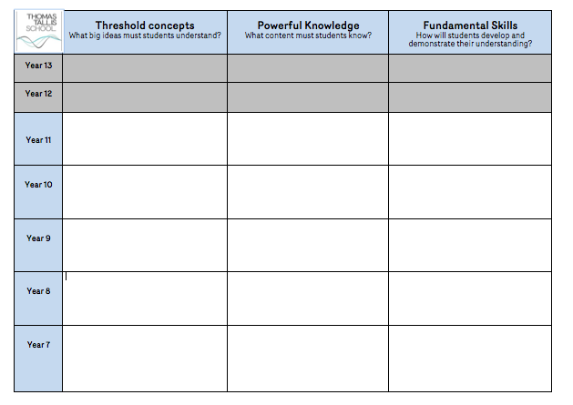

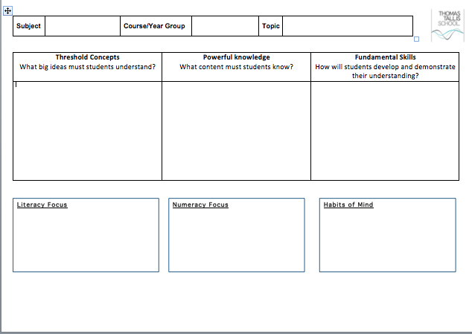
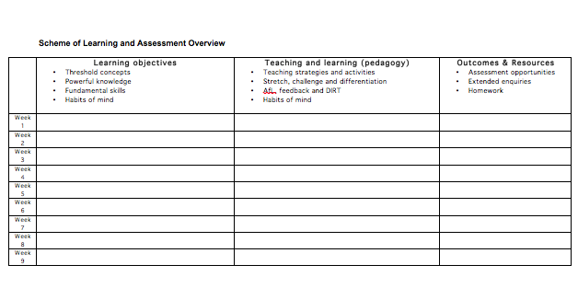
Finally, we add the level of detail for each scheme of learning or unit within the overall programme of study:

How do we define our Tallis Thresholds?
Learning progressions are defined by establishing what a learner should know and be able to do by the end of:
- Year 7?
- Year 8?
- Year 9?

We then establish the thresholds by defining the progressions within each year and unit of work by considering how this would look for:
- Learners who are excelling
- Learners who are secure
- Those who are developing their learning, but are not yet secure
- Emerging learners who are working towards expectations for their year group:

KS3 Tallis Thresholds
Excelling
Securing

Developing

Emerging

We then use these four thresholds to scaffold the learning progressions towards excellence within each year and unit of work, using the thresholds to provide learners with feedback about how they can improve. Across years 7, 8 and 9, each threshold will show increasing levels of demand in terms of expectation, so that a student working within that threshold will be on the flightpath towards their GCSE target grade.

Depending on the subject and topic, progression through the thresholds might be structured around familiar taxonomies such as Bloom’s or SOLO, although these will of course vary between subjects and topics:

Emerging | Developing | Securing | Excelling
Eg.  Bloom’s:  Recognising, recalling and reproducing  SOLO:  Unistructural (single ideas) | Eg.  Bloom’s:  Understanding and explaining  SOLO  Multistructural (many ideas) | Eg.  Bloom’s:  Synthesising and analysing  SOLO:  Relational (linking and relating ideas to form an ‘integrated whole’) | Eg.  Bloom’s:  Evaluating and creating  SOLO:  Extended abstract (abstracting from the ‘integrated whole’ and applying to new relevant areas)
Assessment criteria illustrative framework

KS2 (current) | KS2 (from 2016) | KS3 Tallis Threshold | KS4 (current) | KS4 (from 2017)
6C | Above National standard | Excelling | A* | 9
5A |  |  |  | 8
5B |  |  | A | 7
4A-5C |  | Securing | B2-B1 | 6
4B |  |  | C1-B3 | 5
4C | Below National standard | Developing | C3-C2 | 4
3 |  |  | D | 3
2 |  | Emerging | E | 2
1 |  |  | F | 1
P |  |  | G

As can be seen from the illustrative framework above, progress is planned for both over time, in the programme of study and schemes of work that continue to stretch learners towards excellent outcomes, and also within each year, by focusing on the what each learner would need to do in order to progress to the next threshold. Tallis Thresholds are therefore used to plan for progression as well as to focus assessment and feedback on the key knowledge and skills of learners.

Tracking progress and reporting to parents
In tracking progress and reporting to parents, we will look at performance relative to baseline threshold. We begin by using KS2 data to assign students a baseline threshold as indicated in the illustrative framework above, and then measure progress relative to this starting point:

- Working below baseline threshold, or at the bottom of the Emerging threshold – Below expected progress.
- Working within baseline threshold – Good progress.
- Working above baseline threshold or at the top of or beyond the Excelling threshold – Outstanding progress.

As seen in the illustrative framework above, each student’s baseline threshold is linked to a GCSE flightpath – the GCSE outcome the student should achieve if they make good progress from their starting point. As long as a student maintains their baseline threshold, they will be on the correct flightpath towards their end of KS4 target grade. Of course, we hope that they will even exceed their baseline threshold and GCSE flightpath by make progress towards excellence.
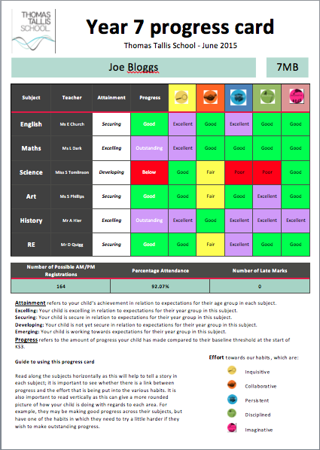
Formative and summative assessment
The Tallis Thresholds rubrics developed by departments will enable teachers to provide on-going formative feedback about how students can make progress through the thresholds based on their day-to-day work. If the Tallis Thresholds model is to be an improvement on the previous system of levels it is imperative that the focus of teachers is on how students can make progress, rather than on the threshold they are working within, which will place a ceiling on their achievement. In order to support a growth mindset in the students, feedback should therefore be focused on enabling all students to aspire towards excellence.

In addition, departments will be responsible for devising suitable assessment tasks that will allow them to assess students summatively against the Tallis Thresholds. This summative assessment data will be collected at key points in the year in order to establish the progress students are making relative to their baseline thresholds. There will be two key assessment points in each school year – a mid-year progress check around Christmas and an end of year check in the Summer Term. The data harvesting for these assessment points will be staggered to accommodate different year groups. Each year group will sit end of year tests during the summer term in order to help make reliable judgements about the progress they are making towards success in their linear GCSEs. Departments will be responsible for devising suitable tests and using the outcomes to determine students’ overall Tallis Thresholds. The outcomes of these end of year tests will be reported to parents and carers with the following explanations of their child’s current attainment:

Attainment refers to your child’s achievement in relation to expectations for their age group in each subject:

Excelling Your child is excelling in relation to expectations for their age group in this subject.

Securing Your child is secure in relation to expectations for their age group in this subject.

Developing: Your child is not yet secure in relation to expectations for their age group in this subject.

Emerging Your child is working towards expectations for their year group in this subject.

Progress refers to the progress your child has made compared to their baseline attainment threshold at the start of KS3.
Benchmarking and standardisation
One of the key challenges of developing bespoke models of assessment is moderation across schools. Representatives from the school have been part of the Royal Greenwich Teaching School Alliance (RGTSA) Transition Assessment Group, which focuses on benchmarking standards across the local authority in English and Mathematics. The group have established expected standards in English and Maths for Year 6, 7 and 8 students that will be shared with schools within the authority. As all schools develop their own systems of assessment without levels, we would expect good practice to involve a process of moderation and standardisation across schools.

Internally, it is imperative that departments are engaged in a regular process of standardisation, so that we can ensure that different teachers reach similar judgments about the quality of student work. In order that this can be most effective, we need to ensure that this is a process focused on standardisation rather than moderation: quality assurance rather than quality control. The focus of standardisation should be on teachers meeting together regularly to talk about quality in student work, not simply on making sure the scores for a particular student are ‘right’; when, instead, the focus is on aligning teachers’ judgements about quality, teachers come to share common ideas of quality, so the benefit is lasting (Dylan Wiliam).

Moderation | Standardisation
Backward looking | Forward looking
Quality control | Quality assurance
Inspects quality | Builds in quality
Static | Dynamic
Ephemeral evidence ignored | Ephemeral evidence used
Usually quantitative in approach | More qualitative in approach

- The benefits of Tallis Thresholds and assessment without levels

We believe that the Tallis Thresholds model of assessment without levels will enable us to simplify assessment and allow teachers to focus on teaching and learning and the effective delivery of our new curriculum. We see the following key benefits to our new model of assessment:

- Assessment and the curriculum

It is clear that assessment, pedagogy and the curriculum are inextricably connected (curriculum is pedagogy, according to Dylan Wiliam). Directly linking the assessment of pupils’ attainment and progress to our newly developed curriculum means that our assessments should be better-tied to our curriculum content: the big ideas, powerful knowledge and key skills our students should acquire by the end of each scheme of learning, year and key stage.

“Study fewer things in greater depth, so a deeper understanding of central concepts and ideas can be developed. Assessment should focus on that.”
― Tim Oates

The new programmes of study and schemes of learning developed by all departments have required subject teachers to discuss, decide and agree upon what standards are expected from each threshold, allowing us to set high expectations of excellence from our students. Focusing on the big ideas, powerful knowledge and key skills has also allowed us to be selective in defining what needs to be assessed for each unit, year or key stage - As Tim Oates advises, “Don't assess everything that moves, just the key concepts”.

- The value of formative assessment and feedback

It became increasingly the case that levels emphasised the summative functions of assessment, which drew focus away from the benefits of day-to-day formative assessment for teaching and learning. In removing levels and reducing the frequency of central data-collection, we hope that formative assessments, such as rich classroom questioning and observational assessments, can now be given a higher priority than activities focused on levelling. Tallis Thresholds can be used to give students ongoing formative feedback, based on their day to day work, about how to improve and make progress towards excellence.

“Good summative assessment requires teachers to share a construct of quality, while good formative assessment requires helping students share the same construct of quality.”

― Dylan Wiliam, Emeritus Professor of educational assessment at the Institute of Education

The new national curriculum is founded on the principle that teachers should ensure pupils have a secure understanding of key ideas and concepts before moving onto the next phase of learning. Ensuring assessment directly evaluates pupils’ knowledge and understanding of our curriculum requirements helps to create a virtuous circle of teaching and assessment: teachers assess pupils’ understanding of a topic and identify where there are gaps; this tells the teacher what to focus on in future lessons and prompts the teacher to consider how his or her teaching approach can be adapted to improve pupils’ understanding; this, in turn, informs the teacher’s thinking about which assessments to use to evaluate whether the new approach has been effective. In this manner, good teaching and assessment continually reinforce each other and generate ongoing improvement: teachers become much better informed about pupils’ understanding of concepts and ideas and can build a more accurate picture of their individual needs.

Marking | Feedback
Summative | Formative
Assessment of Learning | Assessment for Learning
Measures learning | Moves learning forward
Directs thinking | Provokes thinking
Solves | Suggests
“You should…” | “How could you…?”

- Growth mindset and an ethic of excellence

Mindset is a simple idea based on the research of world-renowned psychologist Carol Dweck on achievement and success. At Tallis we believe that developing a ‘growth mindset’ - a love of learning coupled with resilience - is essential for great accomplishment. This can only be done effectively if it is an integral part of our teaching, as well as our day to day interactions with students. We hope that removing the ‘label’ of levels will help to improve our students’ mindsets about their own ability.

“Most discussions of assessment start in the wrong place. The most important assessment that goes on in a school isn’t done to students but goes on inside students. Every student walks around with a picture of what is acceptable, what is good enough. Each time he works on something he looks at it and assesses it. Is this good enough? Do I feel comfortable handing this in? Does it meet my standards? Changing assessment at this level should be the most important assessment goal of every school. How do we get inside students’ heads and turn up the knob that regulates quality and effort”

― Ron Berger, An Ethic of Excellence

Although students will have a baseline threshold assessment, this will not be referred to or used as frequently as NC levels – so that all our students are expected to aspire to excellence. Furthermore, because our reporting emphasises progress over attainment, it celebrates the effort of all students, with different starting points. Students will no longer be given feedback such as ‘you’re a 4a’; teachers will instead focus on formative feedback that requires students to think about how to move their learning forwards and make progress towards excellence.

- Teacher workload

We are aware that the expectation to collect data in efforts to track pupils’ progress towards target levels has an impact on teachers’ workload. We hope that removing levels and replacing them with a teacher-led system of thresholds means that teachers will now build their confidence in using a range of formative assessment techniques as an integral part of their teaching, without the burden of unnecessary recording and tracking.

- Further information

Please remember that as with anything new, it will take time for teachers, students and parents to fully adapt to the Tallis Thresholds system of assessment without levels at KS3. We hope that this booklet explains the new system, as well as the philosophy that underpins it. We are sure that as the year progresses it will become necessary to amend, adapt and refine our procedures, and further information will be provided as and when required. In the meantime, if you have any further questions or feedback, please contact:

Jon Curtis-Brignell
Assistant Head: Teaching and Learning
jcbrignell@thomastallis.org.uk
Ext: 3047

Bibliography and further reading

Allison, Shaun & Tharby, Andy, 2015, Making every lesson count: six principles to support great teaching and learning, Carmarthen, Crown House Publishing Limited

Allison & Mason, 2014, Assessment without levels: The Growth & Thresholds Model, Durrington High School, West Sussex

Allison, Shaun, 2014, “Assessment without levels” https://classteaching.wordpress.com/assessment-without-levels/

Berger, Ron, 2003, An Ethic of Excellence: Building a Culture of Craftmanship with Students, Portsmouth, NH, Heinemann Educational Books

Brinton, Dan, 2014, “Designing a new post-levels curriculum and assessment model from scratch”
https://belmontteach.wordpress.com/2014/06/20/designing-a-post-levels-curriculum-and-assessment-model-from-scratch/

Commission on Assessment Without Levels, 2015, Leaked Draft Report to DfE, July 2015 https://www.dropbox.com/s/wzl6ycooh8pwflo/assessmentcommissionjune15.docx?dl=0

Lilly, Peacock, Shoveller & Struthers, 2014, Beyond Levels: alternative assessment approaches developed by teaching schools, Nottingham, National College for Teaching & Leadership https://www.gov.uk/government/uploads/system/uploads/attachment_data/file/349266/beyond-levels-alternative-assessment-approaches-developed-by-teaching-schools.pdf

Lilly, Peacock, Shoveller & Struthers, 2014, Beyond Levels: summary of evidence of outcomes and impact, Nottingham, National College for Teaching & Leadership https://www.gov.uk/government/uploads/system/uploads/attachment_data/file/349269/beyond-levels-national-curriculum-assessment-outcomes-and-impact.pdf

William, Dylan, 2014, Redesigning Schooling: Principled assessment design, SSAT (The Schools Network) Ltd. Available on the SSAT website: https://www.ssatuk.co.uk/wp-content/uploads/2013/09/RS8-Principled-assessment-design-chapter-one.pdf

* In order to address concerns about the potentially demotivating use of GCSE grades in Year 9, we have also decided to use Tallis Thresholds for assessment in this KS4 foundation year.

