Time does not organise itself  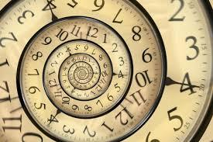  Chronology:  Periodisation is crucial to historical understanding. History is about phases of the past (chronology), but time doesn’t organise itself. Historians organise and shape units of time, in order to encourage a sense of period. | Knowledge is unique to each time period, but is interconnected across time  Substantive Knowledge and Concepts:  People, organisations, places and events of the past are unique to their time periods, but have a curious relationship with those of other periods. | Causes and consequences form a complex web  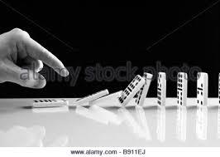  Cause and Consequence  Historical events and actions link together and lead to others in a ripple effect. However, there is always more than one cause and consequence, they link together and their relative importance is debated. It is never straightforward. | Whilst some things change, some things stay the same  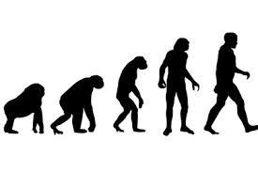  Change and Continuity  Events may lead to something changing or remaining the same, but the extent of either can be underestimated or exaggerated and the type of change is as important as the amount of change.
Tallis History Threshold Concepts
Time periods can be both similar and different at the same time  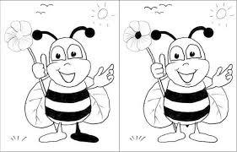  Similarity/difference:  Time periods can have both similarities and differences, and criteria can be used to compare periods of time. However, without specific evidence from each period, comparison reveals little. | Significance is the value that it given to a past event  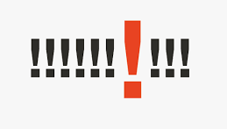  Significance:  In History we think about the importance of events in relation to others. But the extent to which an event is judged significant can vary. Therefore, significance is the value that is given to a past event. | Evidence rarely speaks until it is questioned  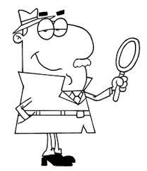  Evidential Enquiry:  Historical evidence does not fall out of the sky but has survived from the past like a witness. Like all witnesses, it should be questioned rigorously, and may vary in its utility. | Historians often disagree  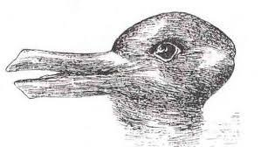  Interpretations:  The past does not change, but our views and understanding of the past do change. Historians often disagree, and we have to think hard about what they say.

