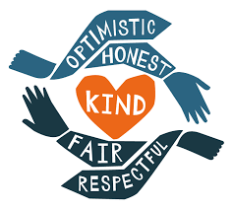
Tallis #BreakTheBias
Community Day – 4th March 2022

Imagine a gender equal world.
A world free of bias, stereotypes, and discrimination.
A world that is diverse, equitable, and inclusive.
A world where difference is valued and celebrated.
Together we can forge women's equality.
Collectively we can all #BreakTheBias
This year, for our second Community Day, we are thinking hard about gender inequality and particularly remembering the terrible consequences of intolerance, prejudice and discrimination so that we can understand the world and change it for the better. We are doing this in advance of International Women’s Day which falls on 8th March.

 | What did you do in each session of the day?  What did it make you think about the consequences of intolerance and hatred? | How could you link this to Tallis Character?  What could you do to encourage acceptance and celebration of diversity?
am reg
P1
P2
P3
P4/5
P6
pm reg

