Horror stories from the Reign of Terror

Source 1 – an extract from a school history textbook:
During the Reign of Terror, which lasted about a year, more than 12,000 people were killed by guillotine, drowned or shot. Some estimations suggest that many more thousands were killed in other ways, but an exact figure is unknown. It was not just the first and second estates who suffered at its hands. At least 1031 nobles were killed, 2923 middle class people were killed, 674 were clergymen, 7878 were workers and peasants and 140 were from unknown classes.

Source 2 – an extract from a school history textbook:
Jean-Baptiste Henry, 18: Convicted for having sawn down a ‘tree of liberty’, executed 6th September 1793.
Marie Plaisant: Convicted of having exclaimed that she was an aristocrat and did not care a fig for the nation. She was condemned and executed the same day.
Henriette Francoise Marboeuf, 55: Convicted of having hoped for the arrival of the Austrians and Prussians and of keeping food for them. She was condemned and executed the same day.
Francois Bertrand, 37: Convicted of having provided the soldiers defending France with sour wine. He was condemned and executed the same day.
Jean Julien: Condemned to death for crying ‘Long live the King!’

Source 3 – an account of a woman executed in records written during the terror:
A woman was charged with the crime of weeping at her husband’s execution. She was condemned to sit for hours under the blade which shed the blood of her dead husband on her, before she was executed by the same blade.

Source 4 – statement by a member of the Committee of Public Safety, nicknamed the Archangel of Death:
‘Only two types of people exist. The Good and the Bad. To the Good the Republic owes protection. To the Bad, death… You must punish not merely traitors but those that don’t care as well.’

Source 5 – an extract from a biography of Robespierre in an encyclopaedia
He fought for universal suffrage… He opposed the abuses of ministerial power, and religious and racial discrimination. He defended actors, Jews, and black slaves… Robespierre [promised a] maximum prices for all foodstuffs and a Revolutionary militia for use in the interior against counterrevolutionaries and grain hoarders… He objected to pointless executions… He was sickened by the massacres condoned by the représentants en mission (members of the National Convention sent to break the opposition in the provinces) and demanded their recall for “dishonouring the Revolution.”… After his death, his memory was relentlessly attacked, and a great many of his papers were destroyed… But, following the appearance of working-class movements in the 19th century, both in France and abroad, homage was paid to this “persecuted patriot,” and his most famous speeches were reprinted. His social ideal consisted in reducing extreme inequalities of wealth, in increasing the number of small property owners, and in ensuring work and education for all. He was a man of his times, of the Enlightenment, a patriot, a man with a sense of duty and of sacrifice, whose influence remains considerable.

Source 6 – an extract from a newspaper, written during the terror:
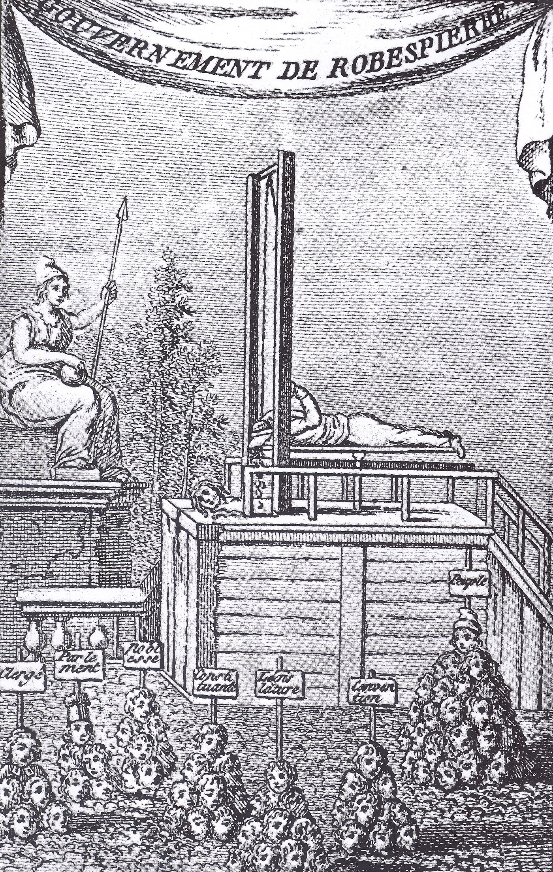
You want to remove all your enemies by means of the guillotine? Do you believe that these women, these old men, these weaklings… are really dangerous?’

Source 7 – an extract from a history book by an historian of the French Revolution, William Doyle
The Great Terror, often known, too, from the moralistic rationale given to it in the speeches of Robespierre, as the Republic of Virtue.

Source 8 – a cartoon attacking the Terror, made at the time. It is called The Government of Robespierre. He is guillotining himself!
The labels on the signs, from left to right, say ‘Clergy, parliament, nobles, constituents, legislature, convention, the people’.

