Look at this data about Tallis diversity with regard to gender, ethnicity, religion and language. Think carefully about the questions below.

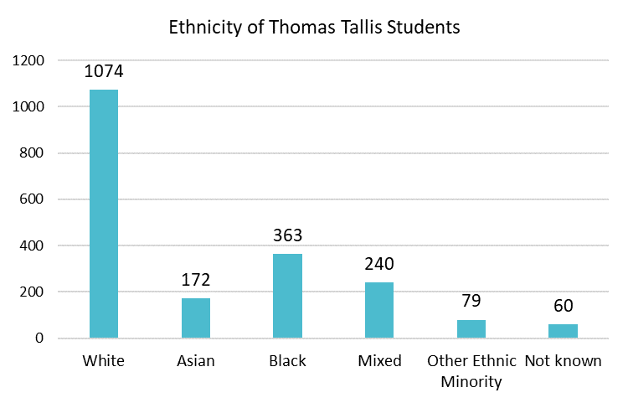 | 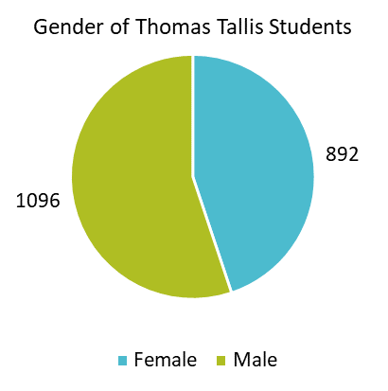 | Questions on Tallis Student Diversity  Use the information provided to work out answers to the following questions:  - What is the total number of students at Thomas Tallis? There are 1988 students in 2019-20.  - How many Tallis students are Male and how many are Female?  - How many Tallis students are of White, Asian, Black, Mixed, Other and Not Known ethnicity?  - What are the main religions of students at Thomas Tallis?  - What are the three most common languages other than English language spoken at home by Tallis students?  Please discuss:  - What is the meaning of diversity?  - What characteristics should we take into account when considering how diverse our Tallis community is?  - How diverse are Thomas Tallis students?  - Are the categories of ethnicity the same or can White, Asian, Black be sub categorised?  - Is there a relationship between ethnic group and religious group? What is this?  - Are there some important categories of diversity which are not considered here?
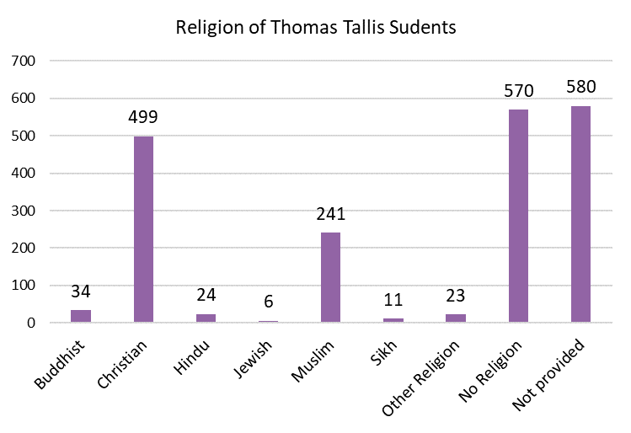 | 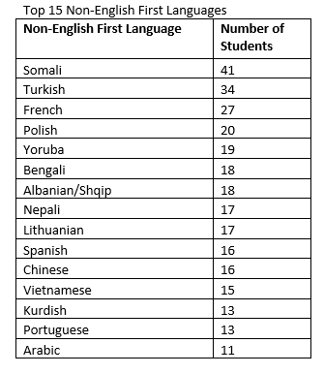

Look at this data from the 2011 Census about the nature of Greenwich and London diversity in comparison to England with regard to ethnicity and religion, Think carefully about the questions below.
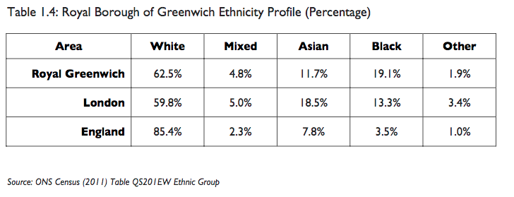 | Questions on Greenwich and London Diversity  Use the information provided to work out answers to the following questions:  - What percentage of Greenwich residents are White, Mixed, Asian, Black and other and how does this compare as a percentage to London and England as a whole?  - How are the ethnic groups subcategorised in the census return for 2011?  - What different data is given in Table 2? A breakdown or ethnicity by………..  Please discuss:  - What is the meaning of diversity in the London Borough of Greenwich?  - What characteristics should we take in account when considering how diverse a population is?  - How diverse is the London Borough of Greenwich compared to England as a whole?
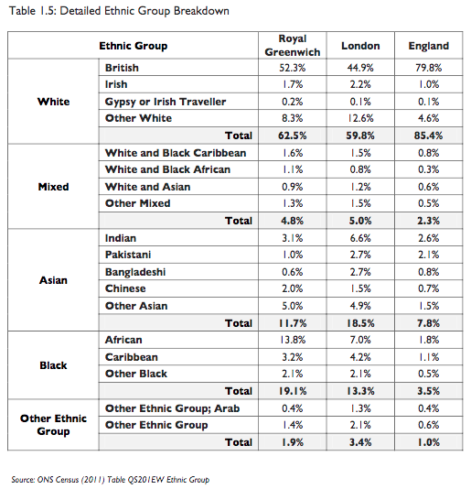 | 