**Example 5 (from 9HI0 1C)**

Study Extracts 1 and 2 in the Extracts Booklet before you answer this question.

**Question 5:** In the light of differing interpretations, how convincing do you find the view that the Glorious Revolution ‘transformed the relationship between King and Parliament’? (Extract 1 Line 5)

To explain your answer, analyse and evaluate the material in both extracts, using your own knowledge of the issues.

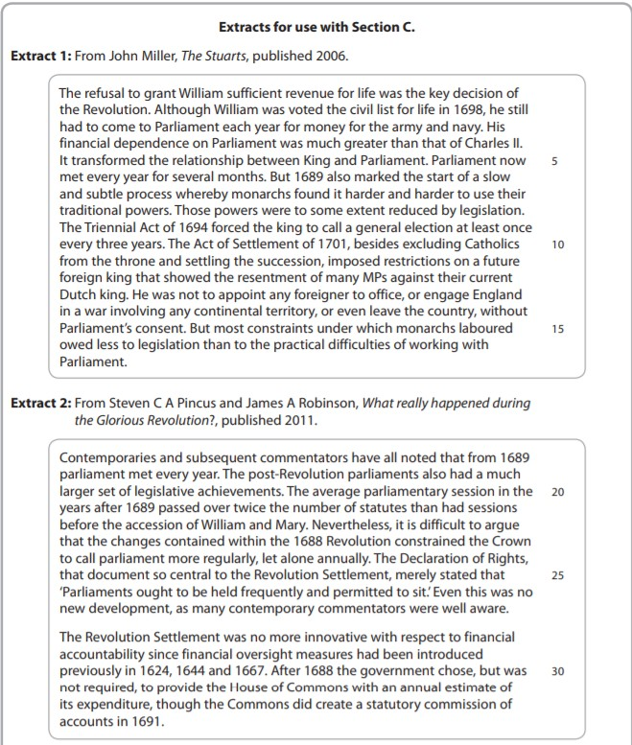

**Student response to question 5 from 9HI0 1C:**

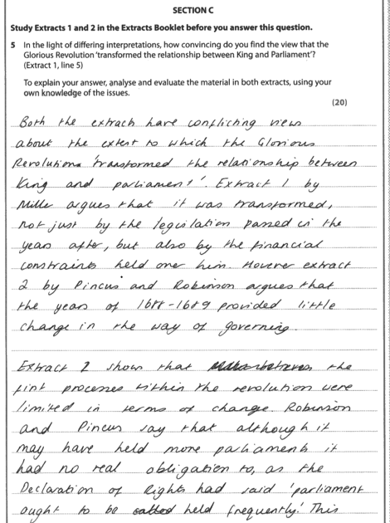

Straightaway, the candidate demonstrates a confident grasp of the arguments contained in the two extracts.

With reference first to Extract 2, the candidate then analyses the

issues raised, clearly demonstrating understanding of

the basis of its arguments, here concerning the

lack of precision of the Declaration of Rights.

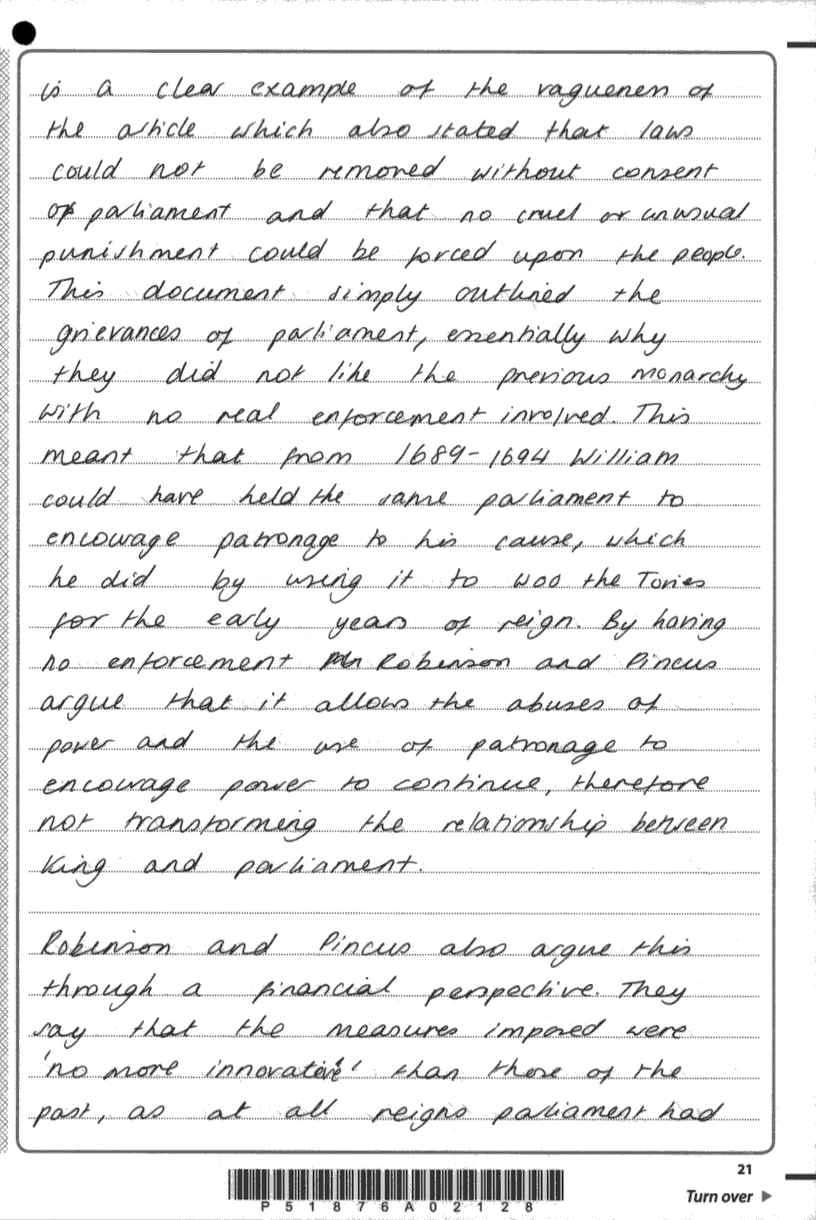

Here, well selected knowledge is integrated with the evidence from Extract 2 to discuss the merits of the argument.

Here, the candidate clearly shows appreciation of the basis of the arguments used by the authors.

The analysis of the interpretation in Extract 2 is sustained here with a discussion of another aspect of its evidence.

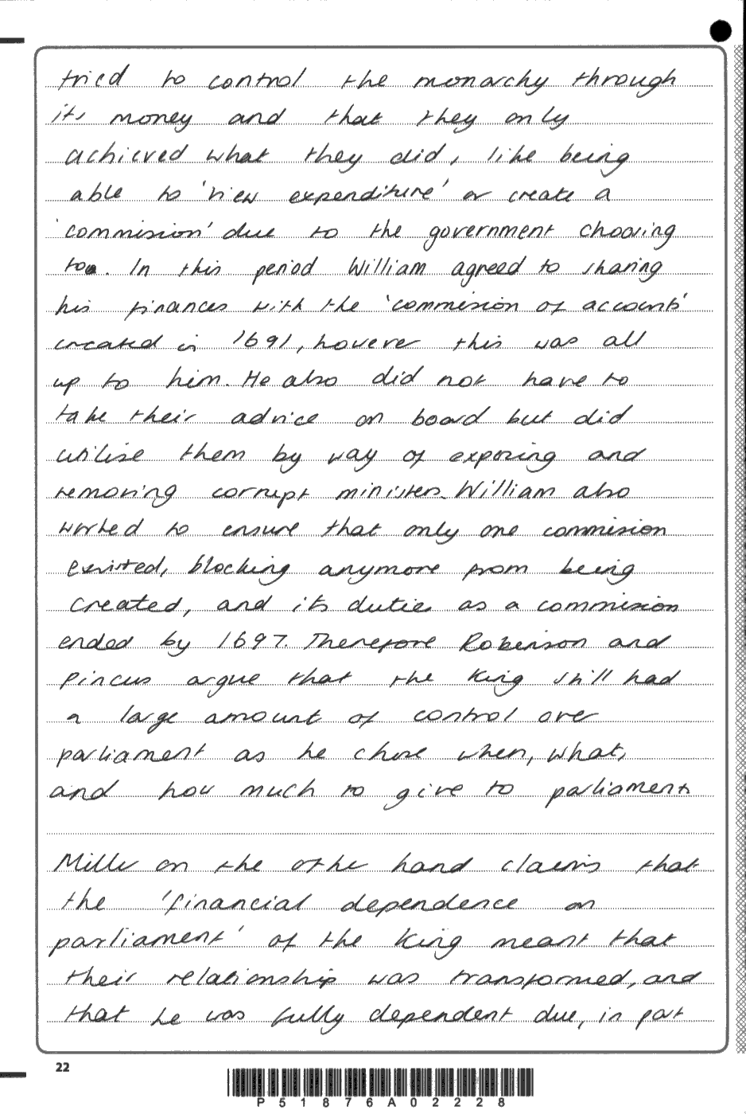

The evidence of the extract is analysed confidently before own knowledge of the context of the debate is again added to develop the discussion of its merits.

In starting to consider the arguments in Extract 1, the candidate is clearly aware of its differences

with Extract 2

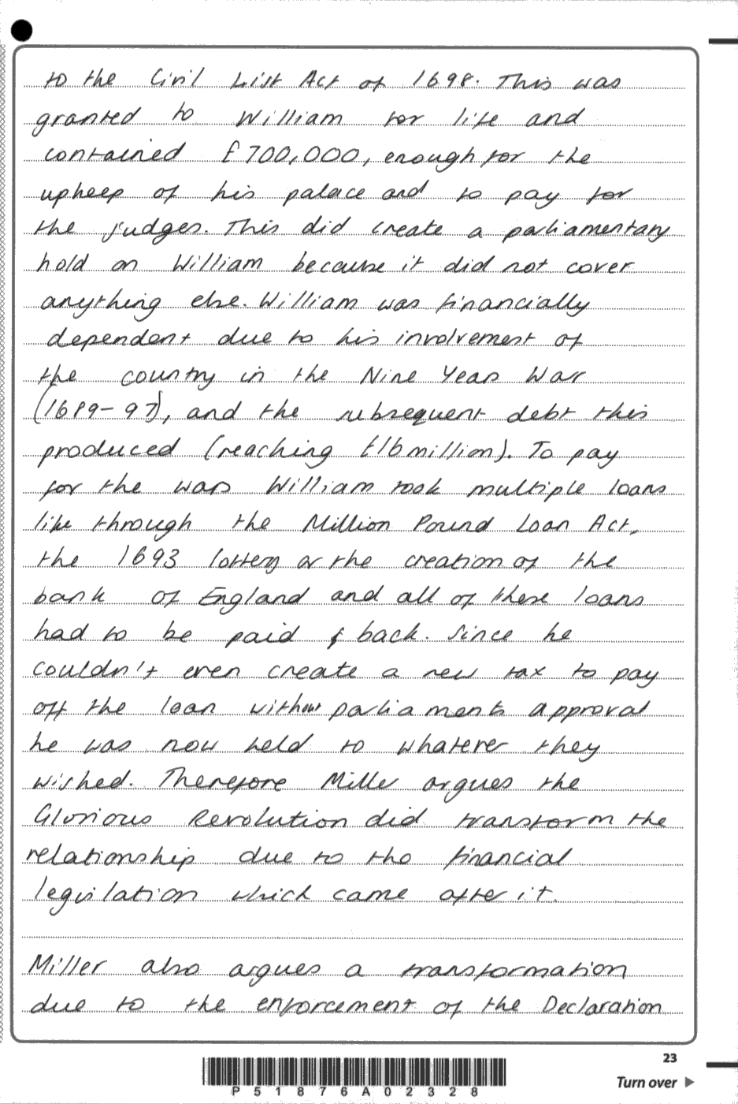

Once more, the evidence of the extract is handled with confidence and discrimination and is integrated fully with the candidate’s own knowledge. This can be seen through the candidate’s comments on the evidence and their use of own knowledge to evaluate its merits This is

a clear feature of L5 responses

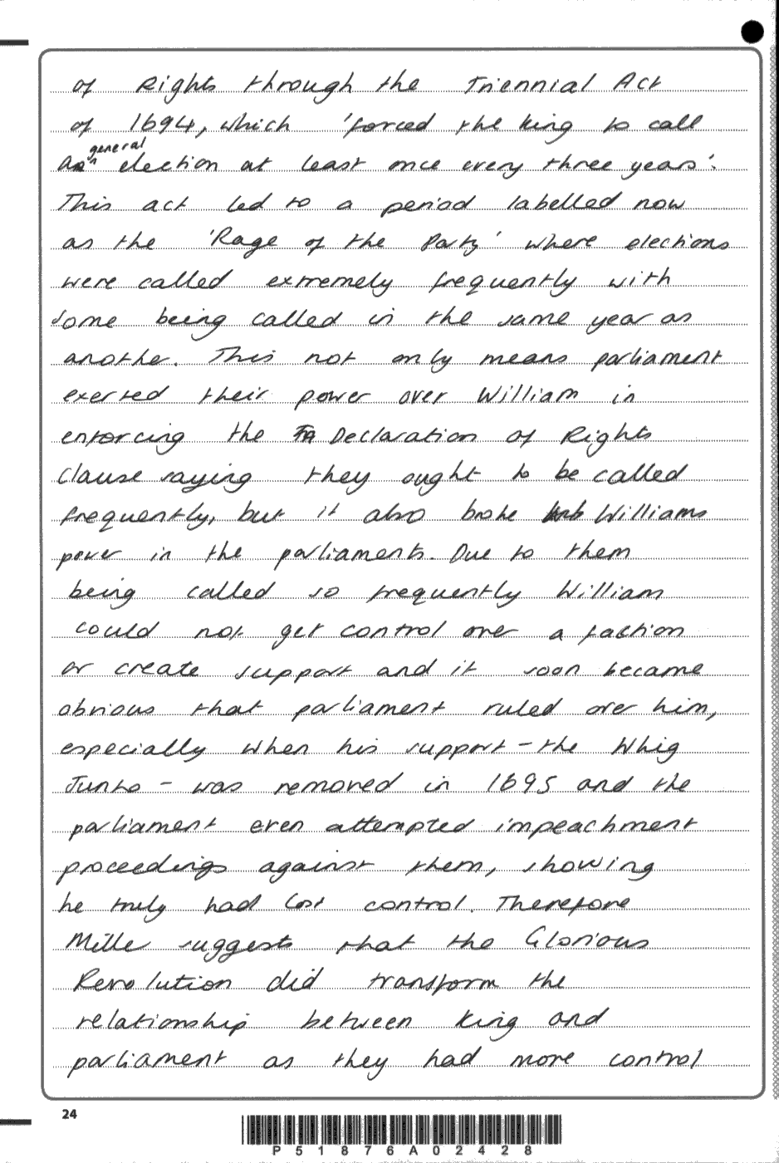

The discussion and evaluation is sustained by considering another aspect of the evidence of Extract 1.

The judicious use of own knowledge, firmly linked to the evidence in the extract, is again clearly apparent.

Through the discussion of the evidence of Extract 1, the candidate begins to draw conclusions with regard to the merits of the arguments of the two.

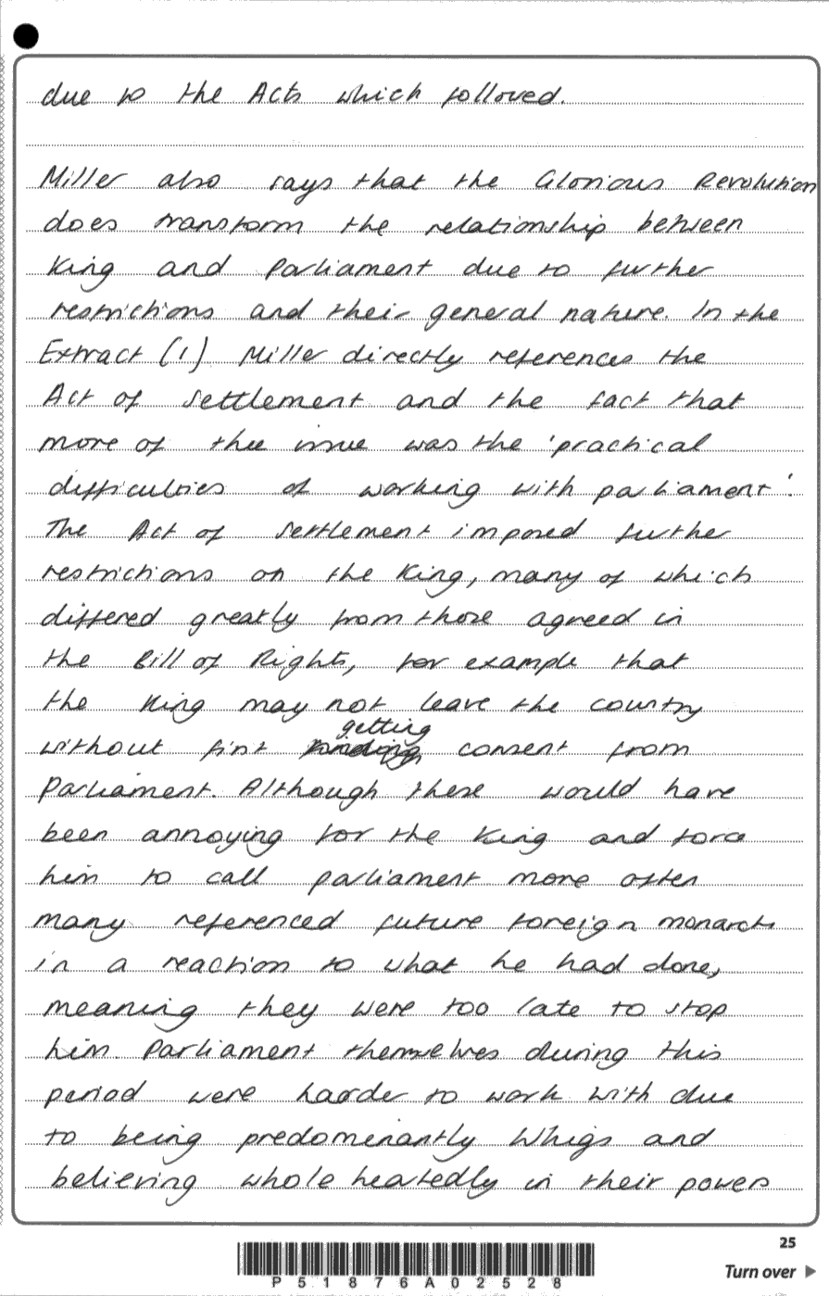

Yet another aspect of the evidence of Extract 1 is discussed fully with the support of the candidate’s knowledge.

Here, the candidate again clearly shows appreciation of the basis of the arguments used by the author.

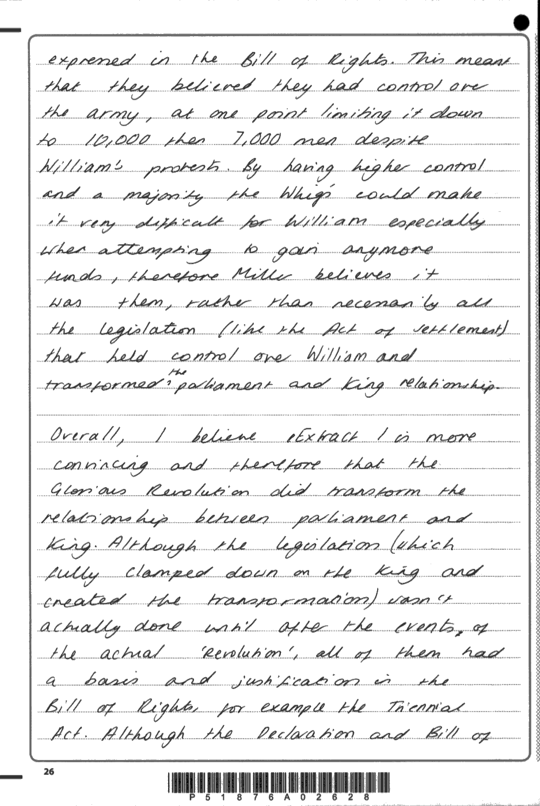

Following a sustained, evaluative argument, the candidate reaches a fully substantiated judgement on the merits of the arguments in both extracts.

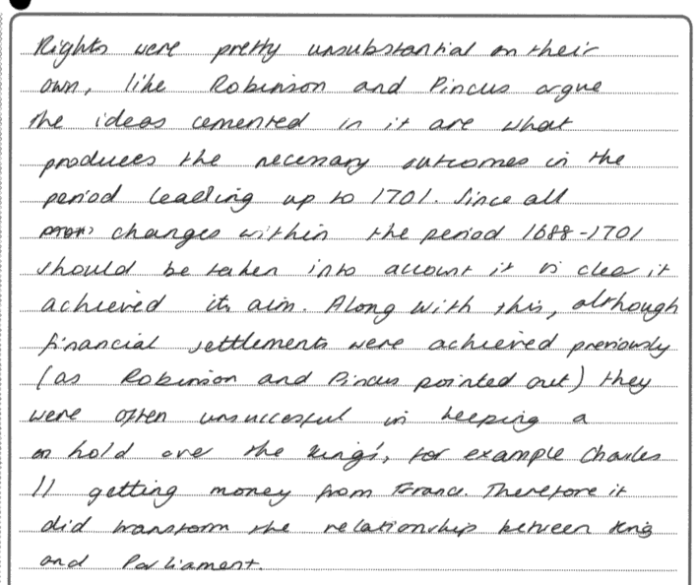

Here, it is clear that the candidate has a full understanding that the extracts presented are interpretations of the past and shows a clear awareness of the nature of historical debate.

**Examiner Comments**

**This response was awarded level 5**

This response fully justified full marks, satisfying each of the Bullet Points in the generic mark scheme at L5. A feature of this answer is its confident handling of the evidence in both extracts, and its sustained analysis of different aspects of the issues under debate. It clearly shows appreciation of

the basis of the arguments offered by both authors. Using detailed knowledge, chosen to examine the merits of the arguments with discrimination, the candidate carefully considers the differences between the interpretations of the Glorious Revolution as if they are the ‘third historian’ in the room, evaluating them continually. Lastly, a fully substantiated judgement is reached with the candidate responding to aspects of the arguments in Extract 2 and qualifying them as occurs in historical debate. It should be noted that this is a standout example of a L5 response and that a candidate may achieve a L5 mark without producing a response of such quality.