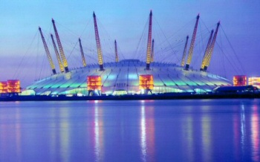

The Millennium Dome, or O2 arena, in North Greenwich.

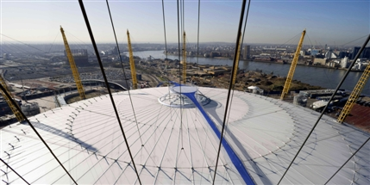
The Millennium Dome, or O2 arena, in North Greenwich.

The Dome was built to house the Millennium Experience, an exhibition to celebrate the third millennium in the year 2000. The idea was originally proposed by the Conservative government of John Major in the early 1990s, but was pushed through by Tony Blair in 1997.

"In the Dome we have a creation that, I believe, will truly be a beacon to the world". Tony Blair, 1999.

Design
The Dome was designed by the architect Richard Rogers. It is round, resembling a clock-face, and has 12 supporting towers, one for each hour of the day, or each month of the year. It is 52m tall, representing the weeks of the year, and 365m in diameter, one meter for each day of the year. This is because Greenwich is home to Greenwich Mean Time. The design of the Dome is very similar to the Dome of Discovery, built for the Festival of Britain in London in 1951, which attracted tourists from all over the world.

Controversy
It was hoped that the Dome would attract around 12 million visitors, but this was overly optimistic. Only around 6 million people came to see the Dome. The building and financing of the Dome were badly organised and heavily criticised. The exhibits inside, designed to be modern and inspiring, were met with disappointment by many.

Use
Originally, the Dome contained a number of exhibitions. After it closed on December 31st 2000, it was temporarily used for music festivals, homeless shelters and a Winter Wonderland experience in 2003. Finally, in May 2005, it was publicly renamed as the O2, which brought much more success.

The Dome now contains an indoor arena, cinema, exhibition space and bars and restaurants. In 2012 the artistic gymnastics, basketball and wheelchair basketball events of the London Olympic and Paralympic Games were held there, and the Up at the O2 experience opened, allowing people to climb along a 190m walkway on the top of the dome.

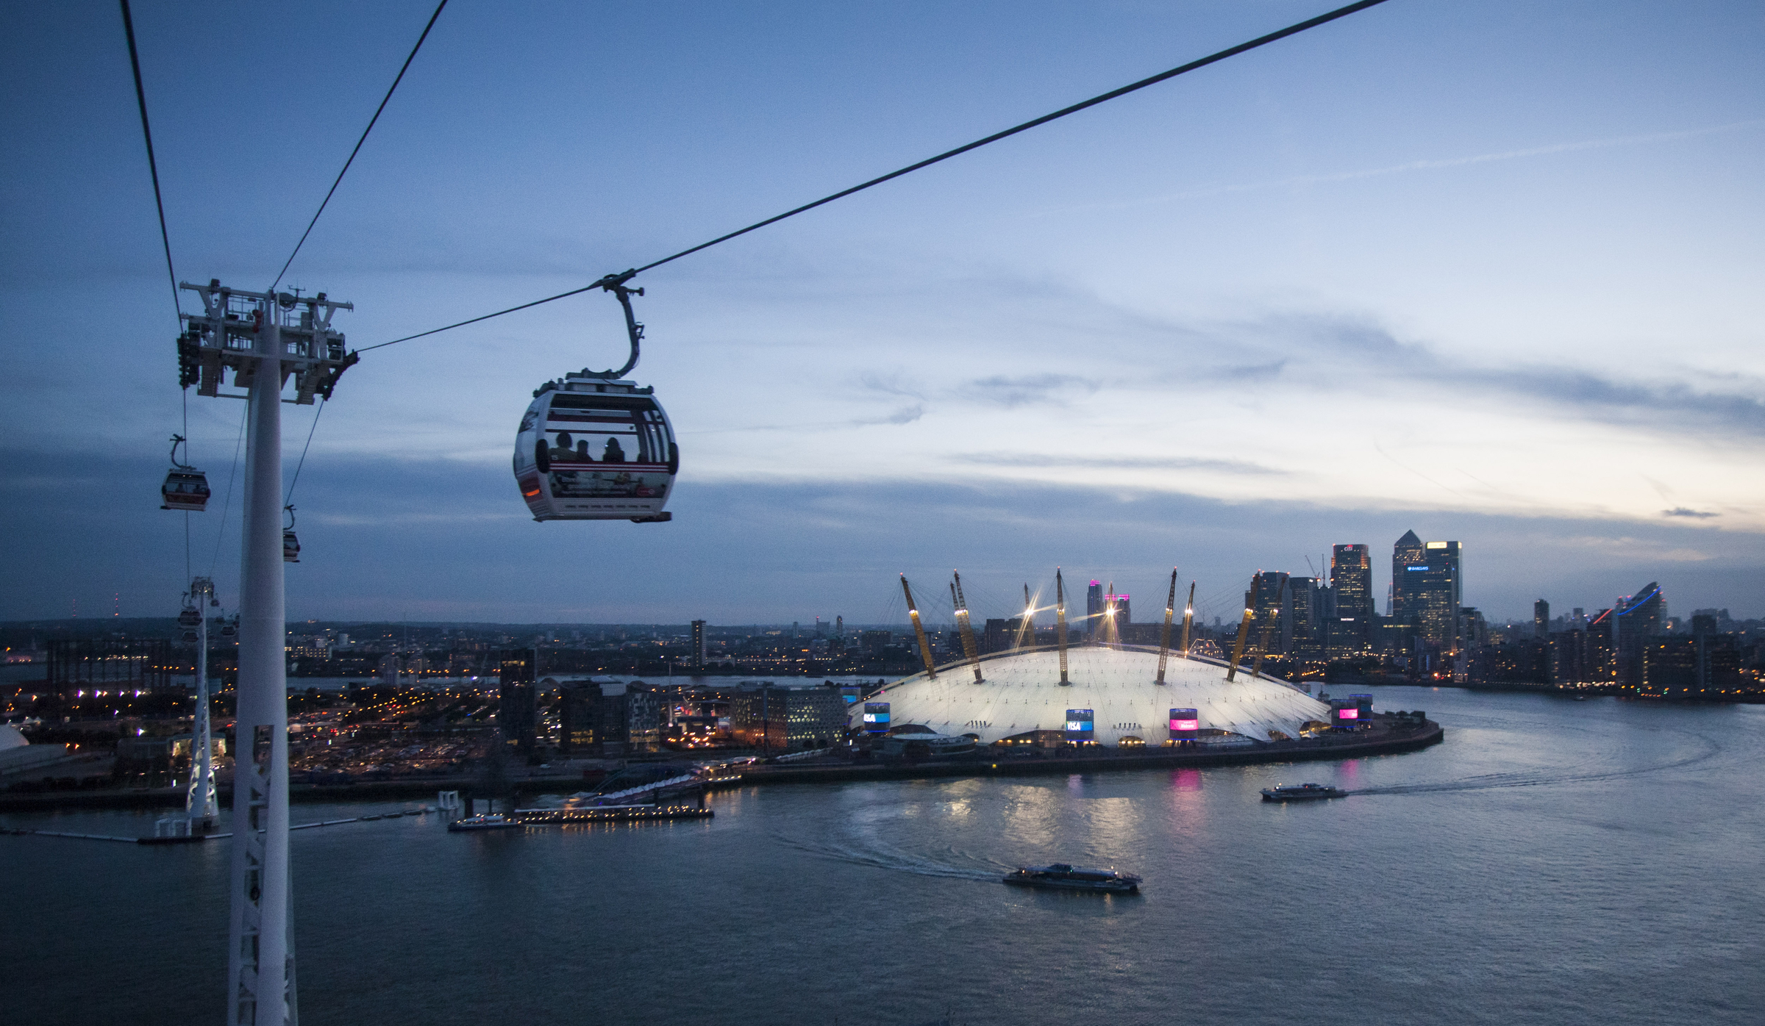

The Emirates Air Line

The Emirates Air Line

The Emirates Air Line is a 1km cable car line that crosses the River Thames from the Greenwich Peninsula to the Royal Victoria Dockyard. Construction began in August 2011, and the Air Line was opened to the public in June 2012. As with the marketing of the London Eye, the cable car journey is referred to as a ‘flight’, and tickets are called ‘boarding passes’.

Success
At the Air Line’s opening, the Mayor of London Boris Johnson described the service as:
“A stunning addition to London’s transport network, providing a much-needed new connection across the Thames… [which supports] my ambitious plans to revive the neighbouring areas… creating jobs for Londoners… This area will undergo a tremendous transformation in the next 10-15 years… [The journey] provides a panorama of some of the most opportunity-rich areas in the capital.”

Up to 1,500 people were employed in the construction of the Air Line, and more than 60 people have been kept on to operate the service. Around half of these people were local, meaning that the service has helped to boost the local economy through increased employment in the area, as well as money from tourists who ride on the cable car.

In the second week of October 2012 42,500 journeys were made (around 6,071 a day, an average of 252 an hour). However, the same week in 2013 showed a drop to 23,000 (around 3,285 a day, or 136 an hour).

Controversy
The cable car has received a lot of criticism as an impractical transport solution, which is appealing to tourists, but not commuters or locals trying to get around, partly due to its location, and partly because of the high cost of tickets. Many people would rather have a walking or cycling bridge instead.

There was more criticism over the cost of building (£60 million, rather than the £25 million predicted). It is estimated to be losing around £50,000 a week in costs over profit, as passenger numbers have now fallen by around 80% since the end of the Olympic Games.

The London Marathon in Blackheath and Greenwich.
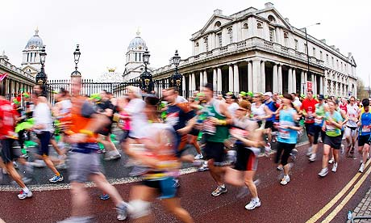

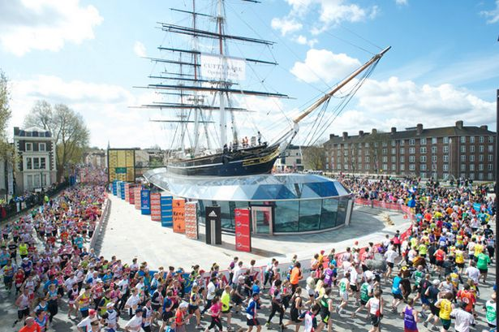
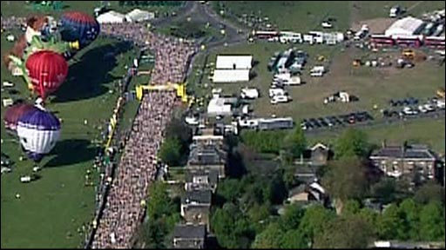

The London Marathon in Blackheath and Greenwich.

Origins
The London Marathon began in 1981, and was founded by journalist Chris Brasher and athlete John Disley. After running the New York City Marathon in 1979, Brasher wrote an article asking ‘whether London could stage such a festival?’ He and Disley decided it could!

More than 20,000 people applied to run in the first London Marathon. 6,747 were accepted, and 6,255 crossed the finish line. The first wheelchair marathon race was held in 1983 and was praised for reducing the stigma surrounding disabled athletes. There is also a mini marathon (the final 3 miles of the course) for children aged 11-17, and a mini wheelchair race.

The Course
The course begins at 3 separate points: southern Greenwich Park on Charlton Way, St John’s Park and Shooter’s Hill Road on Blackheath. From these three points, the runners head through Charlton, and join together in Woolwich, close to the Royal Artillery Barracks. They also run past the Old Royal Naval College and around the Cutty Sark before continuing towards central London.

Interesting Facts
- London is one of the top 6 world marathons that form the World Marathon Majors competition, with a £1 million prize.
- 15 runners, known as the ‘Ever Presents’ have completed every one of the London Marathons since the first in 1981. They are all men, and the oldest was Kenneth Jones, who was 80 years old in the 2014 race.
- The London Marathon is the Guinness World Record's largest annual fundraising event in the world. Since its launch runners have raised more than £500m for charity. Around 80% of runners raise money for charity.
- A total of 888,552 runners have completed the Marathon since 1981.
- The record holders are Emmanuel Mutai (Kenya) at 2:04:40 and Paula Radcliffe (UK) at 2:15:25. The fastest wheelchair athletes were Kurt Fearnley (Australia) at 1:28:57 and Tatyana McFadden (USA) at 1:46:02.
- The most common occupation for people running the 2014 race was teaching (1,408), with 309 scientists, 526 nurses, 47 taxi drivers, and 7 politicians.
- There are 2,000 plasters available on the route.
- There are 23 water stations and 80 pubs along the course.

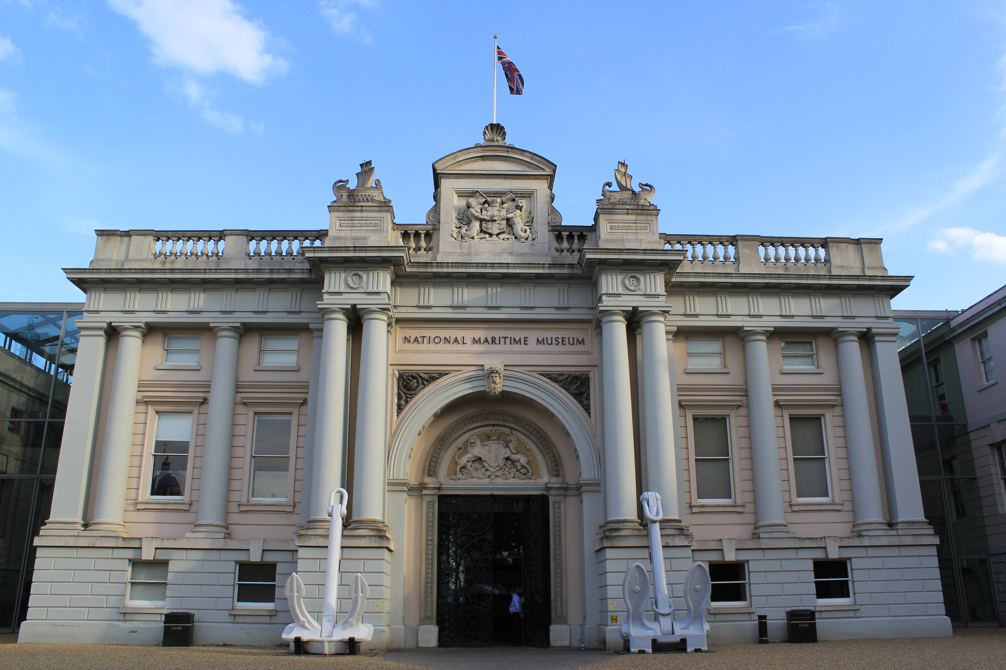

The National Maritime Museum, Greenwich Park.

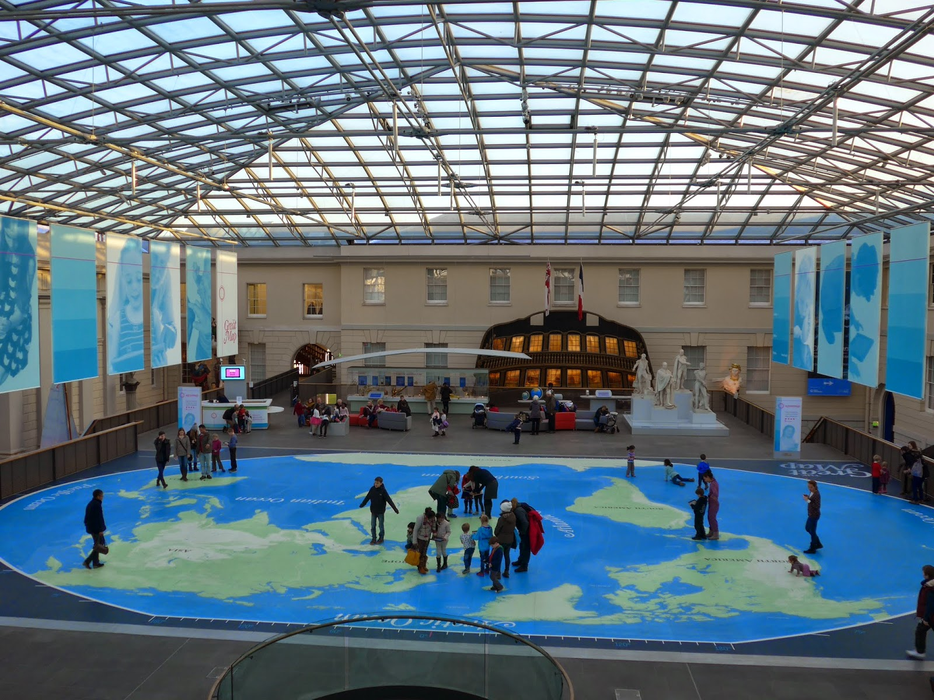

The National Maritime Museum, Greenwich Park.

The National Maritime Museum is based in Greenwich Park, and occupies the building on the wings of and including the Queen’s House and also the Royal Observatory. It was once the Royal Naval Asylum, for orphaned children of dead sailors, and later Greenwich Royal Hospital School. In 1934 it became a museum and was officially opened by King George VI in 1937. Now, it is a modern and interactive museum.

Collections
The Museum has over 2 million items, including maritime art, cartography (maps), manuscripts, official public records, ship models and plans, scientific and navigational instruments, time-keeping instruments, and portraits. As it is paired with the Royal Observatory (where the stars were studied, to allow sailors to navigate at sea), there is an interesting combination of history, art and science to see.

A Modern Museum
Although the museum is housed in an old building, it is now modern and interactive, with exciting exhibitions, live shows, and games to engage with. The change in the use of the building over time has not taken away from its past, but embraces the local history and emphasises the importance of the river and the naval links for Greenwich.

Free for all
The museum is completely free of charge, meaning that anyone and everyone can visit, as many times as they like. Like many museums and galleries in London, this allows equal opportunities for everyone to learn about the past.

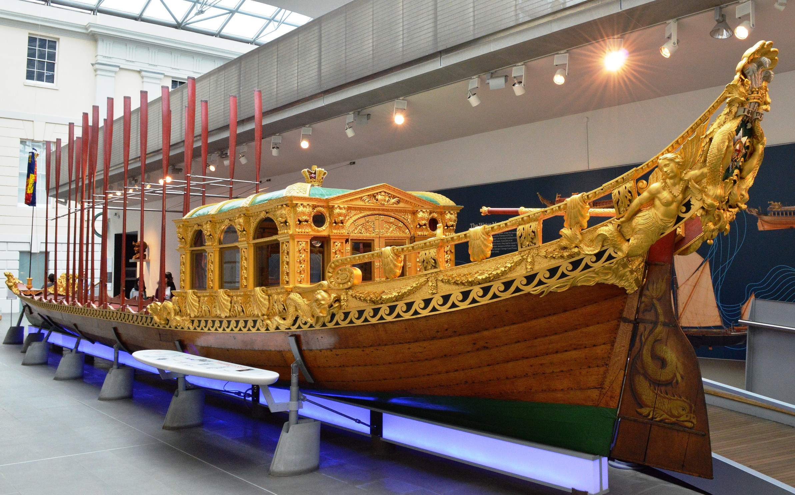

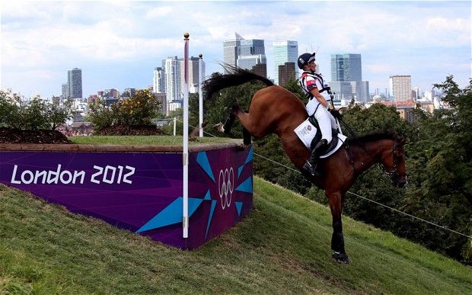
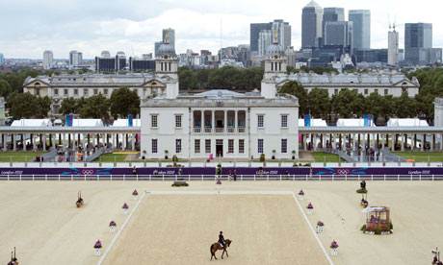
Equestrian events at the London 2012 Olympics, in Greenwich Park.

Equestrian events at the London 2012 Olympics, in Greenwich Park

During the London 2012 Olympic Games, Greenwich Park was the home of the equestrian (horse-riding) events: dressage, jumping and eventing.

The park was chosen as an Olympic Venue for a number of reasons:
- It is close to central London, and easily accessible by public transport, reducing travel time for athletes and spectators.
- It was cost effective as it could be used for both equestrian events and for the modern pentathlon.
- It is a popular London location, and allowed people to enjoy beautiful surroundings while enjoying the Games.
- It would showcase Greenwich to the world, bringing in tourism and therefore money to the area.

Different Opinions
There was some controversy about using the park. Some people thought that it would ruin the natural environment. Parts of the park also had to be closed for a long time while the stadium was built. However, once the Olympic Games got underway, many people seemed happy with the venue. One visitor said:

"I had never heard of Greenwich Park, and having seen it, I envy the people who have the benefit of being allowed spend time there… The days I spent in Greenwich Park I will remember for the rest of my life. It is a beautiful park, and the people of Greenwich should be rightly proud, that this park is now known across the world."

Olympic Legacy for Greenwich
The Olympic Games benefitted the local area in a number of ways:
- Increased employment – thousands of jobs were created for local people.
- Investment in the local area from big businesses worldwide.
- Regeneration of the local area’s transport links and hotels.
- A boost in tourism and development of local cultural venues such as theatres.
- Greater participation of schools in sports, including over £14 million of investment into school and community sports facilities, such as those at Thomas Tallis School.
- The establishment of a local sporting charity.

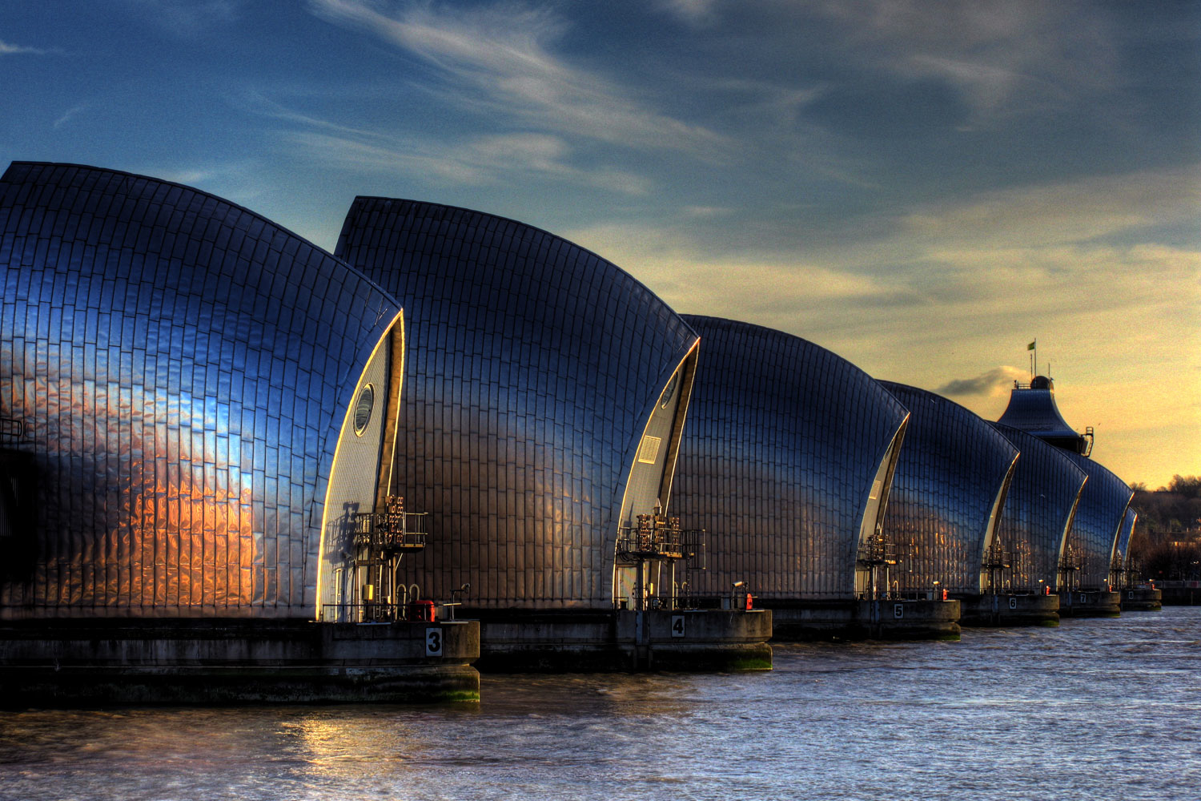

The Thames Barrier

The Thames Barrier

The Thames Barrier is a flood prevention mechanism on the River Thames, downstream from central London in Woolwich. It can be opened and closed when necessary to prevent too much water from getting into the Thames in central London.

Requirement
London is very vulnerable to flooding, as the high tides can cause dangerously high water levels. In 1928, 14 people died in a flood and thousands were left homeless, and in 1953 300 people died in the North Sea Flood, and 30,000 people were evacuated from their homes. This disaster made the issue more urgent.

History
In the 1950s Charles Draper got the idea for the design from brass gas taps, which open and close to let out gas in different amounts. Work began in 1974, and the barrier was completed in 1982. Flood defences down the river for 11 miles were also strengthened, and the barrier was officially opened by the Queen in 1984. It costs £634 million to build in total.
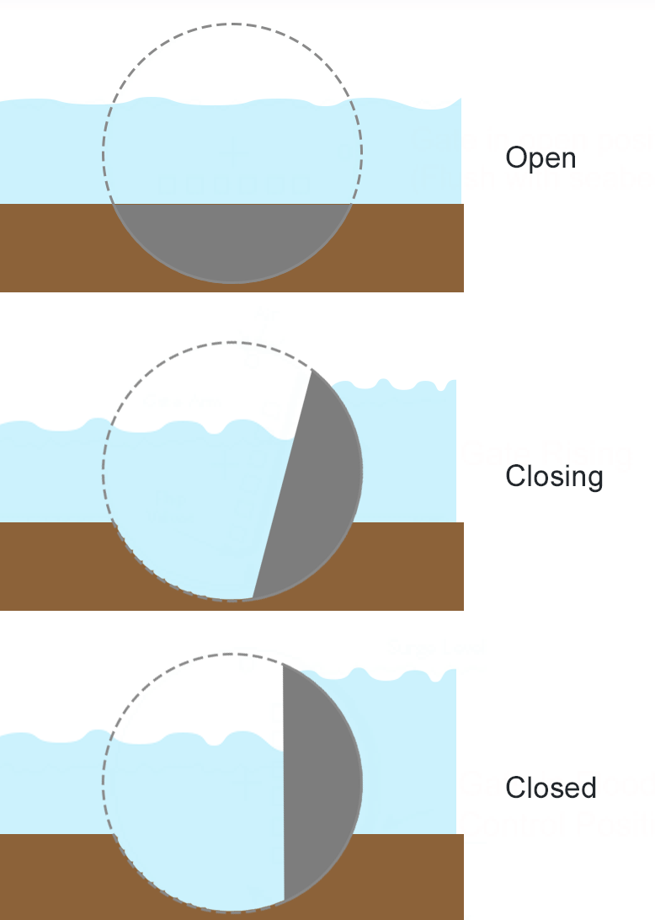
The barrier works by spinning circular gates. When open, the gate in in the river bed and the water can go over the top. When closed, the gate is upright in the water, and forms a wall that the water cannot get through. The gate is usually open, but is closed when the tide is high and there could be a flood.

Use
In the barrier’s history, it has been closed more than 170 times. The winter of 2000-2001 was the worst, with 24 closures, and 2002-2003 was next with 20 closures. The average is about 6-7 closures per year, although predictions estimated it would only be needed 2-3 times per year. The barrier has survived 15 boat collisions.

In popular culture
The Thames Barrier has featured in TV and music, including an episode of Doctor Who, Spooks, Top Gear and the music video for Take That’s hit single The Flood.

