Lessons 2-3: Depth 1.1:
Title: How did communists gain power in Russia 1917?

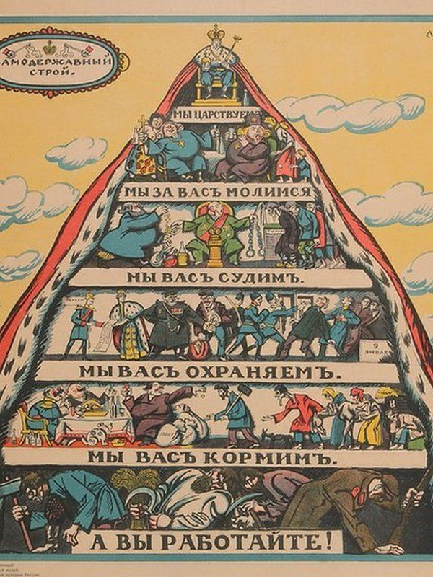
Starter: Using your knowledge from last lesson and the cartoon, answer the questions in the box
What do you think the message of the cartoon is?

What do you think the purpose of the cartoon is? (Why did the artists draw it?)

How useful is this cartoon for learning about communism in Russia before 1917? (1 not useful, 10 very useful, give a reason for your choice).

Source B: Drawn by communists Vladimir Mayakovsky and Alexei Radakov in 1917, just before the Russian Revolution. From top to bottom: "We reign. We pray for you. We judge you. We protect you. We feed you. And you work."
Key Words: Tsar: a ruler of Russia, similar to a king. A queen is known as a tsarina.

Challenge: what is a limitation to the utility of the source for learning communism in Russia before 1917?

Activity 1: Watch the clip on the Russian pre-1917 up to 2 minutes and answer the questions below https://www.youtube.com/watch?v=OHZ3Qww9kIY
- Prior (before) to 1900, what social class were the majority of Russians? P____________
- Writings by who inspired revolutionary ideas among the working classes?
- When did Russia enter in 1914?
- In 1917 what did the Tsar (King) of Russia have to do?

Activity 2: Read the information on Russia pre 1917 and answer the questions.
For decades after Marx’s death, only a tiny minority across the world believed communism was a good idea, or even possible. However, events in Russia changed everything. Russia at the start of the 20th century was a country with deep problems. Russia was ruled by Tsar Nicholas II, and he believed he was God’s representative on Earth. Because of this, he was extremely reluctant to share power with anyone else. However, Russia was undergoing major social and political changes that created a growing class or workers, particularly in the major cities in St Petersburg (Petrograd) and Moscow. These workers were unhappy with he social conditions of the country. In addition, a growing middle class began to call for involvement in the running of the country.
A small revolutionary political party known as the Bolsheviks went even further. Under their leader, a man known simply as ‘Lenin’, they began to call for a communist revolution. At this stage few people were willing to listen to such radical demands, and many Bolsheviks were either locked up by the Tsar’s police or forced to exile.
In 1905, strikes and demonstrations forced the tsar to allow a kind of parliament called the Duma to be created, but as time went on, he increasingly ignored it, and little changed.
In 1914, Russia was drawn into the First World War. Initially, the outbreak of the war was met by enthusiasm and patriotism. However, the war led to huge casualties and massive shortages, and the desire for change amongst many Russian people became greater than ever.
- Give one reason that communism became more popular in Russia in the 20th century.
- What was a weakness of Tsar Nicholas II?
- Give an example of a social problem in Russian cities.
- What was the name of the communist revolutionary party?
- Who was their leader?
- Why was the tsar forced to make changes in 1905?
- How did the Russian people’s attitude change to the First World War?

Challenge: Write a paragraph explaining why some Russian people were so unhappy with the Tsar by 1914.

Activity 3: Complete the table below on the causes of the Russian Revolution 1917, for each event write the correct factor, some may be more than one.
*First World War (FWW) *Political division (PD) *social unrest (SU)
Summary of events that led to the Bolshevik Revolution | Which factor? | Rank 1-10 which was the most important
The First World War was a disaster for Russia, In February 1917, a combination of strikes and huge protesting crowds crippled Petrograd (St Petersburg)
Troops were brought in to restore social order, but many were unwilling to open fire on the crowd. This was the first revolution in 1917.
In March, the Tsar was forced to abdicate due to social and political unrest. A provisional (temporary) government was formed to try to introduce reform and end the unrest.
The provisional government decided to continue to war, which made them very unpopular both with the people and the communists
In October 1917, the communist Bolsheviks seized power from the provisional government in a final revolution. The provisional government ended.
In 1918 a Civil war developed between the ‘Reds’ (the communists) and the ‘Whites’ (groups that wanted to get rid of the communist Bolsheviks.) The ‘Reds’ (the communists) were ultimately victorious.

Activity 4: Write the following response in your exercise book: Explain why the Russian communists were able to gain power in 1917

One reason the Russian communists were able to gain power was due to (First World War/Political division/ social unrest)

For example…

This meant that…

Another reason the Russian communists were able to gain power was due to (First World War/Political division/ social unrest)

For example…

This meant that…

