Lesson 9
Title: What was life like in Germany under a Nazi dictatorship?

Activity 1: Watch the clip on life in Nazi Germany and fill in the table below https://www.youtube.com/watch?v=E2VE--RqpyQ
Evidence of Support for the Nazis | Evidence of fear of the Nazis

Activity 1: Read the information below on life under the Nazis. Highlight/label methods of:
*control *propaganda/persuasion. [Each box may contain more than one]
From 1933, Hitler was able to turn Germany into a dictatorship under his complete control. Firstly, he was able to take control between 1933-34 using the Emergency Decree, Enabling Act and the Night of the Long Knives and once he was in firm control the Nazis used a variety of methods to keep control over the German population. The success of Nazi control is highlighted in the lack of opposition throughout the Nazi years.
Fear and Terror
Everyone is Germany lived under constant fear of the Nazi state, it was the prime method of control
The Gestapo (Nazi secret police) could tap phones, raid houses and could imprison you without trail, Over 160,000 were arrested for ‘political crimes’, hundred were killed.
The Gestapo used informers to watch local communities, you could be taken for Anti-Hitler jokes or not doing the Heil Hitler salute.
The SS were a fanatically loyal Aryans under Himmler, they had unlimited power. They ran the concentration camps and they took out the SA in the Night of the Long Knives
Concentration Camps like Dachau had over 100,000 inmates. Camps were used for Nazi enemies. Hard labour, beatings and murder were common

Propaganda
Josef Goebbels, Minister of Propaganda, used propaganda to brainwash Germany
Propaganda focused on; the greatness of Germany, the Fuhrer cult, the Aryan Race and attacking Germany’s enemy's (communism and Jews)
Goebbels controlled all newspapers. Anti-Nazi papers were shutdown, negative news was censored.
The Nazis produced over 1000 films and ones The Eternal Jew encouraged anti-Jewish feelings
The Nazis controlled all music, books and plays. It had to be pro-German
Goebbels controlled all stations and cheap ‘peoples receivers’ were made so 70% of homes had one. Hitler's speeches were common. Loudspeakers were put up in streets so all could listen

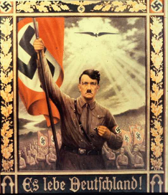
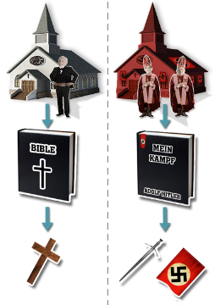
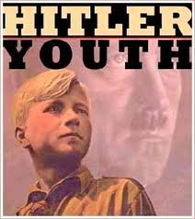
Censorship
The Nazis censored everything – all anti-Nazi ideas were banned. The Nazis controlled what people read, saw and heard – it was part of their indoctrination. 1,600 newspapers were shut down.
During WW2, only positive news stories were shown to show Nazi successes.
Writers, film makers and artists could only produce pro Nazi arts. Jazz music was banned.
Telling an Anti-Nazi joke was a crime, leading to a fine or imprisonment.
In 1933, 20,000 Jews books were burnt.

The Fuhrer Cult
The Nazis developed he 'Führer cult’. The aim was for Germans to idolise and follow their leader – like a god.

The Legal System
The Nazis also controlled the legal system – the Enabling Act meant that the Nazis could pass any law they wanted and meant Hitler had no opposition in the government as he banned other parties in July 1933
Whilst the ‘People’s Court’ used Nazi judges who swore on oath of loyalty to Hitler. Over 44 crimes became punishable by death, 40,000 were killed

Controlling Workers
Hitler banned all Trade Unions in May 1933 and made strikes illegal. Workers had to join the DAF which took away their rights.
Workers had their wages dropped and hours increased to over 60 per week. They could not leave their jobs without permission.
Benefits of the KDF were offered to keep workers ’happy’ with cheap holidays.
Other methods of control
The Nazis banned RE in schools, closed church schools and set up their own Reich Church in 1936 to reduce to power of the church.
Jews and minorities had their civil rights stripped away and were put into camps, ghettos and eventually killed in Death Camps during WW2.
15% of women were sacked from jobs, they were forced into being housewives under Nazi rule.

The Youth
Germanys children had their whole lives controlled, through education and youth groups. They could not escape Nazi brainwashing.
Education in schools was used to indoctrinate boys and girls. There was anti-Jewish propaganda and Nazi ideology in every lesson
The Nazis banned all other youth groups and used their own to create loyal Nazis for the future. They even encouraged children to snoop on their own parents, loyalty to Hitler was the priority. Training loyal future Nazis was key.

Challenge: ‘The use of fear and terror was the most important method in controlling the people between 1933-45’ How far do you agree with this statement?

