Lessons 8-9: Overview 4
Alternative Second World War Narratives:
Which stories are often neglected or not remembered?

Activity 1: Women at War
Read about the following women and answer the questions in your book.
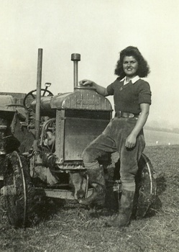
Women on the Home Front:

Women in Britain and in other countries played important roles in industry, agriculture, and medicine including the 80,000 Land Girls and 950,000 munitions workers. The number of British women in work increased by over 2 million, with around 85% of able-bodied women aged 18 to 40 were engaged in some form of work or National Service by 1943. They were crucial to the war effort.
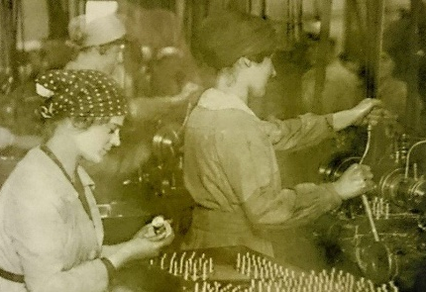

Women supporting the Armed Forces:

640,000 women served in the British armed forces, including the WRNS (Navy), WAAF (Air Force) and ATS (Auxiliary Services). Whilst they didn’t fight, they provided important information on the ground, working radar systems, treating the injured and ensuring the safety of British civilians. The Queen, then 19-year-old Princess Elizabeth trained as a driver and mechanic.

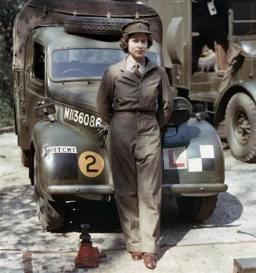
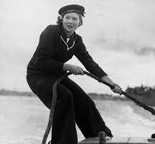

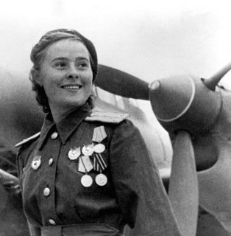
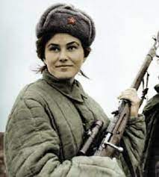
Female Fighters:

The Soviet Union had over 800 women in 3 all-female air regiments. These were founded by pilot Marina Raskova, who was the first woman to achieve the diploma of professional air navigator. There were also 2,000 female snipers in the Soviet army, of whom 500 survived the war. The most successful of these was Lyudmila Pavlichenko, who killed 309 soldiers, gaining the nickname ‘Lady Death’.

Female Spies:

In 1940, the Special Operations Executive (SOE) was established in London, with 10,000 men and 3,000 women employed throughout the war. Of these, around 45 female agents from around the world were sent by boat or parachute behind enemy lines as spies. They gathered information secretly sent it back to Britain and sabotaged enemy communications. Some were caught and executed in concentration camps.

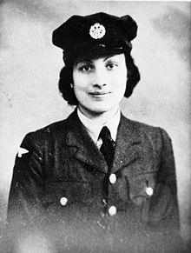
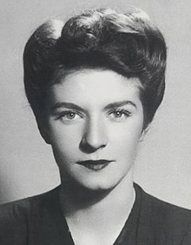

- Which of these roles were you aware of? Do any surprise you? Why?
- Why was the use of female fighters and spies so effective?
Challenge: The Nazis had traditional ideas about gender. How would they feel about women working? What do you think their policies were? How and why might they have changed over time?
Activity 2: LGBT+ Contributions to WWII
The National Survey of Sexual Attitudes and Lifestyles has estimated that up to 250,000 of the 5 million men who served in the British armed forces were gay or bisexual. This is based on statistics from the 1990s, where 6% of men reported having had homosexual experiences. We don’t know the exact numbers, but we do know that many people from the LGBT+ community served their countries around the world, and many more supported from home. Most of them would have had to keep their sexuality secret due to discriminatory laws and attitudes of the times. Most of the information we have about member of the LGBT+ community at this time relates to their murder in the Holocaust.

Read below about Alan Turing, filling the gaps and answering the questions.

Alan Turing

Missing words: 1952, mathematician, several, naval, Bletchley, daily, code, OBE, 2021

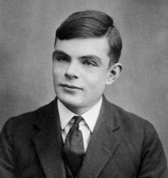
Perhaps the most famous member of the LGBT+ community associated with WWII is Alan Turing. Turing was a brilliant _______________, who studied at Cambridge and Princeton. In 1939 he began working at ________________ Park, where he worked as a codebreaker, trying to decipher military codes used by the Nazis and their allies.

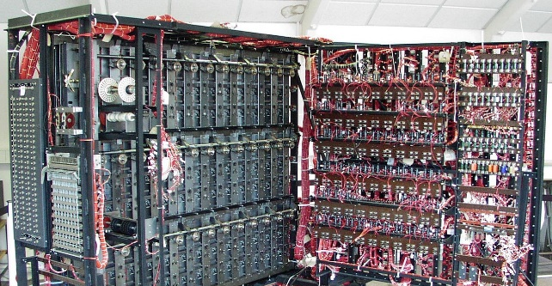
Turing was tasked with cracking the Enigma ________. The Enigma was an enciphering machine used by the German army to send secure messages. Polish mathematicians worked out how to read the messages, but the cipher was changed ___________, so further decoding work was needed. Turing invented a machine known as the Bombe, which helped to decode these messages. He also managed to crack other German __________ codes, which was pivotal in helping the Allies in the Battle of the Atlantic, where German U-boats had been causing significant damage. He continued to develop another code-breaking machine, and a speech scrambling device.

In 1945, Turing was awarded an _______ for his wartime work. However, in ___________ he was arrested for homosexuality, which was still illegal in Britain, and was forced to undergo hormone treatments, which made him infertile. In 1954, he was found dead in his home, ruled as a suicide.

Much of Turing’s story was kept secret until the 1990s. It is estimated that his work, and that of his colleagues, shortened the war by ______________ years, and undoubtedly saved countless lives. In 2009, Prime Minister Gordon Brown issued an apology on behalf of the British government, in 2012, Turing was granted a pardon for his ‘crime’, and in 2017 a new ‘Alan Turing Law’ was introduced, which pardons people previously charged under outdated homophobic laws. In __________, Turing was chosen as the face of the new £50 note.

- How significant was Alan Turing’s contribution to WWII? Explain your answer with examples of his achievements.
- Why do we know so little about the experiences of the LGBT+ community during WWII?
- Why was Gordon Brown’s statement of apology important?
Challenge: Can you work out what long-term impact his work had on modern society?
Activity 3: Black, Asian and Empire Contributions to WWII.
As with WWI, the contributions from Black and Asian people from across the world, and especially the British Empire forces, has often been overlooked. Read these case studies to find out more.

‘Mother to Mother’
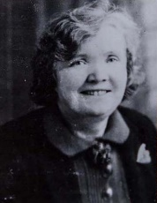
Around 130,000 African American troops were stationed in Britain during the war. In 1940s America, segregation was prevalent. Whilst Britain was far from perfect, it was more tolerant than the USA and some Black soldiers were pleasantly surprised by their stay. Jessie Prior had US soldier Wilson Monk, staying in her home. She wrote to his mother, promising to take care of Wilson while he was with her.

Forgotten Soldiers
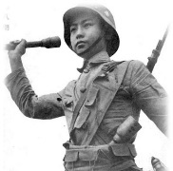
The British government and army failed to fairly pay the 600,000 African men who joined the armed forces. A white corporal would earn 12 shillings a month, Asian personnel 7 ½ shillings, and a Black corporal just 4 shillings. African and Asian soldiers were also barred from reaching higher ranks than white soldiers. Many were left with no support after the war, though some individual officers did lobby the government to provide these soldiers with a proper pension. More than 3.5 million Indian and African soldiers fought alongside their European allies, and the contribution of Chinese soldiers should also be remembered, who fought bravely despite suffering terrible treatment during Japanese occupation.

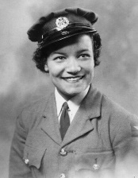
Pilots of the Caribbean, and India
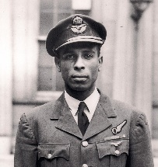
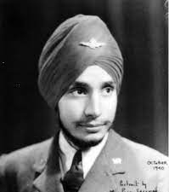
During WWII, 500 pilots and 6,000 ground crew came from the Caribbean islands to join the RAF. Ulric Cross from Jamaica was the most decorated Caribbean airman of WWII, and a precision bomber and excellent navigator. Lilian Bader, of British and Barbadian heritage, joined the WAAF and became one of the first women to become an instrument repairer, before working her way up to Acting Corporal. Mohinder Singh Pujji was one of the few Indian pilots to fly in all three major theatres of the war. He was awarded a Distinguished Flying Cross for ‘outstanding leadership and courage’.

Gurkhas: Men of Action
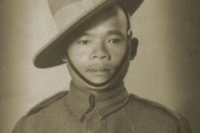
During WWII, 140,000 Nepalese soldiers called Gurkhas served alongside the British and Allied forces. Gurkhas are known for their skill and courage on the battlefield. During an attack by the Japanese in Burma, Lachhiman Gurung threw back 3 enemy grenades, and then fought on for a further 4 hours, despite a grenade severing his fingers and blinding him in one eye. He killed 31 soldiers, and the Japanese attack failed. Gurung received a Victoria Cross for bravery, but was not allowed to settle in the UK until 2008 that the Gurkha Justice Campaign managed to secure the right for Gurkhas to settle in Britain.

ANZACS
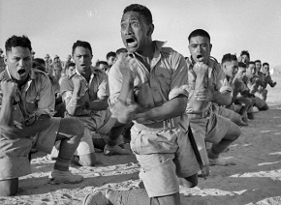
The Australia and New Zealand Army Corps, created in WWI, was briefly re-established in 1941 for the Battle of Greece. Although the battle was a Nazi victory, the Greek, British and ANZAC forces held off the Italian forces, and damaged the enemy hold over North Africa, where they had been fighting. Australian and New Zealand forces also supported the Allies separately throughout the war, in North Africa, the Middle East and the Pacific. The New Zealand forces also included a Maori Battalion.

- Which of the above groups were you aware of? Which ones did you not know? Why is this?
- Why is it important to learn about these different contributions?
Challenge: Can you link this to your writing about the dominant narrative of a ‘European conflict’? (p. 8-10)
Activity 4: Conscientious Objectors
Conscientious Objectors refuse to fight on moral or religious grounds. They were looked down upon during WWII. 59,192 people registered through tribunals as Conscientious Objectors (COs). Many of these people were sacked from their jobs. Tribunals varied greatly, with rejections ranging from 6% to 41%. Some COs agreed to support in non-violent ways, such as working on farms, but others refused to engage in any activity that would aid the war effort. As the war went on, fewer men objected to fighting, especially after Dunkirk.

Consider how Sources 12 and 13 present Conscientious Objectors.

Source 12: A WWI propaganda cartoon, that reflects some of the attitudes still held in WWII.
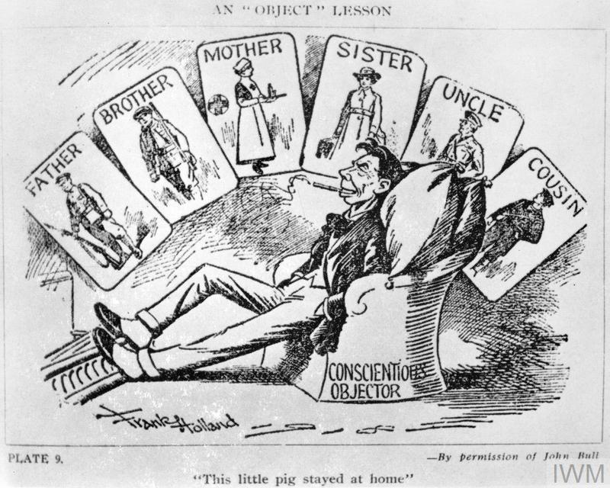
Answer the following questions in your book:

- How does the source present the CO? Give details from the source to support your answer.

- What does the caption at the bottom say, and what impression does it give of the CO?

Challenge: What do the cards show, and what is the message they present? Give examples of your own knowledge to explain how this would have been similar in WWI and WWII.

Source 13: An interview with Donald Saunders, a WWII Conscientious Objector, from 2019.
https://www.youtube.com/watch?v=liAK_KmH5kc

Answer the questions below:
- What happened to Saunders’ father in WWI?

- How did people treat Saunders’ mother during WWI, and why?

- How does Saunders suggest that propaganda worked?
  - Young people believed it was…

- How does Saunders feel about conscription?
  - It was not…

- What happened in a tribunal?
  - You would read…
  - You would answer…
  - ___________________ could be called to give evidence.
  - A judge…

- How did Saunders’ friends feel about his pacifism?

- What did Saunders do to help civilians, instead?

Activity 5: Design a pitch for a Netflix documentary about one of the alternative narratives.
- Select one of the alternative narratives from p. 19-22.
- Think about why this particular group should have greater recognition.
- Design a proposal you could pitch to Netflix for a documentary about this group. Use this planning sheet to help you:

Documentary Proposal
Group selected:

3+ main things the documentary will inform people about:

Extra points:

Reason why this group deserves greater recognition:

Now practise your pitch. You can use the following sentences or your own words:
- Good morning/afternoon. I am here today to propose a documentary about…
- The documentary would highlight…
- This group deserves greater recognition as…
- This documentary would…

Homework: Continue with Activity 4 your homework booklet.

