Lessons 6-7: Overview 3
Dominant Second World War Narratives:
Dunkirk, the Blitz, the Battle of Britain and D-Day

When studying WWII in British schools, there is an overwhelming focus on the heroic British rescues and victories of the war. These were significant events, some of which proved to be turning points in the outcome of the war, and their importance is rightly recognised. Over the next two lessons you will find out about them. Challenges on p. 18!

Activity 1a: What happened at Dunkirk?
Read the information then use the sources to answer the questions below.

Dunkirk is a small town on the coast of France that was the scene of a massive military campaign during World War II. In May 1940, Nazi Germany launched a blitzkrieg (‘lightning war’), taking over Luxembourg, Belgium and invading France. They pushed back French, British and Allied forces to the coast. Prime Minister Neville Chamberlain resigned, and Winston Churchill took over. Eventually, he had no choice but to attempt to withdraw the British troops from France to avoid a massacre that would devastate the British army. On 26 May 1940, the British put Operation Dynamo into place. However, the Luftwaffe (German Air Force) heavily bombed the beaches and harbour, slowing down the evacuation. They hoped to rescue 30,000 men in two days, but only managed 17,000.
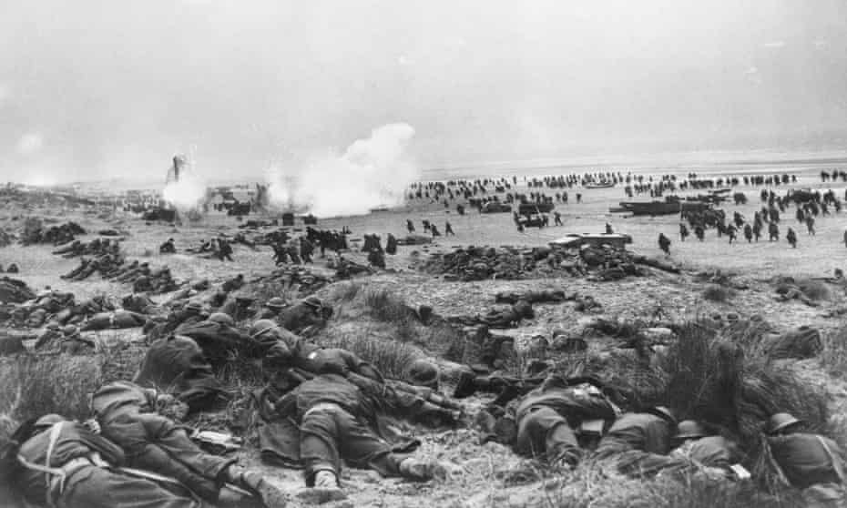

The beaches were shallow and the Royal Navy couldn’t reach the shore, so in desperation the government put out a call for smaller ships to help in the evacuation. Around 1000 ‘Little Ships’, many of them leisure or fishing boats, set sail to France. In total by 4 June 1940, over 338,000 British troops, along with French and Allied soldiers, were rescued from the beaches of Dunkirk.

Churchill made a speech in Parliament that day, famously saying:

‘We shall go on to the end. We shall fight in France, we shall fight on the seas and oceans, we shall fight with growing confidence and growing strength in the air, we shall defend our island, whatever the cost may be. We shall fight on the beaches, we shall fight on the landing grounds, we shall fight in the fields and in the streets, we shall fight in the hills; we shall never surrender’.

Source 1: Clip from the film Atonement (2007): https://www.youtube.com/watch?v=55CaD_j5FQs
- List 3 things you can see or hear happening on the beach:

- What is the general atmosphere like on the beach – calm, or chaotic? Give an example.

- Why are the soldiers shooting the horses and destroying the car engines?

Source 2: Clip 1 from the film Dunkirk (2017): https://www.youtube.com/watch?v=2W3KDB0yHYM
- How does the atmosphere at the start of scene on the beach compare to the previous clip? Give an example.

Source 3: Clip 2 from Dunkirk (2017): https://www.youtube.com/watch?v=ZYLTYZlZymM (to 2:30)
- How does this scene present the Little Ships? Explain your answer.

- What is the mood amongst the soldiers? Give details from the clip to support this.

Activity 1b: How useful are Sources 1, 2 and 3 for telling us about Dunkirk?

 | Source 1: Atonement | Sources 2 and 3: Dunkirk
Useful | - Shows realistic range of emotions and sense of hopelessness amongst some soldiers.  - Shows the scale of the operation with the large number of soldiers on the beach. | - Accurate – men did wait calmly in line for their evacuation.  - Bombings highlight the danger the men were in waiting on the beaches.  - Depicts the enormous and significant contribution of the Little Ships.
Limited | - Overdramatised – in reality the beach was far more orderly. Men did wait in line for their evacuation, determined to be off the beach as fast as possible.  - A film – focuses on impressive shots and scenes more than accuracy. | - Emotionless – there is perhaps too little emotion shown in the beach scene – some men would have been less calm and orderly.  - Fails to show the contribution of North African soldiers amongst the French.  - A British film – maybe too overly heroic a portrayal of the rescue?

In your exercise book, copy and complete the writing frame below answering the question above. Use the planning grid to help you.
In some ways, the films Atonement and Dunkirk are useful for telling us about Dunkirk. Source 1… for example… Furthermore, Sources 2 and 3… For example…

However, in some ways the films are limited in their utility. For example, Source 1… This is because it is… Additionally, Sources 2 and 3… This is because…

Activity 2a: What was the Battle of Britain?
Read the information.
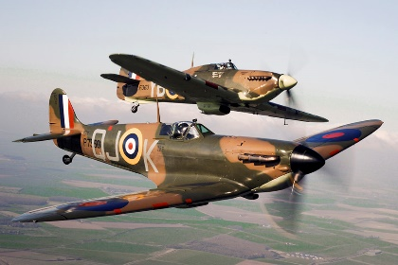
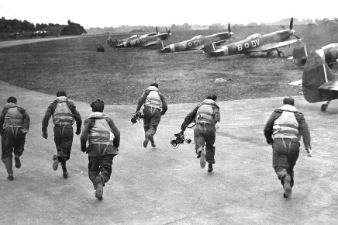
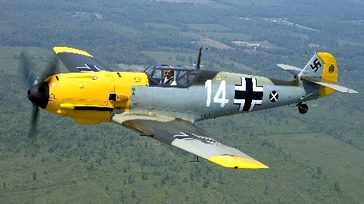
The Battle of Britain was a military campaign between the British Royal Air Force (RAF) (supported by the Royal Canadian Air Force) and the German Air Force (Luftwaffe). It lasted from 10 July to 31 October 1940. The Luftwaffe hoped to compel the British to surrender or reach a peace settlement that suited them. In July, the British set up air and sea blockades, as the Luftwaffe began to target ships and ports, before turning to RAF airfields, factories and eventually civilians. The name came from a speech by Churchill, following Nazi occupation of France. He said ‘The Battle of France is over. The Battle of Britain is about to begin.’
As Germany prepared for an amphibious seaborne attack, and air attacks, the RAF began night raids on German ships in a pre-emptive strike. The main types of fighter planes used in the Battle were the Messerschmitt (Luftwaffe), Hurricane and Spitfire (RAF). In total, the British deployed 1963 aircraft, and lost 1542 men, and the Germans deployed 2550 aircraft, and lost 2585 men. The Battle of Britain marked the first major German military defeat of WWII. Radar (Radio Detecting and Ranging) allowed the British to know when and where the Luftwaffe was going to attack and prepare their own anti-aircraft guns and RAF to counter the attack.

Although the major fighting ended in October, the Luftwaffe did continue bombing British cities until May 1941, in what became known as the Blitz. Britain and their allies also later bombed German cities, most notably Dresden in early 1945.

Optional clip: https://www.bbc.co.uk/teach/class-clips-video/history-ks2-the-battle-of-britain-and-beyond/zrk847h

Activity 2b: Read the two interpretations below, and then answer the questions below in your books.

Interpretation 1: George Orwell, who was working on BBC propaganda, 1942.  September 15th was celebrated throughout this country and the world as the second anniversary of the Battle of Britain… September 15th is celebrated as the anniversary because on that day the Royal Air Force shot down no less than 185 German planes… Now that we can look back and see… that the Battle of Britain ranks in importance with the defeat of the Spanish Armada and other battles of the past in which the invading forces of a seemingly invincible monarch or dictator have been beaten back and which have formed a turning point in history. | Interpretation 2: Rephrased from Amy Irvine, who writes for and edits a HistoryHit website, 2021.  The Germans were overconfident, estimating that they would defeat the RAF in 4 weeks. The Luftwaffe had unstable leadership from Hermann Goering, who made impulsive, erratic decisions. The Luftwaffe’s strength was in short, quick battles (Blitzkrieg), not extended campaigns. They also made errors in their tactics, with over-reliance on dive-bombers, which were slow and not very manoeuvrable.

- Interpretations 1 and 2 give different views on why the Luftwaffe lost the Battle of Britain. What is the main difference between these views?
  - Interpretation 1 argues that… For example, it says ‘…’.
On the other hand, Interpretation 2 argues that… For example, it says ‘…’
Therefore, the difference between the interpretations is that…

- Explain why the authors give different views. Consider their jobs.

Activity 3a: What was the Blitz?
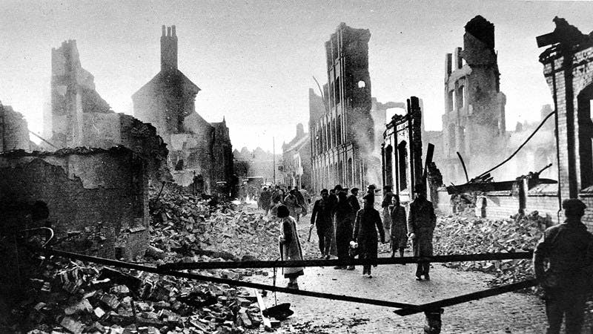
Read the information below.

Starting on 7 September 1940, the Blitz continued out of the Battle of Britain, which had evolved into a war on civilians. Nearly 2,000 people were killed or wounded on the first night, when over 350 bombers dropped 300 tonnes of bombs on London’s East End. This continued for 56 consecutive nights, and then less frequently until May 1941, destroying about 1/3 of London. Coventry had one of the worst air raids – 4,550 homes were destroyed and 554 people killed. In total, 32,000 civilians were killed, and 87,000 seriously injured, and 2 million houses were destroyed, 60% of which were in London. The name came from the German word Blitzkrieg, meaning ‘lightning war’.

Different types of bombs were dropped: high explosive bombs, incendiary bombs (fire bombs), and oil bombs. About 10% didn’t explode on impact, but could do so later if disturbed, so people had to be evacuated from areas with UXBs (unexploded bombs) until the bomb teams diffused them. Later in the war, V1 and V2 flying bombs with no pilots were developed, which were more dangerous.

Most air raids happened at night. Radar was used to identify when planes were on their way, so that the people could be warned and defences prepared. Air raid sirens warned people to get under cover in an air raid shelter. When the danger had passed, an all-clear siren would sound, so people knew it was safe to come out again. A range of air raid shelters existed – public shelters in cities, Anderson Shelters (to build in your garden), Morrison Shelters (metal cages that doubled as tables for people in homes with no garden), and London Underground stations. At night, there was a blackout, where thick black curtains had to be put up to block out any lights, and streetlamps were put out, so that planes couldn’t spot cities from the air. People in London spent regular nights sleeping in shelters.
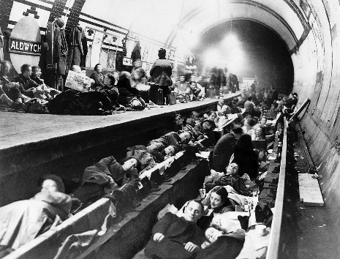
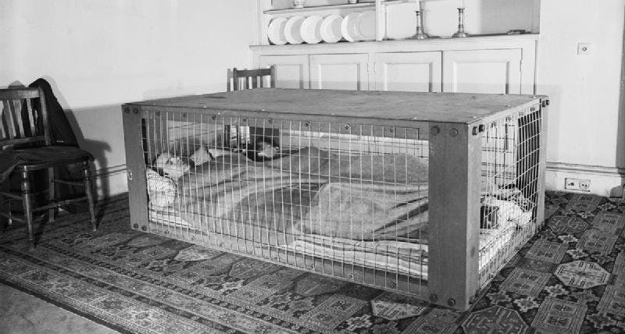
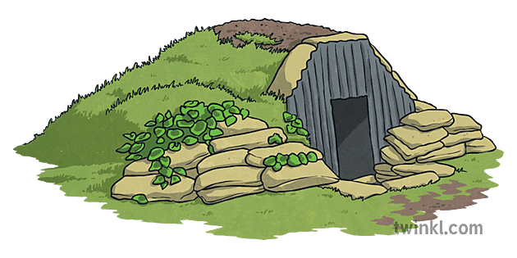

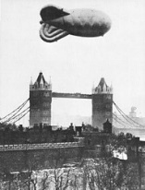
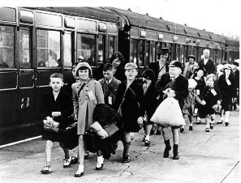
As well as shelters, the government used other methods to protect people. Barrage balloons were put up to force the Luftwaffe to fly higher, and make their bombs less accurate. The steel cables that held them in place were strong enough to destroy planes that flew into them. Anti-aircraft guns were used to shoot down planes, stationed across England and in the sea on platforms. Children, young mothers and pregnant women were evacuated out of the city, sometimes with their teachers, to the countryside to keep them safe from attacks in the early years of the war. Whilst many of these children went to pleasant homes, and had a much healthier life in the country air with fresh food available, others suffered from homesickness, and even abuse at the hands of unfriendly foster parents. Some ran away.

The Blitz finally ended in May 1941 when the Luftwaffe had to turn its attention eastwards to prepare for the invasion of the Soviet Union.

Activity 3b: How useful are the following sources for an enquiry into the Blitz?

 | Sources 4, 5 and 6: Government information films from the war.  Evacuating the children: https://www.youtube.com/watch?v=ZPs8hbksOg8  What to do in an air raid:  https://www.youtube.com/watch?v=mHep5WA9qqU  Your Anderson shelter this winter:  https://www.youtube.com/watch?v=rHyxP3epU-w | Source 7: An account of the Blitz.  An air raid is horrific, not just from the bombs but also the terrible noise of the anti-aircraft guns and the shrapnel that rains down… After the explosions, we always went through the drill of calling out our neighbours' names to see if they escaped injury. We also had a couple who lived next door and used to come into our shelter, so there were six of us trying to sleep in this small area. | Source 8: An account from an evacuee.  I lived the life of Reilly… It was right next to the village school, so this meant I got myself up in the morning, came down to a cooked breakfast, then next door to school until lunchtime when a lunch awaited me. After school I was totally free to meet up with my friends... It is a tribute to the family that they made their evacuees so welcome and happy. | Source 9: An account from an evacuee.  The last off the coach and allocated the worst billet, flea and bug ridden… I was not fed and once my paper carrier of rations ran out (cornflakes, biscuits and corned beef)… I was left to my own devices and lived on scrumped apples, and crisps from the local pub for the next month before being rescued.
Useful
Limited

Activity 3c: Are sources 4-6, or sources 7-9 more useful? Explain why in your book, including information from both the content of the sources and who made them.

Activity 4a: What was D-Day?
Read the information then use the primary sources to answer the questions below.

After Dunkirk, there was no fighting, except by resistance movements, on the Western Front of Europe for some time, due to the need to rebuild and prepare forces before another attack. Fighting continued elsewhere around the world, and in Europe especially on the Eastern Front, where the Soviet Union were doing most of the fighting. For some time, Stalin had been asking the Western Allies to launch another attack to open a Second Front in Europe, which would split Germany’s forces and support to Soviet army.

Preparations took place for a long time, and eventually by the summer of 1944, the Allied forces were ready. 150,000 soldiers from Britain, France (those evacuated from Dunkirk), America, Canada, Australia, Belgium, Czechoslovakia, Denmark, Greece, the Netherlands, New Zealand, Norway and Poland all took part. Beforehand, air strikes were increased in an attempt to weaken German defences in France, with over 1000 bombers a day hitting German targets such as railways, bridges and fortifications. The Germans therefore new an invasion was coming, but they didn’t know where it would take place due to Allied forces bombing other locations as well to cause confusion.

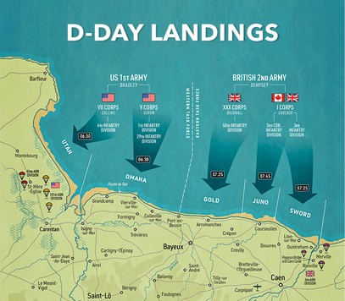
On 6 June 1944, paratroopers, along with thousands of dummies to distract the firing, and landed behind enemy lines to capture key bridges to allow later troops access inland. Bombers weakened German defences, and French Resistance forces sabotaged German communications and transport. 6,000 ships carrying troops, weapons, tanks and equipment landed on 5 code-named Normandy beaches. By 17th June, over 500,000 Allied troops had come ashore and pushed back German troops. Around 4,000 Allied forces were killed in total. It was the largest seaborne invasion in history, and a turning point in the war, laying the foundations for the Allied victory the next year.

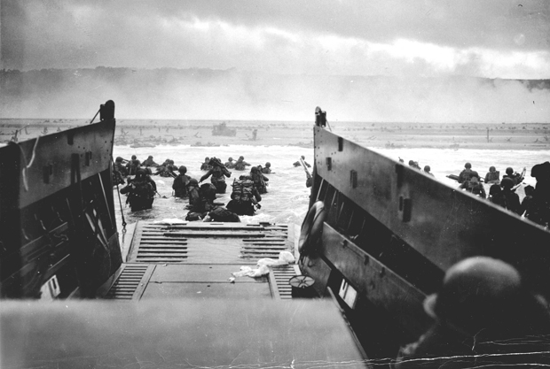
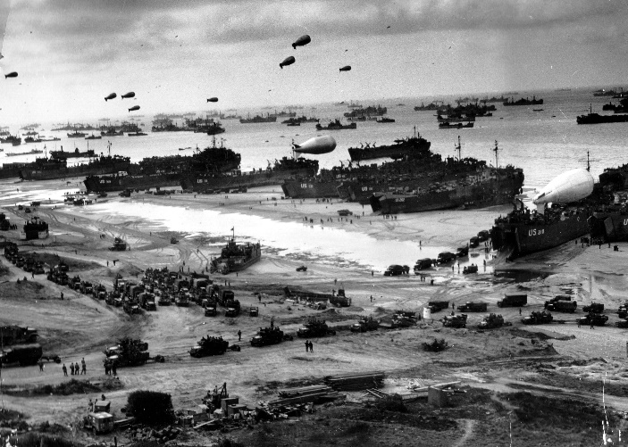

Source 10: Account and photograph of the D-Day landings by William Spearman, of No. 4 Commando Special Forces Unit. From an interview in the 1980s. Listen from 21:25 to the end of the reel and/or read the extracts below: https://www.iwm.org.uk/collections/item/object/80009580
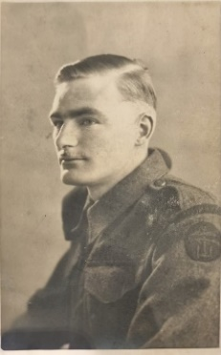
‘Going across the channel, the enormity of everything became apparent… ships in every direction as far as the eye could see… If our boat had sunk, I don’t know who would have taken over… because there were no reserves for us. It was a very thin green line that we set up… who would have knocked out the gun battery? Who would have defended the left flank? I suppose… a lot of fortune and a lot of misfortune went on…

The troops that landed in front of us, Third Brigade… had never been on an assault landing before. And in retrospect… I often wonder if they were put there as… gun fodder to distract their attention for us to go in… They never even left the beach… Nobody can know what it’s like to be on a beach where you can do nothing, where you’re under severe fire, and you’ve got to get off… You’ve either go to stay and die, or get off and live… Some of the boats got blown up before they even reached it…

We had tremendous weight on our backs… we had flamethrowers, we had shells, the idea was we had to have enough food… to support ourselves for three months in case we didn’t get reinforcements…

I was shocked by the number of bodies, dead bodies, living bodies, and all the blood in the water, giving the appearance they were drowning in their own blood… The whole place was littered like it…

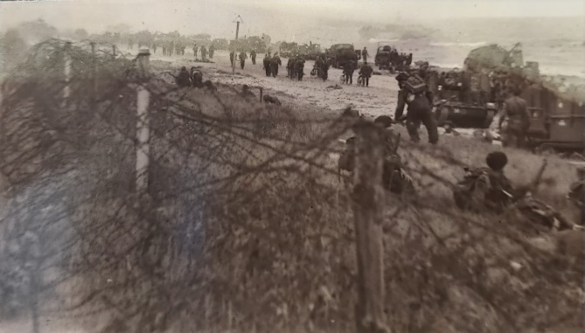
There were great monstrous fortifications on the beach… tremendous cubes or criss-cross steel girders to stop gliders landing and to stop ships coming in… and the whole beach area… was covered by flamethrowers, it was a desperate situation… And why the powers [that] be – I criticise them on this… to put so many untrained troops on that D-Day landing on the beach first, any one of us could tell you they wouldn’t get off, they’d be so transfixed with fright.’

Activity 4b: Source analysis
What can you infer from Source 10 about the D-Day landings?
- I can infer that it was a large-scale operation. I know this because it says…

- I can also infer that…

I know this because it…

- Challenge: I can also infer that…

I know this because…

Source 11: A letter from US Army General Eisenhower to the British Armed Forces in advance of D-Day.
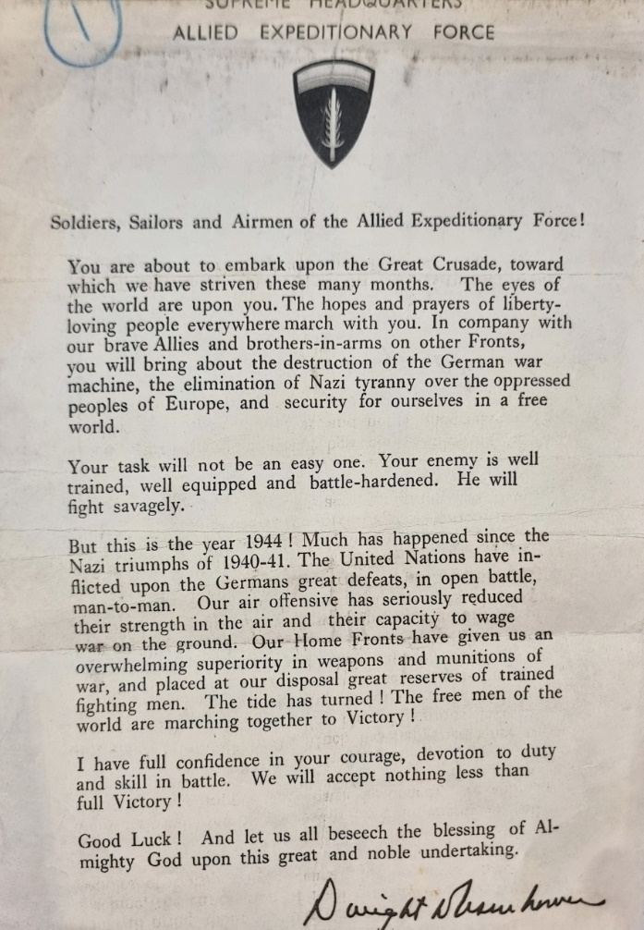
What is the purpose of this letter? Select quotes to support your answer.
______________________ ______________________
______________________ ______________________
______________________ ______________________
______________________ ______________________
______________________ ______________________
______________________ ______________________
______________________ ______________________
______________________ ______________________
______________________ ______________________
______________________

Challenge Activities:
- Explain the importance of the Dunkirk evacuation, or of the RAF in the war.
- Write a diary entry about your first night in an Anderson shelter, or your first night away from home as an evacuee, or about the night before you set off for D-Day. Soldiers were sold to pack up their valuables and send them home in advance.

Activity 5: What is the dominant narrative of the Second World War?
Answer this question in your book, using the sentence starters below and the information on p. 11-18 to help you.

The dominant narrative of the Second World War focuses on heroic British rescues and victories, particularly Dunkirk, the Battle of Britain, the Blitz, and D-Day. Explain what each of these events was.

These events are rightly recognised as significant. Explain why each event was significant.

The most significant event was… because… Explain which of the events you think was most significant, and why.

Homework: Start Activity 4 in your homework booklet.

