Lesson 5: Depth 2.1
Title: What were the key ideas of communism in China and how did the communists gain power in 1949?

Key Words: Republic: a form of government whose head of state is not a monarch

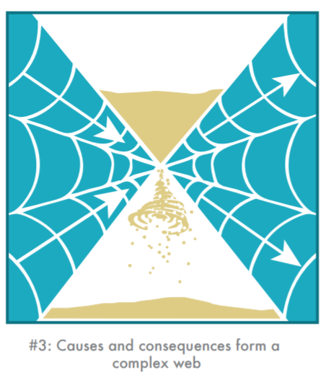
Starter: Look at the threshold concept below. What do you think are common causes for revolution? E.g. War.

Challenge: What are common consequences of revolution?

Activity 1: Read the introduction to China below and highlight/ label:
*key individuals *key dates *key historic events

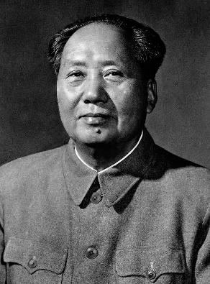
China had been a republic from 1911. It was no longer ruled by emperors. The country was politically unstable, and the government had little control. In 1928, the party's leader, Chiang Kai-shek, captured Beijing. He set up a new government with the support of the businessmen and landowners.
Between 1927 and 1934, Chiang waged five 'encirclement campaigns' against a rival group, China's communists. They were led by Mao Zedong. In 1934, Mao and 100,000 communists fled to Yenan in north-west China on 'the Long March'; it was a horrific 6,000-mile march. As they marched, they fought their way past ten opposing armies. Only 20,000 arrived alive in Yenan, but Mao was able to create a small communist state and build up his power.
After the Second World War, the communists waged a guerrilla war against Chiang Kai-shek's government. The Guomindang government was corrupt, and did nothing to improve the life of the peasants. Mao's communists were popular with the peasants, promising land reforms. In 1949, Chiang Kai-shek fled to the island of Taiwan.
Mao Zedong took control of a country of 600 million peasants, that was ruined by war and on the brink of mass-starvation. Not everyone agreed with his policies while he was in power, and they are still the subject of much debate.

Activity 2: Read the information on how the communists gained power in China. Watch the clip and answer the questions https://www.bbc.co.uk/bitesize/clips/zcfdrdm
- What did China become in 1911?
- What was the Western political philosophy that become popular in China?
- What key individual was at the first meeting of the Chinese Communist party in 1921?
- What were the conditions like for Chinese peasants in the 1920s?
- What did Mao Zedong train as?
- What did the government under Chiang Kai-Shek decide should happen to the communists?
- How long was the Long March in 1934?
- Who invaded China in 1937?
- How many people were massacred in Nanjing?
- Who was the common enemy between the nationalists and the communists?
- What were the two problems facing China?
- How many civilians died in the conflict with Japan?
- When did the Japanese surrender?
- When was the People’s Republic of China founded?
- “The imposition of communism in China caused (disasters/ successes)” circle as appropriate.
- How many died in the Great Famine?

Activity 3: Give two things you can infer from Source A about what the communists valued in society. (______/4 marks)
Source A- Communist propaganda poster. It reads: ‘Brave the wind and the waves, everything has remarkable abilities.’ (1958)

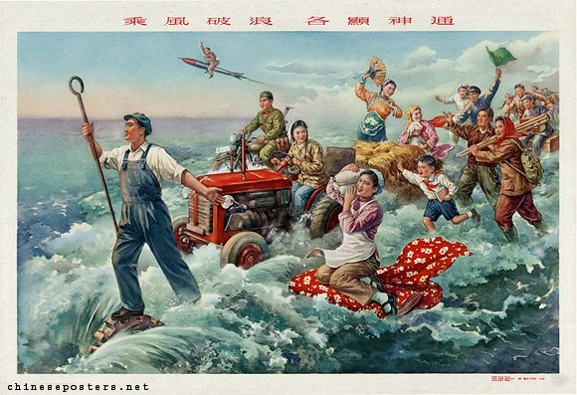
I can infer…

An example from the source that tells me this…

I can infer…

An example from the source that tells me this…

