Lessons 4-5: Overview 2
Was the Second World War a six-year, European conflict?

Activity 1: Was the Second World War a six-year conflict?
Read the timeline and label the regions involved in each row: the Mediterranean, Africa, and the Middle East (MAM)/ Asia and the Pacific (AP)/ the Western Europe (WE) / or Eastern Europe (EE).

Region: | Hitler appointed Chancellor, overrules Treaty of Versailles. | France and Britain declare war on Germany. | Germany had now invaded many Western European countries. Battle of Britain and Dunkirk Evacuation took place. |  | After troops are evacuated from Dunkirk, there is little fighting in Western Europe, although resistance movements continue to fight against Nazi occupation. |  | D-Day landings in Normandy re-open a Second Front against Germany. | Hitler commits suicide, Germany surrenders. | Western Europe receives financial aid from the USA. NATO created.
Region: | Hitler takes over Austria and parts of Czechoslovakia. | Hitler invades Poland, triggering war, and signs a peace deal with the USSR meaning he does not need to fear the Russian army. |  | Hitler invades Russia, after takeover of Eastern Europe. | Germany fails to gain control of Stalingrad. | Soviet forces push back German troops from Eastern Europe, gradually gaining control. |  | Soviet troops take over Berlin, Germany surrender. | Soviet forces remain in control across Eastern Europe.
Region: | Italian leader Mussolini invades Ethiopia. | Alliance signed between Italy and Germany. | Italy declares war on France and Britain, and vice versa. Italy invades Egypt and British Somaliland. | Germany assists Italian forces in Egypt, pushing for oil supplies in the Middle East. | Allied forces defeat German and Italian troops, at El Alamein in Egypt. | Allies invade Italy. Italy switches sides after Mussolini’s removal. | Allies begin to push German forces back from Southern Europe. | Axis powers (Germany and their allies) are fully defeated in the region. | Struggles for power in the Middle East and Africa continue. The creation of Israel leads to tensions.
Region: | Japanese invade China. | Japanese-Russian conflict over borders. Japan seeks to expand control in the Pacific. | Japan invades and occupies Indo-China. | Soviets defeat Japanese at the Battle of Khalkhin Gol. Japanese bomb Pearl Harbour, bringing USA into the war. | US navy defeats Japanese navy at the Battle of Midway. | US push back Japanese control in the Pacific. |  | USA drops two atomic bombs on Japan, bringing their conflict to an end. | USSR and USA compete for influence in Asia. China becomes communist in 1949, increasing tensions.
Timeline | Pre-1939 | 1939 | 1940 | 1941 | 1942 | 1943 | 1944 | 1945 | Post-1945
Activity 2: Was WWII a European conflict? Use the map in your planner to identify each location as you read about where the fighting took place.

North America  North American soldiers fought in other areas- there was no conflict on the mainland. However, they did become involved in battles to gain control of the sea and air. The US Naval base at Pearl Harbour was attacked by Japanese forces in December 1941, triggering their entry into the war. Canadian forces were active throughout the war, from 1939. | Europe  There was significant fighting on the Eastern and Southern fronts which impacted the entire continent. All fronts involved Allied forces pushing back German and Axis forces from the height of the German Empire in November 1942. The Eastern front was the most unforgiving of these fronts with very high solider and civilian death rates. | The Middle East  The region was quiet for the first few months of the war, until Italy declared war against France and Britain June 1940. It remained a major theatre of war for two and a half years.
Caribbean  The Islands were involved in fighting in many other theatres of war as part of British Empire forces, but there was no conflict on the mainland. The Battle of the Caribbean refers to a naval campaign waged during World War II that was part of the Battle of the Atlantic, from 1941 to 1945. | 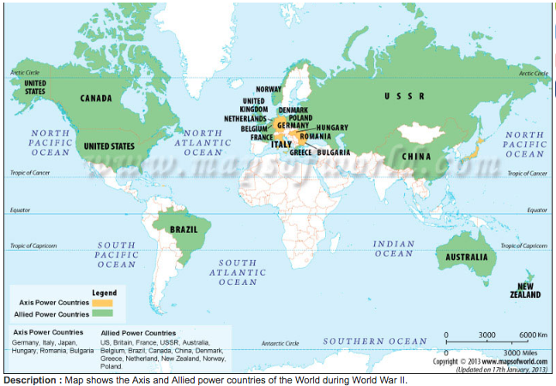 | Asia  Became the main location for the war between America and Japan (who were aided by Thailand).  The war ended when America dropped atomic bombs on the Japanese cities of Hiroshima and Nagasaki, These bombs targeted civilians. Across the two cities, between 120, 000 and 230,000 people are believed to have died. Japan surrendered on 15 August 1945. The South-East Asian Theatre of World War II was the name given to the campaigns of the Pacific War.
Sea and skies  As well as land conflicts around the word, there were also battles for the sea and air. The Battle of Britain took place in 1940, and the Battle of the Atlantic occurred between 1941 and 1945. It involved German U-boats and Italian submarines attempted to disrupt the Allied supply of oil and other material. | Africa  Also known as the Abyssinian campaign, fighting in took place mostly between Italian forces (who had colonised parts of East Africa) and Allied (mainly British and Empire) troops. It is considered to be the first significant Allied victory, with Italian troops pushed back throughout 1941. Small groups continued fighting British troops until 1943 in the form of smaller guerrilla wars. | Australasia  Considerable Australian and New Zealander military resources were devoted to protecting the seas from Axis submarines and warships. A high proportion of Australian operational squadrons were used to protect shipping at various times.
Additional activity: Look through the powerpoint as a class to see how the war spread globally.

Challenge: How does the geography of WWII compare to that of WWI? In your book, explain your answer. Use the sentence starters below to help you.
There are many similarities between the geography of WWII and WWI, as the names would suggest. For example…
However, there are also some differences. For example…

Activity 3: How far do you agree that WWII was a six-year, European conflict?
- Complete the planning grid below, ticking the boxes to show your views.

 | Mostly Agree | Mostly Disagree | Evidence to support view
WWII was a six-year conflict.
WWII was a European conflict.

- Now use one of the following writing frames to complete your assessment in your books. Challenge sections are in italics.

DISAGREE – it was NOT mainly a six-year, European conflict.
I mainly disagree that WWII was a six-year European conflict.

In some ways, I agree with the statement. Firstly, the conflict did mainly last six years. For example… This suggests that…
Furthermore, the conflict was in large part European. For example… This suggests that…

However, there is more evidence to disagree with the statement. Firstly, even though for many countries the conflict lasted… for others… For example… This shows that… Furthermore, despite the contributions of… the conflict was actually… For example… Additionally… This shows that…

Overall, whilst there is evidence to suggest that…, especially regarding…, there is greater evidence to disagree. This is because…

AGREE – it WAS mainly a six-year, European conflict.
I mainly agree that WWII was a six-year European conflict.

In some ways, I disagree with the statement. Firstly, the conflict took place... For example… This suggests that…
Furthermore, WWII was not a six-year conflict for everyone involved. For example… This suggests that…

However, there is more evidence to agree with the statement. Firstly, even though for some countries the conflict lasted… for the majority… For example… This shows that… Furthermore, despite the contributions of… the conflict was mainly led by… For example… Additionally… This shows that…

Overall, whilst there is evidence to suggest that…, especially regarding…, there is greater evidence to agree. This is because…

Homework: Complete Activity 3: Pearl Harbour in your homework booklet

