Lessons 3-4: Depth 2
How have people viewed King John through history?

Different people have different opinions on things, events and people, and they choose to represent them in different ways. As historians we have to consider lots of different representations to decide which we think is the most accurate, and which we agree with.

Activity 1: Look at the 3 representations of King John and write some key words below each one.
Think about:
- The way they present John’s character (what he was like as a person)
- The way they present John’s ability (how good he was as a king)
- Why they have chosen to present John in this way
- What you already know that agrees with or disagrees with how they have presented John

Representation 1 – a picture drawn by a monk called Matthew Paris, from St Albans near London, about twenty years after John died.
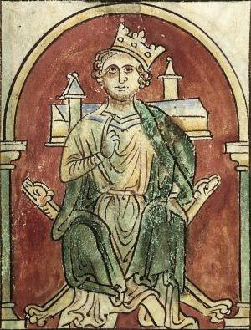
John’s crown is falling off.
John is almost entirely blocking the Church.

John is sitting on a campaign stool (taken on long battle campaigns) not a throne.

Background information:
Matthew Paris was not born when John became king, and he never met him. He was a chronicler at the monastery and copied opinions he read from people before him. Sometimes these were based on documents, and sometimes gossip from the barons. Matthew Paris didn’t like John because he opposed taxes and didn’t think John supported the Church.

Key words:
Character: Selfish,

Ability:
Representation 2 – a clip from the film Robin Hood, made by Disney in 1973.
https://www.youtube.com/watch?v=fDtctooXZz4&t=17s
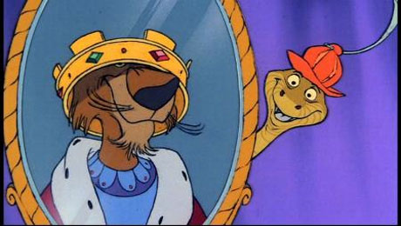

Background information:
Films often make things seem more dramatic than they really were to make the story more exciting for the viewers. It is a modern film and would have used historical sources to make sure that a lot of the information was true, but cartoons often exaggerate details. It is also a children’s film so things may have been simplified to make it easier to understand.
Key words:
Character:

Ability:

Representation 3 – written by R. V. Turner, a modern historian, in his book King John, which was published in 1994.
John was no coward. He was good at planning for war and was a skilled soldier and besieger of castles. John had the potential for success. He was intelligent and good at administration. However, too many personality faults held him back. He was secretive, arrogant and cruel. He lacked the likeable qualities of his brother and father. He would not listen to advice. It was very difficult for men to stay loyal to him.

Background information:
Modern historians like Turner gather up information from lots of different sources in order to try and create an accurate account of what really happened. He is much less likely to have strong personal opinions on John than someone writing at the time. This is good because personal opinions can get in the way of writing a balanced view.
Key words:
Character:

Ability:

Transcript for King John Video

John: ‘Taxes, ahahaha, taxes! Beautiful lovely taxes, ahah!
Sir Hiss: ‘Sire, you have an absolute skill for encouraging contributions from the poor. Haha!’
John: ‘To coin a phrase my dear counsellor, rob the poor to feed the rich, ahah! Am I right? Tell me, what is the next stop, Sir Hiss?’
Sir Hiss: ‘Let’s see… Oh! Nottingham, sire!’
John: ‘Oh, the richest plum of them all! Noting-hahaha-ham!’
Crown falls over his face.
Sir Hiss: ‘A perfect fit sire! Most becoming. You look regal, dignified, sincere, masterful, noble, chivalrous-‘
John: ‘Ah – don’t overdo it, Hiss. There, that, I believe, does it. This crown gives me a feeling of power, power! Forgive me a cruel chuckle! Hahahaha hmmm power!’
Sir Hiss: ‘And how well King Richard’s crown sits on your noble brow.’
John: ‘Doesn’t it! Uh – King Richard?! I told you never to mention my brother’s name!’
Sir Hiss: ‘Uh – a mere slip of the forked tongue your majesty! We’re in this plot together, if you don’t mind my saying so, and remember it was your idea I hypnotised him!’
John: ‘I know, and sent him off on that crazy crusade! Ahah, ahah!’
Sir Hiss: ‘Much to the sorrow of the Queen Mother.’
John: ‘Mother! Mother always did like Richard best.’
Sucking his thumb.
Sir Hiss: ‘Your highness, please don’t do that. If you don’t mind me saying so – you see, you have a very loud thumb. Hypnotism can rid you of your phsychooosissss soo eeaaasilyyy!’
Tries to hypnotise John.
John: ‘No! None of that. None of that!’
Sir Hiss: ‘Well I was only trying to help.’
John: ‘I wonder. Silly serpent.’
Sir Hiss: ‘Silly serpent?’
John: ‘Now look here, one more one more hiss out of you, er, Hiss, and you are walking to Nottingham.’
Sir Hiss: ‘Snakes don’t walk, they slither. So there.’

Activity 2: Complete the table, analysing each of the representations in more detail.

Rep. | How does it present John’s character/personality? (Selfish, kind, vain, generous, greedy, thoughtful, caring…?) | How does it present John’s ability as king? Does he seem competent (good at doing his job) or incompetent? | Why did this person give this impression of John? What kind of source is it? What is its purpose/who is it for? Who made it and when? | Challenge: Does it match up with your own knowledge from last lesson, or do you think things might be wrong? Is it accurate?
1 | Character:  Evidence from representation: | Ability:  Evidence from representation: | Source type:  Who made it and when?  Purpose: | Own knowledge to agree:  Own knowledge to disagree:  Accurate? Yes / No
2 | Character:  Evidence from representation: | Ability:  Evidence from representation: | Source type:  Who made it and when?  Purpose: | Own knowledge to agree:  Own knowledge to disagree:  Accurate? Yes / No
3 | Character:  Evidence from representation: | Ability:  Evidence from representation: | Source type:  Who made it and when?  Purpose: | Own knowledge to agree:  Own knowledge to disagree:  Accurate? Yes / No

