Lesson 13
Title: What methods did people use to resist the Nazis?

Starter: Answer this question below: How do you think people resisted the Nazis? Think of some examples below:

Activity 1:

- Content warning: violence shows a battle scene: Watch the clip one a group of Jewish fighters attack a Nazi battalion in World War Two https://www.youtube.com/watch?v=CZrA-i6kOdc
and two https://www.youtube.com/watch?v=YonJOKRFIfs carefully and think about what they have to do with resistance
- What similarities/difference were there between the different types of resistance?

- Which one would you say was more ACTIVE? Which one was more PASSIVE?

- If a form of resistance is passive does that mean it is not important?

Activity 2: Look at the sources carefully. Try to look at as many sources as you can. Briefly summarise how people resisted Nazi persecution at the bottom of each source box.

Extension: Decide whether the source shows an example of passive (P) or active (A) resistance, label the sources.

Challenge: Explain why you think that resistance was important. What was it trying or what did it succeed in achieving?

Source C- JEWISH PARTISANS IN VILNA
This photograph shows a group of people in Vilna following the liberation of the city in 1944. In 1941 the Nazis had murdered most of Vilna’s Jews; around 20,000 remained in the ghetto which was created in September of that year. The leader of the ghetto’s Jewish Council, Jacob Gens, hoped that they could survive by working in German factories. Therefore, he tried not to do anything which would anger the Nazis. Some people disagreed and argued that the Nazis intended to kill all Jews. They formed resistance groups and escaped from the ghetto. These people used forests as a base for guerrilla fighting against the Germans. The Vilna Ghetto was liquidated in September 1943.

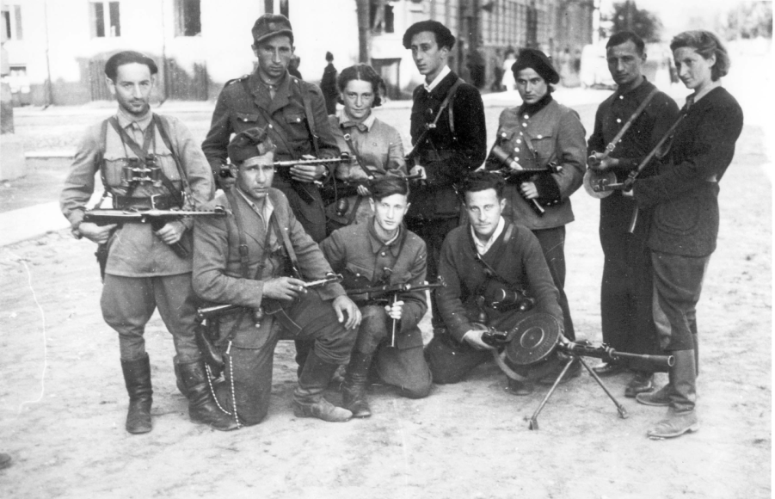
Summarise how people resisted the Nazis:

Source B- SURVIVORS OF THE SOBIBÓR UPRISING

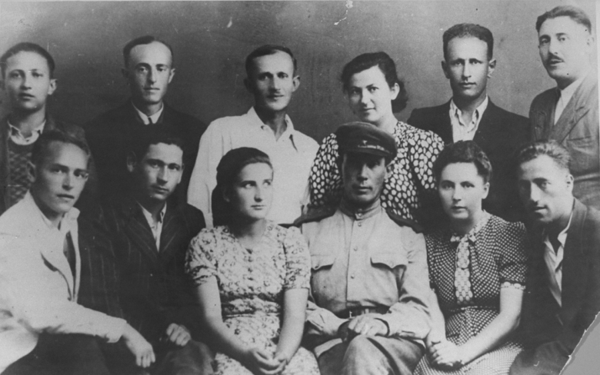
This photograph shows a group of survivors of the uprising in the Sobibór extermination camp. Sobibór was located in a remote area of Poland where few people lived. It was surrounded by forests and swamps. Mines were planted around the camp. Between May 1942 and September 1943 at least 170,000 Jews were murdered there. Nearly all of the people who were sent to Sobibór were killed immediately but a small number (around 700) were selected to work, either disposing of bodies or sorting property stolen from the victims. On 14th October 1943, the prisoners rebelled. They killed around 20 SS men and Ukrainian guards. Around 300 prisoners were able to escape but most were caught and killed soon afterwards. Between 50 and 70 survived to the end of the war.
Summarise how people resisted the Nazis:

Source A - A BUNKER IN THE WARSAW GHETTO UPRISING
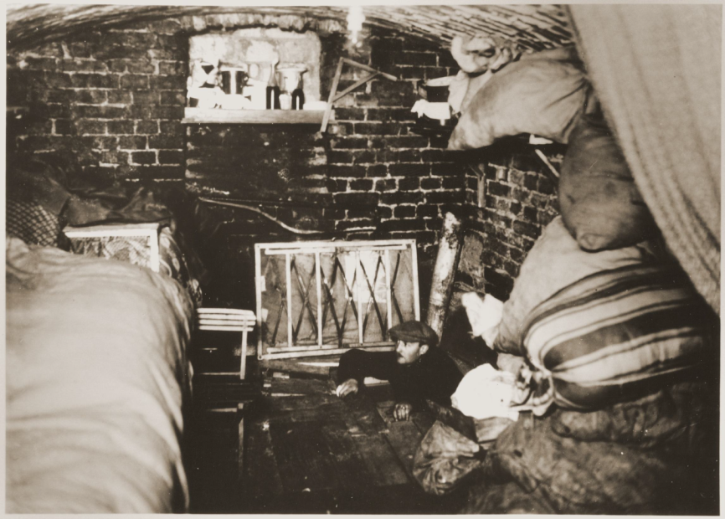
This photograph shows a Jewish fighter in an underground bunker during the Warsaw Ghetto Uprising of 1943. When the ghetto was created in 1940, more than 400,000 people were imprisoned within its walls; tens of thousands died of disease and starvation. Between July and September 1942, at least 235,000 people – including almost all children and old people – were deported from the ghetto to their deaths in the Treblinka extermination camp. By 1943 only 60,000 people remained in the ghetto. When the final deportations began on 19th April 1943, Jewish resistance groups launched the uprising. They fought German forces for four weeks.
Summarise how people resisted the Nazis:

Source D- YOURA LIVSCHITZ
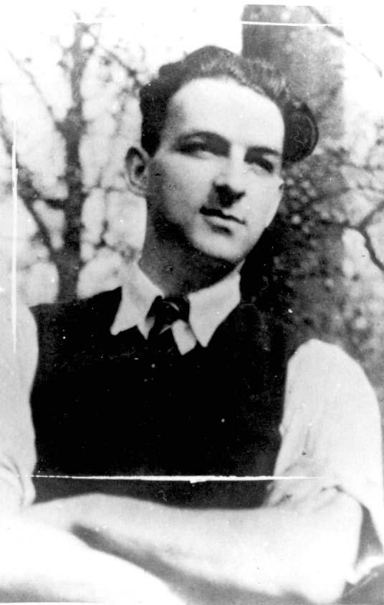
Youra Livschitz was a Jewish medical student and a member of the Belgian Resistance. On 19th April 1943, Youra and two non-Jewish friends – Jean Franklemon and Robert Maistriau – succeeded in stopping a train carrying 1,631 Jews from the Mechelen transit camp to Auschwitz-Birkenau. The three young men were armed only with a pistol, a pair of wire cutters, and a lamp covered in red paper to make it look like a stop signal. Their actions helped 231 people to get off the train; 115 of these people successfully escaped. The youngest survivor was an 11-year-old boy. Youra was arrested by the Gestapo in 1944 and executed.
Summarise how people resisted the Nazis:

Source D- JEWISH CHILDREN RESCUED FROM AMSTERDAM
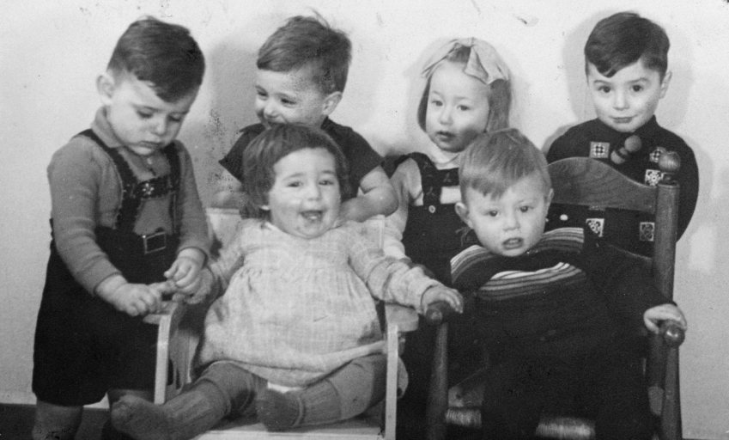
This photograph shows six Dutch Jewish children who were rescued during the Holocaust. When deportations to Auschwitz-Birkenau began in 1942, Amsterdam’s Jews were held in a theatre in the city centre before they were sent to the Westerbork transit camp. Babies and toddlers were placed in a nursery opposite the theatre. The Jewish officials responsible for registering new arrivals tried to ensure that the children were not registered. The children were then smuggled out of the nursery in rucksacks, laundry baskets and even milk churns by the Jewish nursery staff. Homes were found for them in the countryside with the help of the Dutch Resistance. Hundreds of children were saved.
Summarise how people resisted the Nazis:

Source E- A SECRET SCHOOL IN THE KAUNAS GHETTO
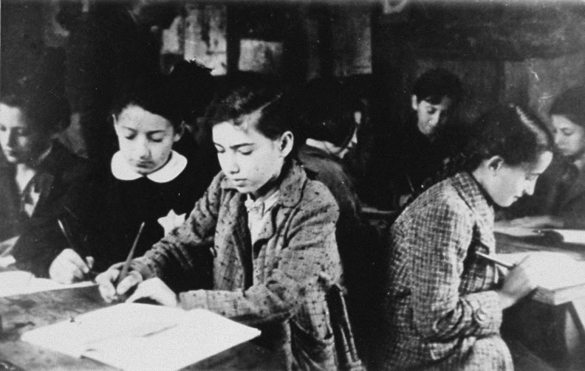
This photograph shows one of several secret schools that existed in the Kaunas (Kovno) Ghetto. Following the invasion of the Soviet Union, a ghetto was established in Kaunas in August 1941. Its population included almost 10,000 children and teenagers. Around half of these children were shot in October 1941. The ghetto’s Jewish Council created schools for the surviving children but these were banned by the Nazis in August 1942. Soon after, the Germans forced children as young as 12 to work. Many younger children also worked so that their families could get extra food. Murders continued throughout this period. Despite this, secret schools were created for some children and were illegally supported by the Jewish Council. In March 1944 the Nazis murdered the remaining children.
Summarise how people resisted the Nazis:

