Lessons one- two
Title: When and why did Europeans start exploring the seas?

Activity 1a: Look at the picture and caption below. Answer the questions in your books

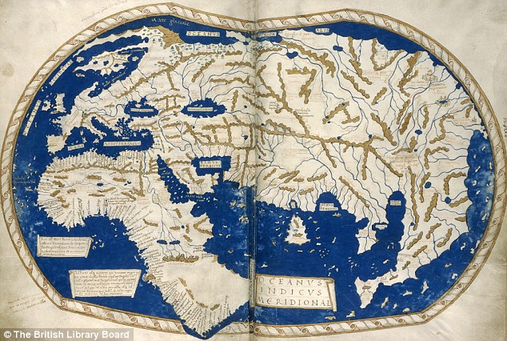
This is a map of the world in 1042. Below is a map of the world today.

- Write down five differences between the two maps
- Which continents are missing from the first map.
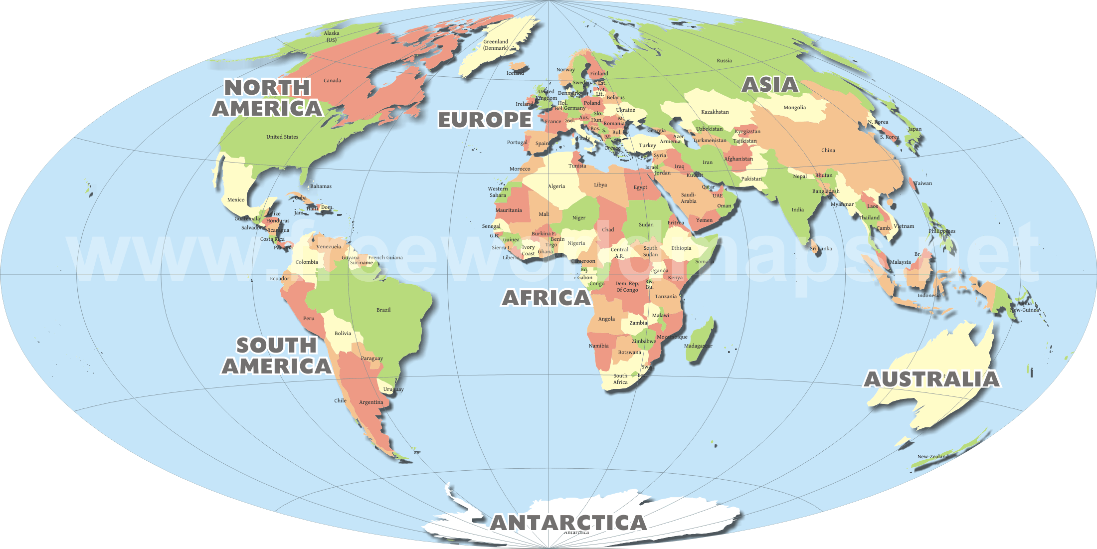
Challenge: Answer the questions below:
Why do you think they are missing?
Apart from the missing continents in the first map, how accurate is the map? What do you think is the reason for this?

Activity 1b: Why did the Portuguese first start exploring the seas?

Activity 2 fill in the gap
Spices Silk Road Sea Route Age of Exploration Africa

The _______________________started in the 1400s. The term “Age of Exploration” refers to the time period when people from Europe explored the world from the 1400s-1700s. There were many reason why people from Europe wanted to explore the world. Europeans were desperate to get ________________from Asia. Spices were used to preserve foods and keep them from spoiling. Spices, however, were expensive and dangerous to get. Traders had to travel parts of the
dangerous _____________________(a land route from Europe to Asia) to get them. Because the Silk Road was frequently closed due to various wars, European rulers began to pay for explorations to find a ____________________to Asia so they could get spices more easily and for cheaper. Portugal was the first European country that sent explorers to search for the sea route to Asia.
In the 1400s, however, sailors were afraid of ______________________and boiling hot water at the Equator, so progress was slow.

Portuguese exploration
location exploration Sea monsters
The Age of Exploration marked the beginning of Portuguese power and wealth. At the beginning of the 1400s Portugal had a population of one and a quarter million and an economy dependent on maritime trade with Northern Europe. Although Portugal was not as rich as the other European countries, it would lead the European community in the ____________________of sea routes to the African continent, the Atlantic Islands, and to Asia and South America over the course of the sixteenth century.
Portugal was so important in early exploration because of its ________________________along the west coast of the Europe, which allowed for the natural development of a seafaring tradition. This meant that they spent much of their time exploring the western coast of ________________. It is hard to believe that it was so dangerous and scary for these ships, but there had never been a European ship that had traveled all the way down the western coast of Africa.
Key words:
maritime trade - trading done by sea.
Contributed- Help
seafaring tradition- families using boats and ships for a long time..

Spanish exploration
artistic diseases civilizations powerful god
During the Age of Exploration, Spain was one of the most __________ countries. The country of Spain paid for some of the most important explorations throughout the entire age. The four voyages of Columbus (between 1492 and 1504) served to open the door to European exploration, colonization and exploitation of the New World. The Spanish explorers encountered three major ___________in the New World: the Incas in present-day Peru and the Mayans and Aztecs in Mexico and Central America. The Spanish were truly amazed by what they found — immense wealth in gold and silver, complex cities rivaling or surpassing those in Europe, and remarkable __________ and scientific achievements. Spanish conquest in the New World was driven by the three 'G's—gold (greed), glory, and ______. In his drive to gather riches.
Key words:
Voyages- Journeys
Colonization- When a country takes over and rules another country.
Exploitation- When a country takes another countries resources and does not give a fair price.
Decimated- Wipe out and kill.

Columbus and others enslaved and decimated the local populations. The numbers of these Native Americans plummeted, in part because of war against the colonial forces, but also because of the introduction of _________ to which the natives had no natural immunity. The natives contracted malaria, smallpox and measles from the Europeans.

Challenge: Answer the questions:
Pick three words why people wanted to explore the world in the 15th century.
What was the first country to start exploring the world in a major way? Bonus (Why do you think it was this country)
Why were spices important to people from Europe?

Activity 3- Watch the video and answer the questions.
Watch from around 2:00 to 7:00 https://www.youtube.com/watch?v=BZGJczLj3fU
- Why did the Portuguese want to travel to China?
- Why didn’t Europeans sail around Africa?
- When did Prince Henry start the School of Navigation?
- What was the new design of ships?
- Give one benefit of the new ship design.
- Why did sailors need to know their longitude and latitude?
Plenary discussion
Why did Portugal start sailing through what they thought would be dangerous waters?
What three civilizations were encountered by the Spanish and what happened to them?
What diseases were exchanged between the Spanish and the Natives?

Activity 1: Why was there an increase in British overseas exploration?
Highlight or label the boxes in these categories: [some might be more than one]
- Economic (money/trade)
- Political (power)
- Science and technology
- Communication
Explorers were looking for new trade routes from the East to Europe because luxury goods from the East such as silk and spices were slow and expensive to bring to Europe | This was the age of the Renaissance which encouraged learning and a spirit of adventure. It was suggested that ships could sail north round Russia, or south around Africa, or west across the Atlantic in order to reach the Far East. | The printing press now meant that maps were quicker and easier to get.  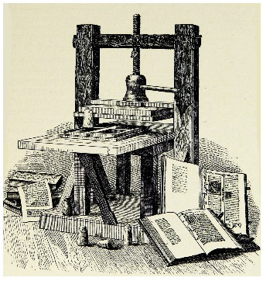 | There had also been developments in ship design. The triangular lateen sail (copied from Arab ships) meant that ships could now sail whichever way they wished, whatever the wind direction. 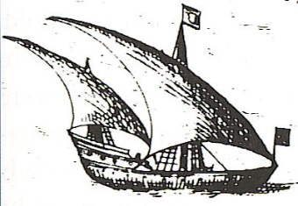
In 1487 the Portuguese navigator, Diaz sailed round the southern tip of Africa. This proved that ships could sail around Africa without falling off the end of the world. 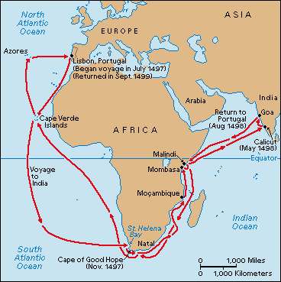 | The invention of the astrolabe also meant that a ship’s position could be plotted accurately, and the magnetic compass was developed.  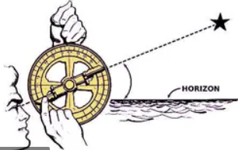 | In the late fifteenth and early sixteenth centuries new countries were reached by Europeans such as America, and several explorers successfully travelled across the Atlantic. | Spain and Portugal dominated the world of exploration by the early 16th century. They became enormously rich and powerful as a result. Both began to establish overseas empires and oversaw the beginning of the transatlantic slave trade.
Spain did not allow other countries to trade with their colonies in the New World (the Americas) without a license, and such licenses were rarely granted to English sailors. | The Spanish monopoly of the New World goods angered the English and led to lots of English pirates robbing Spanish treasure ships and ports. | Patriotism and nationalism meant that the English were jealous of Spanish and Portuguese achievements- England also wanted a share of the New World. | England was looking to set up direct links with new trading partners. Several trading companies formed because of the connections made by explorers e.g. the East India Company (1600)
Challenge: Number the boxes 1-10 (10 being very important)

Activity 2: Write a PEE paragraph in answer to this question:
What do you think was the most important cause for an increase in European exploration in 1500-1700?
Sentence starters:
The most important cause for an increase in European expansion was… [political/ economic/ communication/ science and technology]
For example…
This meant that….

Challenge: What was the most important consequence of European expansion?

Activity 3: watch the video and think about this question: Why did Hakluyt create a travel book?
From 3.30 until around 6.45/7 minutes https://www.youtube.com/watch?v=Wp0HwCATDpY
A remarkable travel guide made from first-hand records of Tudor seafarers in the 16th century. Professor Nandini Das explores Hakluyt's Principal Navigations, which records accounts of ventures in search of lucrative spices and dyes. It has advice, warnings, descriptions of remarkable people and a list of vocabulary to talk with foreigners. It became a book that all English seafarers kept on board ship. But the descriptions of encounters with foreigners also lay the foundations for later colonialism and conquest.

