KT4 TMA Germany 1918-39
Focus Points and Elements | Sub-elements | Key Picture | Key Narrative
1 Nazi policies  Towards women | - Nazi views on women and the family. | 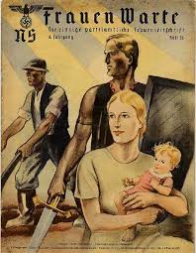 | Nazi policies towards women reflected Hitler's own personal views. He hated the changes in the position of women in society, which had occurred in the 1920s, and wanted to create a society where women had a precise and specific domestic role. He did not want women to be involved in the world of work and saw their task as bearing and rearing children while their husbands worked. Hitler believed that education for women should be focused on their future role in society and hence that it should prepare them for marriage and motherhood. Though most women accepted the policies imposed by the Nazis, there were some who did not and were active in opposing the loss of their rights. These women were eventually arrested and sent to concentration camps.
1 Nazi policies  Towards women | - Nazi policies towards women, including marriage and family, employment and appearance. | 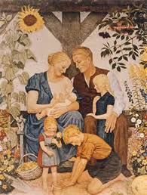 | The Nazis brought in a series of measures to change the role of women. One of the first actions of the Nazis, as part of the Gleichschaltung process, was to bring all 230 women's organisations together under one body- the Women's Front (Frauenfront). The women's groups were then expected to ensure that Jews could not be members. In 1934, Getrude Scholtz-Klink was appointed National Women's Leader of Germany. Nazi ideal were spread to areas of Marriage and family law and organisations.
2 Nazi policies  towards the young | - Nazi aims and policies towards the young. The Hitler Youth and the League of German Maidens. | 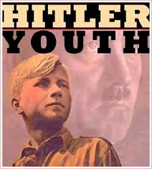 | The Nazis also wanted to control the young i n their spare time. This was to be achieved through the Hitler Youth, which covered both boys and girls. The head of the Hitler Youth was Baldur von Schirach.  • All ocher youth organisations were banned.  • From 1936 membership was compulsory, though many did not join.  • By 1939 there were seven million members.
2 Nazi policies  towards the young | - Nazi control of the young through education, including the curriculum and teachers. | 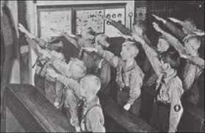 | When the Nazis came to power, they established the Ministry for Science, Education and National Culture with Bernhard Rust at its head. Textbooks, Teachers and lessons began to change to fit with Nazi Volkgemeinschaft - the creation of an obedient racial state. Under the Nazis the school curriculum was changed to prepare students for their future roles. Hitler wanted healthy, fit men and women so 15 per cent of time was devoted to physical education. With the boys the emphasis was on preparation for the military. There was also great emphasis on Germany's past and the Aryan race. Students were taught that Aryans were superior and should not marry inferior races such as Jews.
3 Employment  and living  standards | - Nazi policies to reduce unemployment, including labour service, autobahns, rearmament and invisible unemployment. | 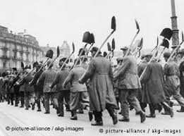 | Hitler at first spent billions on job creation schemes, rising from 18.4 billion marks in 1933 to 37.1 billion five years later. The Nazis subsidised private firms, especially in the construction industry. They also introduced a massive road-building programme to provide Germany with 7,000 kilometres of autobahns (motor ways). Hitler was determined to build up the armed forces in readiness for war. This greatly reduced unemployment
3 Employment  and living  standards | - Changes in the standard of living, especially of German workers.  - The Labour Front, Strength Through Joy, Beauty of Labour. | 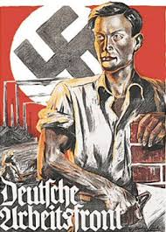 | Strength through Joy was an organisation set up by the German Labour Front . The KdF tried to improve the leisure time of German workers by sponsoring a wide range of leisure and cultural trips. These included concerts, theatre visits, museum rou rs, sporting events, weekend trips, holidays and cruises. All were provided at a low cost, giving ordinary workers access tO activities normally reserved for the better off In 1938, more than 10 million people took KdF holidays.
4 The persecution of  minorities | - Nazi racial beliefs and policies and the treatment of minorities:  - Slavs, ‘gypsies’, homosexuals and those with disabilities. | 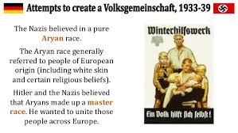 | Ideal Germans were 'socially useful' i n that they had a job and contributed to the state. Anyone else was seen as a 'burden on the community'. These included those who could not work, the unhealthy, mentally disabled, tramps and beggars. The term used to describe them was 'asocial'. The Nazis considered these people worthless and expensive to the state and they had to be removed because they could not contribute to the Volksgemeinschaft.
4 The persecution of  minorities | - The persecution of the Jews, including the boycott of Jewish shops and businesses (1933), the Nuremberg Laws and Kristallnacht. | 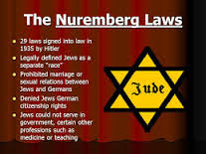 | Almost as soon as he had become Chancellor, Hitler began to take steps against the Jews. Germans were persuaded to boycott Jewish shops and businesses. The boycott was a reaction to stories in the international press which criticised the new Nazi regime. The Nazis claimed chat these stories were instigated by Jews living abroad. On 15 September 1935, the Nazi government passed two new racial laws at their annual Reich Party Congress in Nuremberg, Germany. The events of 9-10 November became known as Kristallnacht, meaning 'Crystal Night' or 'the Night of Broken Glass'. About 100 Jews were killed and 20,000 sent to concentration camps. About 7,500 Jewish businesses were destroyed.

Trigger Memory Story Medicine 50-1350

The story must be very imaginative. It must involve you seeing, talking and doing things. It must link the ten trigger words together in the form of a continuous story. You should then rehearse the story and commit it too your long term memory to be recalled when necessary. This will take some effort but will be very useful! Use different colours to write the trigger words in your story.

I was...

