KT3 TMA Germany 1918-39
Focus Points and Elements | Sub-elements | Key Picture | Key Narrative
1 The creation  of a dictatorship,  1933–34 | - The Reichstag Fire.  - The Enabling Act  - The banning of other parties and trade unions. | 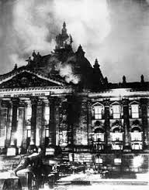 | One week before the election, on 27 February, the Reichstag building was set on fire. On the day following the fire, Hitler persuaded President Hindenburg to sign the 'Decree for the Protection of People and State'. The decree replaced the constitutional government by a permanent state of emergency and suspended basic civil rights. Hitler's next step was to pass the Enabling Act. This would give him and his government full powers for the next four years and would mean that the Reichstag would become a rubber stamp for Nazi activities.
1 The creation  of a dictatorship,  1933–34 | - The threat from Röhm and the SA,  - The Night of the Long Knives  - The death of von Hindenburg.  - Hitler becomes Führer, the army and oath of allegiance. | 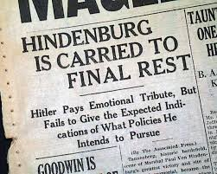 | The Night of the Long Knives (also known as 'Operation Hummingbird' or the 'Blood Purge') was the purging of Hitler's political and military rivals in the SA (Sturmabteilung). One cause of the removal of the leaders of the SA was the need to win the support of the army. On the death of Hindenburg in August 1934, the army swore allegiance to Hitler who, having combined the posts of Chancellor and President, was now their Fuhrer. Hitler decided he needed to seek the approval of the German people when he combined the posts.
2 The police state | - The role of the Gestapo, the SS, the SD and concentration camps. | 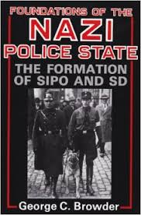 | A key element in maintaining a Nazi dictatorship was to create a climate of fear- make people too frightened to actively oppose the Nazi state. This was achieved through the establishment of a police state, including a secret police (the Gestapo), the SS, an intelligence agency (the Sicherheitsdienst, Security Service), Nazi control of the law courts and the setting up of concentration camps.
2 The police state | - Nazi control of the legal system, judges and law courts. | 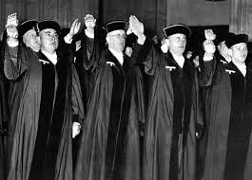 | The law courts had to experience Gleichschaltung , just as any other part of society. Some judges were removed and all had to become members of the National Socialist League for the Maintenance of Law ( NSRB). This meant that Nazi views were upheld in the courts. In October 1933, the German Lawyers Front was established and there were more than 10,000 members by the end of the year. The lawyers had to swear that they would 'strive as German jurists to follow the course of our Fuhrer to the end of our days'.
2 The police state | - Nazi policies towards the Catholic and Protestant Churches, including the Reich Church and the Concordat. | 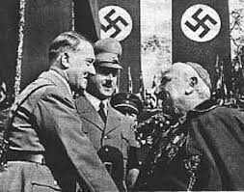 | Hitler could not immediately persecute Christianity as Germany was essentially a Christian country. Almost two-thirds of the population was Protestant, most of whom lived in the north; almost one­ third was Catholic, most of whom lived in the south. A Concordat (understanding) with the Catholic Church was agreed and the Reich Church established to unite Protestants. Hitler set up a Ministry of Church Affairs in 1935 in an attempt to weaken the hold the Catholic and Protestant Churches had on the people.
3 Controlling  and influencing  attitudes | - Goebbels and the Ministry of Propaganda: censorship  - Nazi use of media, rallies and sport, including the Berlin Olympics of 1936. | 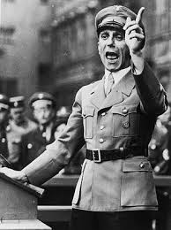 | Goebbels used his Ministry of Public Propaganda and Enlightenment and the Reich Chamber of Culture to control the thoughts, beliefs and opinions of the German people. Musicians, writers and actors had to be members of the Chamber. It was important for the long-term future of the Third Reich that the majority of the population believed in the ideals of the Nazi Party. All aspects of the media were censored and skilfully manipulated by Goebbels. He used a variety of methods to ensure that even the fine arts, music, theatre and literature were controlled
3 Controlling  and influencing  attitudes | - Nazi control of culture and the arts, including art, architecture, literature and film. | 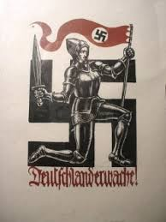 | Just as it was important to control the media, Hitler realised that other aspects of everyday life could be controlled in order to re-inforce the ideology of Nazism. Thus, the Arts were controlled and people became used to seeing Nazi imagery in paintings, buildings and plays. It became impossible to avoid the message of the Nazis in art, architecture, literature and film.
4 Opposition,  resistance and  conformity | - The extent of support for the Nazi regime. | 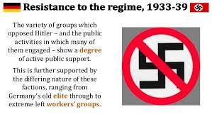 | In the years 1933-39, there were about 1.3 million people sent to concentration camps in Germany and this would see m to be an indication of quite widespread opposition to the regime. Nevertheless, many Germans gained much from Hitler's successes after 1933 and consequently Hitler was readily able to maintain support. There were economic successes which began to erase the Depression. Germany's international standing grew and this seemed to remove the shame of defeat in the war and the Treaty of Versailles (the Saar was returned in 1935, the army was built up after 1935, and in 1936 the Rhineland was reoccupied). Some Germans were happy to see the Communists, Socialists and SA leaders removed.
4 Opposition,  resistance and  conformity | - Opposition from the Churches, including the role of Pastor Niemöller. | 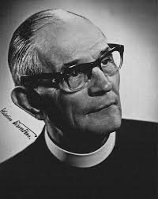 | Pastor Martin Niemoller opposed Nazi control of the Church and became leader of the Confessional Church, which followed traditional German Protestantism. He established the Pastors' Emergency League, which opposed Nazi attempts to control the Protestant Church and saw membership rise co 7,000 by 1934. However, many pastors left when they were persecuted by the Nazis. Niemoller was arrested in 1937 after having preached that people must obey God and not man. He was tried and kept in prison and concentration camps until 1945.
4 Opposition,  resistance and  conformity | - Opposition from the young, including the Swing Youth and the Edelweiss Pirates. | 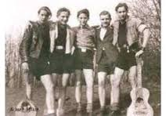 | Although many of che young joined the Hider Youth (see page 92), it was not popular with some of its members and not all young people accepted the Nazi ideas. Indeed by the mid-1930s gangs began to appear on street corners. They played their own music and boys and girls were free robe together. Many grew their hair long and wore their own choice of clothes as a rebellion against the regimentation of Nazi ideas. Some went looking for members of the Hitler Youth and beat them up.

Trigger Memory Story Medicine 50-1350

The story must be very imaginative. It must involve you seeing, talking and doing things. It must link the ten trigger words together in the form of a continuous story. You should then rehearse the story and commit it too your long term memory to be recalled when necessary. This will take some effort but will be very useful! Use different colours to write the trigger words in your story.

I was...

