KT3 TMA The end of the Cold War, 1970–91

Focus Points and Elements | Sub-elements | Key Picture | Key Narrative
Focus 1 Attempts to reduce tension between East and West  Détente in the 1970s, SALT 1, Helsinki, and SALT 2. | - Détente in the 1970s  - SALT 1  - Helsinki,  - SALT 2. | 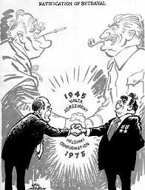 | At the Moscow 1972 meeting, Nixon agreed to take part in a European Security Conference, from which emerged the Helsinki Agreements 1975, Nixon was keen to show his commitment to detente was able to do this by making a public declaration with the Soviet Union. In 1972 SALT I was agreed and a further Nixon visit to Moscow in 1974 promoted increased understanding and confidence between the peoples of both countries. SALT II began in 1974 and the treaty was signed in June 1979.  - A limit of 2400 strategic nuclear delivery vehicles for each side  - A 1320 limit on MIRV systems for each side  - A ban on construction of new land-based ICBM launchers  - Limits on deployment of new types of strategic offensive arms  - SALT II to last until 1985.
The significance of Reagan and Gorbachev’s changing attitudes. | - The significance of Reagan and Gorbachev’s changing attitudes | 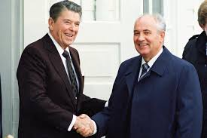 | Gorbachev had no foreign policy experience prior to becoming the leader of the Soviet Union. At first, he viewed the relationship with the US President Ronald Reagan in rather simplistic terms. For example, following his first meeting with Reagan in 1985, he described him as retarded. However, his ‘new thinking’ led to major changes in relations with the West.
Gorbachev’s ‘new thinking’ and the Intermediate-Range Nuclear Force (INF) Treaty 1987. | - Gorbachev’s ‘new thinking’ and the Intermediate-Range Nuclear Force (INF) Treaty 1987 | 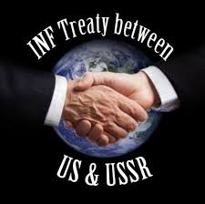 | Gorbachev did not intend to abandon the Communist Party or communism, but introduced a radical programme of reform known as ‘new thinking’ in order to revive communism. This involved three main strategies which effectively ended the Cold War:  - Initiating sweeping reforms -perestroika (restructuring) and glasnost (openness).  - Ending the arms race with the USA and signing various arms reduction agreements.  - Abandoning the Brezhnev Doctrine and stopping Soviet interference in eastern European satellite states  The INF Treaty of December 1987 eliminated nuclear and conventional ground ­launched ballistic and cruise missiles with ranges of 500 to 5,500 kilometres (300 to 3,400 miles). By the treaty's deadline, June 1991, a total of 2,692 such weapons had been destroyed, 846 by the USA and 1,846 by the Soviet Union.
Focus 2 Flashpoints  The significance of the Soviet invasion of Afghanistan, the Carter Doctrine and the Olympic boycotts., | - The significance of the Soviet invasion of Afghanistan, the Carter Doctrine and the Olympic boycotts., | 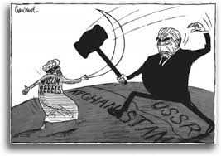 | The Soviet Invasion of Afghanistan was to drastically change relations between East and West.The USA saw that a Soviet-occupied Afghanistan would threaten India and Pakistan and would be a stepping stone to possible Soviet control of much of the West’s oil supplies. Apart from religious reasons, the Soviet union invaded because it did not wish to see the collapse of a neighbouring socialist state nor did it wish to see the growth of US influence on its borders.The intent of Soviet Union can be seen by the huge military contingent. Carter’s tough approach to the Soviet Union became known as the Carter Doctrine. It was a policy which stated that the USA would use military force if necessary to defend its national interests in the Persian Gulf region. The carter Doctrine also promised US military aid to all of the countries bordering Afghanistan. President carter’s most controversial decision after the soviet invasion was to pressure the United States Olympic committee (USOC) to boycott the Moscow Olympic Games (July-August 1980)
Reagan and the ‘Second Cold War’ | - Reagan and the ‘Second Cold War’ | 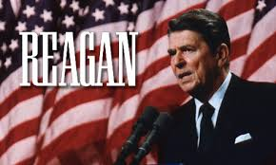 | Fighting communism became the major emphasis of Reagan’s policy and he made it clear that he intended to confront the Soviet Union whenever possible. This change of policy has been called the ‘Second Cold War’. Reagan was aware of the arsenal that the Soviet Union had built-up but he was determined not to be intimidated by it. Reagan announced that the US defence programme between 1981 and 1987 would cost more than a trillion dollars. There was a view that Reagan and his advisers felt that they could win a limited nuclear war against the Soviet Union using a strategy known as NUTS. Relations grew worse when the Soviet delegation walked out of the START talks in 1983 and Reagan announced the SDI.
The Strategic Defence Initiative. | - The Strategic Defence Initiative. | 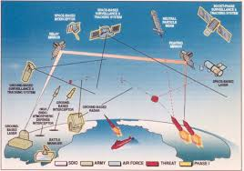 | On 23 March 1983, President Reagan announced the Strategic Defence Initiative, quickly nicknamed the ‘Star Wars’ programme (after the film) by the media. SDI was a plan for a ground- and space-based, laser-armed anti- ballistic missile system that, if deployed, would shield against missiles launched at the US, destroying them in the process. SDI presented enormous problems for Andropov and his advisers, who realised that the Star Wars programme meant that they would have to spend even more money on armaments in order to compete with the USA.
Focus 3 The collapse of Soviet control of Eastern Europe  The impact of Gorbachev’s ‘new thinking’ on Eastern Europe: the loosening Soviet grip on Eastern Europe. | - The impact of Gorbachev’s ‘new thinking’ on Eastern Europe: the loosening Soviet grip on Eastern Europe. | 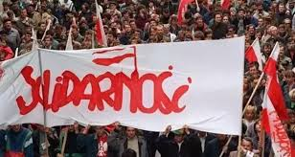 | Gorbachev had shown that he was prepared to make deals with the US and to think the unthinkable. The soviet economy could no longer stand the the strain of supporting forces in eastern Europe. He went even further when he rejected the Brezhnev Doctrine in 1988 and in in 1989 he accepted that members of the Warsaw Pact could make changes to their own countries without expecting outside interference. This became shown as the Sinatra Doctrine. This was part of Gorbachev's ‘new thinking’ , on Eastern Europe which mean that ideology would play a much smaller role in Soviet foreign affairs. In practice, this meant that the Soviet union would no longer favour trade with with communist countries over trade and capitalist countries. Gorbachev was keen for Eastern European countries to embrace his ‘new thinking’ and enjoy perestroika and glasnost. In addition , he withdrew soviet troops from Eastern European bases in order to save money.
The significance of the fall of the Berlin Wall. | - The significance of the fall of the Berlin Wall. | 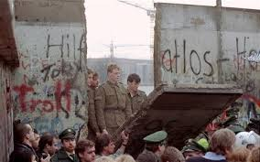 | As soon as democratic elections were announced in Hungary there was a mass movement of East German citizens through Hungary to West Germany. As part of this decision to ease travel, on the evening of 9 November, the East German government announced the opening of the border crossings into West Germany. The people began to dismantle the Berlin Wall. Within a few days, over one million people per day had seized the chance to see relatives and experience life in the West. West.and East Germany were formally reunited on 3 October 1990. Tension in the world seemed to ease by the day while the power of the Soviet Union seemed to be dwindling so quickly. The new Germany joined NATO and, in 1991, the Warsaw Pact was dissolved.
The collapse of the Soviet Union and its significance in bringing about the end of the Warsaw Pact. | - The collapse of the Soviet Union and its significance in bringing about the end of the Warsaw Pact. | 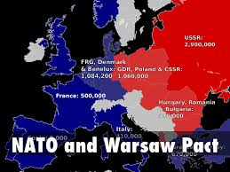 | As Soviet control of eastern Europe fell away, it became obvious that the Warsaw Pact could not survive. The Pact was an alliance that united the communist states of eastern Europe against the capitalist states of the west. However, as first Poland, then Hungary and finally East Germany all rejected communism, the Pact no longer served any purpose. The Soviet Union’s military strength had been called into question in Afghanistan and its weak economy meant that it could no longer bolster the Warsaw Pact. Furthermore, internal divisions and demands for independence from some of its own socialist republics meant the Soviet Union was on the verge of collapse. The Soviet Union had been the cement which kept the Eastern Bloc together. As the cement dissolved, so did the Warsaw Pact. Military co-operation stopped in early 1990 and the Warsaw Pact was formally ended in July 1991.

KT3 TMA story ”The end of the Cold War, 1970–91”.
The story must be very imaginative. It must involve you seeing, talking and doing things. It must link the ten trigger words together in the form of a continuous story. You should then rehearse the story and commit it to your long term memory to be recalled when necessary. This will take some effort but will be very useful! Use different colours to write the trigger words in your story.

Focus Points and Elements | My Cold War KT3 Trigger Memory Story…..arriving at history today I stepped through the door with X and...
Focus 1 Attempts to reduce tension between East and West
Détente in the 1970s, SALT 1, Helsinki, and SALT 2.
The significance of Reagan and Gorbachev’s changing attitudes.
Gorbachev’s ‘new thinking’ and the Intermediate-Range Nuclear Force (INF) Treaty 1987.
Focus 2 Flashpoints
The significance of the Soviet invasion of Afghanistan, the Carter Doctrine and the Olympic boycotts.,
Reagan and the ‘Second Cold War’
The Strategic Defence Initiative.

Focus 3 The collapse of Soviet control of Eastern Europe
The impact of Gorbachev’s ‘new thinking’ on Eastern Europe: the loosening Soviet grip on Eastern Europe.
The significance of the fall of the Berlin Wall.
The collapse of the Soviet Union and its significance in bringing about the end of the Warsaw Pact.

Key Topic 3 Questionnaire

Focus 1. X

Pictures

Focus 2. X
Pictures

Focus 3. X

Pictures

