Key Topic 3. Elizabethan society in the Age of Exploration, 1558–88.
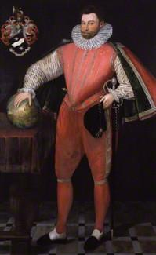

The most famous of all English seafarers, Drake earned his fame and fortune through his skilful seamanship and outstandingly successful piracy. His circumnavigation of the globe from 1577-81 involved a number of very profitable raids on Spanish ships and ports. Drake's increasingly frequent and serious attacks during the 1580s were an important factor contributing to Philip II's decision to launch the Armada which was in turn defeated by the English fleet. In this full-length portrait Drake rests his hand on a globe which, intriguingly, is orientated the other way up from modern representations of the planet. The names of the continents are marked in French..

Content
In a Nutshell: Overview of developments Elizabethan society in the Age of Exploration, 1558–88.

Causes and Analysis including:

Focus 1. Education, and leisure Hodder p80-87
Education in the home, schools and universities. Sport, pastimes and the theatre.

Focus 2. The problem of the poor. Hodder p88-91
The reasons for the increase in poverty and vagabondage during these years.The changing attitudes and policies towards the poor.

Focus 3. Exploration and voyages of discovery. Hodder p93-101
Factors prompting exploration, including the impact of new technology on ships and sailing and the drive to expand trade. The reasons for, and significance of, Drake’s circumnavigation of the globe.

Focus 4. Raleigh and Virginia. Hodder p102-104
The significance of Raleigh and the attempted colonisation of Virginia. Reasons for the failure of Virginia.

Cracking the Puzzle – Preparing for assessment.

Language and Literacy
Key Terms and their meanings in society in the Age of Exploration, 1558–88
Key Terms and their meanings in society in the Age of Exploration, 1558–88

(I) In a Nutshell: Overview of society in the Age of Exploration, 1558–88

Content overview

(II) Causes and Analysis of developments:
Activity 1 – On your marks…..
The timeline grid sums up developments between 1558-88. It covers an overview of society and the Age of exploration. For each area colour code each box; stable/successful (green), becoming unstable/some difficulties (yellow) or significant problems/unsuccessful (red).

Activity 2 – Get set…..
Your teacher will give you an A3 copy of a concept map. Stick it in your book. You will fill sections in at the end of each key focus area. As well as adding information to your concept map you can add a colour scheme to identify key themes.

Activity 3 – Go…..
As well as the lesson work and activities, read your book independently and visit the library. There are also many excellent websites listed in the back of this booklet to check out. Try to develop your own individual interest in this area of focus .

Focus 1. Education, and leisure
Sport, pastimes and the theatre. Education in the home, schools and universities.

Activity 1
Overview. More comfortable lives p80-81
Overview. More comfortable lives
Four classes of people
The Fourth sort
The better off had a better life

Activity 2
Sports, pastimes and the theatre p82-83
Sports, pastimes and the theatre
Lords and gentry and their families
Everyone
Working people their families and the unemployed

Activity 3
Going to the theatre p84-85
Going to the theatre
The first theatres
Growth of the London theatre
Who attended?
Elizabethan playwrights
Opposition to the theatre
The Queen and the theatre

Activity 4
Education in the home, schools and universities p86-87
 | Education in the home, schools and universities
Increased Education | Home  School  University
Limited education | Home  School  University

Activity 5

SECTION B: Tudor depth options
Answer EITHER Question 4 OR Question 5. Do question 5, which is Option B4!

Option B4: Early Elizabethan England 1558–88
Answer Question 5(a), 5(b) and EITHER 5(c)(i) OR 5(c)(ii).
5 (a) Describe two features of the theatre. 4 marks

(b) Explain why the number of children going to school increased in Elizabethan times. (12 marks)
You may use the following in your answer:
- Home education
- Increase in schools and Universities
You must also use information of your own

Answer EITHER (c)(i) OR (c)(ii)
EITHER
(c) (i) ‘The sports and pastimes engaged in by people varied amongst the social classes.’ How far do you agree? Explain your answer.
(16 marks)
You may use the following in your answer:
- Lords and gentry
- Working people and the poor
You must also use information of your own.

OR
(c) (ii) ‘The increase in schools was the main cause of the expansion of Education in Elizabethan times.’ How far do you agree? Explain your answer.
(16)
You may use the following in your answer:
- Grammar schools
- University Education
You must also use information of your own.

Focus 2. The problem of the poor.
The reasons for the increase in poverty and vagabondage during these years. The changing attitudes and policies towards the poor.

Activity 1
Reasons for increase in poverty and vagabondage p88-89
Reasons for increase in poverty and vagabondage
Harvests and changes in farming
Unemployment in industries
Population Growth
Inflation - rising prices
The closure of the monasteries

Activity 2
Attitudes towards the poor. Elizabethans were worried! p90-91
Attitudes towards the poor. Elizabethans were worried!
1 People should work hard.
2 Concerns over vagabonds and the threat to social order
3 The cost of the poor to the rich.
4 The poor might spread disease.
5 Beggars turned to crime
Vagabonds

Activity 3
New laws for the poor. Help and punishment. p91
New laws for the poor. Help and punishment.
A flexible policy
Vagabonds Act 1572
Act for the relief of the Poor 1576
Evidence from Norwich census of the Poor and city records.

Activity 4

SECTION B: Tudor depth options
Answer EITHER Question 4 OR Question 5. Do question 5, which is Option B4!

Option B4: Early Elizabethan England 1558–88
Answer Question 5(a), 5(b) and EITHER 5(c)(i) OR 5(c)(ii).
5 (a) Describe two features of the increase in poverty. 4 marks

(b) Explain why their was an increase in Poverty. (12 marks)
You may use the following in your answer:
- Poor harvests
- Inflation
You must also use information of your own

Answer EITHER (c)(i) OR (c)(ii)
EITHER
(c) (i) ‘The growth of population was the main reason for the growth in poverty.’ How far do you agree? Explain your answer.
(16 marks)
You may use the following in your answer:
- Population growth
- Inflation
You must also use information of your own.

OR
(c) (ii) ‘Rise in crime was the main cause of concern about the growth of Poverty.’ How far do you agree? Explain your answer.
(16)
You may use the following in your answer:
- Rise in crime
- Social control
You must also use information of your own.

Focus 3. Exploration and voyages of discovery.
Factors prompting exploration, including the impact of new technology on ships and sailing and the drive to expand trade. The reasons for, and significance of, Drake’s circumnavigation of the globe.

Activity 1
Reasons for the growth of overseas exploration p94-95
Reasons for the growth of overseas exploration
1 Commercial rivalry with Spain
2 The design of ships
3 The desire to increase markets to sell goods
4 The desire to speculate to earn money
5 To convert other areas to Christianity
6 The development of knowledge
7 To spread British influence
8 Growth of experienced seafarers

Activity 2
English voyages of exploration p96-97
English voyages of exploration
1497 John Cabot
1553 Sir Hugh Willoughby and Richard Chancellor
1562-68 John Hawkins
1576 Martin Frobisher
1577-80 Sir Francis Drake
1583 Sir Humphrey Gilbert
1585-87 Sir Walter Raleigh
1585-87 John Davis
1595 Sir Walter raleigh

Activity 3
Reasons for and significance of Drake’s circumnavigation of the world 1577-80 p98-101
Reasons for and significance of Drake’s circumnavigation of the world 1577-80
Drakes aims
Drake’s ships
Stage 1 Sailing to Brazil December 1577-April 1578
Stage 2 Brazil to Guatulco April 1578-April 1579
Stage 3 South America to Plymouth April 1579 - September 1580

Activity 4

SECTION B: Tudor depth options
Answer EITHER Question 4 OR Question 5. Do question 5, which is Option B4!

Option B4: Early Elizabethan England 1558–88
Answer Question 5(a), 5(b) and EITHER 5(c)(i) OR 5(c)(ii).
5 (a) Describe two features of the attempts to colonise Virginia in the 1580s. 4 marks

(b) Explain why overseas exploration grew in Elizabeth’s reign. (12 marks)
You may use the following in your answer:
- The design of ships
- The desire to increase trade
You must also use information of your own

Answer EITHER (c)(i) OR (c)(ii)
EITHER
(c) (i) ‘The impact of Drake’s circumnavigation of the world was mainly successful.’ How far do you agree? Explain your answer.
(16 marks)
You may use the following in your answer:
- The successes
- The problems
You must also use information of your own.

OR
(c) (ii) ‘Commercial expansion was the main reason for the voyages of exploration.’ How far do you agree? Explain your answer.
(16)
You may use the following in your answer:
- Commercial reasons
- The design of new ships
You must also use information of your own.

Focus 4. Raleigh and Virginia.
The significance of Raleigh and the attempted colonisation of Virginia. Reasons for the failure of Virginia.

Activity 1
Were the voyages of Sir Walter Raleigh really significant? p102
Were the voyages of Sir Walter Raleigh really significant?
Early life 1552-78
1578-88
What did Sir walter raleigh actually do
The advantages of establishing a British colony in North America

Activity 2
The 1585 voyage p103
The 1585 voyage
April 1584
An unfortunate start
On his return

Activity 3
The 1587 voyage p104
The 1587 voyage
The beginning of a second expedition
A second colony
The Lost colony
Reasons why Raleigh’s settlement in Virginia failed.
The longer term impact of Raleigh’s expeditions.

Activity 4

SECTION B: Tudor depth options
Answer EITHER Question 4 OR Question 5. Do question 5, which is Option B4!

Option B4: Early Elizabethan England 1558–88
Answer Question 5(a), 5(b) and EITHER 5(c)(i) OR 5(c)(ii).
5 (a) Describe two features of the attempts to colonise Virginia in the 1580s. 4 marks

(b) Explain why the voyages to Virginia were unsuccessful. (12 marks)
You may use the following in your answer:
- Poor relations with the Native Indians
- Lack of food
You must also use information of your own

Answer EITHER (c)(i) OR (c)(ii)
EITHER
(c) (i) ‘Poor relations with Native Americans was the main problem for Raleigh’s settlements in Virginia failing.’ How far do you agree? Explain your answer.
(16 marks)
You may use the following in your answer:
- Relations with Native Indians
- Problem with food supply
You must also use information of your own.

OR
(c) (ii) ‘Lack of secure food supplies was the main cause of the failure for Raleigh’s Virginia settlements.’ How far do you agree? Explain your answer.
(16)
You may use the following in your answer:
- Lack of food
- Relations with Native Americans
You must also use information of your own.

(III) Assessment for Learning
Puzzle practise : X
In the puzzle 5A AND B will be compulsory questions and either C i or ii will be optional questions covering the core content. The content will come from either one or a combination of the key themescovered in each of the key questions;

The following examples are focussed on content from ..

Exam Practise
SECTION B: Tudor depth options
Answer EITHER Question 4 OR Question 5. Do question 5, which is Option B4!

Option B4: Early Elizabethan England 1558–88
Answer Question 5(a), 5(b) and EITHER 5(c)(i) OR 5(c)(ii).
5 (a) Describe two features of the attempts to colonise Virginia in the 1580s. 4 marks

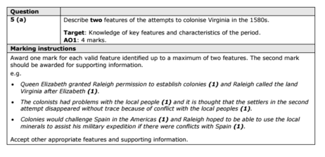

(b) Explain why the Throckmorton Plot (1583) was a threat to Queen Elizabeth. (12 marks)
You may use the following in your answer:
- Mary, Queen of Scots
- foreign threat
You must also use information of your own

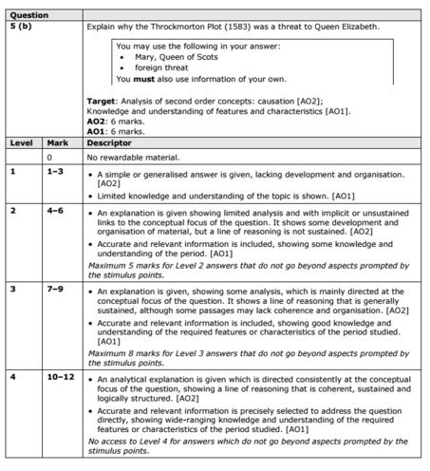

Answer EITHER (c)(i) OR (c)(ii)
EITHER
(c) (i) ‘The threat of invasion was Elizabeth’s main problem when she became queen in 1558.’ How far do you agree? Explain your answer.
(16 marks)
You may use the following in your answer:
- France
- Elizabeth’s legitimacy
You must also use information of your own.

OR
(c) (ii) ‘Religion was the main cause of the Revolt of the Northern Earls in 1569–70.’ How far do you agree? Explain your answer.
(16)
You may use the following in your answer:
- Catholic grievances
- the Earls of Northumberland and Westmorland
You must also use information of your own.

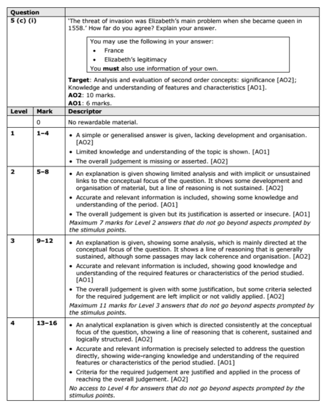
Trigger Memory Activity for society in the Age of Exploration, 1558–88

Trigger Words | Trigger Picture | Add Trigger  Points from your notes
1 Overview More comfortable lives
2 Sports pastimes and theatre
3 Going to theatre
4 Education at home, school and university
5 Reasons for increase of poverty and vagabondage
6 Attitudes towards the poor
7 New laws for the Poor
8 Reasons for growth of overseas exploration
9 English voyages of exploration
10 Reasons for and significance of Drake’s circumnavigation of the world
11 Significance of Sir Walter Raleigh’s voyages
12 1585 voyage
13 1587 voyage

Trigger Memory Story society in the Age of Exploration, 1558–88

The story must be very imaginative. It must involve you seeing, talking and doing things. It must link the ten trigger words together in the form of a continuous story. You should then rehearse the story and commit it to your long term memory to be recalled when necessary. This will take some effort but will be very useful! Use different colours to write the trigger words in your story.

I was on my way to a history lesson and on entering the room the clock began to go backwards, minutes, hours, days, months, years coming to a halt in 1558. Queen Elizabeth had inherited the throne and the first 30 years of her reign were going to witness momentous changes in society and the development of overseas expansion.

