KT2 TMA The Cold War 1958-70
Focus Points and Elements | Sub-elements | Key Picture | Key Narrative
Focus 1 Increased tension between East and West  The refugee problem in Berlin. | - The refugee problem in Berlin. | 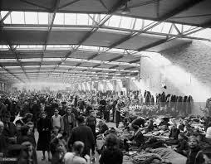 | Between 1949 and 1961 , about 4 million East German fled to the west through Berlin because they were dissatisfied with economic and political conditions at home. The forced collectivisation of agriculture and the end of private trading were not popular among the people of east Germany, moreover, there were shortages of consumer goods, which could be bought cheaply in West Berlin.
Khrushchev’s Berlin ultimatum (1958), | - Khrushchev’s Berlin ultimatum (1958), | 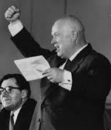 | In 1958 Khrushchev issued the Berlin Ultimatum. He accused the Allies of breaking the Potsdam agreement telling them that they should leave Berlin within six months and suggesting that it should become neutral free city. President Eisenhower of the USA seemed prepared to negotiate. He did not want to risk a war over Berlin.
The summit meetings of 1959–61. | - Paris May 1960  - Vienna June 1961 | 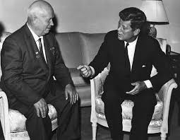 | Khrushchev and Eisenhower were due to meet in Paris on 14 May 1960. There were bitter exchanges between Khrushchev and Eisenhower at preliminary meeting, which ended with Khrushchev storming out of the first session (see source B). Eisenhower immediately cancelled his planned visit to the Soviet Union. The summit did not take place. At the Vienna Summit of June 1961, Khrushchev again demanded that the western forces leave West Berlin. He said he would make a treaty with the East Germany which would end all occupation rights, including Western access to Berlin. Kennedy refused to withdraw western forces and increased US defence spending by $3.5 billion the following month.
Soviet relations with Cuba, the Cuban Revolution and the refusal of the USA to recognise Castro’s government. | - Soviet relations with Cuba  - Cuban Revolution USA refusal to recognise Castro’s government. | 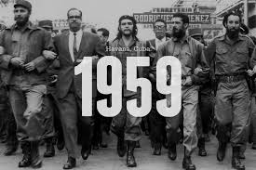 | Khrushchev, delighted to have an ally very close to the American mainland, offered to buy the Cuban sugar. He also sent weapons to Cuba at the end of 1959 and, in 1960, senior Soviet diplomats visited Fidel Castro. Castro was seen as ‘a beacon,a hopeful lighthouse for all The unfortunate, exploited peoples of Latin America’.  In September 1960, Khrushchev openly promised to send Castro military assistance and this pushed Cuba’s leader more closely to the Soviet camp. Having been unable to re-unite Berlin, Khrushchev was keen to challenge the USA over Cuba. Khrushchev was sure that he could out manoeuvre John F. Kennedy, the inexperienced new American president. Moreover Khrushchev needed some successes to deflect criticism of his failures within the Soviet Union.
The significance of the Bay of Pigs incident. | - The significance of the Bay of Pigs incident. | 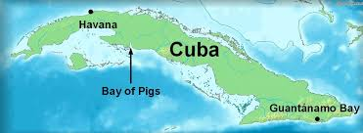 | Castro had been losing support before the invasion because of the increasingly severe economic situation in Cuba. Many Cubans had fled the country because of these problems, seeking more prosperous countries in which to settle , including the USA. However Castro’s position in Cuba became stronger due to the failure of the invasion, as the threat from the USA united the Cuban people. The USA also lost support in the rest of Latin America because of events at the Bay of pigs. The failure was also a great embarrassment to Kennedy and made him more determined than ever to remove Castro. He set up operation mongoose , secret operations organized by the American CIA to remove Castro. Moreover US missile bases in Italy and Turkey, and thus thought soviet union bases in Cuba would restore the balance of power , in addition from future attacks from the USA and disgruntled Cuban exiles.
Opposition in Czechoslovakia to Soviet control: the Prague Spring. | - Opposition in Czechoslovakia to Soviet control  - The Prague Spring. | 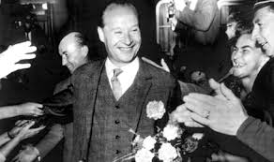 | The failure of economic reform encouraged many Czechoslovakians to demand greater democracy . In october 1967. A number of reformers including Alexander Dubcek and the and the economist Ota Sik, challenged Novotny’s leadership at a meeting of the central committee of the communist party. Dubcek’s reforms, however, encouraged opponents of communism and led to demands for even more radical reforms. For example, in June 1968 the Social Democrats began to form a separate party as a rival to the Communist Party. Around the same time Ludvik Vaculik, a leading journalist, published a manifesto entitled The Two Thousands Words. In it called on the Czechoslovakian people to take the initiative and force even more extreme reform.
Focus 2 Cold War crises  The construction of the Berlin Wall, 1961. | - The construction of the Berlin Wall, 1961. | 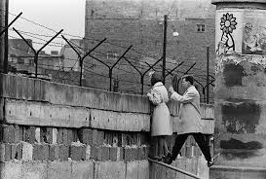 | The differences over berlin worsened in 1961 on 13 August,Khrushchev closed the border between East and West Berlin were torn up by German troops so that could erect a barbed wire entanglement around the 43 km (27 miles) which separated the two Berlins. The USA and its Allies did nothing to stop the building of the Wall,especially as the new barrier of East Berlin.Within a few days,construction began on the Wall itself as well as chains fences on the minefields. An area was cleared so that East German guards would be able to shoot at any East Germans who tried to cross to west Berlin. Eventually,East German officials replaced the temporary wall with one that was much stronger.
The events of the Cuban Missile Crisis. | - The events of the Cuban Missile Crisis. | 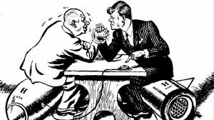 | 22nd October: Kennedy’s television address. 24th October: Eighteen soviet ships approaching Cuba turned around to avoid confrontation with the US blockade (quarantine), Kennedy demanded the removal of all missiles; failure to do so would lead to the invasion of Cuba. 26th October: Khrushchev sent Kennedy a letter, offering to remove the missiles if the blockade was removed and there was a promise not to invade Cuba. 27th October: Khrushchev sent a tougher letter. He promised to remove the missiles if the USA removed its missiles from Turkey. U-2 spy plane shot down over Cuba by Soviet missile. The crisis deepened. 28th October: President Kennedy, at the suggestion of his brother, Robert, decided to ignore the second letter and accepted the terms of the first. He added if there was no positive Soviet response by 29 October, the US forces would invade Cuba. Khrushchev accepted the offer. The USA agreed to remove missiles from Turkey, but this would take place well after the removal of the missiles on Cuba.
The Brezhnev Doctrine and the re-establishment of Soviet control in Czechoslovakia. | - The Brezhnev Doctrine  - The re-establishment of Soviet control in Czechoslovakia. | 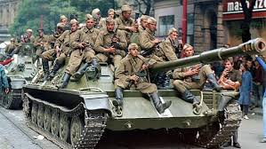 | In August 1968, Leonid Brezhnev, who had taken over as leader of the Soviet Union from Khrushchev in 1964, introduced the Brezhnev Doctrine in order to justify the Soviet Union invasion. According to this doctrine, the Soviet Union had the right to invade any country in Eastern Europe whose actions appeared to threaten the security of the whole Eastern Bloc. On 20-21 August 1968, thousands of Soviet troops, backed by units from Bulgaria, East Germany, Hungary, and Poland, entered Czechoslovakia. Czechoslovakia threw petrol bombs at the Soviet tanks as they moved through Prague.
Focus 3 Reaction to crisis  Impact of the construction of the Berlin Wall on US-Soviet relations. | - Impact of the construction of the Berlin Wall on US-Soviet relations. | 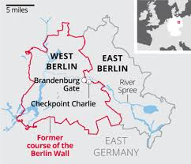 | The construction of the Berlin Wall led to a serious stand-off between the two superpowers in October 1961. The USA disputed the right of the Soviet troops to patrol and guard the checkpoints to the Wall as well as to check the passports of American officials who passed through these checkpoints. The Americans stationed their own troops and tanks on the Western side of checkpoints which, in turn, provoked the Soviets to place tanks on the East German side. One wrong move and there was a real possibility of armed conflict. The US President, Kennedy, worked behind the scenes to avoid any such conflict, promising Khrushchev that if the Soviet Union removed its troops, the USA would do the same. This ended the stand-off.
Kennedy’s visit to Berlin in 1963. | - Kennedy’s visit to Berlin in 1963. | 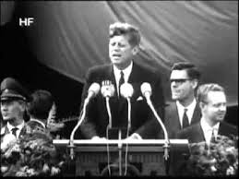 | The Wall became the symbol of division in the world and, for Berliners, it was a constant reminder that their country was still a tool of the superpowers. President Kennedy visited West Germany in 1963. He made several speeches in some of it’s major cities, where he was met by huge, cheering crowds. When he moved on to West Berlin, he embarked on a thirty-mile tour of the main streets, which were lined with an estimated 1.5 million people (out of a population of about 2.5 million). He spoke to a crowd of about 200,000 in the centre of the city, near the Wall. Some East Berliners listening to him on the other side of the Wall applauded him, too.
The consequences of the Cuban Missile Crisis: the ‘hotline’, the Limited Test Ban Treaty 1963; | - The consequences of the Cuban Missile Crisis  - The ‘hotline’  - The Limited Test Ban Treaty 1963 | 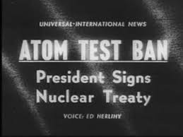 | The Cuban Missile Crisis did, at first,intense rivalry and tension between the USA and the Soviet union.However,in other respects,it reduced tension between the two superpowers. The superpowers had almost almost gone to war-a war that would have destroyed most of the world.There was relief that the crisis was over and there was a great reduction of tension.To ensure that the two leaders did not have to communicate by letter in the case of a crisis,a hotline telephone link was established between the White House in Washington DC and the Kremlin in Moscow. Further improvements came when the Limited Test Ban Treaty was signed in August 1963,whereby both the USA and Soviet Union agreed to stop testing nuclear weapons in the atmosphere.
The Outer Space Treaty 1967; and the Nuclear Non-Proliferation Treaty 1968. | - The Outer Space Treaty 1967  - The Nuclear Non-Proliferation Treaty 1968. | 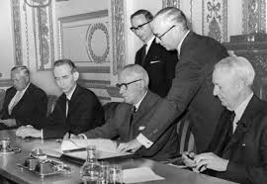 | In 1968,the two superpowers,together with Britain and several other countries,signed the Outer Space Treaty,by which they promised to use Outer space for peaceful purposes and not place nuclear weapons on orbit. The Outer Space Treaty was followed by the Nuclear Non-proliferation Treaty signed in 1968,which was designed to stop the spread of nuclear weapons.Those countries signing agreed not to develop nuclear weapons.The idea that the arms race had almost brought about nuclear war helped to push the superpowers to consider limitations to their arsenals,and talks began in 1969.These became known as the Arms Limitation Talks,which became part of the policy detente, a reduction in tension between the USA and Soviet Union.
International reaction to Soviet measures in Czechoslovakia. | - International reaction to Soviet measures in Czechoslovakia. | 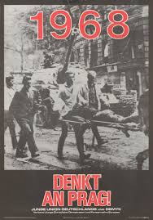 | The Soviet invasion of Czechoslovakia temporarily worsened relations between East and West. Western countries, especially Britain and the USA, protested about Soviet actions. However, ultimately the invasion did not endanger Soviet-American relations, and detente continued after a slight break. The USA was in the middle of a presidential election during 1968 and was also pre-occupied with the Vietnam War. Moreover, Brezhnev and the American President, Lyndon B Johnson, had an unspoken deal that the USA would not intervene in Czechoslovakia as long as the Soviet Union did not intervene in Vietnam. Therefore, while America publicly condemned the invasion, they offered no military support to Czechoslovakia.

KT2 TMA story “X” linking the Focus Points and Elements.
The story must be very imaginative. It must involve you seeing, talking and doing things. It must link the ten trigger words together in the form of a continuous story. You should then rehearse the story and commit it to your long term memory to be recalled when necessary. This will take some effort but will be very useful! Use different colours to write the trigger words in your story.

Focus Points and Elements | My Elizabeth KT3 Trigger Memory Story…..arriving at history today I stepped through the door with X and...
Focus 1 Increased tension between East and West
The refugee problem in Berlin.
Khrushchev’s Berlin ultimatum (1958),
The summit meetings of 1959–61.
Soviet relations with Cuba, the Cuban Revolution and the refusal of the USA to recognise Castro’s government.
The significance of the Bay of Pigs incident.

Opposition in Czechoslovakia to Soviet control: the Prague Spring.
Focus 2 Cold War crises
The construction of the Berlin Wall, 1961.
The events of the Cuban Missile Crisis.
The Brezhnev Doctrine and the re-establishment of Soviet control in Czechoslovakia.
Focus 3 Reaction to crisis
Impact of the construction of the Berlin Wall on US-Soviet relations.
Kennedy’s visit to Berlin in 1963.
The consequences of the Cuban Missile Crisis: the ‘hotline’, the Limited Test Ban Treaty 1963;
The Outer Space Treaty 1967; and the Nuclear Non-Proliferation Treaty 1968.
International reaction to Soviet measures in Czechoslovakia.

Key Topic 2 Questionnaire

Focus 1. X

Pictures

Focus 2. X
Pictures

Focus 3. X

Pictures

