KT2 TMA Germany 1918-39
Focus Points and Elements | Sub-elements | Key Picture | Key Narrative
1 Early  development  of the Nazi  Party, 1920–22 | Hitler’s early career:  Joining the German Workers’ Party and setting  up the Nazi Party, 1919–20. | 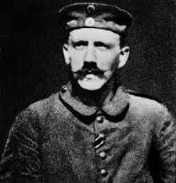 | When the First World War ended, Germany experienced tremendous social and political upheaval. During the five years after the war, several new parties emerged and there were communist and right-wing uprisings. One of the new parties was the DAP (Deutsche Arbeiterpartei). As it grew, it added the words 'national' and 'socialist' to become the NSDAP and during its transformation it acquired a new leader, Adolf Hitler. Hitler changed the DAP from a small number of malcontents to a party which tried to take over the Bavarian state government in 1923.
1 Early  development  of the Nazi  Party, 1920–22 | The early growth and features of the Party.  The Twenty-Five Point Programme.  The role of the SA. | 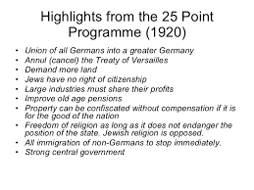 | In February 1920, Hitler and Drexler wrote what became known as the Twenty-Five Point Program me (Table 5.1). It was a political manifesto and Hitler kept to most of the ideas throughout the rest of his life. The programme was announced at a key meeting in Munich a nd shortly after 'national socialist' was added to the party's name. The party grew rapidly in 1920 and Hitler was largely responsible for this - his public speaking attracted hundreds to meetings of the NSDAP. During the period 1921-23, the SA was used to disrupt the meetings of the Social Democratic Party and the Communist Party.
2 The Munich  Putsch and  the lean years,  1923 –29 | The reasons for, events and consequences of the Munich Putsch. | 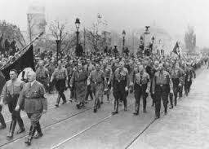 | On the evening of8 November 1923, Hitler and 600 Nazis seized the Biirgerbraukeller (a huge beer hall in Munich), where Kahr, Seisser and Lossow were attending a political meeting. Hitler placed the three leaders in a room and won promises of support for his planned takeover from them after they had been held at gunpoint. Hitler was arrested along with his main supporter, Erich Ludendorff, and was tried for treason. The trial began in February 1924 and lasted almost one month. The trial gave Hitler nationwide publicity and introduced him to the German public via the national press.
2 The Munich  Putsch and  the lean years,  1923 –29 | Reasons for limited support for the Nazi Party, 1924–28.  Party  reorganisation and Mein Kampf.  The Bamberg Conference of 1926. | 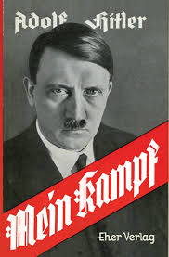 | Hitler's leadership and reorganisation of the party achieved results. The party had only 27,000 members in 1925 bur exceeded 100,000 by the end of 1928. It was a nationwide party that had begun to attract all classes. Yet, despite the changes, the Nazis won only 12 seats i n parliament in the 1928 elections, having held 32 in 1924. There were further changes within the Nazi Party in the late 1920s when Hitler began to target the peasants as a key electoral group. He also replaced Strasser as head of party propaganda with Josef Goebbels.The political and economic events of 1929 (see pages 39-40) helped the Nazi Party rise from relative obscurity to become one of the leading parties in the country. The 'lean years' were at an end.
3 The growth in support for  the Nazis, 1929–32 | The growth of unemployment – its causes and impact.  The failure of  successive Weimar governments to deal with unemployment from 1929 to January 1933.  The growth of support for the Communist Party. | 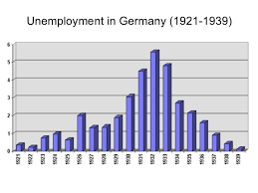 | When its stock market collapsed in October  1929 - the Wall Street Crash - the problems created had huge consequences for the German economy. The death of Stresemann also added to the crisis. Successive Weimar governments, more especially the Bruning government of 1930-32, failed to deal with the problem of unemployment. The economic crisis created problems for the Weimar government and there was little agreement about how to tackle unemployment and poverty. During the years of the Weimar Republic the KPD was the largest communist party in Europe, and was seen as the 'leading party' of the communist movement outside the Soviet Union. It maintained a solid electoral performance, usually polling more than 10 per cent of the vote, and gained 100 deputies in the November 1932 elections.
3 The growth in support for  the Nazis, 1929–32 | Reasons for the growth in support for the Nazi Party, The appeal of Hitler and the Nazis  The effects of propaganda  The work of the SA. | 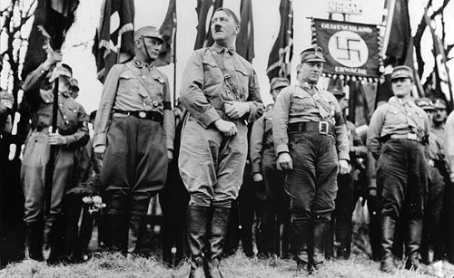 | The economic problems led to political discontent and meant extreme parties were able to secure increasing support of the electorate in elections as opposed to the established pro democratic political parties in Germany. Hitler was able to appeal to all classes of society; his simple messages and slogans could be understood by all.
4 How Hitler  became  Chancellor, 1932–33 | Political developments in 1932.  The roles of Hindenburg, Brüning, von Papen and von Schleicher. | 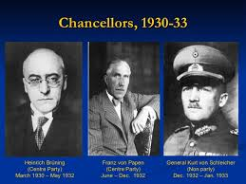 | However, Papen could not secure a majority in the Reichstag and, at the same time, Hitler continued to demand the post of Chancellor. Papen suggested abolishing the Weimar constitution and at this, Kurt von Schleicher, the Minister of Defence, persuaded Hindenburg that if this happened there might be civil war. Papen lost Hindenburg's confidence and resigned. He was succeeded by Schleicher (translated, his name means 'sneaky', 'furtive' or 'intriguer'), who hoped to attain a majority in the Reichstag by forming a Que1" front, meaning 'cross-front', whereby he would bring together different strands from left and right parties. Papen was determined to regain power and to this end he met Hitler in early January 1933 and they agreed that Hitler should lead a Nazi-Nationalist government with Papen as the Vice-Chancellor. Intrigue and trickery now took the place of considered, open political debate.
4 How Hitler  became  Chancellor, 1932–33 | The part played by Hindenburg and von Papen in Hitler becoming Chancellor in 1933. | 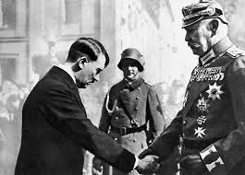 | The army, major landowners and leaders of industry were convinced that Papen and Hitler were saving Germany from Schleicher's plans and a possible communist takeover. Papen was able to convince President Hindenburg that a coalition government with Hitler as Chancellor would save Germany and bring stability to the country. Papen said that he would be able to control Hitler - he would 'make Hider squeak'.  On 30 January 1933, Adolf Hider became Chancellor of Germany.

Trigger Memory Story Medicine 50-1350

The story must be very imaginative. It must involve you seeing, talking and doing things. It must link the ten trigger words together in the form of a continuous story. You should then rehearse the story and commit it too your long term memory to be recalled when necessary. This will take some effort but will be very useful! Use different colours to write the trigger words in your story.

I was...

