Key Topic 2. Challenges to Elizabeth at home and abroad, 1569–88
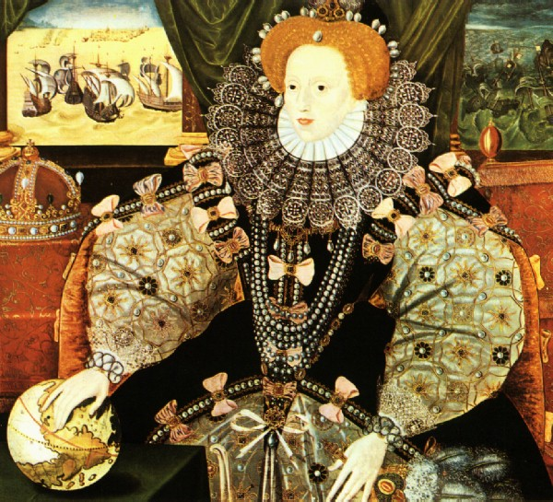

This portrait was painted to commemorate the most famous conflict of Elizabeth's reign, the defeat of the Spanish Armada in 1588. It was originally of the same horizontal format as two other known versions of this painting. Here we can see the scenes behind the Queen showing, on the left, the English fire ships setting out in clear, calm weather and on the right the Spanish fleet being wrecked off the dark, rocky coast of Scotland or Ireland. Elizabeth's hand rests on a globe, her fingers over the Americas, indicating England's dominion of the seas and expansion into the New World.

Content

In a Nutshell: Overview of developments in Challenges to Elizabeth at home and abroad, 1569–88

Causes and Analysis of developments in Challenges to Elizabeth at home and abroad, 1569–88, including:

Focus 1. Plots and revolts at home Hodder p48-59
The reasons for, and significance of, the Revolt of the Northern Earls, 1569–70. The features and significance of the Ridolfi, Throckmorton and Babington Plots. Walsingham and the use of spies. The reasons for, and significance of, Mary Queen of Scots’ execution in 1587.

Focus 2. Relations with Spain Hodder p62-64
Political and religious rivalry. Commercial rivalry. The New World, privateering and the significance of the activities of Drake.

Focus 3. Outbreak of war with Spain, 1585–88 Hodder p65-69
English direct involvement in the Netherlands, 1585–88. The role of Robert Dudley. Drake and the raid on Cadiz: ‘Singeing the King of Spain’s beard’.

Focus 4. The Armada Hodder p70-74
Spanish invasion plans. Reasons why Philip used the Spanish Armada. The reasons for, and consequences of, the English victory.

Cracking the Puzzle – Preparing for assessment.

Language and Literacy
Key Terms and their meanings in challenges to Elizabeth at home and abroad 1569-88.
Key Terms and their meanings in challenges to Elizabeth at home and abroad 1569-88.

(I) In a Nutshell: Overview of challenges to Elizabeth at home and abroad 1569-88

Content overview

(II) Causes and Analysis of developments:
Activity 1 – On your marks…..
The timeline grid sums up developments between 1569-88. It covers the challenges to Elizabeth from both home and abroad.

Activity 2 – Get set…..
Your teacher will give you an A3 copy of a concept map. Stick it in your book. You will fill sections in at the end of each key focus area. As well as adding information to your concept map you can add a colour scheme to identify key themes.

Activity 3 – Go…..
As well as the lesson work and activities, read your book independently and visit the library. There are also many excellent websites listed in the back of this booklet to check out. Try to develop your own individual interest in this area of focus .

Focus 1. Plots and revolts at home
The reasons for, and significance of, the Revolt of the Northern Earls, 1569–70. The features and significance of the Ridolfi, Throckmorton and Babington Plots. Walsingham and the use of spies. The reasons for, and significance of, Mary Queen of Scots’ execution in 1587.
Activity 1
An overview of challenges facing Elizabeth at home and abroad p46-47
 | An overview of challenges facing Elizabeth at home and abroad
The problem with challenges at Home | 1569 The revolt of the Northern Earls  1571 The Ridolfi Plot  1583 The Throckmorton Plot  1586 The Babington Plot
Challenging relations with the Pope
Challenging relations with Spain
Challenging issue of Spain’s policy toward the Netherlands
Challenging impacts of overseas voyages

Activity 2
The Revolt of the Northern Earls 1569 and its causes p49-50
The Revolt of the Northern Earls 1569 and its causes
9-15 November 1569
22-30 November 1569
16-19 December 1569
Cause 1 To restore Catholicism
Cause 2 To restore the powers of northern nobility
Cause 3 Remove some of the Queen’s councillors
Cause 4 The support from abroad

Activity 3
The significance of the threat of the Northern Earls p51
The significance of the threat of the Northern Earls
Yes. The revolt had a high chance of success.
The revolt had some chance of success
No. The revolt had no chance of success.

Activity 4
Were the Catholic plots really dangerous. The Ridolfi Plot 1571? p52-53
The Ridolfi Plot 1571
The plotters and their aims
What happened?
The consequences
Yes. The revolt had a high chance of success.
The revolt had some chance of success
No. The revolt had no chance of success.

Activity 5
Were the Catholic plots really dangerous. The Throckmorton Plot 1583? p54
The Throckmorton Plot 1583
The plotters and their aims
What happened?
The consequences
Yes. The revolt had a high chance of success.
The revolt had some chance of success
No. The revolt had no chance of success.

Activity 6
Were the Catholic plots really dangerous.The Babington Plot 1586? p55
The Babington Plot 1586
The plotters and their aims
What happened?
The consequences
Yes. The revolt had a high chance of success.
The revolt had some chance of success
No. The revolt had no chance of success.

Activity 7
Catching the plotters. The work of Sir Francis Walsingham? p56
 | Catching the plotters. The work of Sir Francis Walsingham
Who was Sir Francis Walsingham?
How did the Privy Council and parliament put pressure on Elizabeth?
What was Elizabeth’s response
Walsinghams methods | 1 Intercepting coded letters and messages  2 Employing a network of spies and agents  3 Supporting Acts of Parliament  4 Searches and registers  5 Using informers in England  6 Interrogation and torture  7 capturing Catholic priests and recusants

Activity 8
Footsteps to the execution of Mary Queen of Scots February 1587. p57
Footsteps to the execution of Mary Queen of Scots February 1587
Step 1 1569-71
Step 2 1573
Step 3 1584-85
Step 4 1586
Step 5 1587
Step 6 8th Feb 1587
The puzzles of the death warrant

Activity 9

SECTION B: Tudor depth options
Answer EITHER Question 4 OR Question 5. Do question 5, which is Option B4!

Option B4: Early Elizabethan England 1558–88
Answer Question 5(a), 5(b) and EITHER 5(c)(i) OR 5(c)(ii).
5 (a) Describe two features of the work of Sir Francis Walsingham. 4 marks

(b) Explain why the Throckmorton Plot (1583) was a threat to Queen Elizabeth. (12 marks)
You may use the following in your answer:
- Mary, Queen of Scots
- foreign threat
You must also use information of your own

Answer EITHER (c)(i) OR (c)(ii)
EITHER
(c) (i) ‘The Ridolfi plot was Elizabeth’s main problem in the period 1569-88.’ How far do you agree? Explain your answer.
(16 marks)
You may use the following in your answer:
- Babington Plot
- Throckmorton Plot
You must also use information of your own.

OR
(c) (ii) ‘Religion was the main cause of the Revolt of the Northern Earls in 1569–70.’ How far do you agree? Explain your answer.
(16)
You may use the following in your answer:
- Catholic grievances
- the Earls of Northumberland and Westmorland
You must also use information of your own.

Focus 2. Relations with Spain
Political and religious rivalry. Commercial rivalry. The New World, privateering and the significance of the activities of Drake.

Activity 1
Trade and Commercial rivalry between England and Spain p62-63
Trade and Commercial rivalry between England and Spain
Commercial rivalry
Conflict over the New World
Elizabeth’s unofficial support for piracy
1568 San Juan de Ulua
1562-64 slaving voyages
1572 Nombre de Dois
1579 The cacafuego

Activity 2
Religious and Political rivalry between England and Spain p64
Religious and Political rivalry between England and Spain
Religious rivalry
Political rivalry

Activity 3

SECTION B: Tudor depth options
Answer EITHER Question 4 OR Question 5. Do question 5, which is Option B4!

Option B4: Early Elizabethan England 1558–88
Answer Question 5(a), 5(b) and EITHER 5(c)(i) OR 5(c)(ii).
5 (a) Describe two features of the commercial rivalry between England and Spain. 4 marks

(b) Explain why the Spanish were a threat to Queen Elizabeth. (12 marks)
You may use the following in your answer:
- Commercial rivalry
- Religious rivalry
You must also use information of your own

Answer EITHER (c)(i) OR (c)(ii)
EITHER
(c) (i) ‘The political rivalry was the main problem with relations with Spain.’ How far do you agree? Explain your answer.
(16 marks)
You may use the following in your answer:
- Commercial rivalry
- Religious rivalry
You must also use information of your own.

OR
(c) (ii) ‘Religion was the main cause of the emerging rivalry with Spain by 1585.’ How far do you agree? Explain your answer.
(16)
You may use the following in your answer:
- Religious rivalry
- Commercial rivalry
You must also use information of your own.

Focus 3. Outbreak of war with Spain, 1585–88
English direct involvement in the Netherlands, 1585–88. The role of Robert Dudley. Drake and the raid on Cadiz: ‘Singeing the King of Spain’s beard’.

Activity 1
English direct involvement in the Netherlands and the role of Robert Dudley. p65-66
English direct involvement in the Netherlands and the role of Robert Dudley
The difficulties of the Netherlands
Elizabeth’s policy of supporting the rebels
Elizabeth’s policy of direct involvement
Treaty of Nonsuch 1585

Activity 2
The beginnings of the Armada and Sir Francis Drake’s raid on Cadiz. p68-69
The beginnings of the Armada and Sir Francis Drake’s raid on Cadiz
The beginnings of the Armada
Drake and the raid on Cadiz

Activity 3

SECTION B: Tudor depth options
Answer EITHER Question 4 OR Question 5. Do question 5, which is Option B4!

Option B4: Early Elizabethan England 1558–88
Answer Question 5(a), 5(b) and EITHER 5(c)(i) OR 5(c)(ii).
5 (a) Describe two features of the English intervention with the Netherlands. 4 marks

(b) Explain why Sir Francis Drake raided Cadiz. (12 marks)
You may use the following in your answer:
- Religious divisions
- Military concerns
You must also use information of your own

Answer EITHER (c)(i) OR (c)(ii)
EITHER
(c) (i) ‘The English intervention in the Netherlands was mainly for religious reasons.’ How far do you agree? Explain your answer.
(16 marks)
You may use the following in your answer:
- Support for the Protestant cause
- Opposition to Spain
You must also use information of your own.

OR
(c) (ii) ‘Religion was the main cause of the Spanish Armada.’ How far do you agree? Explain your answer.
(16)
You may use the following in your answer:
- Religious grievances
- Commercial rivalry
You must also use information of your own.

Focus 4. The Armada
Spanish invasion plans. Reasons why Philip used the Spanish Armada. The reasons for, and consequences of, the English victory.

Activity 1
The Spanish Armada plan and Tactics p70-71
The Spanish Armada plan and Tactics
King Philip of Spain’s plan
The problems of the plan
Tactics. First stage successful.
Tactics. Lord Howard’s offensive

Activity 2
The Spanish Armada 1588. Weather and leadership p72-73
The Spanish Armada 1588. Weather and leadership
The wind and weather
The quality of leadership
Lord Howard of Effingham
Sir Francis Drake
John Hawkins

Activity 3
The Spanish Armada. Resources p74
 | The Spanish Armada. Resources
1 Ships | English  Spanish  The winner
2 Weapons | English  Spanish  The winner
3 Forces at sea | English  Spanish  The winner
4 Forces on land | English  Spanish  The winner

Activity 4

SECTION B: Tudor depth options
Answer EITHER Question 4 OR Question 5. Do question 5, which is Option B4!

Option B4: Early Elizabethan England 1558–88
Answer Question 5(a), 5(b) and EITHER 5(c)(i) OR 5(c)(ii).
5 (a) Describe two features of the Spanish plan for the Armada. 4 marks

(b) Explain why the Spanish Armada failed in 1588. (12 marks)
You may use the following in your answer:
- Leadership
- Weather
You must also use information of your own

Answer EITHER (c)(i) OR (c)(ii)
EITHER
(c) (i) ‘The Spanish Armada failed mainly because of the weather.’ How far do you agree? Explain your answer.
(16 marks)
You may use the following in your answer:
- Weather
- Sir Francis Drake
You must also use information of your own.

OR
(c) (ii) ‘Religion was the main cause of the Spanish Armada.’ How far do you agree? Explain your answer.
(16)
You may use the following in your answer:
- Religious grievances
- Commercial rivalry
You must also use information of your own.

(III) Assessment for Learning
Puzzle practise : X
In the puzzle 5A AND B will be compulsory questions and either C i or ii will be optional questions covering the core content. The content will come from either one or a combination of the key themescovered in each of the key questions;

The following examples are focussed on content from ..

Exam Practise
SECTION B: Tudor depth options
Answer EITHER Question 4 OR Question 5. Do question 5, which is Option B4!

Option B4: Early Elizabethan England 1558–88
Answer Question 5(a), 5(b) and EITHER 5(c)(i) OR 5(c)(ii).
5 (a) Describe two features of the attempts to colonise Virginia in the 1580s. 4 marks

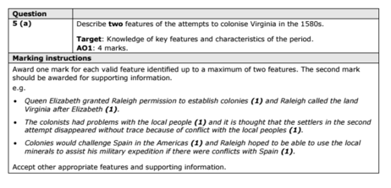

(b) Explain why the Throckmorton Plot (1583) was a threat to Queen Elizabeth. (12 marks)
You may use the following in your answer:
- Mary, Queen of Scots
- foreign threat
You must also use information of your own

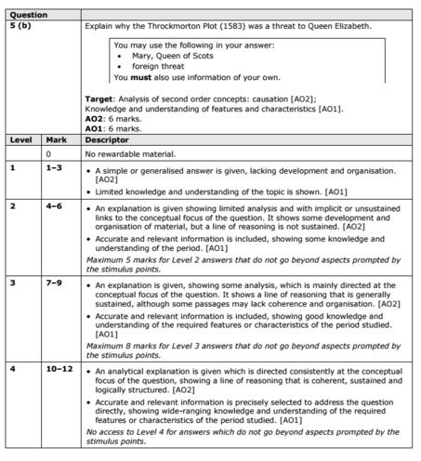

Answer EITHER (c)(i) OR (c)(ii)
EITHER
(c) (i) ‘The threat of invasion was Elizabeth’s main problem when she became queen in 1558.’ How far do you agree? Explain your answer.
(16 marks)
You may use the following in your answer:
- France
- Elizabeth’s legitimacy
You must also use information of your own.

OR
(c) (ii) ‘Religion was the main cause of the Revolt of the Northern Earls in 1569–70.’ How far do you agree? Explain your answer.
(16)
You may use the following in your answer:
- Catholic grievances
- the Earls of Northumberland and Westmorland
You must also use information of your own.

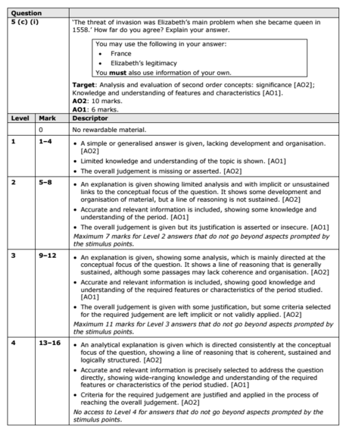
Trigger Memory Activity for challenges to Elizabeth at home and abroad 1569-88

Trigger Words | Trigger Picture | Add Trigger  Points from your notes
1 Overview of challenges facing Elizabeth at home and abroad.
2 Causes of the revolt of the Northern Earls
3 Significance of the revolt of the Northern Earls
4 Catholic Plot. Ridolfi Plot 1571.
5 Catholic Plot. Throckmorton Plot 1583.
6 Catholic Plot. Babington Plot 1586.
7 Work of Sir Francis Walsingham
8 The execution of Mary Queen of Scots 1587
9 Trade and commercial rivalry with Spain
10 Religious and political rivalry with Spain.
11 English intervention in the Netherlands and the role of Robert Dudley
12 Sir Francis Drake and the raid on Cadiz.
13 Spanish Armada. Plan and Tactics
14 Spanish Armada. Weather and Leadership
15 Spanish Armada. Resources

Trigger Memory Story challenges to Elizabeth at home and abroad 1569-88

The story must be very imaginative. It must involve you seeing, talking and doing things. It must link the ten trigger words together in the form of a continuous story. You should then rehearse the story and commit it to your long term memory to be recalled when necessary. This will take some effort but will be very useful! Use different colours to write the trigger words in your story.

I was on my way to a history lesson and on entering the room the clock began to go backwards, minutes, hours, days, months, years coming to a halt in 1569. Queen Elizabeth had been on the throne for 11 years now but many problems were beginning to arise

