KT1 TMA Queen, government and religion, 1558–69
Focus Points and Elements | Sub-elements | Key Picture | Key Narrative
F1 The situation on Elizabeth’s accession  Elizabethan Society 1558 | - Monarch  - Nobles  - Gentry  - Wealthy Merchants  - Yeoman and Tenant farmers  - Craftspeople, labourers, servants and the poor | 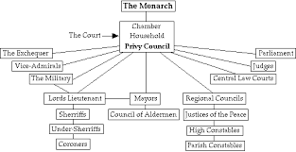 | Elizabethan society was extremely divided. The Monarch was the most powerful and influential but they needed the support of powerful noble landowners and and the increasingly wealthy gentry and merchant class in order to rule effectively. Below them were yeoman farmers and craftspeople. The labouring rural and urban poor were by far the biggest group characterised by poverty and powerlessness.
Elizabethan Government in 1558 | - The Monarch  - The Court and Privy Council  - The Law courts  - The Church  - Parliament | 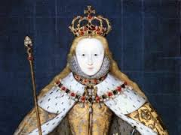 | Government was made up of the rich and powerful led by the Monarch who appointed the Court and Privy Council to govern the localities with the support of the Church and the law courts in each area. Parliament was made up of nobles and gentry and their role was advisory.
The problems facing the “Virgin Queen” | - 1 Catholic or Pro  - 2 Law  - 3 Privy Council  - 4 Succession  - 5 Foreign Policy  - 6 Her gender  - 7 Her Legitimacy |  | On her accession to power Elizabeth faced a range of difficult problems over religious problems and government appointments. The country was at war with France, and many questioned Elizabeth’s legitimacy and her gender in order to be an effective monarch.
Elizabeth’s character and strengths | - Her parents  - Education  - Danger  - Apprenticeship |  | Elizabeth mother was executed and In 1543, when Henry married his sixth wife Catherine Parr, she persuaded him to bring elizabeth back to court. She was extremely well educated but faced many dangers from Catholics and Puritans.
Elizabeth’s problem at home. | - Importance of the Privy council  - Elizabeth’s choices  - Elizabeth’s decisions |  | Choosing the Privy Councillors was a crucial task for Elizabeth. If she got it right, she would have a loyal team to help her run the country, if she got it wrong, she would have alienated some of the most powerful men in the country. The diagram below shows some of the issues she had to consider. She appointed William Cecil as Secretary of State.
Elizabeth’s financial weaknesses and creating peace and prosperity | - Financial weaknesses  - Creating peace and prosperity |  | In 1558, the royal finances had been severely strained by the war with France and Elizabeth inherited a debt of £300,000. In addition, most of the crown’s wealth came from land ownership, and the monarchy had suffered from the same problems as the other landowners in the sixteenth century.To strengthen the royal finances, Elizabeth severely cut back government spending right from the beginning of the reign, and strictly monitored the costs of her household.
Doubts about her ability, legitimacy and Marriage and Succession | - Doubts about whether a Queen could rule successfully  - The problem of legitimacy  - Problem of Marriage and succession  - Later marriage possibilities |  | Women rulers in the sixteenth century were seen as both unnatural and a liability; they did not fit with the ideal of womanhood described above. Even the Queen’s closest adviser,William Cecil,writing two years into the reign, told an ambassador off for discussing with Elizabeth,’a matter of such weight,being too much for a women's knowledge’. The problem of having a female ruler was made worse by the fact that some people did not believe that Elizabeth had a legitimate claim to the throne.People expected that Elizabeth would marry quickly and have children to provide the next Tudor monarch
Elizabeth’s challenges from abroad | - Scotland  - France  - Spain  - Choices and decision  - How great was the problem |  | When Elizabeth became Queen, Scotland was ruled by her cousin, Mary, Queen of Scots. In 1558, France was at war with both England and Spain. Spain was the most powerful and wealthy country in Europe. Elizabeth had made her decision quickly. Peace was signed with France in January 1559, just three months after she became Queen, in the Treaty of Cateau-Cambresis, and Calais was lost forever.
F2 The ‘settlement’ of religion  The importance of religion in Elizabethan England and religious divisions | - The story of Margaret Ward “Pearl of Tyburn”  - Religious divisions in 1558 | 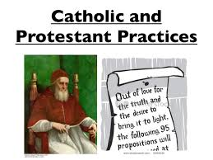 | The story of Margaret Ward shows that people in the sixteenth century were prepared to die for their religious beliefs. This made it very difficult for the new Queen to decide which religion the Church of England was going to be. Whatever she chose, some people were going to be angry and might even fight to change it. This explains why religion is central to your understanding to the entire period.
Elizabeth’s Four key issues about her Church she needed to decide | - 1 The Head of the Church and the Bishops  - 2 Decoration and music  - 3 The clergy  - 4 The Bible and Church services  - The Church of England and its role in Society | 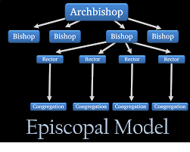 | On her accession to the throne Elizabeth had inherited a Catholic country and she faced key decisions immediately on reilgous matters. She had to make decisions on how the Church was organised and governed, how Church was decorated and experienced by people, who the Clergy would be, how Church services were run and the role of the Church in Elizabethan society.
Religious divisions faced by Elizabeth | - Warnings from the past  - Warnings from abroad  - Divisions amongst the English people  - Elizabeth’s dilemma  - Elizabeth’s early moves | 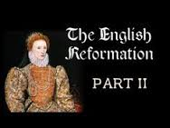 | England was religiously divided between Catholics, moderate Protestants and Puritans.  Elizabeth also had to weigh the effects each choice would have on England’s Relations with other countries. France, Spain and Scotland were all catholics in 1558. It may seem that a compromise was the obvious and easy solution. however , a compromise ran the risk of pleasing no one.As a committed Protestant, she could not accept Catholic doctrine and beliefs, or the pope as head of the Church of England..
Elizabeth’s Religious Settlement 1559 | - Elizabeth’s plans and actions  - Why did Elizabeth choose this settlement? | 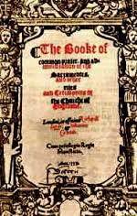 | Elizabeth and her Council spent the autumn of 1558 drawing up plans for a new Church; the the Queen called a meeting of Parliament in February in 1559. Parliament then passed the Acts of Supremacy and Uniformity, which established her government and doctrine of the new Church of England. England became a Protestant country again.
What was the new Church of England like? | - 1 Head of the Church and the Bishops  - 2 Church decoration and music  - 3 The Bible and Church services  - 4 The clergy | 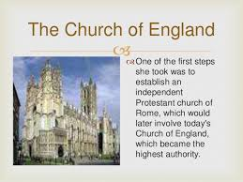 | Elizabeth, not the Pope, was now Head of the Church, but the title she gave himself was Supreme Governor. Ornaments and decoration were allowed in churches. The singing of hymns continued.The bible and church services had to be in English.  Every church had to have a Bible written in English.  A new protestant Prayer Book had to be used in every church. All clergy had to take an oath, recognising Elizabeth’s title and agreeing to use the new Prayer Book.
How Elizabeth won support for the new Church? | - Her image  - Church attendance  - Adding Accession Day to the calendar  - Licensing the clergy | 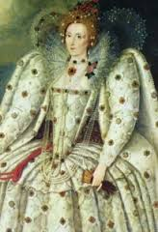 | Attracted support by describing herself as the saviour of Protestantism. Made attendance at church a test of loyalty to crown a country. Added her Accession Day to the calendar of Church festivals, so that a day of feasting, drinking and having fun would be associated with the Queen. She Licensed the clergy and told them what to say in their sermons.
F3 Challenge to the religious settlement.  Why did the Puritans challenge the Religious Settlement? | - Puritan attitudes to the new settlement  - Puritan actions  - Puritan divisions  - Elizabeth’s views of Puritans | 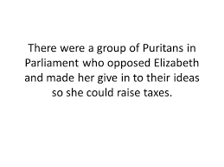 | Puritans did not believe in a head of the church  Puritans wanted to be run by committees elected by churchgoers rather than bishops  Puritans wanted the parish clergy to wear only plain black gowns. Puritans wanted very plain churches: whitewashed halls and no stained-glass windows, pictures or statues; plain tables instead of alters, and no music Puritans believed that the presence of jesus in the communion service was spiritual, not physical. Puritans were critical of Elizabeth.
Why did some Catholics challenge the Religious Settlement and how did she react? | - Strength of Catholicism outside London  - Catholic attitudes - acceptance  - Catholic attitudes - opposition  - Catholic attitudes - opposition abroad  - Elizabeth’s reaction to Catholic challenges | 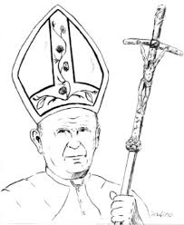 | The majority of people, certainly away from London and and the South-east, were still Catholic. They remained strongly attached to their local parish church, with its familiar appearance and services. The hugely powerful noble families, especially in the north, were also still Catholic, as were many gentry. In addition, there were 8,000 clergy from Mary I’s reign who had spent the last five years holding Catholic services. This suggests that there could of been mass opposition to Elizabeth’s Religious Settlement, but this did not happen.They believed in the doctrine of the Catholic church , especially in the Latin mass , and were not prepared to compromise . Many of this group regarded Elizabeth as an illegitimate heretic, the bastard daughter of Anne Boleyn , and wanted her replaced by Mary, Queen of Scots.
F4 The problem of Mary, Queen of Scots  Why was Mary Queen of Scots a problem? | - Mary Queen of Scots escapes to England with a problem.  - Mary Elizabeth’s heir  - Elizabeth’s options  - Mary, France and Scotland  - Mary’s marriages  - Mary and Catholic opponents of Elizabeth  - Mary in England  - Elizabeth’s dilemma | 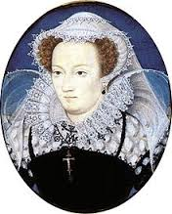 | In 1568 Mary fled from her enemies in Scotland and came to England where Elizabeth kept her under house arrest because she represented a major problem for the unity and support for her government. As long as Elizabeth remained childless, her heir was Mary. Mary was also a Catholic and had supporters in England as well as in France and Spain.Elizabeth could not accept the idea that she should execute her cousin, who, as yet, had not been involved in any attempt to overthrow Elizabeth. None of the options was ideal. As if often the case, Elizabeth did not choose the best option when she decided to imprison Mary. She chose the ‘least worst’ option- the option that seemed to have the fewest dangers.
What were relations between Elizabeth and Mary Queen of Scots like? | - Why it is difficult to answer this question  - Ups  - Downs  - Further down still | 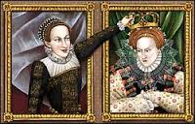 | The relationship between the two queens and cousins had its ups and downs over the years, although probably more downs than ups.  1568: The arrival of Mary in England, asking for Elizabeth’s help in regaining her throne, placed their relationships at an all-time low and put Elizabeth in an impossible position.  1569: Elizabeth’s preference was probably to restore Mary to throne, through negotiations, not war, and subject to certain conditions, such as that Mary should give up attempts to secure the English throne.  Her failure to do this was due partly to her councillors, who did not want Mary back in Scotland, and partly to Mary herself. From the time of her arrival onward. Mary proved to be a schemer, writing to France, Spain, the Pope and English Catholics.

KT1 TMA story “Queen, government and religion, 1558–69” linking the Focus Points and Elements.

The story must be very imaginative. It must involve you seeing, talking and doing things. It must link the eighteen focus points and elements together in the form of a continuous story. You should then rehearse the story and commit it to your long term memory to be recalled when necessary. This will take some effort but will be very useful! Use different colours to write the trigger words in your story.
Focus Points and Elements | My Elizabeth KT1 Trigger Memory Story…..arriving at history today I stepped through the door with X and saw the whole of ..
F1 1 Elizabethan Society 1558
2 Elizabethan Government in 1558
3 The problems facing the “Virgin Queen”
4 Elizabeth’s character and strengths
5 Elizabeth’s problem at home.
6 Elizabeth’s financial weaknesses p21 and creating peace and prosperity
7 Doubts about her ability, legitimacy and Marriage and Succession
8 Elizabeth’s challenges from abroad
F2 1 The importance of religion in Elizabethan England and religious divisions
2 Elizabeth’s Four key issues about her Church she needed to decide
3 Religious divisions faced by Elizabeth
4 Elizabeth’s Religious Settlement 1559
5 What was the new Church of England like?
6 How Elizabeth won support for the new Church?
F3 1 Why did the Puritans challenge the Religious Settlement?
2 Why did some Catholics challenge the Religious Settlement and how did she react?
F4 1 Why was Mary Queen of Scots a problem?
2 What were relations between Elizabeth and Mary Queen of Scots like?

Key Topic 1 Questionnaire

Focus 1. The situation on Elizabeth’s accession
Elizabethan England in 1558: society and government. The Virgin Queen: the problem of her legitimacy, gender, marriage. Her character and strengths. Challenges at home and from abroad: the French threat, financial weaknesses.

Pictures

Questions | Answers
1 How divided was Elizabethan Society 1558?
2 What were the main parts of Elizabethan Government in 1558?
3 What were the problems facing the “Virgin Queen”?
4 What were Elizabeth’s character and strengths?
5 What were Elizabeth’s problem at home?
6 What were Elizabeth’s financial weaknesses in 1558?
7 What were the doubts about her ability, legitimacy and Marriage and Succession?
8 What were Elizabeth’s challenges from abroad?

Focus 2. The ‘settlement’ of religion
Religious divisions in England in 1558. Elizabeth’s religious Settlement (1559): its features and impact. The Church of England: its role in society.

Pictures

Questions | Answers
1 F2 What was the importance of religion in Elizabethan England?
2 What were Elizabeth’s Four key issues about her Church she needed to decide upon?
3 What were the Religious divisions faced by Elizabeth?
4 What were the key elements of Elizabeth’s Religious Settlement 1559?
5 What was the new Church of England like?
6 How did Elizabeth win support for the new Church?

Focus 3. Challenge to the religious settlement
The nature and extent of the Puritan challenge. The nature and extent of the Catholic challenge, including the role of the nobility, Papacy and foreign powers.

Pictures

Questions | Answers
F3 Why did the Puritans challenge the Religious Settlement?
Why did some Catholics challenge the Religious Settlement and how did she react?

Focus 4. The problem of Mary, Queen of Scots
Mary, Queen of Scots: her claim to the English throne, her arrival in England in 1567. Relations between Elizabeth and Mary, 1567–69

Pictures

Questions | Answers
1 F4 Why was Mary Queen of Scots a problem?
2 What were relations between Elizabeth and Mary Queen of Scots like?

