KT1 TMA Germany 1918-39
Focus Points and Elements | Sub-elements | Key Picture | Key Narrative
1 The origins of  the Republic, 1918–19 | - The legacy of the First World War.  - The abdication of the Kaiser  - The armistice  - The revolution, 1918–19. | 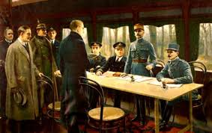 | On 9 November 1918, Kaiser Wilhelm II abdicated the German throne and fled to Holland. Germany became a republic and, two days later, the Armistice was signed bringing an end to fighting in the First World War (1914-18).
1 The origins of  the Republic, 1918–19 | - The setting up of the Weimar Republic.  - The strengths and weaknesses of the new Constitution. | 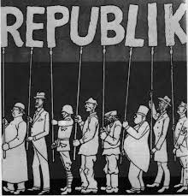 | Within a few months a new republic with a new constitution was set up. This new constitution was in many respects one of the most democratic in the world with a president as the head of state. However, it also included several features which were to contribute to the instability, weakness and eventual downfall of the Weimar Republic, particularly proportional representation and Article 48 which gave powers to the president in an emergency.
2 The early  challenges to  the Weimar  Republic,  1919–23 | - Reasons for the early unpopularity of the Republic, including the ‘stab in the back’ theory  - The key terms of the Treaty of Versailles. | 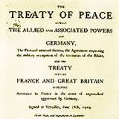 | The Treaty of Versailles imposed extremely severe terms on Germany. Germany lost 13 per cent of its land, 48 per cent of its iron production and more than 6 million citizens were absorbed into other countries. Perhaps the harshest term for Germany was Article 231- the War Guilt Clause. This stated that Germany had to accept blame for starting the war in 1914. This was compounded when the treaty denied Germany entry to the league of Nations, thus showing that Germany was a pariah.For most Germans, the Treaty stoked the fire of shame and humiliation. Versailles was nothing more than a dictated peace (Diluat). A scapegoat was needed - and Ebert, the Weimar Government and its politicians fitted the bill and people began to call them the November Criminals.
2 The early  challenges to  the Weimar  Republic,  1919–23 | - Challenges to the Republic from Left and Right: Spartacists,  - Freikorps, the Kapp Putsch. | 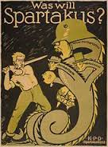 | At the same time that Ebert and Scheidemann were trying to establish a new government in Germany, there was political turmoil across the country. In its early years, the Weimar Republic faced constant threats from the left and right and there were several uprisings across Germany that threatened the existence of the Government. It seemed that the Weimar Government could not win. Its politicians were criticised for ending the war, accepting the Treaty of Versailles and then introducing high taxes for the better off in society in order to meet the Allied reparations.
2 The early  challenges to  the Weimar  Republic,  1919–23 | - The challenges of 1923: hyperinflation;  - the reasons for, and effects of, the French occupation of the Ruhr. | 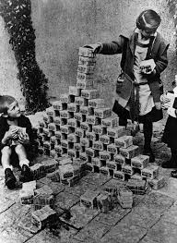 | The problems facing the Weimar Republic worsened in 1923 due to the French occupation of the Ruhr and the effects of hyperinflation. When the reparations figure was announced - £6,600 million at £100 million per year- the Weimar Government claimed that it could not pay. The value of the German currency started to fall rapidly and, because no reparations were paid, France sent troops into the Ruhr.
3 The recovery  of the Republic,  1924–29 | - Reasons for economic recovery, including the work of Stresemann, the Rentenmark,  - The Dawes Plan 1924  - The Young Plan 1929 and American loans and investment. | 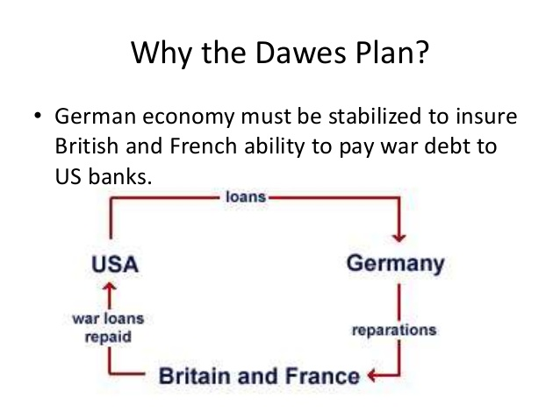 | Following the crises of 1923, including the French occupation of the Ruhr and hyperinflation, Germany seemed to experience a period of recovery at home and abroad under the direction of Gustav Stresemann and with the assistance of American loans. This, in turn, seemed to encourage greater support for the Weimar Republic and less support for extremist parties such as the Nazis and Communists.German recovery was largely due to the work of Gustav Stresemann, who was able co work successfully with Britain, France and the USA co improve Germany's economic and international position
3 The recovery  of the Republic,  1924–29 | - The impact on domestic policies of Stresemann’s achievements abroad:  - The Locarno Pact  - Joining the League of Nations  - The Kellogg-Briand Pact. | 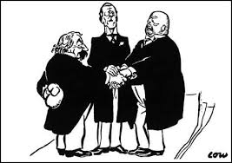 | Stresemann realised that France needed to feel secure in order to co-operate over changes in the Versailles peace treaty. Therefore, in 1925 Germany signed the Locarno Pact with Britain, France, Belgium and Italy. In 1928 Germany signed the Kellogg-Briand Pact along with 64 other nations. It was agreed that they would keep their armies for self-defence and solve all international disputes 'by peaceful means'.
4 Changes in society, 1924–29 | - Changes in the standard of living, including wages, housing,  - Unemployment insurance. | 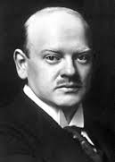 | During this period, German workers did, to a certain extent, benefit from increases in the value of real wages. By 1928 there had been an increase in real wages of over ten per cent which meant Germany had workers some of the best-paid workers in Europe. However, many of the middle class did not share in this increased prosperity. These changes in real wages were of little benefit to the middle classes, many of who had been bankrupted by the hyperinflation of 1923.
4 Changes in society, 1924–29 | - Changes in the position of women in work, politics and leisure. |  | In 1919, women over 20 years old were given the vote and took an increasing interest in politics. The Weimar Constitution also introduced equality in education for the sexes, equal opportunity in civil service appointments and equal pay in the professions. By the end of this period, German women had some of the most advanced legal rights of any country in Europe. Furthermore, by 1926 there were 32 women deputies in the Reichstag, which was a higher proportion than the number in Britain and the USA. The proportion of women who took up work outside the home remained much the same during the Weimar Republic. Women enjoyed much more freedom socially than had been the case before the Weimar Republic. They went out unescorted, drank and smoked in public, were fashion conscious, often wearing relatively short skirts, had their hair cut short and wore make-up.
4 Changes in society, 1924–29 | - Cultural changes: developments in architecture, art and the cinema. | 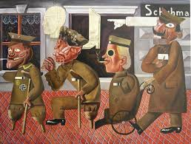 | This period saw the emergence of some of the most exciting art and culture in Europe. The strict p re-war censorship was removed. Throughout the 1920s, Berlin challenged Paris as the cultural capital of Europe, with new and significant developments in painting, cinema, architecture, literature and theatre. However, this led to criticism that artists were undermining traditional German values, especially from right-wing politicians such as Hitler. They said these cultural changes were un-German and immoral.

Trigger Memory Story Medicine 50-1350

The story must be very imaginative. It must involve you seeing, talking and doing things. It must link the ten trigger words together in the form of a continuous story. You should then rehearse the story and commit it too your long term memory to be recalled when necessary. This will take some effort but will be very useful! Use different colours to write the trigger words in your story.

I was...

