KT1 TMA The origins of the Cold War, 1941–58.

Focus Points and Elements | Sub-elements | Key Picture | Key Narrative
Focus 1. Early tension between East and West  The Grand Alliance and the Tehran Conference November 1943. | - Allies  - Stalin, Roosevelt and Churchill  - The Tehran Conference November 1943 | 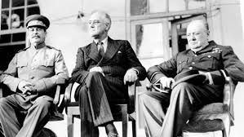 | US and USSR had been allies in WW2 to defeat the Nazis in Europe. Roosevelt, Stalin and Churchill recognised that they shared a common interest in opposing Nazism whilst acknowledging that they may have different ideologies and security interests that might divide them when it came to make the decisions about who would have control and influence in Europe after the war. The Tehran conference 1943 confirmed this situation.
The outcomes of the Yalta and Potsdam Conferences. | - The Yalta Conference February 1945  - The Potsdam Conference July 1945  - Agreements made at Potsdam  - Disagreements made at Potsdam | 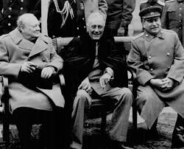 | The Yalta and Potsdam Conferences of February and July 1945. There was some broad base agreements made at each with regard to acknowledging the need to consider each others interests in the post war settlement but there was disagreement with regard to how Germany should be governed and how strong it should be and also with regard to how to organise and administer elections in Eastern European countries occupied by Soviet military forces. This would cause a great deal of tension between US and USSR in the European dimension of the Cold War.
The ideological differences between the superpowers and the attitudes of Stalin, Truman and Churchill. | - Ideological differences - Communist countries  - Ideological differences - Capitalist countries | 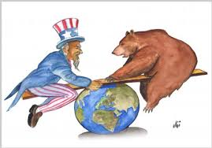 | US had been a democratic Republic since 1776 with Capitalist economy whilst Russia had been the first country to have a Communist revolution in 1917. Political differences were between a US democratic system compared to a Russian one party state. The Americas had a free market economy of private business ownership whereas the USSR had a state controlled economy. Both powers sought to extend their power and influence in the post war world along with ensuring each others security from the mutual suspicion and anxiety the held for each other
The impact on US-Soviet relations of the development of the atomic bomb, the Long and Novikov telegrams. | - Arms race and Space race  - The Long Telegram  - The Novikov Telegram  - The impact on US-Soviet relations and the Iron Curtain speech | 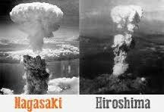 | In 1945 US developed the first Nuclear bomb. By 1949 the USSR had developed one too and competition to get more powerful and plentiful bombs led to Hydrogen bomb technology in the 1950’s and the development of rocket base delivery systems and the emergence of a space race after USSR launched the worlds first satellite in 1957. Kenans Long Telegram and Novikovs Telegram essentially confirmed each others hostility by 1947 and made more probable the division of Europe into a USSR dominated Eastern Europe and a US dominated Western Europe.
The creation of Soviet satellite states in Eastern Europe | - Soviet Expansion  - The pattern of establishing satellite states  - Poland  - Romania  - Hungary  - Bulgaria  - Czechoslovakia  - Yugoslavia | 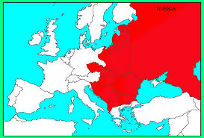 | Having freed much of eastern europe from the Nazis, the Red army remained in occupation and the Soviet Union established communist governments in countries that were closely controlled from Moscow. These countries became known as Satellite states. The same pattern was followed in each country:  - Coalition governments were set up in which the communists shared power.  - Backed by Stalin, the communists took over the civil service, media, and security..  - Opposition leaders were arrested  - Elections were held, but were fixed to ensure support for the communists.  - ‘People’s democracies’ were set up.
Focus 2. The development of the Cold War  The impact on US-Soviet relations of the Truman Doctrine and the Marshall Plan, 1947. | - The Truman Doctrine 1947  - The Truman Doctrine. The consequences  - Marshall Aid. Why was it introduced?  - Marshall Aid. The consequences  - Marshall Aid. Soviet reaction. | 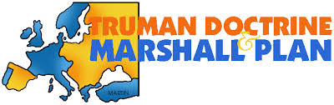 | In 1947 Truman began a US policy of containment. This meant using US influence and military resources to prevent the expansion of communism into non-communist countries. Truman introduced this policy because the US, and especially Truman, believed that the soviet union was trying was trying to spread communism - first through eastern Europe and then to the west and beyond. Truman backed up his policy of containment with economic aid to Europe, the plan, officially called the European recovery plan but nicknamed the ‘Marshall plan’ was announced by the US secretary of state, general George Marshall,
The significance of Cominform (1947), Comecon (1949) and the formation of NATO (1949). | - Cominform 1947  - Comecon 1949  - North Atlantic Treaty Organization and consequences  - (NATO) | 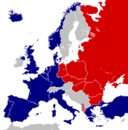 | The Communist information Bureau was set up in 1947 to enable the Soviet union to coordinate parties throughout Europe. It was the Soviet Union’s response to the Truman Doctrine. The council for Mutual assistance (comecon), founded in 1949, was the Soviet response to the Marshall plan.It was supposed to be a means by which the Soviet Union could financially support countries in eastern Europe. The Berlin crisis had confirmed Truman’s commitment to western Europe, However, western Europe states, even joined together, were no match for the Soviet Union and needed the formal support of the USA, in April 1949 the North Atlantic Treaty Organization was signed NATO.
Berlin: its division into zones and the Berlin Crisis (blockade and airlift) and its impact. | - Long term causes of the crises  - Short term causes of the crises  - Stages of the crises 1948  - The Berlin airlift | 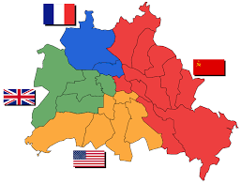 | During the peace conferences of 1945, the Allies had agreed to divide Germany and Berlin into four zones of occupation. Germany however, was supposed to be kept as one country and to hold free elections. Almost immediately there were differences between the Soviet and Western zones. 24 June 1948- Stalin accused the West of interfering in the Soviet zone. He cut off road, rail, and canal traffic in an attempt to starve West Berlin, Stalin was trying to force the Allies to pull out of their sectors and abandon plans for separate development on their German Zones. The airlift began on 28th June 1948 and lasted for 10 months. The British codenamed it ‘Operation Plainfare’. It was the start of the biggest airlift in history. On 12 May 1949 Stalin called off the Blockade, He had failed to starve the Allies out of Berlin. That evening berliners put on evening dress and danced in the streets.
The formation of the Federal Republic of Germany and German Democratic Republic. | - Results of the crisis  - A divided Germany  - East West rivalry | 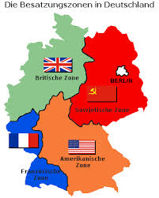 | The crisis had three major effects  -it confirmed the divisions of Germany and Berlin.  -it greatly increased East-west rivalry.  -it led to the creation of NATO  Germany was now clearly divided. Within a few days of the end of the Berlin crises, in May 1949, the Western allies announced that their former occupation zones, including west Berlin, would join together to form the Federal Republic of Germany (FRG). Stalin’s response was rapid and in October 1949 the Soviet zone became the German Democratic Republic
Focus 3. The Cold War intensifies  The significance of the arms race and the formation of the Warsaw Pact. | - The Warsaw Pact 1955  - The arms race  - Superpowers arms spending  - Weaponry by 1961  - The impact of sputnik | 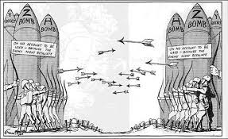 | Within six years of NATO being formed the Soviet Union had set up the Warsaw Pact. Now that both the USA and the Soviet Union had the same atomic bomb, they both began to pour money into projects to build more and bigger bombs and new delivery systems. There was some hope that the two superpowers would slow down their arms development, but in 1957 the situation changed completely when a soviet rocket launched sputnik, a satellite which could orbit the earth in one and a half hours. The USA saw this launch as a military threat.
Events in 1956 leading to the Hungarian Uprising. | - Hungary after 1945  - Impact of Soviet control  - The rule of Rakosi  - Key events of the Hungarian uprising | 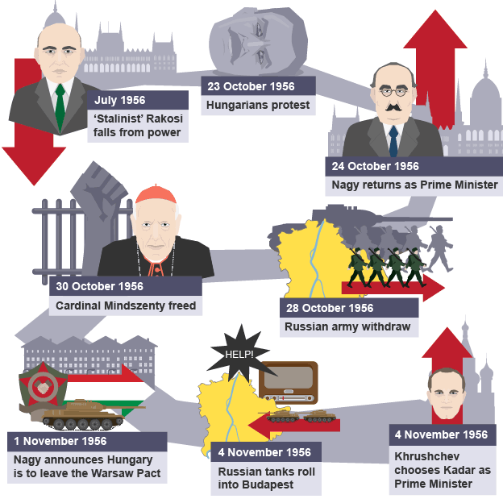 | 1953 March- death of stalin, Rakosi replaced by Imre Nagy as Hungary’s prime minister.  1955 April- Nagy replaced by Rakosi.  may- creation of the Warsaw Pact.  1956 February- khrushchev’s ‘secret speech’.  july - Rakosi forced from power on the orders of Moscow and succeeded by his close friend Erno Gero.  October - victims of Rakosis purges were re-burled.  23 October- students demonstrated in Budapest, the capital of Hungary, demanding free elections, free pass and the withdrawal of Soviet troops, Statue of Stalin was pulled down in Budapest and dragged through the streets.
The Hungarian Uprising and Khrushchev’s response. | - The demands of Nagy and the rebels  - Krushchev’s response to the uprising  - Events of the invasion  - Results of the uprising | 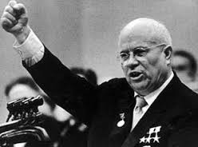 | Khrushchev was anxious not to be seen as weak by other members of the Warsaw pact. Furthermore, Mao Zedong, the chinese leader,was urging him to stand firm against any deviation from communism. Khrushchev decided that Nagy had gone too far, and on the the 4th of november, 200,000 Soviet troops and 6,000 tanks returned to Hungary, Figure 3.5 below summarises the reasons for the Soviet invasion. Soviet troops were easily able to defeat the Hungarian rebels, but at a cost. About 7,000 of them were killed, though the rebels lost at least 20,000. About 200,000 Hungarians fled the country during the uprising, with many becoming political refugees.
The international reaction to the Soviet invasion of Hungary. | - The West’s response  - UN response  - Soviet response | 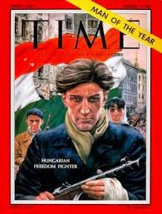 | There was very little the the West, especially the USA and Britain, could do to help the Hungarians, apart from condemn the actions of the Soviet Union and stage demonstrations in support of the Hungarian protestors(see source I, page 37). Hungary was too far away for military intervention and, with the development of the arms race there was also the threat of nuclear war. In addition, the Suez crisis meant that it was now difficult for the west to criticise similar actions from the Soviet Union in hungary. The Un convened a special inquiry into the events of October-November 1956, but both the Hungarian and Soviet government refused to participate. The inquiry resulted in a condemnation of the Kadar regime, but no other action or significant findings. The Soviet Union had maintained its empire and sent out a warning to any satellite state thinking of breaking away. Khrushchev's policy of de-Statlisinisation would only go as far as he wanted it to. Poland and Hungary made only slow and gradual reforms after 1956 and remained firmly under the yoke of the Soviet Union. The West saw Khrushchev’s recent messages of peace as a sham.

KT1 TMA story “Cold War” linking the Focus Points and Elements.
The story must be very imaginative. It must involve you seeing, talking and doing things. It must link the ten trigger words together in the form of a continuous story. You should then rehearse the story and commit it to your long term memory to be recalled when necessary. This will take some effort but will be very useful! Use different colours to write the trigger words in your story.

Focus Points and Elements | My Cold war KT1 Trigger Memory Story…..arriving at history today I stepped through the door with X and...
Focus 1. Early tension between East and West
The Grand Alliance and the Tehran Conference November 1943.
The outcomes of the Yalta and Potsdam Conferences.
The ideological differences between the superpowers and the attitudes of Stalin, Truman and Churchill.
The impact on US-Soviet relations of the development of the atomic bomb, the Long and Novikov telegrams.
The creation of Soviet satellite states in Eastern Europe
Focus 2. The development of the Cold War
The impact on US-Soviet relations of the Truman Doctrine and the Marshall Plan, 1947.
The significance of Cominform (1947), Comecon (1949) and the formation of NATO (1949).
Berlin: its division into zones and the Berlin Crisis (blockade and airlift) and its impact.
The formation of the Federal Republic of Germany and German Democratic Republic.
Focus 3. The Cold War intensifies
The significance of the arms race and the formation of the Warsaw Pact.
Events in 1956 leading to the Hungarian Uprising.
The Hungarian Uprising and Khrushchev’s response.
The international reaction to the Soviet invasion of Hungary.

Key Topic 1 Questionnaire

Focus 1. Early tension between East and West
The Grand Alliance. The outcomes of the Tehran, Yalta and Potsdam conferences. The ideological differences between the superpowers and the attitudes of Stalin, Truman and Churchill. The impact on US-Soviet relations of the development of the atomic bomb, the Long and Novikov telegrams and the creation of Soviet satellite states in Eastern Europe.

Pictures

Focus 1. Early tension between East and West
What was the outcome of Grand Alliance and the Tehran Conference November 1943?
What was the outcome of the Yalta Conference?
What was the outcome of the Potsdam Conference?
What were the ideological differences between the superpowers and the attitudes of Stalin, Truman and Churchill?
What was the impact on US-Soviet relations of the development of the atomic bomb, the Long and Novikov telegrams?
Where and how were Soviet satellite states created in Eastern Europe?

Focus 2. The development of the Cold War
The impact on US-Soviet relations of the Truman Doctrine and the Marshall Plan, 1947. The significance of Cominform (1947), Comecon (1949) and the formation of NATO (1949). Berlin: its division into zones. The Berlin Crisis (blockade and airlift) and its impact. The formation of the Federal Republic of Germany and German Democratic Republic.

Pictures

Focus 2. The development of the Cold War
What was the impact on US-Soviet relations of the Truman Doctrine and the Marshall Plan, 1947?
What was the significance of Cominform (1947), Comecon (1949) and the formation of NATO (1949)?
How was Berlin divided and what was the Berlin Crisis (blockade and airlift) and its impact?
Describe the formation of the Federal Republic of Germany (FRG) and German Democratic Republic (GDR).

Focus 3. The Cold War intensifies
The significance of the arms race and the formation of the Warsaw Pact. Events in 1956 leading to the Hungarian Uprising, and Khrushchev’s response. The international reaction to the Soviet invasion of Hungary.

Pictures

Focus 3. The Cold War intensifies
Explain the significance of the arms race and the formation of the Warsaw Pact.
What were the events in 1956 leading to the Hungarian Uprising?
What was the Hungarian Uprising and Khrushchev’s response?
Explain the international reaction to the Soviet invasion of Hungary.

