Key Topic 1. Queen, government and religion, 1558–69
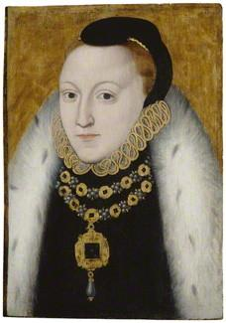

This portrait was probably painted just after Elizabeth's accession. It has a formulaic quality that suggests it was not painted from the life. It was probably one of many versions executed to fulfil a demand for the queen's likeness in the early years of her reign when she was still expected to enter into marriage and before she became associated with the more complex emblems of virginity that are often found in later portraits. Recent technical analysis has shown that the background was originally a vibrant shade of blue which has discoloured to a yellowish brown over time. This is due to the presence of an unstable blue pigment called 'smalt'. The inscription 'ELIZABETH REGINA' would therefore have originally stood out more clearly against the background. The Queen's features have been sketched out over a pale pink ground and then painted over in one thin layer. Some of the under drawing is still just visible beneath the paint layer. It may have hung originally as part of a group of royal portraits acting as a painted record of English monarchy.

Content
In a Nutshell: Overview of developments Queen, government and religion, 1558–69

Causes and Analysis of Queen Elizabeth, government and religion 1558-69, including:

Focus 1. The situation on Elizabeth’s accession Hodder p12-29
Elizabethan England in 1558: society and government. The Virgin Queen: the problem of her legitimacy, gender, marriage. Her character and strengths. Challenges at home and from abroad: the French threat, financial weaknesses.

Focus 2. The ‘settlement’ of religion Hodder p9-11, p24-25, p30-31
Religious divisions in England in 1558. Elizabeth’s religious Settlement (1559): its features and impact. The Church of England: its role in society.

Focus 3. Challenge to the religious settlement Hodder p31-35
The nature and extent of the Puritan challenge. The nature and extent of the Catholic challenge, including the role of the nobility, Papacy and foreign powers.

Focus 4. The problem of Mary, Queen of Scots Hodder p36-40
Mary, Queen of Scots: her claim to the English throne, her arrival in England in 1567. Relations between Elizabeth and Mary, 1567–69

Cracking the Puzzle – Preparing for assessment.

Language and Literacy
Key Terms and their meanings in Queen Elizabeth, government and religion 1558-69
Key Terms and their meanings in Queen Elizabeth, government and religion 1558-69

(I) In a Nutshell: Overview of Queen Elizabeth, government and religion 1558-69

Content overview

(II) Causes and Analysis of developments:
Activity 1 – On your marks…..
The timeline grid sums up developments between 1558-69. It covers Queen Elizabeth’s government and religion.

Activity 2 – Get set…..
Your teacher will give you an A3 copy of a concept map. Stick it in your book. You will fill sections in at the end of each key focus area. As well as adding information to your concept map you can add a colour scheme to identify key themes.

Activity 3 – Go…..
As well as the lesson work and activities, read your book independently and visit the library. There are also many excellent websites listed in the back of this booklet to check out. Try to develop your own individual interest in this area of focus .

Focus 1. The situation on Elizabeth’s accession
Elizabethan England in 1558: society and government. The Virgin Queen: the problem of her legitimacy, gender, marriage. Her character and strengths. Challenges at home and from abroad: the French threat, financial weaknesses.
Activity 1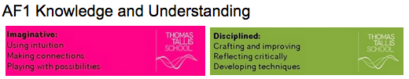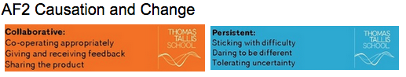
Elizabethan Society in 1558 p12
Elizabethan Society in 1558
Monarch
Nobles
Gentry
Wealthy Merchants
Yeoman and Tenant farmers
Craftspeople, labourers, servants and the poor

Activity 2
Elizabethan Government in 1558 p13
Elizabethan Government in 1588
The Monarch
The Court and Privy Council
The Lawcourts
The Church
Parliament

Activity 3
The problems facing the “Virgin Queen” in 1558 p16
The problems facing the “Virgin Queen” in 1558
Problem 1
Problem 2
Problem 3
Problem 4
Problem 5
Problem 6
Problem 7

Activity 4
Elizabeth’s character and strengths p17
Elizabeth’s character and strengths
Her parents
Education
Danger
Apprenticeship

Activity 5
Elizabeth’s problem at home. Choosing her councillors
Elizabeth’s problem at home. Choosing her councillors
Importance of the Privy council
Elizabeth’s choices
Elizabeth’s decisions

Activity 6
Elizabeth’s financial weaknesses p21 and creating peace and prosperity p28
Elizabeth’s financial weaknesses and creating peace and prosperity
Financial weaknesses
Creating peace and prosperity

Activity 7
Doubts about her ability, legitimacy and Marriage and Succession p26-27
Doubts about her ability, legitimacy and Marriage and Succession
Doubts about whether a Queen could rule successfully
The problem of legitimacy
Problem of Marriage and succession
Later marriage possibilities

Activity 8
Elizabeth’s challenges from abroad p22-23
Elizabeth’s challenges from abroad
Scotland
France
Spain
Choices and decision
How great was the problem

Activity 9

SECTION B: Tudor depth options
Answer EITHER Question 4 OR Question 5. Do question 5, which is Option B4!

Option B4: Early Elizabethan England 1558–88
Answer Question 5(a), 5(b) and EITHER 5(c)(i) OR 5(c)(ii).
5 (a) Describe two features of the problems facing Elizabeth. 4 marks

(b) Explain why the challenges from abroad was a threat to Queen Elizabeth. (12 marks)
You may use the following in your answer:
- Mary, Queen of Scots
- Relations with France and Spain
You must also use information of your own

Answer EITHER (c)(i) OR (c)(ii)
EITHER
(c) (i) ‘The threat of invasion was Elizabeth’s main problem when she became queen in 1558.’ How far do you agree? Explain your answer.
(16 marks)
You may use the following in your answer:
- France
- Elizabeth’s legitimacy
You must also use information of your own.

OR
(c) (ii) ‘Financial problems were the main cause of Elizabeth’s difficulties when she became queen.’ How far do you agree? Explain your answer.
(16)
You may use the following in your answer:
- Catholic grievances
- The problems of Elizabeth’s legitimacy, marriage and the succession
You must also use information of your own.

Focus 2. The ‘settlement’ of religion
Religious divisions in England in 1558. Elizabeth’s religious Settlement (1559): its features and impact. The Church of England: its role in society.
Activity 1
The importance of religion in Elizabethan England and religious divisions p9-10
The importance of religion in Elizabethan England and religious divisions
The story of Margaret Ward “Pearl of Tyburn”
Religious divisions in 1558

Activity 2
Elizabeth’s Four key issues about her Church she needed to decide. p10-11
 | Elizabeth’s Four key issues about her Church she needed to decide
1 The Head of the Church and the Bishops | Catholics  Protestants  Puritans
2 Decoration and music | Catholics  Protestants  Puritans
3 The clergy | Catholics  Protestants  Puritans
4 The Bible and Church services | Catholics  Protestants  Puritans
The Church of England and its role in Society

Activity 3
Religious divisions faced by Elizabeth p24-25
 | Religious divisions faced by Elizabeth
Warnings from the past
Warnings from abroad
Divisions amongst the English people | Support for Catholicism  Support for Protestantism
Elizabeth’s dilemma
Elizabeth’s early moves

Activity 4
Elizabeth’s Religious Settlement 1559 p30
Elizabeth’s Religious Settlement 1559
Elizabeth’s plans and actions
Why did Elizabeth choose this settlement?

Activity 5
What was the new Church of England like? p31
 | What was the new Church of England like?
1 Head of the Church and the Bishops | What Elizabeth ordered in the Religious Settlement of 1559  What was the impact?
2 Church decoration and music | What Elizabeth ordered in the Religious Settlement of 1559  What was the impact?
3 The Bible and Church services | What Elizabeth ordered in the Religious Settlement of 1559  What was the impact?
4 The clergy | What Elizabeth ordered in the Religious Settlement of 1559  What was the impact?

Activity 6
How Elizabeth won support for the new Church?p31
How Elizabeth won support for the new Church?
Her image
Church attendance
Adding Accession Day to the calendar
Licensing the clergy

Activity 7

SECTION B: Tudor depth options
Answer EITHER Question 4 OR Question 5. Do question 5, which is Option B4!

Option B4: Early Elizabethan England 1558–88
Answer Question 5(a), 5(b) and EITHER 5(c)(i) OR 5(c)(ii).
5 (a) Describe two features of the Religious Settlement of 1559. 4 marks

(b) Explain the impact of Elizabeth’s Religious Settlement on the Church of England. (12 marks)
You may use the following in your answer:
- Orders for the Bishops and the Clergy
- The Bible, Church services and decoration
You must also use information of your own

Answer EITHER (c)(i) OR (c)(ii)
EITHER
(c) (i) ‘The threat of invasion was Elizabeth’s main problem when she became queen in 1558.’ How far do you agree? Explain your answer.
(16 marks)
You may use the following in your answer:
- France and Spain
- Religious Divisions
You must also use information of your own.

OR
(c) (ii) ‘Religion was the main cause of Elizabeth’s problems.’ How far do you agree? Explain your answer.
(16)
You may use the following in your answer:
- Catholic grievances at home and abroad
- Financial problems
You must also use information of your own.

Focus 3. Challenge to the religious settlement
The nature and extent of the Puritan challenge. The nature and extent of the Catholic challenge, including the role of the nobility, Papacy and foreign powers.
Activity 1
Why did the Puritans challenge the Religious Settlement? p32-33
 | Why did the Puritans challenge the Religious Settlement?
Puritan attitudes to the new settlement | 1 The Queen as Supreme Governor  Puritans thought that  2 Bishops running the Church  Puritans thought that  3 Religious robes like vestments  Puritans thought that  4 The Catholic appearance of the new Church  Puritans thought that  5 Some of the wording of the new Prayer Book  Puritans thought that
Puritan actions | Despite their disappointment many Puritans hoped
Puritan divisions | Puritans tried to persuade Elizabeth
Elizabeth’s views of Puritans | 1  2  3  4  5

Activity 2
Why did some Catholics challenge the Religious Settlement and how did she react? p34-35
Why did some Catholics challenge the Religious Settlement and how did she react?
Strength of Catholicism outside London
Catholic attitudes - acceptance
Catholic attitudes - opposition
Catholic attitudes - opposition abroad
Elizabeth’s reaction to Catholic challenges

Activity 3

SECTION B: Tudor depth options
Answer EITHER Question 4 OR Question 5. Do question 5, which is Option B4!

Option B4: Early Elizabethan England 1558–88
Answer Question 5(a), 5(b) and EITHER 5(c)(i) OR 5(c)(ii).
5 (a) Describe two features of the challenge to the Religious Settlement of 1559. 4 marks

(b) Explain why Religious divisions was a threat to Queen Elizabeth. (12 marks)
You may use the following in your answer:
- Challenge of the Catholics at home and abroad
- Challenge of the Puritans
You must also use information of your own

Answer EITHER (c)(i) OR (c)(ii)
EITHER
(c) (i) ‘The threat of invasion was Elizabeth’s main problem when she became queen in 1558.’ How far do you agree? Explain your answer.
(16 marks)
You may use the following in your answer:
- France and Spain
- Religious divisions
You must also use information of your own.

OR
(c) (ii) ‘Religion was the main cause of Elizabeth’s problems.’ How far do you agree? Explain your answer.
(16)
You may use the following in your answer:
- Catholic and Puritan grievances at home
- Challenges from abroad
You must also use information of your own.

Focus 4. The problem of Mary, Queen of Scots
Mary, Queen of Scots: her claim to the English throne, her arrival in England in 1567. Relations between Elizabeth and Mary, 1567–69
Activity 1
Why was Mary Queen of Scots a problem? p36-39
Why was Mary Queen of Scots a problem?
Mary Queen of Scots escapes to England with a problem.
Mary Elizabeth’s heir
Elizabeth’s options
Mary, France and Scotland
Mary’s marriages
Mary and Catholic opponents of Elizabeth
Mary in England
Elizabeth’s dilemma

Activity 2
What were relations between Elizabeth and Mary Queen of Scots like? p40
What were relations between Elizabeth and Mary Queen of Scots like?
Why it is difficult to answer this question
Ups
Downs
Further down still

Activity 3

SECTION B: Tudor depth options
Answer EITHER Question 4 OR Question 5. Do question 5, which is Option B4!

Option B4: Early Elizabethan England 1558–88
Answer Question 5(a), 5(b) and EITHER 5(c)(i) OR 5(c)(ii).
5 (a) Describe two features of Elizabeth’s Religious problems. 4 marks

(b) Explain why Mary Queen of Scots was a threat to Queen Elizabeth. (12 marks)
You may use the following in your answer:
- Mary as heir and her marriages
- Mary and the foreign threat
You must also use information of your own

Answer EITHER (c)(i) OR (c)(ii)
EITHER
(c) (i) ‘The threat of invasion was Elizabeth’s main problem when she became queen in 1558.’ How far do you agree? Explain your answer.
(16 marks)
You may use the following in your answer:
- France
- Elizabeth’s legitimacy
You must also use information of your own.

OR
(c) (ii) ‘Religion was the main cause of Elizabeth’s problems.’ How far do you agree? Explain your answer.
(16)
You may use the following in your answer:
- Catholic and Puritan grievances
- Mary Queen of Scots
You must also use information of your own.

(III) Assessment for Learning
Puzzle practise : X

In the puzzle 5A AND B will be compulsory questions and either C i or ii will be optional questions covering the core content. The content will come from either one or a combination of the key themescovered in each of the key questions;

The following examples are focussed on content from ..

Exam Practise
SECTION B: Tudor depth options
Answer EITHER Question 4 OR Question 5. Do question 5, which is Option B4!

Option B4: Early Elizabethan England 1558–88
Answer Question 5(a), 5(b) and EITHER 5(c)(i) OR 5(c)(ii).
5 (a) Describe two features of X. 4 marks

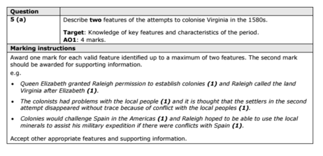

(b) Explain why X was a threat to Queen Elizabeth. (12 marks)
You may use the following in your answer:
- Mary, Queen of Scots
- foreign threat
You must also use information of your own

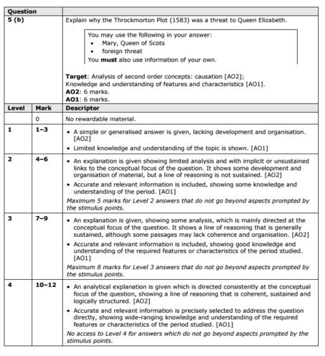

Answer EITHER (c)(i) OR (c)(ii)
EITHER
(c) (i) ‘The threat of invasion was Elizabeth’s main problem when she became queen in 1558.’ How far do you agree? Explain your answer.
(16 marks)
You may use the following in your answer:
- France
- Elizabeth’s legitimacy
You must also use information of your own.

OR
(c) (ii) ‘Religion was the main cause of Elizabeth’s problems 1558-69.’ How far do you agree? Explain your answer.
(16)
You may use the following in your answer:
- Catholic and Puritan grievances
- Mary Queen of Scots
You must also use information of your own.

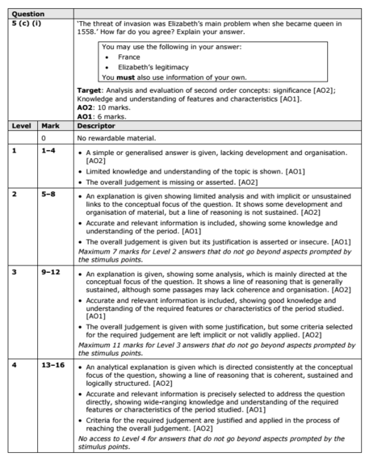

Trigger Memory Activity for Queen, government and religion, 1558–69

Trigger Words | Trigger Picture | Add Trigger  Points from your notes
1 Elizabethan Society
2 Elizabethan Government
3 Problems facing the Virgin Queen
4 Elizabeth’s character and strengths
5 Problems at Home. Councillors
6 Financial weakness and Economy
7 Doubt about legitimacy, Marriage and Succession
8 Challenges from abroad
9 Importance of Religion
10 Four key religious decisions
11 Religious Settlement of 1559
12 The new Church of England
13 Puritan challenge and reaction
14 Catholic challenge and reaction
15 Mary Queen of Scots as a problem
16 Elizabeth’s relations with Mary

Trigger Memory Story 1 : Queen, government and religion, 1558–69

The story must be very imaginative. It must involve you seeing, talking and doing things. It must link the ten trigger words together in the form of a continuous story. You should then rehearse the story and commit it to your long term memory to be recalled when necessary. This will take some effort but will be very useful! Use different colours to write the trigger words in your story.

I was on my way to a history lesson and on entering the room the clock began to go backwards, minutes, hours, days, months, years coming to a halt in 1558. Elizabeth succeeded her half sister Mary as Queen of England and I could see that she immediately faced a range of issues. Society (1) for example..

