Trigger Memory Activity for Medicine 1250-1500
Trigger Words | Trigger Picture | Add Trigger Points from your notes
Factors of Change |  | Individuals  Ideas  Government  Science and Technology  War  Education
Factors of continuity |  | Individuals  Ideas  Government  Science and Technology  War  Education
Overview. Focus 1 What did people think caused disease 1250-1500. |  | If you were sick, you might have thought God had sent the illness to punish you for your sins or that you had breathed in bad air. Specialist doctors called physicians treated the rich. They would blame your sickness on the four Humours (liquids) in your body being out of balance. This Theory of the Four Humours had been developed by Hippocrates and Galen, who were doctors in Ancient Greece, and people still believed their ideas many centuries after they died.
Supernatural and religious explanations of the cause of disease |  | The most widely believed explanation was that God had sent illness and diseases to punish people for their sins. This was a logical explanation as people believed that God controlled all significant events. Disease and illness was therefore part of God’s plan to make people less sinful and save them from Hell. The clinching evidence that God had sent the illness and disease was that no human being could stop or cure it. Only God could do that.
Rational explanations: the Theory of the Four Humours and the miasma theory; | 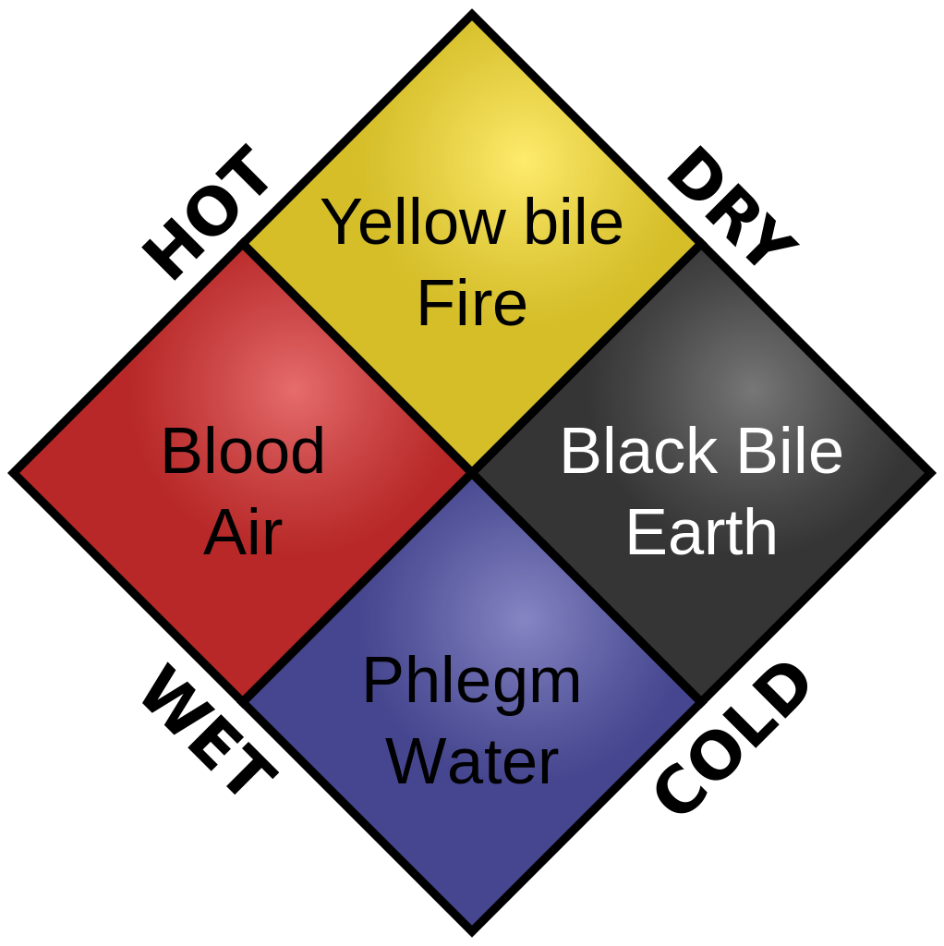 | Hippocrates and Galen taught that the body contains four Humours or liquids: blood, phlegm, yellow bile and black bile. When we are healthy these Humours are perfectly balanced in our bodies but we fall sick when we have too much or too little of one Humour. You can see the evidence when you are sick and your body gets rid of excess Humours.  People therefore believed that dirt poisoned the air and the poisoned air then made them ill. However, this was not a separate theory. They knew God allowed the air to be poisoned as part of his plan to cleanse people of sin.
The continuing influence in England of Hippocrates and Galen. | 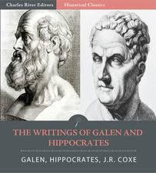 | One vital thing to understand about the Middle Ages is that people respected traditional ideas. Doctors therefore followed the ideas of Hippocrates who had lived over 1500 years earlier in Greece. Claudius Galen was also Greek but worked in Rome 500 years after Hippocrates and was even more respected. He wrote over 300 medical books that were still trusted by doctors in the Middle Ages. The triangle below gives you a summary and the speech bubble and illustrations on the right explain their ideas about what caused illnesses.  Ideas about causes They believed that people became sick when the four Humours in their bodies were out of balance.  Treatment They treated illnesses by bleeding patients or making them vomit. This restored the balance of the Humours.  They tried to prevent illness by recommending exercise and a good diet. This would keep the Humours in the body well-balanced.
Overview. Focus 2 Approaches to prevention and treatment 1250-1500 |  | You could pray to God, asking him to forgive you and make you well. You could also take herbal remedies (made from plants) which had helped friends or relatives with the same illness. If you saw a physician he checked the colour, smell and taste of your urine to see if your Humours were out of balance. Then he balanced your Humours by bleeding (taking blood from your body) or making you vomit. He might also suggest exercise and a different diet.
Approaches to prevention and treatment and their connection with ideas about disease and illness: religious actions, bloodletting and purging, purifying the air, and the use of remedies. |  | Physicians advised wealthy clients how to stay healthy, suggesting regular washing, cleaning teeth, combing hair, exercise in fresh air and bathing in hot water. The wealthy sent their urine to physicians to make sure that they were not falling ill. Simple, hand-copied guides to healthy living and how to avoid plague were sold in towns and around the country and so reached a wide audience. Many were written in rhyme so the details could be more easily remembered. People also tried hard to keep their towns clean.  The most common remedies were made from herbs, minerals and animal parts. Most women knew them by heart, but they were written down in books called ‘herbals’, with pictures of the ingredients and explanations of the exact quantities of each ingredient and how to mix the potion. They included prayers to say while collecting the herbs to increase the effectiveness of the remedy.  Bleeding, urine and zodiac charts were the three most common illustrations in medical books. Bleeding and purging the stomach were used to restore the balance of the humours. Purging meant swallowing herbs and animal fat to make the person sick or taking a laxative to empty their bowels.
New and traditional approaches to hospital care in the thirteenth centuries. | 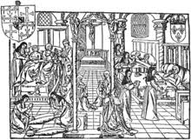 | The first wave of hospitals appeared in towns in the eleventh century. They mostly cared for older people who could no longer look after themselves. They were run by monks and nuns who provided food, warmth and prayers. Everyone could see the altar where priests said mass seven times each day. They rarely admitted the sick in case they spread infection. One of the most famous early hospitals was St Bartholomew’s in London, founded in 1123. From the thirteenth century a second group of much smaller hospitals were founded, often by guilds, organisations of wealthier townspeople who worked in the same trade – shoemakers, silversmiths, etc. These hospitals cared for guild members and local citizens who could no longer look after themselves. By 1400 there were over 500 hospitals, many with only five or six beds.
The role of the physician, apothecary and barber surgeon in treatment and care provided within the community and in hospitals, c1250–1500. | 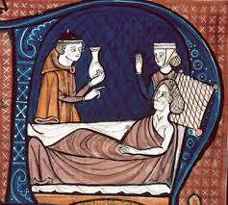 | Physicians trained at universities for seven years, reading books by Hippocrates, Galen and Arab medical writers such as Rhazes and Ibn Sina [Avicenna]. However there were fewer than 100 physicians in England in 1300 and only the rich could afford their fees. Apothecaries mixed ingredients to make ointments and medicines for physicians. They learned from other apothecaries. They also made their own medicines to sell to the sick. Surgeons did not go to university but trained as apprentices through observing others. They improved their skills through practice and reading books on surgery. They did basic surgery such as bleeding, removing surface tumours, sewing up wounds and making splints for broken bones. There were no effective anaesthetics but occasionally they had to amputate a limb or remove painful bladder stones. Some surgeons used fine needles to remove cataracts from eyes to restore or improve sight.
Dealing with the Black Death, 1348–49; approaches to treatment and attempts to prevent its spread. | 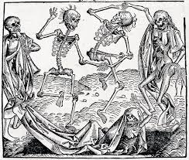 | Many attempts to prevent plague were therefore linked to religion: The king and bishops ordered services and processions in every church at least once a day, in which people prayed for forgiveness and asked God to stop the disease. People lit huge numbers of candles in churches as offerings to God or fasted (stopped eating) to show they were sorry for their sins. Many went on pilgrimages to pray for God’s forgiveness at the tombs of saints. Activities that might be insulting God were ended. In Suffolk they stopped using churchyards for wrestling matches. Some people punished themselves in public and begged God for forgiveness,.The Black Death was terrifying. Fear and panic drove people to try desperate remedies. However, most ideas about what caused the Black Death were rational, fitting people’s ideas about how the world worked. Monks scoured books in monastery libraries to find treatments and cures. People stopped strangers entering their villages in case they were carrying the plague. People did everything they could to prevent plague spreading, given the knowledge and skills they had. Some people explained the Plague in terms of Miasma or the Theory of the Four Humours

Trigger Memory Story Medicine 1250-1500
The story must be very imaginative. It must involve you seeing, talking and doing things. It must link the ten trigger words together in the form of a continuous story. You should then rehearse the story and commit it to your long term memory to be recalled when necessary. This will take some effort but will be very useful! Use different colours to write the trigger words in your story. I was...

