Trigger Memory Activity for Medicine 1900-2000
Trigger Words | Trigger Picture | Add Trigger Points from your notes
Change and Continuity |  | The great breakthroughs before 1900 had been vital stepping stones to better health and longer lives but medicine had not been revolutionised overnight. By 1900 life expectancy was beginning to increase but was still below 50 years of age. However, steady progress did give way to rapid change. The most obvious measure of change is that life expectancy has nearly doubled since 1900.
Overview. Focus 1 What did people think caused disease 1900-2000.  Continuity and change in explanations of the cause of disease and illness.  Advances in understanding the causes of illness and disease: the influence of genetic and lifestyle factors on health. | 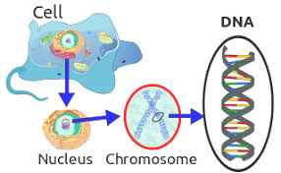  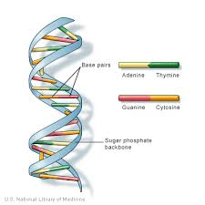 | Pasteur made a huge breakthrough in medicine with his germ theory, which led to many changes in methods of preventing and treating diseases. However, identifying bacteria did not find the cause of all illnesses. As the diagram below shows, two other major reasons for illness have played a big part in medical changes – the impact of genetic problems and of people’s lifestyles.  DNA stands for deoxyribonucleic acid but you do not need to remember that – just talk and write about DNA.  Turning point 1: Discovering DNA’s structure  The first step came in 1953 when two scientists in Cambridge, Francis Crick and James Watson, discovered the structure of DNA illustrated. They proved that this DNA structure was present in every human cell and showed how it passed on information from parents to children. This was the launch pad for further discoveries.  Turning point 2: Mapping the human genome  The complete set of genes in a living creature is called a genome. In 1986 the Human Genome Project began to identify the exact purpose of each gene in the human body, compiling a complete map of human DNA. The task was completed in 2001, 15 years later. This research was so complex it needed teams of scientists in 18 countries to take part, including the USA, Britain, Japan, France and Canada. Each team worked on a different part of human DNA. This work could not have been done before computers. The information carried in human DNA would fill 80,000 books the size of this one but the electronic equivalent can be passed around the world instantly via the internet.
Improvements in diagnosis: the impact of the availability of blood tests, scans and monitors. |  | Single drop of blood reveals entire history of viral infection  Cheap and rapid test allows doctors to access list of every virus that has infected or continues to infect a patient, and could transform disease detection  Researchers have developed a cheap and rapid test that reveals a person’s full history of viral infections from a single drop of blood.  Microscopes  The electron microscope enables doctors to observe matter much smaller than individual cells  Endoscopes  This is a camera inserted into the human body to identify areas of concern  Nuclear Medicine  Radioactive elements are injected into the bloodstream where they track and diagnose changes in the body due to disease  Scans and Monitors  These machines are widely used to look at every part of the human body in detail t identify disease including cancer and other illnesses.
Overview. Focus 2 Approaches to prevention and treatment 1900-2000  The extent of change in care and treatment: improvements in hospital care | 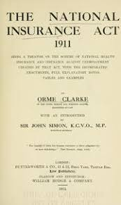  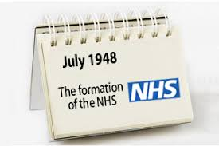 | improved access to care 1900–48  One major problem in 1900 was the cost of medical treatment. Many working people simply could not afford to pay a doctor or buy medicine. Attitudes to government intervention in people’s lives were also gradually changing. Knowledge of how bacteria cause diseases made people more accepting of laws to improve healthcare.  Here are some of the reforms. They may seem very ordinary today but a century ago they were revolutionary.  1902 Training for midwives was made compulsory. 1907 All births had to be notified to the local medical officer of health. A health visitor visited each mother to make sure she knew how to protect her baby’s health.  1907 Nurses or doctors had to carry out medical checks on children in schools.  1911 The National Insurance Act provided help for workers who fell ill. Before this they had to carry on working or get no pay. The National Insurance Act required the worker, his employer and the government to pay into a sickness fund. When a worker fell ill he received ten shillings a week for up to 26 weeks and free medical care. It was a major step forward but only included workers, not their families or the unemployed, the elderly or anyone with a long-lasting illness.  1912 Clinics in schools gave children free medical treatment.  1919 The Ministry of Health was set up, the first government department to have an overview of health throughout the country. This was a major step in government involvement in health.  1919 The Nursing Act set up the General Nursing Council to enforce nursing standards.  The changes above meant that more people were able to get medical care and treatment and that care was improving. However, there were still many people who could not afford to see a doctor or pay for medicines. This situation grew worse in the 1930s when the rate of unemployment was extremely high. The most worrying evidence came from towns where unemployment was high. There the number of deaths among children under the age of one was rising again.  The impact of the NHS from 1948  The Beveridge Report  In 1942 the wartime coalition government asked a leading civil servant, Sir William Beveridge, to write a report on what should be done to improve people’s lives. He recommended: Setting up a National Health Service, free to everyone and paid for from taxes. Doctors, nurses and other medical workers would become government employees instead of charging the sick to create their wages. Everyone in work would pay National Insurance out of their wages. This would pay benefits (sick pay, old-age pensions, unemployment pay, etc.) to everyone who needed it whether they were working or not.  The beginning of the NHS  In July 1948 the NHS was introduced. Now everyone could get free treatment at the point of delivery. About 8 million people had never seen a doctor before. Diagram A shows the range of services provided by the NHS. Many hospitals were rebuilt. Doctors and nurses got new improved equipment. The NHS played an important part in increasing people’s life expectancy, particularly helping to reduce the numbers of women dying in or shortly after childbirth. One major area of government spending since 1948 has been on hospitals. Some of this has been spent on much better qualified staff who can provide more specialist care. Many nurses develop specialist skills such as care of patients who have had breast surgery or cancer patients undergoing radiotherapy or chemotherapy. Some of these specialist nurses have the ability to prescribe a limited range of medicines – something which in the past could only be done by doctors.  Protecting patients from acquiring new illnesses in hospital has also become a major aspect of hospitals’ work. This was always a problem but became worse in the late 1900s as bacteria developed immunity to some antibiotics and outbreaks of ‘Superbugs’ (such as MRSA) occasionally killed patients. Since then hospitals and governments have taken action to protect patients from such infections.  High-tech medical and surgical treatments in hospitals  Hospitals have become the major centres of high-tech treatments, some of which are summarised here and on page 90. In some cases better treatments and care have meant the need for more care and treatments because, for example, patients with illnesses such as cystic fibrosis are now living longer because of better treatments.  Blood transfusions: The problem of storing blood was solved during the First World War. Firstly, sodium citrate was added to prevent blood clotting. Then scientists discovered how to separate and store the crucial blood cells and keep them in bottles  X Rays. In 1895 a German scientist, Wilhelm Röntgen, discovered rays of light that could pass through black paper, wood and flesh and still light up a wall. He did not know what they were so called them X-rays. Within months, X-ray machines were in use in hospitals.  Radiotherapy and Chemotherapy Marie Curie and her husband, Pierre, continued research on X-rays. They discovered radium which has been used ever since to diagnose cancers, and in radiotherapy to treat cancers.  Other treatments include: Transplant Surgery, Customised drugs, Gene Therapy, Plastic Surgery, Keyhole surgery, Dialysis, Improved anaesthetics, Pacemakers
The impact of the NHS and science and technology: improved access to care; advances in medicines, including magic bullets and antibiotics; high-tech medical and surgical treatment in hospitals. | 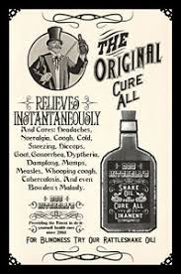  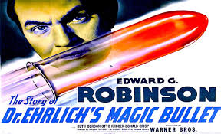  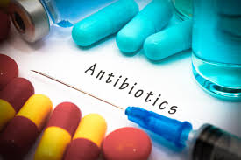 | By the early 1900s ‘cure-all’ pills were being replaced by effective medicines for use in the home and by doctors. One of these medicines was aspirin which is used as a painkiller and remedy for fevers. It comes from willow bark which had actually been used as a medicine for centuries but no one knew why it worked. Developments in science enabled scientists to identify the exact chemical in willow bark that was beneficial. It was then manufactured in huge quantities and marketed as aspirin. Pharmaceutical companies including Boots and Beechams became worldwide businesses. These companies were successful through:  1 Investing in research and development (including employing scientists) to look for better remedies.  2 Using improved scientific techniques and equipment to identify the precise chemicals that work as medicines.  3 Using industrial technology to make huge quantities of each remedy and using commercial skills to market them worldwide.  4 Using experiments and experience to find the exact dosages needed by patients.  ‘Magic bullets’ – the development of sulphonamide drugs  In 1909 Paul Ehrlich (one of Koch’s research team in Germany) developed the first chemical drug that killed bacteria inside the body. This was Salvarsan 606 which he called a ‘magic bullet’ because it homed in on and destroyed the bacteria that cause syphilis. Unfortunately Salvarsan 606 killed the patient too. It took until the 1930s to find a magic bullet that did not kill the patients. Gerhard Domagk tried out a chemical mix called Prontosil on mice and discovered it killed the bacteria causing blood poisoning. He didn’t try it on people until his daughter developed blood poisoning. Normally she would have died but Domagk gave her Prontosil. She was the first human cured by a chemical cure. Scientists discovered the important chemical in both Salvarsan 606 and Prontosil was sulphonamide and drug companies then developed sulphonamide cures for diseases such as pneumonia and scarlet fever and mass-produced huge quantities for general use.  The development of antibiotics  When the war ended in 1945, there was still a great deal to do to make antibiotics available for the whole population. This took place because of the following:  - There was investment in the discovery and development of other antibiotics by pharmaceutical companies.  - Scientific techniques and equipment were improved to develop antibiotics.  - After 1948 the government-funded NHS provided antibiotics free.  - Scientists and doctors communicated their research so they could learn from each other.
New approaches to prevention: mass vaccinations and government lifestyle campaigns. | 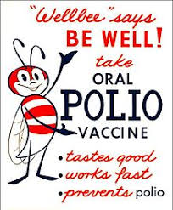  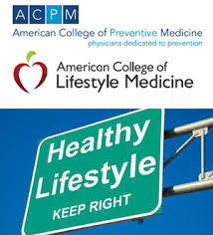 | Vaccines and public health reforms put an end to the devastating epidemics of smallpox and cholera but scientists needed more time to find vaccines for other infectious diseases that killed thousands of people. The microbe causing poliomyelitis wasn’t identified until 1946. In 1954 American scientist Jonas Salk developed a vaccine that protected people from polio. Pharmaceutical companies invested in new technology to mass-produce the vaccine, which was then made available to use throughout Britain and the world. However, in Britain, people were slow to use the vaccine until Jeff Hall’s death. This frightened people into being vaccinated, and so may have saved many lives. The demand for the vaccine was so great that emergency supplies had to be flown in from the USA  The breakthroughs linked to the discovery of DNA have led to important new. If doctors know the exact gene responsible for medical conditions they can test or screen patients as part of preventive medicine. This genetic screening or testing identifies potential illnesses, enabling doctors to take action even before an illness has developed. For example, they can identify whether a person’s genes carry the risk of suffering from breast cancer and take action to prevent cancer developing. This kind of screening is done to check unborn babies for possible conditions such as Down’s syndrome. There have been regular campaigns and initiatives to try to prevent illnesses linked to lifestyle. Single-issue campaigns have focused on warning of the dangers of smoking or of lack of exercise or have promoted healthier diets. In 1992 the government’s ‘Health of the Nation’ initiative went further in setting the NHS targets to prevent and reduce deaths and illnesses in five major areas: heart disease, cancer, mental illness, HIV/AIDS and accidents. Everyone over the age of 40 is given the opportunity to have a health check every five years, focusing on blood pressure, weight and cholesterol levels alongside lifestyle advice. More widely, governments have passed laws that attempt to ensure health by reducing air and water pollution and improving food safety to reduce outbreaks of salmonella and E.Coli poisoning.
Focus 3 Case study  Key individual: Fleming, Florey and Chain’s development of penicillin. | 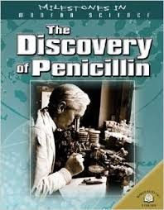 | Stage 1: 1928 – Fleming’s discovery of penicillin. Many soldiers in First World War (1914–18) developed infected wounds. Chemical antiseptics were used successfully to kill many infections but they did not heal infections caused by streptococci and staphylococci bacteria. Soldiers with those infections died. A scientist called Alexander Fleming was sent to France to study these wounds and then, back in England, he worked on finding a way to deal with these bacteria. The hunt took ten years but in 1928 he found the answer. While away on holiday he left a pile of dishes containing bacteria on his laboratory bench. On his return he sorted out the dishes and noticed mould on one of them. Around the mould, as you can see in Picture A, the staphylococci bacteria had disappeared. Fleming then experimented with the penicillin mould on living cells. He discovered that if it was diluted it killed bacteria without harming the cells. He made a list of the germs it killed and used it to treat a colleague’s eye infection. However, it did not seem to work on deeper infections and it took a very long time to create enough penicillin to use. In 1929 Fleming wrote about penicillin in a medical journal but nobody thought his article was important. He had not even used penicillin on animals to heal infections so had no evidence of it being useful.  Stage 2: 1938 – Florey and Chain’s research and trials. In 1938 Howard Florey and Ernst Chain were researching how germs could be killed and read Fleming’s article on penicillin. They realised that it could be very effective and tried to get funding from the government. They got £25. With war near at hand and no proof that penicillin could cure people the government had other things to spend its money on. Instead Florey asked for money from America and got enough to pay for five years’ research. They discovered that penicillin helped mice recover from infections but to treat one person they needed 3000 times as much penicillin! Even large drug companies could not afford to fund this quantity of work. So Florey and Chain began to grow penicillin themselves in whatever they could, using hundreds of hospital bedpans. By 1941 there was enough penicillin to test on one person. The volunteer was Albert Alexander, a policeman who had developed septicaemia – a bacterial infection – from a tiny cut. Chemical drugs had not killed the infection and it was clear that Albert was dying. Florey and Chain requested permission to try penicillin and injections began. The penicillin worked and Albert began to recover. However, they ran out of penicillin after five days even though Florey and Chain were extracting unused penicillin from Albert’s urine and reusing it in a desperate attempt to keep treating him. Without penicillin Albert died. Penicillin had shown that it worked and wasn’t harmful to the patient – but how could they make enough of iT.  Stage 3: 1941 – Wartime need for penicillin. English factories were working flat-out on the war effort during the Second World War (1939–45) and couldn’t be used to mass-produce penicillin. So Florey went to America – at just the right time. In 1941 America was attacked by the Japanese at Pearl Harbor and entered the war. The American government realised the potential of penicillin for treating wounded soldiers and made interest-free loans to US companies to buy the expensive equipment needed for making it. Soon British firms were also mass-producing penicillin, enough to treat the allied wounded on D-Day in 1944 – over 2.3 million doses.  Stage 4: After the war ended in 1945 penicillin began to be manufactured and used by everyone, not just the armed forces. This still took time but antibiotics became more and more common in the 1950s and 1960s, gradually turning from a ‘wonder-drug’ into just an ordinary, everyday life-saver!
The fight against lung cancer in the twenty-first century: the use of science and technology in diagnosis and treatment; government action | 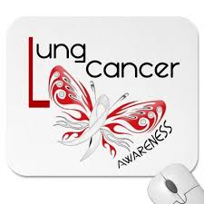 | Lung cancer was extremely rare 150 years go. Its frequency increased greatly in the early 1900s and today it is the second most common form of cancer. Over 40,000 people are diagnosed with it each year. Medical evidence has proved conclusively that cigarette smoking (which first became common in the early 1900s and especially during the First World War) is the major reason for contracting lung cancer. Nearly 90 per cent of cases are the result of smoking, in some cases of passive smoking. The devastation caused by lung cancer now means that huge efforts are made in prevention, diagnosis and treatment. Governments have launched major campaigns to prevent people developing lung cancer. Campaigns warn people of the extreme dangers of smoking, through advertising the dangers, banning advertisements for cigarettes and making them as invisible as possible in shops.  Treatments have taken four forms:  1 Surgery has been used since the 1930s but the majority of lung cancer sufferers have had other smoking-related health problems that have meant that surgery was too dangerous to use. New surgery techniques using remote-controlled micro-instruments and cameras have far less impact on the body and speed recovery.  2 Radiotherapy aims to kill the cancer cells using beams of radiation. Techniques have improved to target cancers more precisely.  3 Chemotherapy has been used since the 1970s if the cancer has developed so far that surgery and radiotherapy are not successful. Chemotherapy involves using particularly powerful chemical medicines to attack the cancer cells, although it can have significant side effects. New combinations of chemotherapy medicines are constantly being used and the results recorded.  4 Immunotherapy. Cancers are able to resist the body’s immune system’s attempts to block their growth. Trials have been taking place to boost the immune system and so stop the cancer cells from resisting it.

Trigger Memory Story Medicine 1900-2000
The story must be very imaginative. It must involve you seeing, talking and doing things. It must link the ten trigger words together in the form of a continuous story. You should then rehearse the story and commit it to your long term memory to be recalled when necessary. This will take some effort but will be very useful! Use different colours to write the trigger words in your story. I was...

