Trigger Memory Activity for Medicine 1750-1900
Trigger Words | Trigger Picture | Add Trigger Points from your notes
Overview. Focus 1 What did people think caused disease 1750-1900.  Continuity and change in explanations of the cause of disease and illness.  The influence in Britain of Pasteur’s Germ Theory  Robert Koch’s work on microbes. | 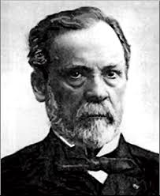  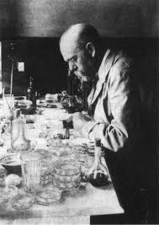 | Stage 1: 1861–64 – theory and proof  Pasteur published his germ theory in 1861. In 1864 he carried out experiments that convinced other scientists that his germ theory was correct. However, his theory was very general – he said that bacteria cause diseases but could not identify the specific bacteria which cause individual diseases.  Stage 2: 1865–76 – struggling to prove the theory’s value  In 1865 there was a cholera epidemic in France and Pasteur tried to find the exact bacterium that causes cholera. However, under his microscope he could only see a confused mass of bacteria. He could not discover which one was causing cholera. Therefore, in the 1860s, Pasteur’s germ theory seemed less useful than Jenner’s vaccination. Jenner did not know that bacteria cause smallpox but he could prevent people catching it! The invisibility of bacteria was one reason why many people still believed that bad air (miasma) was the cause of disease. They could see rotting food and flesh and even faeces in the streets. They knew this dirt gave off terrible smells and assumed that these smells caused and spread disease. This miasma theory was still believed by educated people such as Florence Nightingale (see page 63) and Edwin Chadwick, the civil servant who had done a lot of research to improve public health in England.  Stage 3: 1876 – gotcha! Identifying the bacterium causing anthrax  In 1876 a German doctor called Robert Koch and his research team made a practical breakthrough. They found the bacterium that was causing anthrax. This was the first time anyone had identified the specific microbe that causes an individual disease.  Stage 4: 1876 and afterwards – vaccines to prevent diseases  Over the next 20 years Koch and other scientists identified more bacteria causing individual diseases and this led to the development of vaccines to prevent them (see page 58). This finally persuaded people that bad air was not the cause of disease.
Overview. Focus 2 Approaches to prevention and treatment 1750-1900  The extent of change in care and treatment: improvements in hospital care  The influence of Nightingale. | 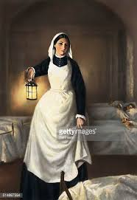 | The heroine of hospital reform was Florence Nightingale. She had horrified her wealthy family by wanting to be a nurse but she trained in Germany, then worked as a nurse and became Superintendent of Nurses in a London hospital. When the Crimean War broke out between Britain, France and Russia in 1854 she took 38 nurses to the Crimea, which lies between Russia and Turkey. Arriving at the army hospital at Scutari, Florence was appalled by the dirty conditions. She concentrated on cleaning the hospital and patients and was so effective that the death rate in the hospital fell from 40 per cent of wounded to 2 per cent.  Florence’s work in the Crimea made her a national heroine, which helped her raise money to set up her first Nightingale School for Nurses in 1860. In 1859 she had written Notes on Nursing and in 1863 Notes on Hospitals. Both books were very influential all over the world, providing the basis for training nurses and hospital design.  She was not a hands-on nurse but a great organiser, convinced that her life’s work was to improve conditions in hospitals and the training of nurses to improve the care of patients. She focused on improving:  1 sanitation in hospitals – clean water supplies, good drains and sewers, toilet facilities, total cleanliness  2 ventilation to make sure patients got fresh, clean air to breathe  3 food supplies, clothing and washing facilities for patients.  One surprising thing was that she paid little attention to Pasteur’s germ theory when it appeared in the decade after the Crimean War. She had been brought up to believe that miasma (bad air) was the main cause of disease and, in many ways correctly, she continued to associate disease with dirt. This is why she concentrated on improving hygiene and cleanliness in hospitals all her life. As a result, her nursing schools concentrated on training nurses in very practical skills. She did not let doctors teach nurses about germ theory because she felt that such ideas would simply get in the way of nurses’ more important task – keeping patients and wards clean.  The impact of other factors on hospitals and care  The improvements in hospital buildings and sanitation could not have come about without improved engineering techniques and new government laws passed to enforce public health improvements. Changes in surgery increased the numbers of complex operations and so surgeons required better-trained nurses to assist them. And, despite Nightingale’s relegation of germ theory, it had a very significant impact on all aspects of medicine, including surgery, and so in turn it affected the ways that nurses carried out their work.
The impact of anaesthetics and antiseptics on surgery. | 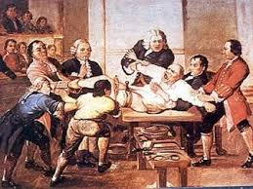  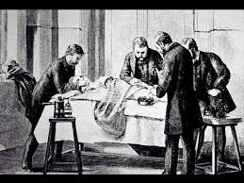 | Simpson’s use of chloroform as an anaesthetic  The answer came from James Simpson, Professor of Midwifery at Edinburgh University. He had used ether but wanted a better anaesthetic. One evening in 1847 he and his colleagues experimented with chemicals to see what anaesthetic effects they had. Simpson realised that chloroform was a very effective anaesthetic. Within days he used it to help women in childbirth and other operations. He wrote articles about his discovery and other surgeons started to use it in their operations. In 1848 John Snow (who you met on page 60) devised an inhaler to regulate the dose of chloroform and reduce the danger of using so much the patient died.  Surgery’s ‘Black Period’, 1850–1870s Using too much chloroform was only one reason why there was opposition to it. Some people, including some doctors, thought pain-free operations were unnatural! More importantly, anaesthetics had not necessarily made surgery safer. With patients asleep, doctors attempted more complex operations, thus carrying infections deeper into the body and also causing more loss of blood. The number of people dying from surgery may even have increased from the 1850s to early 1870s, which is known as surgery’s ‘Black Period’. In the 1870s some surgeons stopped using chloroform as they were concerned about the high death rate and returned to using ether mixed with nitrous oxide.  Joseph Lister and antiseptics. Chloroform changed surgery but surgeons were still wearing old pus-stained clothes, did not wash their hands before operations, nor did they sterilise equipment. Why? Because they did not know that bacteria caused infections in open wounds. The man who developed antiseptics to tackle infections was Joseph Lister. Lister was an outstanding surgeon but he also knew all about Pasteur’s germ theory, which helped spark his own discovery  Lister experimented by treating fractures where the bone breaks through the skin. Infection often developed in these open wounds. Lister applied carbolic acid to the wound and used bandages soaked in carbolic. The wounds healed and did not develop gangrene, saving many lives. In 1867 Lister published his results, showing the value of carbolic acid. He also: Insisted that doctors and nurses wash their hands with carbolic acid before operations to avoid infection from their hands getting into wounds. Developed a carbolic spray to kill germs in the air around the operating table. Invented an antiseptic ligature to tie up blood vessels and prevent blood loss.  The impact of these changes was spectacular. Between 1864 and 1866 there had been 16 deaths after 35 amputations – a death rate of 46 per cent. Between 1867 and 1870, after the introduction of antiseptic surgery, there were six deaths after 40 operations – a death rate of 15 per cent.  Lister’s methods were a turning point. By the late 1890s Lister’s antiseptic methods (killing germs on the wound) had developed into aseptic surgery (removing germs completely from the operating theatre). To ensure absolute cleanliness:  1 Operating theatres and hospitals were rigorously cleaned.  2 From 1887 all instruments were steam-sterilised.  3 Surgeons stopped operating in ordinary clothes and wore surgical gowns and face masks and rubber gloves.  With the problems of pain and infection solved, surgeons began more ambitious operations. The first successful operation to remove an infected appendix was in the 1880s, the first heart operation in 1896 when surgeons repaired a heart damaged by a stab wound. The one major problem still facing surgeons was heavy blood-loss. The answer lay ahead in the twentieth century!
New approaches to prevention: the development and use of vaccinations and the Public Health Act 1875 |  | Prevention 1: Vaccinations  1796 Jenner discovers smallpox vaccine but can not explain scientifically how it worked.  Stage 1 1861 Pasteurs Germ Theory  Stage 2 In 1876 Robert Koch made the first identification of the bacterium causing an individual disease when he identified the bacterium causing anthrax. In 1882 his team of scientists found the bacterium that caused a second disease, tuberculosis (TB). After this, other scientists followed Koch’s methods and quickly identified the bacteria causing other diseases.  Stage 3: 1880s and after – developing vaccines  Koch’s work identifying bacteria still didn’t save people’s lives by itself. What were needed were vaccines that worked like Jenner’s vaccine against smallpox, giving people weak doses of disease to build up their immunity. The hero of this stage was once again Louis Pasteur. He knew all about Jenner’s work and used it to find vaccines. He began with animal diseases and developed vaccines to prevent anthrax and chicken cholera. Then, in 1885, he tested a vaccine for rabies on a boy who’d been bitten by a rabid dog. The vaccine saved the boy’s life. This was the first successful vaccine since Jenner’s work on smallpox. Other scientists then developed vaccines to prevent other diseases.  Prevention 2 Public Health  One result of the overcrowding and poor conditions was the frequent outbreak of  epidemics of disease such as cholera. These epidemics were just as frightening as plague had been in previous centuries because there was still no way of stopping them and they killed many thousands of people, as Table C shows. The shocking conditions led to a civil servant, Edwin Chadwick, compiling his ‘Report on the Sanitary Conditions of the Labouring Population’ in 1842. Chadwick detailed the effects of these conditions on people’s lives, including statistics about the differences in average age at death. In country areas the average age of death for workers was 38. In Liverpool, chosen as an example of a B rapidly growing town, the average age of death for labourers was 15.  The Public Health Act 1848  - A national Board of Health was set up.  - In towns where the death rate was very high the government could force the local council to make public health improvements to water supply and sewerage and appoint a medical officer of health.  - Local councils were encouraged to make collect taxes to pay for public health improvements if they had the support of local tax-payers.  - Councils were allowed to appoint medical officers of health to oversee public health.  Finally, in 1875, a Public Health Act was passed. It was now compulsory for local councils to improve sewers and drainage, provide fresh water supplies and to appoint medical officers and sanitary inspectors to inspect public health facilities. In addition, other laws improved the standards of housing and stopped the pollution of rivers (from which people got water).
Focus 3 Case study  Key individual: Jenner and the development of vaccination. | 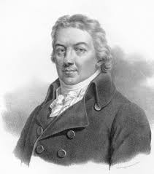 | Jenner was an experienced country doctor in Gloucestershire. Like other country doctors he knew that milkmaids who caught cowpox, a mild disease, never got smallpox. However, no one had made this widely known nor tested the idea scientifically. In the 1790s Jenner decided to carry out experiments to test the theory, observing and recording the details carefully. His experiments were so successful that in 1798 he published a book describing how to prevent smallpox by infecting people with cowpox. He called this method vaccination because the Latin word for cow is vacca.
Fighting Cholera in London, 1854; attempts to prevent its spread; the significance of Snow and the Broad Street pump. | 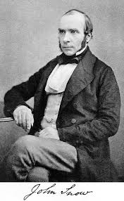  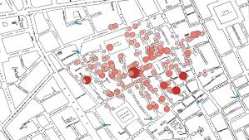 | The 1848 Public Health Act made little difference to people’s health. Most towns did not set up Boards of Health and the National Board was abolished after six years. Then came cholera! Cholera seems to have broken out for the first time in Britain in 1831. It killed its victims in less than a day and when another epidemic broke out in 1854 over 20,000 people died. Table A shows you how people tried to prevent its spread – you may have seen these methods before! In 1849 John Snow published a book saying that people caught cholera from water they used for washing and drinking, not from ‘bad air’. His suggestion was mocked by many doctors. The rest of this page will read like a western! While everyone else ran around frightened of cholera in 1854 a lone hero strode into Broad Street and ‘did what a man’s gotta do’. John Snow took on cholera and beat it – with a pump handle!  Snow’s surgery was near Broad Street in London. Within ten days 500 people around Broad Street had died of cholera. Snow got to work – with a map! He mapped out the deaths in detail (see Map B) and proved that most of the local deaths were of people living close to the water pump in Broad Street. They got their drinking, cooking and washing water from that pump. Snow had the handle of the Broad Street pump taken away so no one could get water from it. There were no more deaths. It was discovered later that a cesspit, only a metre from the pump, was leaking into the drinking water. Snow had proved that clean water was essential for preventing the spread of cholera but even this did not lead to a new Public Health Act enforcing change. Many scientists still clung to the ‘bad air’ theory.

Trigger Memory Story Medicine 1750-1900
The story must be very imaginative. It must involve you seeing, talking and doing things. It must link the ten trigger words together in the form of a continuous story. You should then rehearse the story and commit it to your long term memory to be recalled when necessary. This will take some effort but will be very useful! Use different colours to write the trigger words in your story. I was...

