Trigger Memory Activity for Medicine 1500-1750
Trigger Words | Trigger Picture | Add Trigger Points from your notes
Factors of Change  Factors of continuity  Overview. Focus 1 What did people think caused disease 1500-1750.  Continuity and change in explanations of the cause of disease and illness. |  | One of the main features of the Renaissance was a slow change from respect for tradition to the search for change. If you think of this as a boxing match, tradition had knocked out enquiry in the Middle Ages. This wasn’t surprising, as tradition had the experienced and powerful Christian Church in its corner. What helped change fight back? The Black Death began to encourage change back on its feet. Survivors were paid higher wages because employers had to attract workers. Some people spent their money on educating their children and in time education helped trigger the Renaissance.Renaissance means ‘re-birth’. The Renaissance was a time of re-born interest in all things Greek and Roman – their books, ideas, buildings and sculptures. The development of printing helped people publish many new editions of Greek and Roman books, including nearly 600 editions of Galen’s books. So, what was also re-born was a love of enquiry and willingness to challenge existing ideas. Once they began to ask questions some people began to realise that Galen had not known everything – and had even made mistakes! Of course not everyone agreed. Many people stuck to tradition, still saying it was wrong to challenge Galen. So, what developed between 1500 and 1700 was a battle between attitudes – between tradition, people defending the old ideas, and people seeking change and improvement.  Methods of treating and preventing illness were not changing. This was partly because some treatments, such as some herbal remedies, did work. The methods used to prevent the spread of plague in 1665 were very logical and did help a little. However, the biggest reason by far why methods of treating and preventing diseases had not changed was because understanding of the causes of disease had not changed.
A scientific approach, including the work of Thomas Sydenham in improving diagnosis. | 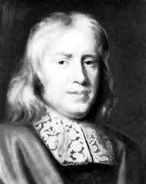 | Thomas Sydenham was a pioneering doctor who did make progress, especially in how to diagnose diseases. He believed that each disease was different and that it was important to identify the exact disease so the correct remedy could be chosen to cure it. Taking a patient’s pulse, for example, was an important part of diagnosis.Sydenham became one of the most respected physicians in London, telling young doctors ‘You must go to the bedside. It is there alone that you can learn about disease’. He stressed that doctors needed to take a full history of the patient’s health and symptoms, observing and recording the illness with great care so that the correct diagnosis was made. Sydenham became known as the ‘English Hippocrates’ because the legendary Greek doctor had placed great importance on this kind of careful observation. Sydenham contributed to the progress of medicine by making detailed descriptions of many illnesses, including the first description of scarlet fever. He also believed in allowing the body to fight the illness by itself. Patients who were used to physicians ordering bleeding or purging must have been delighted when Sydenham prescribed roast chicken and a bottle of wine to restore their strength!
The influence of the printing press and the work of the Royal Society on the transmission of ideas. | 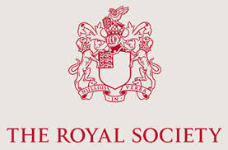 | Earlier in this chapter there have been references to the development of printing. Printing was a crucial development which helped change ideas in medicine and many other subjects because it spread new ideas far more rapidly. Books could be printed faster and more cheaply than when they were copied by hand. The printing press was invented by Johannes Gutenberg in the 1450s. By 1500 printing presses were being used throughout western Europe. Some books were highly illustrated such as this page from Andreas Vesalius’s book on anatomy The Fabric of the Human Body (1543). You will read more about Vesalius on page 44.The first meetings in England of people interested in discussing new scientific ideas took place in London in 1645. The group met weekly to discuss new ideas in physics, botany, astronomy, medicine and other sciences. Members also demonstrated experiments (such as the one shown in Picture A) because the Society had its own laboratory and equipment such as microscopes. It also published books and articles to spread new ideas and discoveries. In 1662 the group became known as the Royal Society after King Charles II attended meetings to hear talks and watch experiments. He even had a laboratory and an observatory built in one of his palaces.
Overview. Focus 2 Approaches to prevention and treatment 1500-1750 | 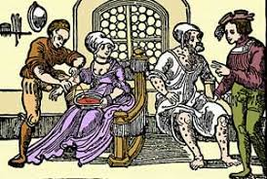 | Bleeding and purging were still very common medical treatments and also continued to be used to prevent illness. Physicians still believed in the Theory of the four humours, that people became ill when the Humours in the body were out of balance. Therefore they used bleeding and purging to correct the balance, even though they must have weakened the patients considerably, as you saw with the treatment of Charles II on page 33. European travels to America and Asia brought new ingredients for treatments to England. Rhubarb from Asia was widely used to purge the bowels. Ipecacuanha from Brazil was prescribed for dysentery and used to make people vomit.  Herbal remedies were handed down through generations from mother to daughter. Girls learned how to mix up remedies, using ingredients such as honey, which we now know kills some bacteria. More people were writing down home remedies because more people could now read and write. Mary Doggett, wife of a London actor, noted a remedy for scurvy which used horseradish roots, white wine, water and a quart of orange juice or 12 thinly cut oranges. We know that scurvy, which leads to internal bleeding and death, is the result of not eating enough fruit and vegetables. Mary did not know this but she did know, from experience, that this remedy worked. Less helpfully, tobacco from America was greeted as a cure-all, being recommended for toothache, poisoned wounds, joint pains, and as protection from plague.  Between 1660 and 1682 over 92,000 people visited the King’s court, believing that if Charles II touched them they would be cured from scrofula, a skin disease known as the King’s Evil. The King was God’s representative on earth so being touched by the King was as close as you could get to being touched by God. There are records of people travelling from as far as Bamburgh in Northumberland in the hope that the King’s touch would heal them.  Many treatments seem rational and would have helped the sick person. However, the treatment below, published in a book called The New London Dispensary in 1682, shows that people still used cures based on magic. Such ideas must have been used because people were desperate for help.
Continuity in approaches to prevention, treatment and care in the community and in hospitals. | 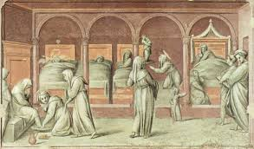 | For most of this period from c.1500–c.1700 physicians still learned about medicine from the books of Galen and other ancient writers. Even in 1668 diarist Samuel Pepys noted that the leading expert on eye problems in London had only ever seen animals’ eyes dissected, but not a human eye. However, very gradually, especially in the late 1600s, the training of doctors did begin to change as you can see in this chart:  1 Training took place on hospital wards  2 They studied the work of Vesalius and Harvey  3 Training emphasised observation, recording and treating  4 More doctors engaged in dissection  5 New technology like microscopes and thermometers were beginning to develop  The story of hospitals was also mostly of continuity. Many medieval hospitals were part of monasteries so they closed when Henry VIII closed the monasteries in the 1530s. However, some were taken over by town councils, especially the almshouses that looked after the elderly poor. In London the city council and charity helped to keep St Bartholomew’s Hospital open. By the 1660s it had 12 wards and up to 300 patients, looked after by three physicians and three surgeons, fifteen nursing sisters and a larger number of nursing helpers. The nursing sisters treated patients with herbal remedies but the nursing helpers did the heavy, manual work – washing, cleaning and preparing food – and had no medical training.  St Bartholomew’s was one of hospitals that were beginning to take in the sick and treat their illnesses. However, most still did not admit people with infectious diseases but just provided food, warmth and prayer for the poor. Anyone with any money paid for a doctor or nurse to look after them at home.
Change in care and treatment: improvements in medical training and the influence in England of the work of Vesalius. | 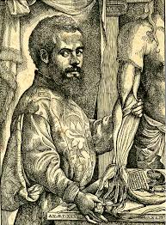 | Doctors believed Galen had given a complete and fully correct description of the anatomy of the body. Vesalius respected Galen’s work but proved, through dissecting bodies, that Galen could be wrong. He proved that:  - The human jaw bone is made from one bone, not two as Galen said.  - The breastbone has three parts, not seven as Galen said.  - Blood does not flow into the heart through invisible holes in the septum, as Galen suggested. Such holes do not exist.  Vesalius published his work in The Fabric of the Human Body in 1543, the first highly illustrated book describing human anatomy. The illustrations showed the body in far more detail and far more accurately than had ever been done before. This book was used to train doctors in England who, therefore, gained more detailed and accurate knowledge of anatomy. Records show that his book was being used in Cambridge by 1560 and led to doctors writing corrections about anatomy in older medical books. In addition, doctors realised they could learn more about anatomy by dissecting bodies themselves. The first  professor of Surgery in dissection by an anatomist in Cambridge was carried out in 1565.
Focus 3 Case study  Key individual: William Harvey and the discovery of the circulation of the blood. | 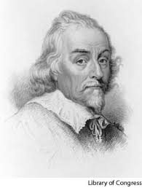 | In 1628 Harvey published his book An Anatomical Account of the Motion of the Heart and Blood which described how the blood circulates round the body. Harvey proved that Galen’s ideas listed above were wrong. He showed that the heart acts as a pump, pumping blood around the body. He did this by:  - Dissecting live cold-blooded animals whose hearts beat slowly so he could see the movement of each muscle in the heart.  - Dissecting human bodies to build up detailed knowledge of the heart.  - Proving that the body has a one-way system for the blood. He tried to pump liquid past the valves in the veins but could not do so.  - Proving that the veins carry blood, not blood and air as Galen had said.  - Calculating that the amount of blood going into the arteries each hour was three times the weight of a man. This showed that the same blood is being pumped  - round the body by the heart.  BuT ...  1. There was still much more to discover about the blood. Doctors could not make blood transfusions until they discovered blood groups in 1901.  2. Harvey’s discovery was only gradually accepted. Some doctors ignored his theory. Others said that he was wrong because he was contradicting Galen. It was 50 years before teachers at the University of Paris taught Harvey’s ideas rather than Galen’s.  3. Harvey’s discovery did not make anyone better. The writer John Aubrey noted ‘All his profession agree Dr Harvey to be an excellent anatomist, but that I never heard any that admired his treatment of the sick.’ Harvey himself said that after he published his discovery fewer patients came to see him because many thought his idea mad.
Dealing with the Great Plague in London, 1665: approaches to treatment and attempts to prevent its spread. | 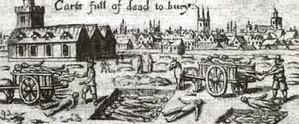 | Explanations for the plague had not changed since the Black Death of 1348, as you can see in the diagram below. These were still rational explanations, given people’s beliefs and understandings, even if they seem very strange today. Treatments for plague were very similar to those used against the Black Death. People prayed for the sick, gave them magical or religious charms to wear or cut open the buboes to let the pus out. Traders sold ‘Great Medicines’ which they claimed had saved ‘vast numbers’ of lives. One such medicine, Theriac, or London Treacle, contained wine, herbs, spices, honey and opium. Physicians may have tried bleeding and purging if the sick lived long enough. Methods of avoiding plague were strongly linked to ideas about its causes. People believed it was vital to keep the air sweet to ward off the bad air that brought plague. Bunches of strong-smelling herbs (such as lavender or sage) were hung in doorways and windows to stop bad air coming into the house. People also held bundles of herbs under their noses as they walked through the streets or drank ‘plague water’ made from herbs mixed with wine, which was thought to give protection against plague. Many people simply stayed at home to avoid contact with others.

Trigger Memory Story Medicine 1500-1750
The story must be very imaginative. It must involve you seeing, talking and doing things. It must link the ten trigger words together in the form of a continuous story. You should then rehearse the story and commit it to your long term memory to be recalled when necessary. This will take some effort but will be very useful! Use different colours to write the trigger words in your story. I was...

