Key Topic 1 c1250–c1500: Medicine in Medieval England.

To what extent did the ideas about the causes of illness change 1250-1500, and how did they impact on approaches to treatment and prevention?
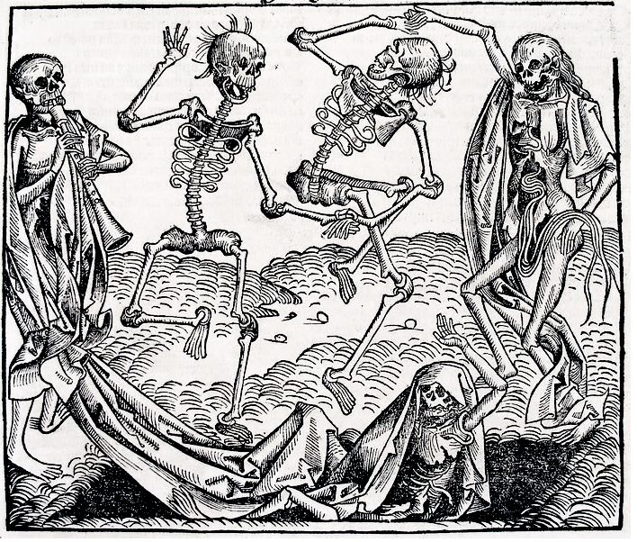

Inspired by the Black Death, The Dance of Death or Danse Macabre, an allegory on the universality of death, is a common painting motif in the late medieval period. - http://www.historytoday.com/ole-j-benedictow/black-death-greatest-catastrophe-ever#sthash.BB2mEWzR.dpuf

Case Study: Dealing with the Black Death, 1348–49; approaches to treatment and attempts to prevent its spread?

Language and Literacy
Key Terms and their meanings in Medicine 1250-1500.
Aqueducts | Structure built to carry water into towns.
Astrology | The study of the stars and planets and how they are thought to affect humans and nature.
Blood letting | The drawing of blood from a patient as a treatment
Christian Church | The organisation of all Christian believers. Very powerful in the Middle Ages
Contagious disease | Diseases which can be passed from person to person
Four Humours | A theory of the causes of disease based on excess fluids; blood phlegm, black and yellow bile
Galen | Leading Roman doctor, who can from Greece. Adapted Humoural Theory, to include the law of opposites
Hippocrates | Leading doctor and thinker from Ancient Greek era
Latrines | A toilet, especially a communal one
Medieval period | A name for the ‘middle ages’ the period between the Ancient World and the Renaissance
Miasma | The theory that disease is caused by poisonous vapours in the air
Monasteries | A Christian religious community, most inhabited by Monks or Nuns. They provided hospitality for travellers, care for the sick and elderly
Physician | A trained doctor
Public health | The standard of living conditions and general health of the people
Roman Empire | A powerful Empire which grew from 70BC to 43AD, which had strong government and an effective army
sewers | An underground system for removing human waste
Theory of Opposites | The treatment of Humoural causes of disease. Rebalancing by eating or climate from the opposite eg hot, red food to treat excess phlegm.
(I) In a Nutshell: Overview of Medicine 1250-1500

Content overview
Focus 1 Ideas about the cause of disease and illness
Supernatural and religious explanations of the cause of disease
Rational explanations: the Theory of the Four Humours and the miasma theory;
the continuing influence in England of Hippocrates and Galen.

Focus 2 Approaches to prevention and treatment
Approaches to prevention and treatment and their connection with ideas about disease and illness: religious actions, bloodletting and purging, purifying the air, and the use of remedies.
New and traditional approaches to hospital care in the thirteenth centuries. The role of thephysician, apothecary and barber surgeon in treatment and care provided within the community and in hospitals, c1250–1500.

Focus 3 Case study
Dealing with the Black Death, 1348–49; approaches to treatment and attempts to prevent its spread.

(II) Causes and Analysis of developments:
What factors help us to understand change and continuity in Medical developments 1250-1500?
Focus : Factors of change and continuity in Medical developments 1250-1500.

Activity 1 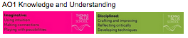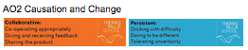

Factors that help us to understand why continuity took place in Medicine c1250-1500. Stick a copy in your book and highlight the key points.
Role of Individuals  The teachings of individuals like Hippocrates and Galen continued to be preserved by the Church in the years after the Roman Empire collapsed. However there were few significant individuals within the middle ages to really promote new approaches to the causes and treatments of illness and disease. |  | Old Ideas  After the Romans left Britain in 383 AD the Church preserved old ideas but also bound them up with ideas of God. There were little progress in Medicine by 1500 in terms of new ideas. Traditional cures and remedies continued to be important, and prayer was encouraged. |  | Role of Government  After the fragmented government for the early middle ages, there was greater centralised power and control within the period 1250-1500. Hoever, warfare was the main concern of King and government in this period, rather than medical developments. Local town authorities had some influence in terms of public health regulations
 |  | FACTORS OF CONTINUITY 1250-1500
Science and Technology  After the collapse of the Roman Empire, technical and engineering knowledge was lost. This meant that public health systems throughout both early and later Middle Ages were very limited. The Medieval times witnessed little development in terms of science and technology. |  | War  Within the Late Middle Ages, there were many wars which meant that governments were more focussed on raising money and organising soldiers than the health of the population. Also there was significant instability, which affected the economy and society, so that medical developments in terms of ideas practice was less likely. |  | Communication and Education  The Church was the only significant international organisation that could preserve and transmit the knowledge left by the Romans. The Church controlled training and preserved record but did not encourage new ideas.

Activity 2
Why were they still reading Galen in 1350? Read through Phase 1, 2 and 3 in DBL SHP Medicine Text, pages 48-49. Write three paragraphs to summarise each phase.
Activity 3
How did Anglo-Saxon, Viking and Norman ideas in the Middle Ages affect Medicine and public health c 383 AD - 1350 AD? Read through the changes and continuities in Medical ideas from Roman times to Medieval Britain c383 AD to 1500 AD.
Ideas that ended with the Roman rule in 383 AD | Ideas that continued from Roman Britain to the Medieval Britain. | New influences in the Medieval Britain
Government became very weak. Roman public health systems collapsed and there wasn’t the money or power to replace them. | Doctors continued to be trained according to the ideas of Hippocrates and Galen, because they were adapted to fit in with the teachings of the Christian Church who preserved what they could and controlled the teaching of doctors and surgeons. | The Christian Church dominated thinking and there was a strong belief that suffering in this life was temporary and controlled by God as a test of perseverance before beginning the afterlife in heaven.
Much of the knowledge of the Greek and roman thinkers and writers were lost in the wars that characterised Medieval Britain. | Traditional cures and remedies continued to be very important throughout. Supernatural and spiritual explanations of illness meant that charms and prayer were encouraged as treatments in Medieval Britain | The Christian Church actively resisted the influence of new ideas because they were seen as a threat to the spiritual explanation. However the Church did organise medical training and preserved the knowledge of Ancient Doctors.
There was lots of fighting but no central organisation of armies and no organised medical treatments for soldiers other than what the Church was able to provide | In addition treatments based on the theory of illness of imbalanced Four humours, that were encouraged by Galen, continued to be used in Medieval Britain | The Christian Church stressed the importance of caring for the sick, but caring rather than treating. Prayer was encouraged as a priority over medical interventions.

Activity 4
How far did changing ideas impact on medicine in the period 50-1500?
Analyse how far changing ideas impacted on medicine by plotting your own living graph and labelling some of the significant points related to changing ideas on it.
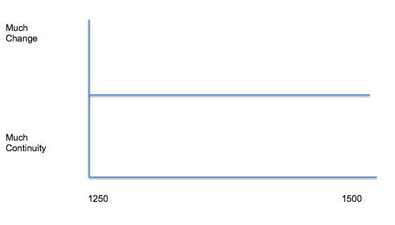

During the period 50-383 AD in Roman Britain new ideas about Medicine and public health were encouraged. These included new ideas on the causes and treatments of illness based on the Four Humours. | During the period 50-383 AD in Roman Britain, the Romans developed a strong system of government which gave both stability and raised money to concentrate on developing public health and medical development. | During the period 50-383 AD in Roman Britain a system of fresh water supply, sewers and army hospitals were developed throughout the main cities of Roman settlement in Britain 43AD to 383 AD.
During the Medieval Britain  383-1500 spiritual and supernatural ideas about the causes of illness predominated as the Christian Church established their control of Medical training and education. | During the Medieval Britain  383-1500 there was a period of intermittent wars for over a thousand years with Anglo saxons, Vikings and Normans competing for power. Government was not sufficiently stable to support developments in Medicine and the influence of the Church was very strong | During the Medieval Britain  383-1500 the public health systems established by the Romans fell into ruin and their was an absence of stability, money and desire to continue the progress the Romans had made.

Focus 1 How far did ideas about the causes of illness change 1250-1500?
Focus : Changing ideas about the Causes of illness.
Supernatural and religious explanations of the cause of disease. Rational explanations: the Theory of the Four Humours and the miasma theory; the continuing influence in England of Hippocrates and Galen.
Activity 1
The ideas of the Greek doctor Hippocrates on Medicine.
Explain the importance of the Greek doctor Hippocrates to medicine by completing the following mind map using DBL SHP Medicine text p28-29.
Hippocratic Oath p28 | Books p28 | Observing and recording p29
 | The significance of Hippocrates.
Causes of disease and the theory of the four humours p29 | Keeping healthy p29 | Natural treatments p29

Activity 2

The ideas of the Roman doctor Galen on Medicine.Explain the importance of the Roman doctor Galen to medicine by completing the following using DBL SHP Medicine text p30-32.
Why important p30 | Books p30 | Anatomy and dissection p31
 | The significance of Galen.
Diagnosis and Four Humours p31 | Influence p32 | Natural Treatments p31
Activity 3
The theory of the Four humours as the cause of illness and disease.
Stick the following table in. Then, using DBL SHP Medicine 29-31, write a paragraph to explain the theory of the Four Humours. The Four Humours had to be in balance for good health and, if not, then this was the cause of illness. Each humour was linked to a season and the four elements e.g. in winter,more water which produces too much phlegm so you would cough and sneeze to expel it.
Humour | Season | Element | Qualities | Ancient name
Blood | Spring | Air | Warm and moist | Sanguine
Yellow bile | Summer | Fire | Warm and dry | Choleric
Black bile | Autumn | Earth | Cold and dry | Melancholic
Phlegm | Winter | Water | Cold and moist | Phlegmatic

Activity 4
What were the different explanations of the causes of disease in the Middle Ages?
Describe the different ideas about the causes of disease. Use DBL SHP Medicine text page 42
Idea. | Description of ideas
1 God or the Devil.
2 The Four Humours.
3 Common sense - bad air or dirt.
4 Desperate explanations

Activity 5:

Why were the ideas of the Greeks and Romans still being used in Medicine in the Middle Ages?

Using DBL SHP Medicine Text p 48-49 complete three paragraphs of writing which explain why the Greeks and Romans still being read by 1350 and how things were beginning to change. The writing must include the following paragraphs;

The chaos in Western Europe after the fall of the Roman Empire (identify the role of Government, ideas, war, communication and education)

The growing power of the Catholic Church (identify the role of Government, ideas, war, communication and education)

The reasons which explain why change was on its way after 1100 ( identify the role of Government, ideas, war, communication and education)

Activity 6
How far did changing ideas impact on medicine in the period 50-1500?
Analyse how far changing ideas impacted on medicine by plotting your own living graph and labelling some of the significant points related to changing ideas on it.

During the period 50-383 AD in Roman Britain the theory of the four humours was very prominent which stressed that the causes of disease were imbalanced humours and could therefore be treated by restoring the balance. | During the period 50-383 AD in Roman Britain the idea that dirt and uncleanliness could be a cause of disease were very strong and this explains the importance that the Romans placed on good public health systems. | During the period 50-383 AD in Roman Britain there was also a belief that Gods could act to influence your life. When the Empire adopted Christianity in 313AD the power of God to control your health emerged.
During the period 383-1500 in Medieval Britain the strong influence of the Christian Church encouraged more spiritual explanations of the causes of illness and disease | During the period 383-1500 in Medieval Britain the ideas of Galen were continued with certain illnesses and disease being explained by the imbalance of the four humours. | During the period 383-1500 in Medieval Britain explanations of the causes of illness based on astrology and miasma were also encouraged

Activity 7

Exam style questions
3 Explain one way in which explanations of illness in Britain were similar in the Medieval period to that of the Ancient World. 4 marks

4 Explain why there was slow change in the explanations of the causes of illness in Britain during the period 1250-1500.You may use the following in your answer:
- The theory of the Four Humours
- The use of charms
You must also use information of your own. 12 marks

Answer EITHER Question 5 OR Question 6.

EITHER
5 ‘There was little progress in medicine in Britain during the Medieval period (c1250–c1500).’ How far do you agree? Explain your answer. 16 marks + 4 SPAG. You may use the following in your answer:
- Training of doctors being based on Ancients
- Influence of the Roman Catholic Church
You must also use information of your own

Focus 2 How far did approaches to treatment of illness change 1250-1500?
Focus Change in treatments and preventions.
Approaches to prevention and treatment and their connection with ideas about disease and illness: religious actions, bloodletting and purging, purifying the air, and the use of remedies.New and traditional approaches to hospital care in the thirteenth centuries. The role of the physician, apothecary and barber surgeon in treatment and care provided within the community and in hospitals, c1250–1500.
Activity 1
The treatments of Hippocrates and Galen were still widely used in 1500. Using DBL SHP Medicine text p29-30 identify as many treatments encouraged by Greek and Roman doctors that were still being used in Medieval Europe by 1500.
Ancient Doctor | Treatments they used
Hippocrates p29  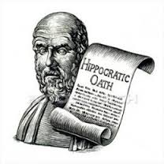 | 1 Natural Treatments  2 Keeping Healthy  3 Four Humours
Galen p30  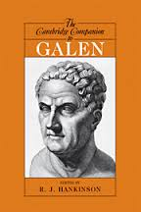 | 1 Natural Treatments  2 Keeping Healthy  3 Four Humours/Theory of the Opposites

Activity 2
Treatment of illness and disease in Medieval Britain c400 AD - 1500 AD.
Using DBL SHP Medicine text p38-41 make notes on Medieval healers, their experience and methods.
Who could you get Medical help from in Medieval Britain? What experience did they have? | How would they treat you?
1 Trained physicians. p38-39, p43  Experience | 1  2  3
2 In hospitals. Gods and their priests, and care homes. p40  Experience | 1  2  3
3 Trained doctors disappeared! Local healers p38  Experience | 1  2  3
4 Women p41  Experience | 1  2  3

Activity 3
How did they treat the sick in Medieval Britain c400 AD - 1500 AD.
Using DBL SHP Medicine text p44-45 make notes on Medieval healers, their experience and methods.
How would they treat you in Medieval Britain? What experience did they have? | How would they treat you?
1 The physician and the urine chart. p44  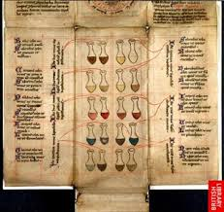 | 1  2  3
2 Bleeding p45  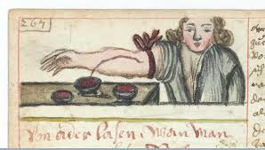 | 1  2  3
3 Home remedies p45 | 1  2  3

Activity 4
What were hospitals like by 1500?
Complete the following thinking matrix using DBL SHP Medicine text p40.

Hospitals in 1500 | Evidence of what hospitals were like in 1500
1 Hospital rules  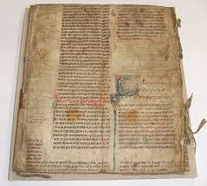 | 1  2  3
2 Specialist Hospitals  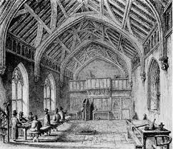 | 1  2  3
3 Care in hospitals  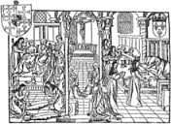 | 1  2  3

Activity5

How far did treatments change in medicine in the period 1250-1500? Analyse how far changing ideas impacted on treatments in medicine by plotting your own living graph and labelling some of the significant points related to changing ideas on it.

During the period 50-383 AD in Roman Britain treatments were often based on the theory of the four humours. For example if it was thought that your humours were imbalanced then they were restored e.g. bloodletting was used for too much blood. | During the period 50-383 AD in Roman Britain treatments there were trained doctors who followed Galen’s theory of the opposites. Treatments were often based on diet, exercise, lifestyle but also beginning to incorporate knowledge of plants and herbs from throughout the Empire. | During the period 50-383 AD in Britain, Roman treatments had spread. Although this was not quick because few doctors travelled to Britain, the army legions did have doctors and surgeons so that by the time the Romans left most doctors were following Roman ideas of treatments.
During the period 383-1500 in Medieval Britain treatments there was little change in the training of doctors, but doctors became far fewer in number. THere were only 100 physicians in the 1300s. For hundreds of years those who were sick mainly got help from the family, local wise women and men who had built up their knowledge through practise. | During the period 383-1500 in Medieval Britain looking after the sick was an important part of the work of the Christian Church and this led to the founding of many hospitals in Churches. By 1400 there were about 500 hospitals but they did not cater for the very sick and were more like care homes for rest and prayer | During the period 383-1500 in Medieval Britain treatments were often the role of women within the family and sometimes they consulted local wise women. They were not allowed to train as doctors or physicians and surgeons in the growing universities from 1200 onwards.
Activity 7

Exam style questions
3 Explain one way in which people’s reactions to the plague in Britain were similar in the fourteenth and seventeenth centuries. 4 marks

4 Explain why there was slow change in the treatment of illness in Britain during the period 1250-1500.You may use the following in your answer:
- The theory of the Four Humours
- The use of charms
You must also use information of your own. 12 marks

Answer EITHER Question 5 OR Question 6.

EITHER
5 ‘There was little progress in treatments of illness in Britain during the Medieval period (c1250–c1500).’ How far do you agree? Explain your answer. 16 marks + 4 SPAG. You may use the following in your answer:
- Training of doctors being based on Ancients
- Influence of the Roman Catholic Church
You must also use information of your own

Focus 3. Case study
Dealing with the Black Death, 1348–49; approaches to treatment and attempts to prevent its spread.

Activity 1
Why was the Black Death so devastating 1348? Answer the following questions in full paragraphs about the Black Death using DBL SHP Medicine text p52-53

Questions | Answers
1 Where and when did the Black Death occur?
2 How many people died in England as a result?
3 What do we now realise were the causes of the Black Death? (Source1)
4 Explain the two types of plague in the Black Death.
5 What were people’s reaction to the the Black Death? (Source2-3)

Activity 2
How were the causes of the Black Death 1348 explained at the time ?
Describe and explain what was thought to be the different possible causes of the Black Death 1348 DBL SHP Medicine text p58.

Possible explanations of the causes of the Black Death. | Evidence that this explanation of disease was used at the time.
1 A punishment from God
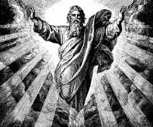
2 The positioning of planets
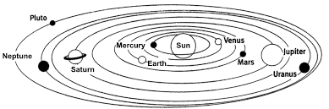
3 Miasma (bad air)
4 Imbalance Four Humours
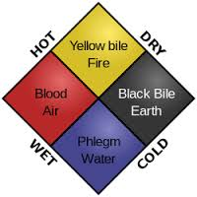
5 Scapegoating.

Activity 3
Why were Medieval physicians no help during the Black Death? DBL SHP Medicine Text p56 and 61.
Why were Medieval physicians no help to people during the Black Death?
1 Training of Medieval doctors.
2 Theory of the Four Humours
3 Preventing illness
4 Treating illness

Activity 4
How did people try to treat or stop the Black Death? DBL SHP Medicine Text p60-61.
 | How did people try to treat or stop the Black Death?
1 Avoiding the sickness  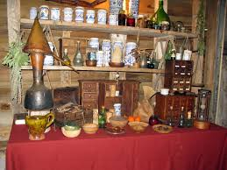 | 1  2
2 Treating with remedies | 1  2
3 Treating with prayer and superstition | 1  2
4 Treating with Four Humours | 1  2

Activity 5

Exam style questions
3 Explain one way in which people’s reactions to the Black Death in Britain were similar in the fourteenth and seventeenth centuries. 4 marks

4 Explain why there was slow change in the explanation of the causes and treatment of illness in Britain during the period 1250-1500.You may use the following in your answer:
- The theory of the Four Humours
- The use of charms
You must also use information of your own. 12 marks

Answer EITHER Question 5 OR Question 6.

EITHER
5 ‘There was little progress in dealing with infectious diseases in Britain during the Medieval period (c1250–c1500).’ How far do you agree? Explain your answer. 16 marks + 4 SPAG. You may use the following in your answer:
- Training of doctors being based on Ancients
- Influence of the Catholic Church
You must also use information of your own

(III) Assessment for Learning
Puzzle practise : Medicine and Public Health 1250-1500

In the puzzle there will be three compulsory questions and two optional questions covering the core content of Medicine and public health 50-2000. The content will come from either one or a combination of the key themes (ideas, causes, treatments and public health) covered in each of the key questions;
· The impact of changing ideas on the development of Medicine 1250-2000.
· The understanding of the causes of disease 1250-2000.
· The understanding of the methods of treatment and prevention 1250-2000.
· The development of public health provision 1250-2000.

The following examples are focussed on content from the second key question medicine 1250-1500.

Exam Practise

There are two sections in this question paper. Answer all Parts of Question 1 and 2A and 2b from Section A. From Section B, answer Questions 3 and 4 and then EITHER Question 5 OR Question 6.

SECTION B: Medicine in Britain, c1250–present
Answer Questions 3 and 4. Then answer EITHER Question 5 OR 6.

3 Explain one way in which people’s reactions to the plague in Britain were similar in the fourteenth and seventeenth centuries. 4 marks

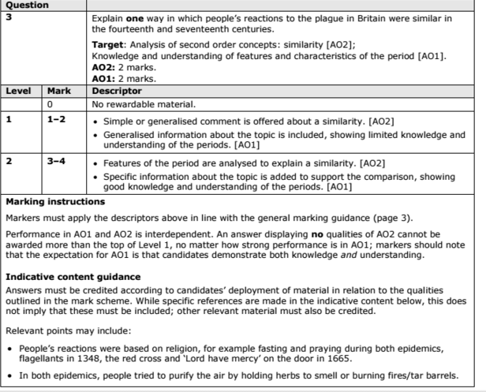

4 Explain why there was slow change in the treatment of illness in Britain during the Medieval period.You may use the following in your answer:
- bleeding
- home remedies
You must also use information of your own. 12 marks

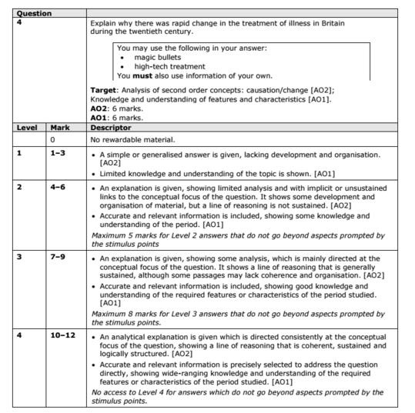

Answer EITHER Question 5 OR Question 6.

EITHER
5 ‘There was little progress in medicine in Britain during the Renaissance period (c1500–c1700).’ How far do you agree? Explain your answer. 16 marks + 4 SPAG. You may use the following in your answer:
•role of the church
•bloodletting and purging
You must also use information of your own
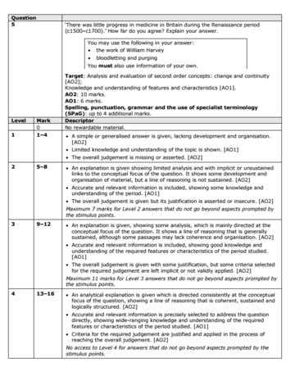

Trigger Memory Activity for Medicine 1250-1500
Trigger Words | Trigger Picture | Add Trigger Points from your notes
Factors of Change
Factors of continuity | 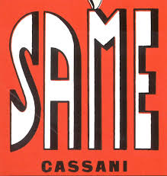
Medieval ideas on medicine by 1500 | 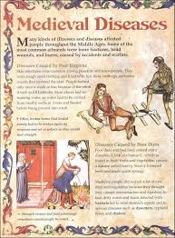
Hippocrates | 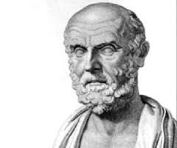
Galen | 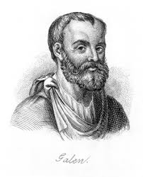
Theory of Four Humours | 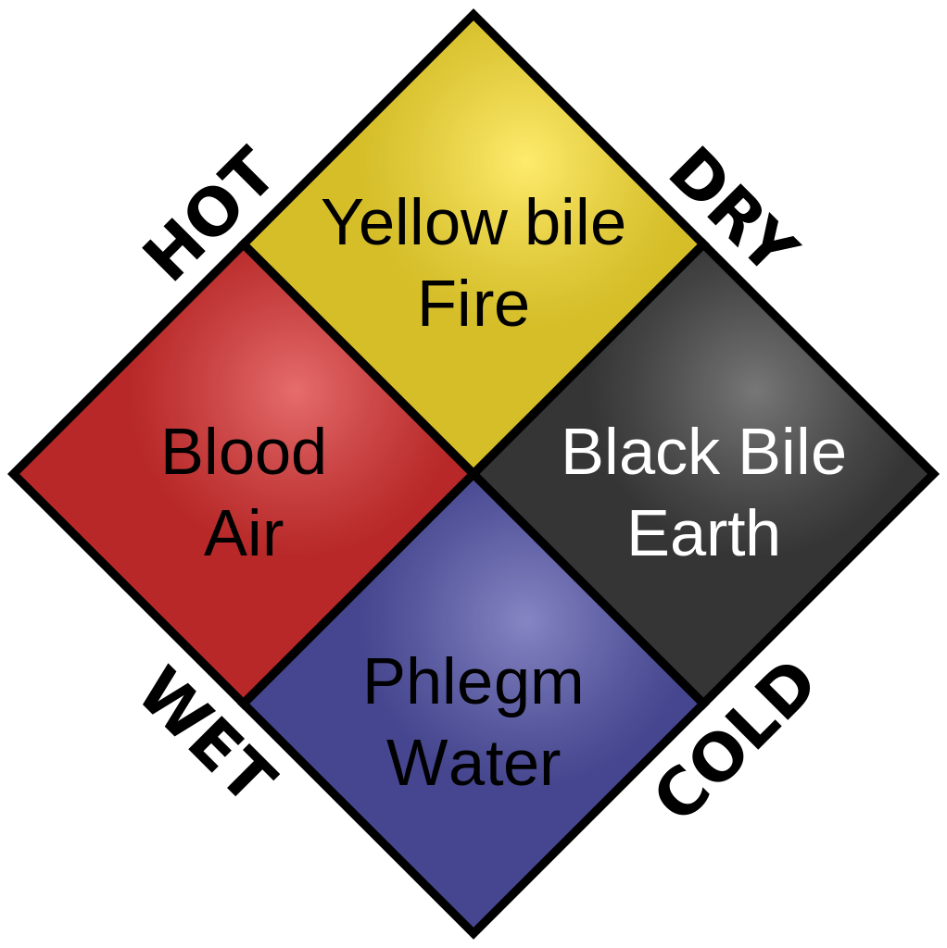
Medieval ideas on causes of disease by 1500 | 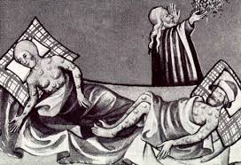
Treatments in Medieval period by 1500 | 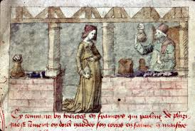
Hospitals in 1350-1500 | 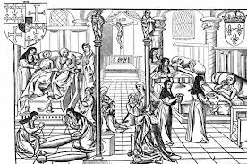
Reasons why public health systems collapsed | 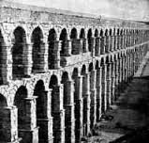
The Black Death | 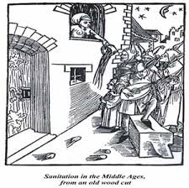

Trigger Memory Story Medicine 1250-1500

The story must be very imaginative. It must involve you seeing, talking and doing things. It must link the ten trigger words together in the form of a continuous story. You should then rehearse the story and commit it to your long term memory to be recalled when necessary. This will take some effort but will be very useful! Use different colours to write the trigger words in your story.

I was...

