Community Day 2019 – Tallis Voices, Tallis Rights
Human Rights Passport

What are Human Rights?
We are all human and we are all entitled to some fundamental rights. As people we should be able to expect to live a life that is free from discrimination and intolerance, one in which we can pursue our interests and form positive relationships with each other. However, there are many places in the world, including often in our own communities, where this is not the case. The coming weeks are about understanding human rights and standing up for everyone, everywhere. At Tallis we believe in being fair, kind, honest, respectful and optimistic and in understanding the world so that we can change it for the better – this is exactly what the coming Community Day is about,
Over the coming few weeks you will have various opportunities to think about Human Rights. After each of the sessions itemised below, write or draw you thoughts in response to the question posed. You will keep this with your tutor and fill it out at the end of each session.

Input | What have I learnt about human rights? How do I feel about human rights?
PSHCE lesson
5th June
Registration 1
10th June
Registration 2
12th June
Registration 3
14th June
Community Day
19th June
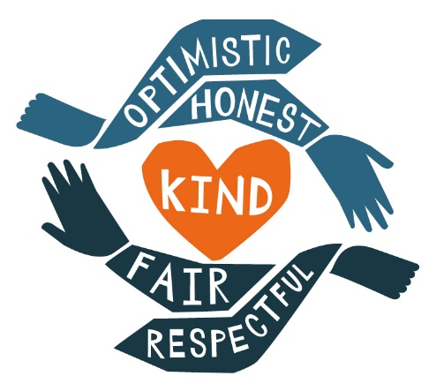
How do human rights link to Tallis Character?

