Has the world become safer since 1945?
Evidence 1: Timeline of the decades of the period 1945-2020. The pattern is complex. At times there is evidence of an escalation of conflict and therefore a more dangerous world. However there is also evidence of international cooperation and thus a safer world.
The world is safer due to… | The UN  - Set up in 1945, it aims to resolve conflict without violence and encourages countries to work together.  - Introduced the Universal Declaration of Human Rights.  - Works with the European Economic Community and the Southeast Asian Treaty Organisation.  - Has 193 members worldwide. | Détente  - Following the Cuban Missile Crisis, 1962, a hotline was set up between the American and Soviet leaders to help them communicate and avoid conflict.  - In the late 1960s until 1979, a period of improved relations emerged and a number of treaties were signed, as both sides feared nuclear war. | The end of the Cold War  - In 1985 Michael Gorbachov became leader of the USSR and he began reforming the country.  - He held talks with the USA that brought the Cold War to an end in 1990.  - Communist ideas were abandoned by Russia and eastern Europe, which became free.  - The threat of nuclear war disappeared. | The UN  - The UN continued to intervene to prevent the spread of conflict in south east Europe and the escalation of conflict in the Middle East.  - The UN also made major efforts to prevent the spread of nuclear weapons from North Korea to Middle-Eastern countries like Iran and Syria. | The UN  - UN Peacekeeping helps countries to end conflict and find peace.  - They have unique strengths, such as being able to integrate civilian peacekeepers with soldiers to help countries adjust after wars. Currently there are over 100,000 UN peacekeepers in 14 areas across the world.
Time | 1945-62 | 1962-79 | 1979-90 | 1990-2001 | 2001-2019
The war is more dangerous due to… | The Cold War  - Began in 1945, between the USA and USSR  - There was an arms race and major wars in Korea (1950-52), crisis in Berlin 1948 and the Cuban Missile Crisis of 1962. | Conflict  - The Vietnam War (1955-75) escalated.  - Major Arab- Israeli wars broke out in 1967 and 1973.  - The USSR repressed uprisings in Poland and Czechoslovakia and built a wall to divide Berlin in 1961. | Conflict  - USSR invaded Afghanistan in 1979, leading to Cold War 2.  - America and Britain expanded their nuclear weapons.  - USSR and USA intervened worldwide against opposition governments | Conflict  - During the 1990’s there were dangerous conflicts in Europe and in the Middle East.  - 11/9/2001: terrorists destroyed the World Trade Centre. America and its allies went to war with Afghanistan 2001 and Iraq in 2003. | Conflict  - Since 2000 there have been conflicts in the Middle East and civil wars in Iraq and Syria following western intervention.  - Terrorism has increased globally.  - Conflicts continue over alliances and trade.
Evidence 2: Graphs showing statistics on wars over time.
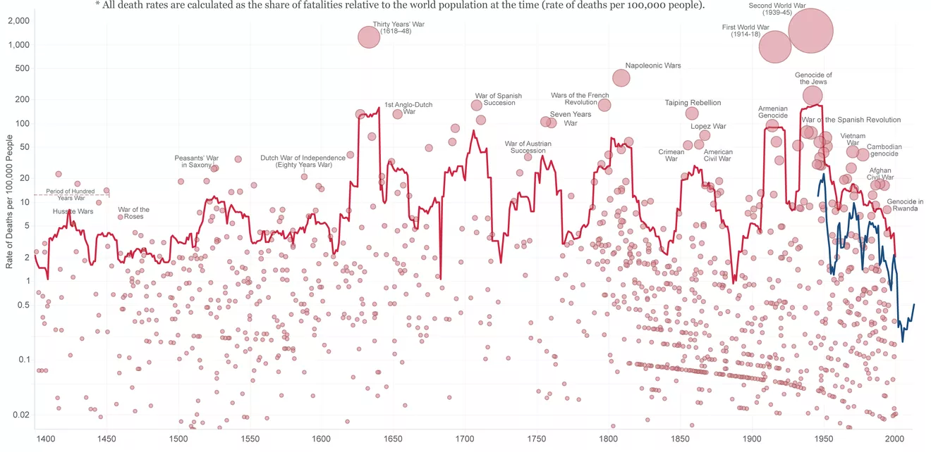

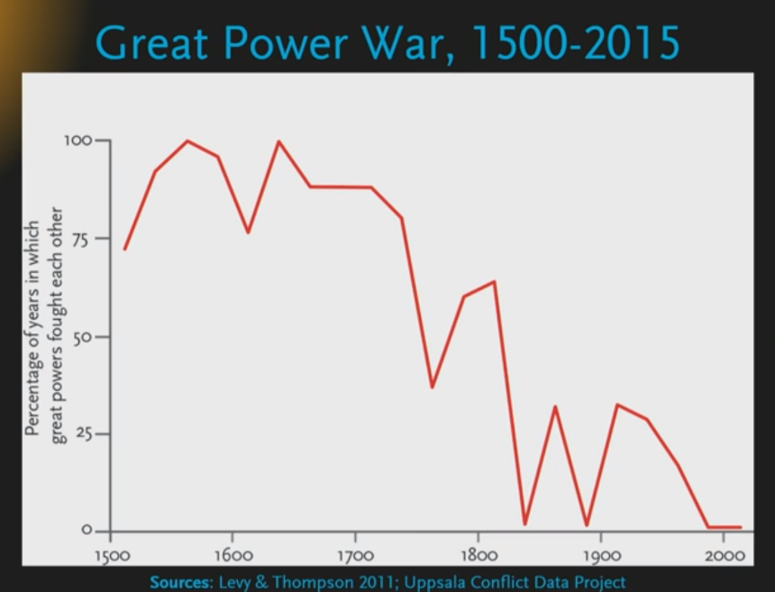
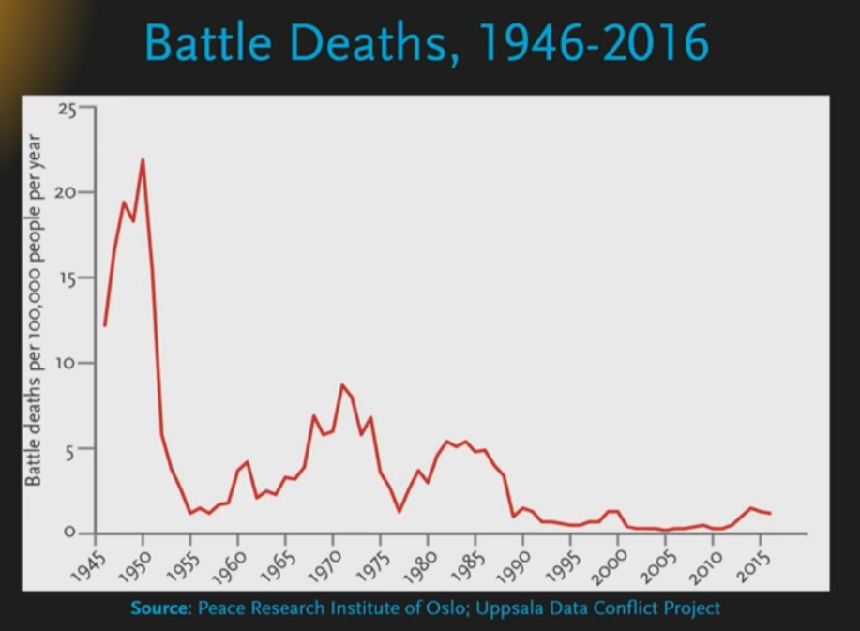

Evidence 3: Graph and Map showing statistics on terrorism over time.

Evidence 4: Extract from the Universal Declaration of Human Rights, signed on 10th December 1948.
Article 1. All human beings are born free and equal in dignity and rights.They are endowed with reason and conscience and should act towards one another in a spirit of brotherhood.

Article 2. Everyone is entitled to all the rights and freedoms set forth in this Declaration, without distinction of any kind, such as race, colour, sex, language, religion, political or other opinion, national or social origin, property, birth or other status. Furthermore, no distinction shall be made on the basis of the political, jurisdictional or international status of the country or territory to which a person belongs, whether it be independent, trust, non-self-governing or under any other limitation of sovereignty.

Article 3. Everyone has the right to life, liberty and security of person.

Article 4. No one shall be held in slavery or servitude; slavery and the slave trade shall be prohibited in all their forms.

Article 5. No one shall be subjected to torture or to cruel, inhuman or degrading treatment or punishment.

