Key Topic 4: Life in Nazi Germany, 1933–39
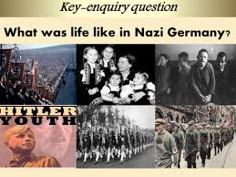

Content
In a Nutshell: Overview of developments

Focus 1 Nazi policies towards women

Focus 2 Nazi policies towards the young

Focus 3 Employment and living standards

Focus 4 The persecution of minorities

Cracking the Puzzle – Preparing for assessment.

Content
In a Nutshell: Overview of developments

Causes and Analysis including:

Focus 1 Nazi policies towards women
Nazi views on women and the family.
Nazi policies towards women, including marriage and family, employment and appearance.

Focus 2 Nazi policies towards the young
Nazi aims and policies towards the young. The Hitler Youth and the League of German Maidens.
Nazi control of the young through education, including the curriculum and teachers.

Focus 3 Employment and living standards
Nazi policies to reduce unemployment, including labour service, autobahns, rearmament and invisible unemployment.
Changes in the standard of living, especially of German workers. The Labour Front, Strength Through Joy, Beauty of Labour.

Focus 4 The persecution of minorities
Nazi racial beliefs and policies and the treatment of minorities: Slavs, ‘gypsies’, homosexuals and those with disabilities.
The persecution of the Jews, including the boycott of Jewish shops and businesses (1933), the Nuremberg Laws and Kristallnacht.

Thematic Analysis of Wider context through a Mystery game;
Why did ?

Cracking the Puzzle – Preparing for assessment.

Language and Literacy
Key Terms and their meanings in Medicine 1250-1500.

(I) In a Nutshell: Overview of
Content overview
Focus 1 Nazi policies towards women
Nazi views on women and the family.
Nazi policies towards women, including marriage and family, employment and appearance.

Focus 2 Nazi policies towards the young
Nazi aims and policies towards the young. The Hitler Youth and the League of German Maidens.
Nazi control of the young through education, including the curriculum and teachers.

Focus 3 Employment and living standards
Nazi policies to reduce unemployment, including labour service, autobahns, rearmament and invisible unemployment.
Changes in the standard of living, especially of German workers. The Labour Front, Strength Through Joy, Beauty of Labour.

Focus 4 The persecution of minorities
Nazi racial beliefs and policies and the treatment of minorities: Slavs, ‘gypsies’, homosexuals and those with disabilities.
The persecution of the Jews, including the boycott of Jewish shops and businesses (1933), the Nuremberg Laws and Kristallnacht.

(II) Causes and Analysis of developments:
Activity 1 – On your marks…..
The timeline grid sums up developments between 1919-1933. It covers economic developments, changes for the weimar government, and developments in the Nazi Party. For each area colour code each box; stable/successful (green), becoming unstable/some difficulties (yellow) or significant problems/unsuccessful (red).

Activity 2 – Get set…..
Your teacher will give you an A3 copy of a concept map. Stick it in your book. You will fill sections in at the end of each key focus area. As well as adding information to your concept map you can add a colour scheme to identify key themes.

Activity 3 – Go…..
As well as the lesson work and activities, read your book independently and visit the library. There are also many excellent websites listed in the back of this booklet to check out. Try to develop your own individual interest in this area of focus .
Focus 1. Nazi policies towards women.
Nazi views on women and the family.
Nazi policies towards women, including marriage and family, employment and appearance.

Activity 1: 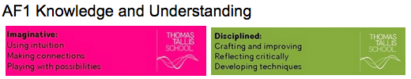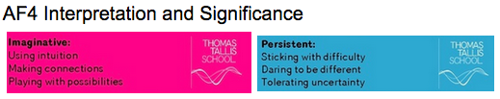
Nazi views on women and the family.
Nazi views on women and the family.

The Nazi view of the role of women
Nazi policies
Nazi ideals

Activity 2:
Nazi policies towards women, including marriage and family, employment and appearance.
Nazi policies towards women, including marriage and family, employment and appearance.

Marriage and the family
Nazi organisations for women
Appearance
Work
Concentration camps
Were these policies successful

Exam Practise KT4 F1
SECTION A
Answer both questions.
Study Source A and then answer Question 1
1 Give two things you can infer from source A about the role of women in Nazi Germany 4 marks

Source A From a speech by Gertrude Scholtz-Klink, after she became Head of the Nazi Women’s Organisation in 1933

Woman is entrusted in the life of the nation with a great task, the care of man - soul, body and mind. It is the mission of woman to minister in the home and in her profession to the needs of life from the first to the last moment of man’s existence. Her mission is comrade, helper and womanly complement of man - this the right of woman in the new Germany.

Guidance
Source A suggests that

I know this because the source says that..

Source A also suggests that

I know this because the source says that..

2 Explain why women’s role changed in Nazi germany.
You may use the following in your answer:
- Nazi ideal and policies
- Married and family life
You must also use information of your own. 12 marks

Guidance
There are three main reasons which link together that explain why X occurred including a, b and c.

The first reason is a. Give three points to support the reason.

The second reason is b. Give three points to support the reason.

The third reason is c. Give three points to support the reason.

Conclusion. Comment on how the reasons link together

Exam Practise KT4 F1
SECTION B
For this section, you will need to use the sources and interpretations in the Sources/Interpretations Booklet.

3 (a) Study Sources B and C.
How useful are Sources B and C for an enquiry into the success of Nazi policies towards women?
Explain your answer, using Sources B and C and your knowledge of the historical context. 8 marks

Source B From a speech by Gertrude Scholtz-Klink, after she became Head of the Nazi Women’s Organisation in 1933  Woman is entrusted in the life of the nation with a great task, the care of man - soul, body and mind. It is the mission of woman to minister in the home and in her profession to the needs of life from the first to the last moment of man’s existence. Her mission is comrade, helper and womanly complement of man - this the right of woman in the new Germany. | Source C Judith Grunfeld An American journalist 1937  How many women did the Fuhrer send home? According to the statistics of the German Department of Labour, there were in June 1936 5,470,000 employed women or 1,200,000 more than in January 1933. The Nazi campaign has not been successful in reducing the number of women employed. It has simply squeezed them out of better paid positions into the sweated trades. This type of labour with its miserable wages and long hours is extremely dangerous to the health of women and degrades the family.

Guidance
The sources B and C have both strengths and limitations for an enquiry into X

Source B is useful in its content and NOP. 3 main points supported by K. However it is limited also because..supported by K.

Source C is useful in its content and NOP. 3 main points supported by K.

However it is limited also because.supported by K..

3 (b) Study Interpretations 1 and 2.
They give different views about the success of Nazi policies towards women. What is the main difference between these views? Explain your answer, using details from both interpretations. 4 marks

Interpretation 1 Lacey 1997  Nazi womens policies were successful for women. The years 1933-39 were good time since those hit by the depression were much better off and benefitted not only from better wages for those in work. Motherhood and women’s role within the family was widely respected and rewarded by the Nazi state. Many women were keen supporters of the Nazi’s and many were in absolute admiration of Hitler’s charisma. This was especially supported by the Fuhrer’s letters and in Nazi Party rallies. | Interpretation 2 Sheppard 1997  Nazi womens policies were unsuccessful. Any potential benefits were highly affected by whether she had a job, her age and her race. Nazi policy was full of contradiction and chaos, particularly with regard to women’s employment since after years of trying to get women out of work increasingly they discovered as the war economy developed after 1936 that they needed them back. Furthermore this collided with the Nazi aim for women to produce more children.

Guidance
Interpretation 1 views the attitudes of X towards Y as……….. This is supported by the quotes “a” and “b”.

On the other hand Interpretation 2 views the attitudes of X towards Y as…… …...This is supported by the quotes “a” and “b”.

3 (c) Suggest one reason why Interpretations 1 and 2 give different views about the success of Nazi policies towards women. You may use Sources B and C to help explain your answer. 4 marks

Guidance
Note: There are 2 possible reasons why the Interpretations differ and you only need to explain 1! Use either of the following plans. p38

Reason 1
The interpretations differ because they have given different weight to two different sources. Identify the views given in the two sources and show how the views match the two interpretations.

Reason 2
The interpretations may differ because the author emphasises and focuses on different aspects of the problem. Identify the different focuses and emphasis given and show how these match the two sources.

3 (d) How far do you agree with Interpretation 2 about the success of Nazi policies towards women?
Explain your answer, using both interpretations and your knowledge of the historical context. 20 marks

Up to 4 marks of the total for part (d) will be awarded for spelling, punctuation, grammar and use of specialist terminology.

Guidance
I mainly agree/disagree with the view given in interpretation 2 which supports the view that

Part 1
There is evidence to support Interpretation 2. Expand the paragraph using 3 main points from your own Knowledge.
Part 2

However Interpretation 1 challenges this view because it suggests that….Expand the paragraph using 3 main points from Interpretation 1.

Part 3
Furthermore Interpretation 2 does not take account of other factors involved. Expand the paragraph using 3 main points from your own Knowledge.

Overall I mainly agree/disagree primarily because the evidence which supports/challenges it is more convincing. I think this because

Focus 2. Nazi policies towards the young.
Nazi aims and policies towards the young. The Hitler Youth and the League of German Maidens.
Nazi control of the young through education, including the curriculum and teachers.

Activity 1:
Nazi aims and policies towards the young. The Hitler Youth and the League of German Maidens.
Nazi aims and policies towards the young. The Hitler Youth and the League of German Maidens.

The Hitler Youth
How successful were these policies

Activity 2:
Nazi control of the young through education, including the curriculum and teachers.
 | Nazi control of the young through education, including the curriculum and teachers.
Control of the young through education
Schools | Textbooks  Teachers  Lessons  Curriculum

Exam Practise KT4 F2
SECTION A
Answer both questions.
Study Source A and then answer Question 1
1 Give two things you can infer from source A about education in Nazi Germany. 4 marks

Source A From memoirs, written in the 1960’s of a German who was a student in the 1930’s.

No one in our class ever read Mein Kampf. I myself only ever used the book for quotations. In general we did not do much about Nazi ideals. Anti-Semitism wasn’t mentioned much by our teachers except through Richard wagner’s essay “The Jews in Music”. We did however, do a lot of physical education and cookery.

Guidance
Source A suggests that

I know this because the source says that..

Source A also suggests that

I know this because the source says that..

2 Explain why the young people were influenced by Nazi ideas.
You may use the following in your answer:
- Hitler Youth
- Nazi policies in school
You must also use information of your own. 12 marks

Guidance
There are three main reasons which link together that explain why X occurred including a, b and c.

The first reason is a. Give three points to support the reason.

The second reason is b. Give three points to support the reason.

The third reason is c. Give three points to support the reason.

Conclusion. Comment on how the reasons link together

Exam Practise KT4 F2
SECTION B
For this section, you will need to use the sources and interpretations in the Sources/Interpretations Booklet.

3 (a) Study Sources B and C.
How useful are Sources B and C for an enquiry into the attitudes of young people toward the Hitler Youth?
Explain your answer, using Sources B and C and your knowledge of the historical context. 8 marks

Source B From a British magazine 1938  There seems little enthusiasm for the Hitler youth, with membership falling. Many no longer want to be commanded, but wish to do as they like. Usually only a third of a group appears for roll call. At evening meetings it is a great event if 20 turn up out of 80, but usually there are only 10 or 12. | Source C The memoirs of a Hitler Youth leader  What i liked about the Hitler Youth was the comradeship. I was full of enthusiasm when i joined the Young people at the age of 10. I was deeply moved by the club motoes “Young people are hard. They can keep a secret. They are loyal. They are comrades”. And then there were the trips. Is anything nicer than enjoying the splendours of the homeland in the company of one’s comrades?

Guidance
The sources B and C have both strengths and limitations for an enquiry into X

Source B is useful in its content and NOP. 3 main points supported by K. However it is limited also because..supported by K.

Source C is useful in its content and NOP. 3 main points supported by K.

However it is limited also because.supported by K..

3 (b) Study Interpretations 1 and 2.
They give different views about the attitudes of young people toward the Hitler Youth. What is the main difference between these views? Explain your answer, using details from both interpretations. 4 marks

Interpretation 1 Wright 2016  The Nazis wanted to control the young in their spare time. This was to be achieved through the Hitler Youth for boys and girls and all other youth organisations were banned. By 1939 there were 7 million members. Many enjoyed the comradeship and the activities and felt a sense of belonging and commitment toward the values of the new Germany or Volksgemeinschaft. | Interpretation 2 Waugh 2016  Although many of the young joined the Hitler youth, it was not popular with some of its members and not all young people accepted the Nazi ideas. Indeed by the mid 30’s gangs began to appear on street corners. They played their own music and boys and girls were free to be together. Many grew their hair long and wore their own choice of clothes as a rebellion against the regimentation of Nazi ideas.

Guidance
Interpretation 1 views the attitudes of X towards Y as……….. This is supported by the quotes “a” and “b”.

On the other hand Interpretation 2 views the attitudes of X towards Y as…… …...This is supported by the quotes “a” and “b”.

3 (c) Suggest one reason why Interpretations 1 and 2 give different views about the attitudes of young people toward the Hitler Youth. You may use Sources B and C to help explain your answer. 4 marks

Guidance
Note: There are 2 possible reasons why the Interpretations differ and you only need to explain 1! Use either of the following plans. p38

Reason 1
The interpretations differ because they have given different weight to two different sources. Identify the views given in the two sources and show how the views match the two interpretations.

Reason 2
The interpretations may differ because the author emphasises and focuses on different aspects of the problem. Identify the different focuses and emphasis given and show how these match the two sources.

3 (d) How far do you agree with Interpretation 2 about the attitudes of young people toward the Hitler Youth?
Explain your answer, using both interpretations and your knowledge of the historical context. 20 marks

Up to 4 marks of the total for part (d) will be awarded for spelling, punctuation, grammar and use of specialist terminology.

Guidance
I mainly agree/disagree with the view given in interpretation 2 which supports the view that

Part 1
There is evidence to support Interpretation 2. Expand the paragraph using 3 main points from your own Knowledge.

Part 2
However Interpretation 1 challenges this view because it suggests that….Expand the paragraph using 3 main points from Interpretation 1.

Part 3
Furthermore Interpretation 2 does not take account of other factors involved. Expand the paragraph using 3 main points from your own Knowledge.

Overall I mainly agree/disagree primarily because the evidence which supports/challenges it is more convincing. I think this because

Focus 3. Employment and living standards.
Nazi policies to reduce unemployment, including labour service, autobahns, rearmament and invisible unemployment.
Changes in the standard of living, especially of German workers. The Labour Front, Strength Through Joy, Beauty of Labour.

Activity 1:
Nazi policies to reduce unemployment, including labour service, autobahns, rearmament and invisible unemployment.
Nazi policies to reduce unemployment, including labour service, autobahns, rearmament and invisible unemployment.

The Reich Labour service
Invisible unemployment
Job creation schemes
Rearmament

Activity 2:
Changes in the standard of living, especially of German workers. The Labour Front, Strength Through Joy, Beauty of Labour.
Changes in the standard of living, especially of German workers. The Labour Front, Strength Through Joy, Beauty of Labour.

Better off
Worse off

Exam Practise KT4 F3
SECTION A
Answer both questions.
Study Source A and then answer Question 1
1 Give two things you can infer from source A about the Reich Labour service. 4 marks

Source A An Austrian visitor describes a Labour Service camp in 1938

The camps are organised on thoroughly military lines. The youths wear uniforms like soldiers. The only difference is that they carry spades rather than rifles and work in the fields.They spend a part of every day carrying out military drills.

Guidance
Source A suggests that

I know this because the source says that..

Source A also suggests that

I know this because the source says that..

2 Explain why there was a great reduction in unemployment in Germany 1933-39.
You may use the following in your answer:
- Rearmament
- The Reich Labour Service
You must also use information of your own. 12 marks

Guidance
There are three main reasons which link together that explain why X occurred including a, b and c.

The first reason is a. Give three points to support the reason.

The second reason is b. Give three points to support the reason.

The third reason is c. Give three points to support the reason.

Conclusion. Comment on how the reasons link together

Exam Practise KT4 F3
SECTION B
For this section, you will need to use the sources and interpretations in the Sources/Interpretations Booklet.

3 (a) Study Sources B and C.
How useful are Sources B and C for an enquiry into the changing standard of living?
Explain your answer, using Sources B and C and your knowledge of the historical context. 8 marks

Source B Nazi Women’s League member on a train in Germany 1936 commenting on the state of the economy  You can not expect the misery brought about by fourteen years of mismanagement will be cured in the twinkling of an eye. But now people have hope. They are off the streets and Germany is strong and powerful again. We have regained our honour. In three years Hitler as accomplished miracles, and from year to year things are getting better. Workers can think of a holiday with Strength through Joy. People have faith in the Fuhrer. | Source C An autobahn worker on a train in Germany 1936 commenting on the state of the economy  At the beginning of 1933 there were over six million unemployed, and now there is only two million. But it is also true that at the beginning of 1933 I was earning good money in my own trade and was at home - and now we work ourselves to the bone and are away from home and the wages keep going down. The whole thing stinks.

Guidance
The sources B and C have both strengths and limitations for an enquiry into X

Source B is useful in its content and NOP. 3 main points supported by K. However it is limited also because..supported by K.

Source C is useful in its content and NOP. 3 main points supported by K.

However it is limited also because.supported by K..

3 (b) Study Interpretations 1 and 2.
They give different views about the changing standard of living. What is the main difference between these views? Explain your answer, using details from both interpretations. 4 marks

Interpretation 1 Waugh 2016  Nazi economic policies of full employment and creating a national community (Volksgemeinschaft) were successful in winning workers over to the regime. Various incentive schemes were introduced such as Strength through Joy set up by the German Labour Front sponsoring a range of leisure activities at low cost including holidays and cultural activities provided at low cost for ordinary German workers to participate. | Interpretation 2 Wright 2016  Although Nazis offered schemes and incentives not all workers benefitted. The trade unions were banned in 1933 ending their right to enter into negotiations with employers for better pay or hours of work. Strikes were banned and opponents of the regime sent to concentration camps ro re-education. The cost of living rose 1933-39 as many food items were in short supply, wages did not match this increase and average working hours increased.

Guidance
Interpretation 1 views the attitudes of X towards Y as……….. This is supported by the quotes “a” and “b”.

On the other hand Interpretation 2 views the attitudes of X towards Y as…… …...This is supported by the quotes “a” and “b”.

3 (c) Suggest one reason why Interpretations 1 and 2 give different views about the changing standard of living. You may use Sources B and C to help explain your answer. 4 marks

Guidance
Note: There are 2 possible reasons why the Interpretations differ and you only need to explain 1! Use either of the following plans. p38

Reason 1
The interpretations differ because they have given different weight to two different sources. Identify the views given in the two sources and show how the views match the two interpretations.

Reason 2
The interpretations may differ because the author emphasises and focuses on different aspects of the problem. Identify the different focuses and emphasis given and show how these match the two sources.

3 (d) How far do you agree with Interpretation 2 about the changing standard of living?
Explain your answer, using both interpretations and your knowledge of the historical context. 20 marks

Up to 4 marks of the total for part (d) will be awarded for spelling, punctuation, grammar and use of specialist terminology.

Guidance
I mainly agree/disagree with the view given in interpretation 2 which supports the view that

Part 1
There is evidence to support Interpretation 2. Expand the paragraph using 3 main points from your own Knowledge.

Part 2
However Interpretation 1 challenges this view because it suggests that….Expand the paragraph using 3 main points from Interpretation 1.

Part 3
Furthermore Interpretation 2 does not take account of other factors involved. Expand the paragraph using 3 main points from your own Knowledge.

Overall I mainly agree/disagree primarily because the evidence which supports/challenges it is more convincing. I think this because

Focus 4. The persecution of minorities.
Nazi racial beliefs and policies and the treatment of minorities: Slavs, ‘gypsies’, homosexuals and those with disabilities.
The persecution of the Jews, including the boycott of Jewish shops and businesses (1933), the Nuremberg Laws and Kristallnacht.

Activity 1:
Nazi racial beliefs and policies and the treatment of minorities: Slavs, ‘gypsies’, homosexuals and those with disabilities.
 | Nazi racial beliefs and policies and the treatment of minorities: Slavs, ‘gypsies’, homosexuals and those with disabilities.
Nazi racial beliefs
The treatment of minorities | People with disabilities  Homosexual people  The Gypsies

Activity 2:
The persecution of the Jews, including the boycott of Jewish shops and businesses (1933), the Nuremberg Laws and Kristallnacht.

The persecution of the Jews, including the boycott of Jewish shops and businesses (1933), the Nuremberg Laws and Kristallnacht.
The persecution of the Jews
How did the lives of German jews change 1933-39?
The boycott of Jewish shops April 1933
The Nuremberg Laws 1935
Kristallnacht, 9 November 1938
The aftermath
Measures taken against the Jews

Exam Practise KT4 F4
SECTION A
Answer both questions.
Study Source A and then answer Question 1
1 Give two things you can infer from source A about the treatment of Jews in Nazi Germany. 4 marks

Source A The Reich Citizenship Law 1935 (Nuremberg Law)

Only a national of Germany or similar blood, who proves by his behaviour that he is willing and able loyally to serve the German people and Reich is a citizen of the Reich. A jew may not be a citizen of the Reich. He has no vote. He may not hold any public office.

Guidance
Source A suggests that

I know this because the source says that..

Source A also suggests that

I know this because the source says that..

2 Explain why there were changes to the lives of Jewish people in Germany 1933-39.
You may use the following in your answer:
- The Nuremberg Laws 1935
- Kristallnacht 1938
You must also use information of your own. 12 marks

Guidance
There are three main reasons which link together that explain why X occurred including a, b and c.

The first reason is a. Give three points to support the reason.

The second reason is b. Give three points to support the reason.

The third reason is c. Give three points to support the reason.

Conclusion. Comment on how the reasons link together

Exam Practise KT4 F4
SECTION B
For this section, you will need to use the sources and interpretations in the Sources/Interpretations Booklet.

3 (a) Study Sources B and C.
How useful are Sources B and C for an enquiry into the attitudes of Germans towards the events of Kristallnacht?
Explain your answer, using Sources B and C and your knowledge of the historical context. 8 marks

Source B A British newspaper Daily Telegraph report 12 November 1938  Mob law ruled in Berlin...as hordes of hooligans went on an orgy of destruction. I have never seen an anti jewish outbreak as sickening….fashionably dressed women clapped their hands with screaming glee and held their children up to see the fun. No attempt was made by the police to stop the rioters. | Source C A British newspaper Daily Mail report 12 November 1938  On the 9th and 10th November gangs smashed and burned jewish property. Some gangs were in Nazi uniforms, others were SA and Hitler Youth. They had been instructed not to wear uniforms so that the violence would appear to be the general public. Some Germans were horrified with the events of Kristallnacht.

Guidance
The sources B and C have both strengths and limitations for an enquiry into X

Source B is useful in its content and NOP. 3 main points supported by K. However it is limited also because..supported by K.

Source C is useful in its content and NOP. 3 main points supported by K.

However it is limited also because.supported by K..

3 (b) Study Interpretations 1 and 2.
They give different views about the attitudes of Germans towards the events of Kristallnacht. What is the main difference between these views? Explain your answer, using details from both interpretations. 4 marks

Interpretation 1 The Third Reich in Power, R J Evans 2006  The violence during Kristallnacht was familiar from the behaviour of brownshirts in 1933. But this time in went much further. It was clearly more widespread and destructive. It demonstrated the hatred of jews now gripped not only the stormtroopers and Nazi Party activists but was spreading to other parts of the population - above all to the young, upon whom five years of Nazism in schools and the Hitler Youth had clearly had an effect. | Interpretation 2 Life in Germany, Waugh 2009  This led to Kristallnacht, so called because of thousands of jewish shop windows which were smashed. Many Germans watched the events with alarm and concern. However the Nazi controlled press presented it as a reaction of ordinary Germans against Jews. Most Germans did not believe this, but hardly anyone protested for fear of arrest and death.

Guidance
Interpretation 1 views the attitudes of X towards Y as……….. This is supported by the quotes “a” and “b”.

On the other hand Interpretation 2 views the attitudes of X towards Y as…… …...This is supported by the quotes “a” and “b”.

3 (c) Suggest one reason why Interpretations 1 and 2 give different views about the attitudes of Germans towards the events of Kristallnacht. You may use Sources B and C to help explain your answer. 4 marks

Guidance
Note: There are 2 possible reasons why the Interpretations differ and you only need to explain 1! Use either of the following plans. p38

Reason 1
The interpretations differ because they have given different weight to two different sources. Identify the views given in the two sources and show how the views match the two interpretations.

Reason 2
The interpretations may differ because the author emphasises and focuses on different aspects of the problem. Identify the different focuses and emphasis given and show how these match the two sources.

3 (d) How far do you agree with Interpretation 2 about the attitudes of Germans towards the events of Kristallnacht?
Explain your answer, using both interpretations and your knowledge of the historical context. 20 marks

Up to 4 marks of the total for part (d) will be awarded for spelling, punctuation, grammar and use of specialist terminology.

Guidance
I mainly agree/disagree with the view given in interpretation 2 which supports the view that

Part 1
There is evidence to support Interpretation 2. Expand the paragraph using 3 main points from your own Knowledge.

Part 2
However Interpretation 1 challenges this view because it suggests that….Expand the paragraph using 3 main points from Interpretation 1.

Part 3
Furthermore Interpretation 2 does not take account of other factors involved. Expand the paragraph using 3 main points from your own Knowledge.

Overall I mainly agree/disagree primarily because the evidence which supports/challenges it is more convincing. I think this because

(III) Assessment for Learning
Puzzle practise : X
In the puzzle there will be 3 compulsory questions 1,2 and 3a b c and d. The content will come from either one or a combination of the key themes covered in each of the key questions;

The following examples are focussed on content from ..

Exam Practise
SECTION A
Answer both questions.
Study Source A and then answer Question 1
1 Give two things you can infer from source A about X. 4 marks

Source A

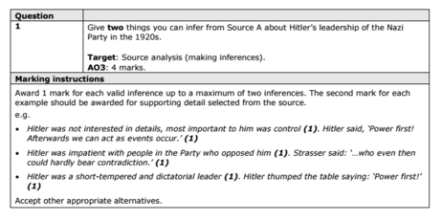

2 Explain why X.
You may use the following in your answer:

You must also use information of your own. 12 marks

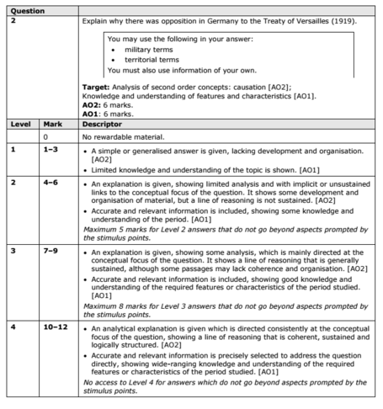

SECTION B
For this section, you will need to use the sources and interpretations in the Sources/Interpretations Booklet.

3
(a)
Study Sources B and C.
How useful are Sources B and C for an enquiry into the attitudes of X towards Y?
Explain your answer, using Sources B and C and your knowledge of the historical context. 8 marks

Source B | Source C

(b)
Study Interpretations 1 and 2. They give different views about the attitudes of X towardsY.
What is the main difference between these views?
Explain your answer, using details from both interpretations. 4 marks

Interpretation 1 | Interpretation 2

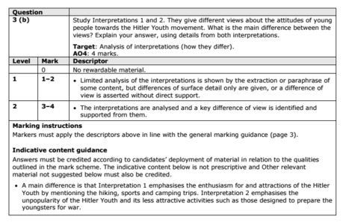

c) Suggest one reason why Interpretations 1 and 2 give different views about the attitudes of X towards Y.
You may use Sources B and C to help explain your answer.4 marks

Up to 4 marks of the total for part (d) will be awarded for spelling, punctuation, grammar and use of specialist terminology.

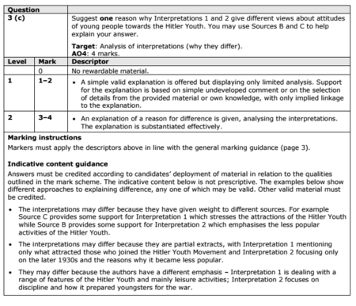

(d) How far do you agree with Interpretation 2 about the attitudes of X towards Y?
Explain your answer, using both interpretations and your knowledge of the historical context. 20 marks

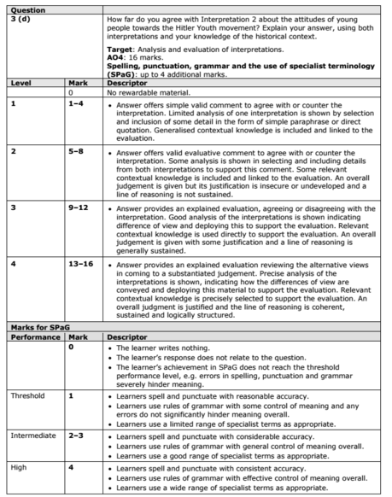

KT4 TMA Germany 1918-39
Focus Points and Elements | Sub-elements | Key Picture | Key Narrative
1 Nazi policies  Towards women | - Nazi views on women and the family. | 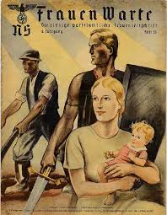 | Nazi policies towards women reflected Hitler's own personal views. He hated the changes in the position of women in society, which had occurred in the 1920s, and wanted to create a society where women had a precise and specific domestic role. He did not want women to be involved in the world of work and saw their task as bearing and rearing children while their husbands worked. Hitler believed that education for women should be focused on their future role in society and hence that it should prepare them for marriage and motherhood. Though most women accepted the policies imposed by the Nazis, there were some who did not and were active in opposing the loss of their rights. These women were eventually arrested and sent to concentration camps.
1 Nazi policies  Towards women | - Nazi policies towards women, including marriage and family, employment and appearance. | 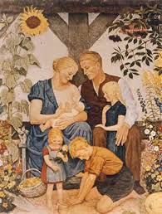 | The Nazis brought in a series of measures to change the role of women. One of the first actions of the Nazis, as part of the Gleichschaltung process, was to bring all 230 women's organisations together under one body- the Women's Front (Frauenfront). The women's groups were then expected to ensure that Jews could not be members. In 1934, Getrude Scholtz-Klink was appointed National Women's Leader of Germany. Nazi ideal were spread to areas of Marriage and family law and organisations.
2 Nazi policies  towards the young | - Nazi aims and policies towards the young. The Hitler Youth and the League of German Maidens. | 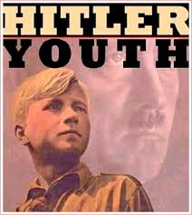 | The Nazis also wanted to control the young i n their spare time. This was to be achieved through the Hitler Youth, which covered both boys and girls. The head of the Hitler Youth was Baldur von Schirach.  • All ocher youth organisations were banned.  • From 1936 membership was compulsory, though many did not join.  • By 1939 there were seven million members.
2 Nazi policies  towards the young | - Nazi control of the young through education, including the curriculum and teachers. | 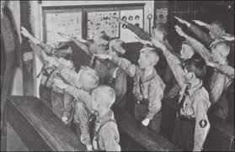 | When the Nazis came to power, they established the Ministry for Science, Education and National Culture with Bernhard Rust at its head. Textbooks, Teachers and lessons began to change to fit with Nazi Volkgemeinschaft - the creation of an obedient racial state. Under the Nazis the school curriculum was changed to prepare students for their future roles. Hitler wanted healthy, fit men and women so 15 per cent of time was devoted to physical education. With the boys the emphasis was on preparation for the military. There was also great emphasis on Germany's past and the Aryan race. Students were taught that Aryans were superior and should not marry inferior races such as Jews.
3 Employment  and living  standards | - Nazi policies to reduce unemployment, including labour service, autobahns, rearmament and invisible unemployment. | 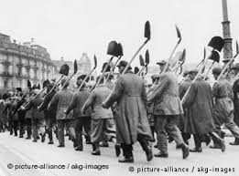 | Hitler at first spent billions on job creation schemes, rising from 18.4 billion marks in 1933 to 37.1 billion five years later. The Nazis subsidised private firms, especially in the construction industry. They also introduced a massive road-building programme to provide Germany with 7,000 kilometres of autobahns (motor ways). Hitler was determined to build up the armed forces in readiness for war. This greatly reduced unemployment
3 Employment  and living  standards | - Changes in the standard of living, especially of German workers.  - The Labour Front, Strength Through Joy, Beauty of Labour. | 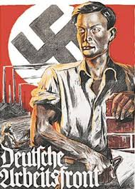 | Strength through Joy was an organisation set up by the German Labour Front . The KdF tried to improve the leisure time of German workers by sponsoring a wide range of leisure and cultural trips. These included concerts, theatre visits, museum rou rs, sporting events, weekend trips, holidays and cruises. All were provided at a low cost, giving ordinary workers access tO activities normally reserved for the better off In 1938, more than 10 million people took KdF holidays.
4 The persecution of  minorities | - Nazi racial beliefs and policies and the treatment of minorities:  - Slavs, ‘gypsies’, homosexuals and those with disabilities. | 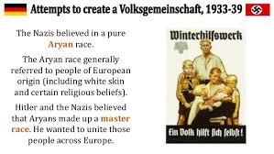 | Ideal Germans were 'socially useful' i n that they had a job and contributed to the state. Anyone else was seen as a 'burden on the community'. These included those who could not work, the unhealthy, mentally disabled, tramps and beggars. The term used to describe them was 'asocial'. The Nazis considered these people worthless and expensive to the state and they had to be removed because they could not contribute to the Volksgemeinschaft.
4 The persecution of  minorities | - The persecution of the Jews, including the boycott of Jewish shops and businesses (1933), the Nuremberg Laws and Kristallnacht. | 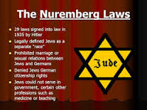 | Almost as soon as he had become Chancellor, Hitler began to take steps against the Jews. Germans were persuaded to boycott Jewish shops and businesses. The boycott was a reaction to stories in the international press which criticised the new Nazi regime. The Nazis claimed chat these stories were instigated by Jews living abroad. On 15 September 1935, the Nazi government passed two new racial laws at their annual Reich Party Congress in Nuremberg, Germany. The events of 9-10 November became known as Kristallnacht, meaning 'Crystal Night' or 'the Night of Broken Glass'. About 100 Jews were killed and 20,000 sent to concentration camps. About 7,500 Jewish businesses were destroyed.

Trigger Memory Story Medicine 50-1350

The story must be very imaginative. It must involve you seeing, talking and doing things. It must link the ten trigger words together in the form of a continuous story. You should then rehearse the story and commit it too your long term memory to be recalled when necessary. This will take some effort but will be very useful! Use different colours to write the trigger words in your story.

I was...

