Key Topic 3: Nazi control and dictatorship, 1933–39

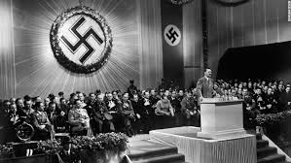

Content
In a Nutshell: Overview of developments

Focus 1 The creation of a dictatorship, 1933–34

Focus 2 The police state

Focus 3 Controlling and influencing attitudes

Focus 4 Opposition, resistance and conformity

Cracking the Puzzle – Preparing for assessment.

Content
In a Nutshell: Overview of developments

Causes and Analysis including:

Focus 1 The creation of a dictatorship, 1933–34
The Reichstag Fire. The Enabling Act and the banning of other parties and trade unions. The threat from Röhm and the SA, the Night of the Long Knives and the death of von Hindenburg. Hitler becomes Führer, the army and oath of allegiance.

Focus 2 The police state
The role of the Gestapo, the SS, the SD and concentration camps.
Nazi control of the legal system, judges and law courts.
Nazi policies towards the Catholic and Protestant Churches, including the Reich Church and the Concordat.

Focus 3 Controlling and influencing attitudes
Goebbels and the Ministry of Propaganda: censorship, Nazi use of media, rallies and sport, including the Berlin Olympics of 1936.
Nazi control of culture and the arts, including art, architecture, literature and film.

Focus 4 Opposition, resistance and conformity
The extent of support for the Nazi regime.
Opposition from the Churches, including the role of Pastor Niemöller.
Opposition from the young, including the Swing Youth and the Edelweiss Pirates.

Thematic Analysis of Wider context through a Mystery game;
Why did ?

Cracking the Puzzle – Preparing for assessment.

Language and Literacy
Key Terms and their meanings in Nazi control and dictatorship, 1933–39.

(I) In a Nutshell: Overview of
Content overview
Focus 1 The creation of a dictatorship, 1933–34
The Reichstag Fire. The Enabling Act and the banning of other parties and trade unions. The threat from Röhm and the SA, the Night of the Long Knives and the death of von Hindenburg. Hitler becomes Führer, the army and oath of allegiance.

Focus 2 The police state
The role of the Gestapo, the SS, the SD and concentration camps.
Nazi control of the legal system, judges and law courts.
Nazi policies towards the Catholic and Protestant Churches, including the Reich Church and the Concordat.

Focus 3 Controlling and influencing attitudes
Goebbels and the Ministry of Propaganda: censorship, Nazi use of media, rallies and sport, including the Berlin Olympics of 1936.
Nazi control of culture and the arts, including art, architecture, literature and film.

Focus 4 Opposition, resistance and conformity
The extent of support for the Nazi regime.
Opposition from the Churches, including the role of Pastor Niemöller.
Opposition from the young, including the Swing Youth and the Edelweiss Pirates.

(II) Causes and Analysis of developments:
Activity 1 – On your marks…..
The timeline grid sums up developments between 1919-1933. It covers economic developments, changes for the weimar government, and developments in the Nazi Party. For each area colour code each box; stable/successful (green), becoming unstable/some difficulties (yellow) or significant problems/unsuccessful (red).

Activity 2 – Get set…..
Your teacher will give you an A3 copy of a concept map. Stick it in your book. You will fill sections in at the end of each key focus area. As well as adding information to your concept map you can add a colour scheme to identify key themes.

Activity 3 – Go…..
As well as the lesson work and activities, read your book independently and visit the library. There are also many excellent websites listed in the back of this booklet to check out. Try to develop your own individual interest in this area of focus

Focus 1. The creation of a dictatorship, 1933–34.
The Reichstag Fire. The Enabling Act and the banning of other parties and trade unions.
The threat from Röhm and the SA, the Night of the Long Knives and the death of von Hindenburg.
Hitler becomes Führer, the army and oath of allegiance.

Activity 1: 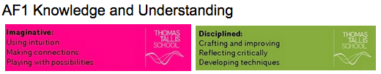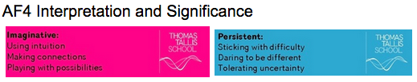
The Reichstag Fire. The Enabling Act and the banning of other parties and trade unions.
 | The Reichstag Fire. The Enabling Act and the banning of other parties and trade unions.
The importance of the Reichstag Fire
The importance of the Enabling Act
The removal of opposition | The end of trade unions  The banning of political parties  The abolition of the Lander

Activity 2:
The threat from Röhm and the SA, the Night of the Long Knives and the death of von Hindenburg.
The threat from Röhm and the SA, the Night of the Long Knives and the death of von Hindenburg.
The importance of the Night of the Long Knives
The events of 30 June 1934
The impact of the Night of the Long Knives

Activity 3:
Hitler becomes Führer, the army and oath of allegiance.

Hitler becomes Führer, the army and oath of allegiance
The support of the army

Exam Practise KT3 F1
SECTION A
Answer both questions.
Study Source A and then answer Question 1
1 Give two things you can infer from source A about Hitler. 4 marks

Source A Hitler’s speech to the Reichstag 13 July 1934, justifying his actions in the Night of the Long Knives concerning the SA

In the circumstances I had to make but one decision. If disaster was to be prevented at all action had to be taken with lightening speed. Only a ruthless and bloody intervention might still perhaps stifle the spread of revolt. If anyone approaches me and asks why I did not resort to the regular courts of justice for conviction of the offenders, then all I can say is “In this hour I was responsible for the fate of the German people and therefor I became the supreme judge of the German people”

Guidance
Source A suggests that

I know this because the source says that..

Source A also suggests that

I know this because the source says that..

2 Explain why Hitler was able to increase his control over Germany 1933-34.
You may use the following in your answer:
- The Enabling Act
- The Night of the Long Knives
You must also use information of your own. 12 marks

Guidance
There are three main reasons which link together that explain why X occurred including a, b and c.

The first reason is a. Give three points to support the reason.

The second reason is b. Give three points to support the reason.

The third reason is c. Give three points to support the reason.

Conclusion. Comment on how the reasons link together

Exam Practise KT3 F1
SECTION B
For this section, you will need to use the sources and interpretations in the Sources/Interpretations Booklet.

3 (a) Study Sources B and C.
How useful are Sources B and C for an enquiry into the Night of the Long Knives?
Explain your answer, using Sources B and C and your knowledge of the historical context. 8 marks

Source B Hitler’s speech to the Reichstag 13 July 1934, justifying his actions in the Night of the Long Knives concerning the SA.  In the circumstances I had to make but one decision. If disaster was to be prevented at all action had to be taken with lightening speed. Only a ruthless and bloody intervention might still perhaps stifle the spread of revolt. If anyone approaches me and asks why I did not resort to the regular courts of justice for conviction of the offenders, then all I can say is “In this hour I was responsible for the fate of the German people and therefor I became the supreme judge of the German people” | Source C A cartoon by British cartoonist David Low in July 1934 showing Hitler’ method of controlling the SA and winning support of the army.  A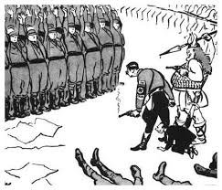

Guidance
The sources B and C have both strengths and limitations for an enquiry into X

Source B is useful in its content and NOP. 3 main points supported by K. However it is limited also because..supported by K.

Source C is useful in its content and NOP. 3 main points supported by K.

However it is limited also because.supported by K..

3 (b) Study Interpretations 1 and 2.
They give different views about the Night of the Long Knives. What is the main difference between these views? Explain your answer, using details from both interpretations. 4 marks

Interpretation 1 Tony Hier 2017  Hitler’s position even by July 1934 was still insecure. In particular he could still be undermined by President Hindenburg and the leadership of the Army. Both were unimpressed with some aspects of the Nazi movement and especially the role of the SA. Hitler had a clear choice to make if he was going to consolidate his position and all of the repressive reforms since the Enabling Act and the banning of German political parties in 1933. The choice was support the SA or the Army. There was no discerning evidence that the SA planned any revolt but Hitler chose to suppress them and win support of the President and the Army to consolidate his personal position. | Interpretation 2 Nikki Collins 2017  By June 1934 Hitler’s consolidation of power was largely complete and he was keen to stabilise the reforms that he had made in his consolidation of power. However the leader of the SA Ernst Rohm had ambitions to take the Nazi revolution further with himself as leader and to take over leadership of the Army and the President. Reluctantly therefor Hitler needed to suppress a genuine threat to German security. After failing to persuade the leaders of the SA to accept the authority of the Government, he had little choice but to have their leaders arrested and incorporating the SA into the German Army.

Guidance
Interpretation 1 views the attitudes of X towards Y as……….. This is supported by the quotes “a” and “b”.

On the other hand Interpretation 2 views the attitudes of X towards Y as…… …...This is supported by the quotes “a” and “b”.

3 (c) Suggest one reason why Interpretations 1 and 2 give different views about the Night of the Long Knives. You may use Sources B and C to help explain your answer. 4 marks

Guidance
Note: There are 2 possible reasons why the Interpretations differ and you only need to explain 1! Use either of the following plans. p38

Reason 1
The interpretations differ because they have given different weight to two different sources. Identify the views given in the two sources and show how the views match the two interpretations.

Reason 2
The interpretations may differ because the author emphasises and focuses on different aspects of the problem. Identify the different focuses and emphasis given and show how these match the two sources.

3 (d) How far do you agree with Interpretation 2 about the Night of the Long Knives?
Explain your answer, using both interpretations and your knowledge of the historical context. 20 marks

Up to 4 marks of the total for part (d) will be awarded for spelling, punctuation, grammar and use of specialist terminology.

Guidance
I mainly agree/disagree with the view given in interpretation 2 which supports the view that

Part 1
There is evidence to support Interpretation 2. Expand the paragraph using 3 main points from your own Knowledge.

Part 2
However Interpretation 1 challenges this view because it suggests that….Expand the paragraph using 3 main points from Interpretation 1.

Part 3
Furthermore Interpretation 2 does not take account of other factors involved. Expand the paragraph using 3 main points from your own Knowledge.

Overall I mainly agree/disagree primarily because the evidence which supports/challenges it is more convincing. I think this because

Focus 2. The police state.
The role of the Gestapo, the SS, the SD and concentration camps.
Nazi control of the legal system, judges and law courts.
Nazi policies towards the Catholic and Protestant Churches, including the Reich Church and the Concordat.

Activity 1:
The role of the Gestapo, the SS, the SD and concentration camps.
The role of the Gestapo, the SS, the SD and concentration camps.

The development of the Nazi state
The role of the SS (Scutzstaffel)
The Gestapo
The Sicherheitsdienst (SD)
The concentration camps

Activity 2:
Nazi control of the legal system, judges and law courts.
Nazi control of the legal system, judges and law courts.

The Nazi control of the legal system
The peoples court
Complete control

Activity 3:
Nazi policies towards the Catholic and Protestant Churches, including the Reich Church and the Concordat.
Nazi policies towards the Catholic and Protestant Churches, including the Reich Church and the Concordat.

Nazism and Christianity
The Catholic Church
The Protestant Church

Exam Practise KT3 F2
SECTION A
Answer both questions.
Study Source A and then answer Question 1
1 Give two things you can infer from source A about life in Germany under the Nazi’s. 4 marks

Source A An incident reported in the Rhineland July 1938

In a cafe a 64 year old woman remarked to her companion that the Italian leader Mussolini had more political sense in one of his boots than Hitler had in his brain. The remark was overheard by an informant and five minutes later the woman was arrested by the Gestapo, who had been alerted by telephone.

Guidance
Source A suggests that

I know this because the source says that..

Source A also suggests that

I know this because the source says that..

2 Explain why the police state was successful in removing opposition to the Nazi regime.
You may use the following in your answer:
- Concentration Camps
- The Gestapo
You must also use information of your own. 12 marks

Guidance
There are three main reasons which link together that explain why X occurred including a, b and c.

The first reason is a. Give three points to support the reason.

The second reason is b. Give three points to support the reason.

The third reason is c. Give three points to support the reason.

Conclusion. Comment on how the reasons link together

Exam Practise KT3 F2
SECTION B
For this section, you will need to use the sources and interpretations in the Sources/Interpretations Booklet.

3 (a) Study Sources B and C.
How useful are Sources B and C for an enquiry into the effectiveness of the Gestapo as a secret police force?
Explain your answer, using Sources B and C and your knowledge of the historical context. 8 marks

Source B A description by an American visitor to Germany in 1939  The Gestapo made silent arrests. Late at night and in the early hours of the morning they took man after man. As accurately as I could learn, this is how the arrests were made. The doorbell or knocker sounded. There stood two or three tall men with pairs of pistols in the belts. The chosen hour was one at which they would find their wanted man relaxed, surprising him at a meal or in bed. | Source C From a modern historian written in 2000  The Gestapo’s power rested on popular consent more than terror. Several major weaknesses have been seen in The Gestapo as a repressive body. Firstly it lacked the personnel to effectively carry out central directives. Major areas such as Frankfurt, Hanover and Bremen had fewer than 50 officers each. At its peak, the Gestapo had only 30,000 officers for the whole country. Furthermore most of these were office workers rather than field agents.

Guidance
The sources B and C have both strengths and limitations for an enquiry into X

Source B is useful in its content and NOP. 3 main points supported by K. However it is limited also because..supported by K.

Source C is useful in its content and NOP. 3 main points supported by K.

However it is limited also because.supported by K..

3 (b) Study Interpretations 1 and 2.
They give different views about the effectiveness of the Gestapo as a secret police force. What is the main difference between these views? Explain your answer, using details from both interpretations. 4 marks

Interpretation 1 Waugh 2013  The Gestapo (secret police) worked under the SS. They spied on people and used an elaborate system of informants which gave the sense that people felt that their were spies everywhere informing the authorities of anything suspicious. Phones were regularly tapped and the Gestapo could enter anyones home without a search warrant. The Gestapo also gave local bloc wardens the right to go and ask questions in the homes of their block. | Interpretation 2 Collins 2017  The Gestapo were unable to stifle all opposition activity. Opponents learnt to evade detection in their communities and there was a lot of private grumbling and discontent. Some opposition went underground and the Gestapo did not have enough officers in the field in order to investigate and eradicate all opponents. Indeed some communities that had previously strong links to other political parties remained in part impervious to their attention.

Guidance
Interpretation 1 views the attitudes of X towards Y as……….. This is supported by the quotes “a” and “b”.

On the other hand Interpretation 2 views the attitudes of X towards Y as…… …...This is supported by the quotes “a” and “b”.

3 (c) Suggest one reason why Interpretations 1 and 2 give different views about the effectiveness of the Gestapo as a secret police force. You may use Sources B and C to help explain your answer. 4 marks

Guidance
Note: There are 2 possible reasons why the Interpretations differ and you only need to explain 1! Use either of the following plans. p38

Reason 1
The interpretations differ because they have given different weight to two different sources. Identify the views given in the two sources and show how the views match the two interpretations.

Reason 2
The interpretations may differ because the author emphasises and focuses on different aspects of the problem. Identify the different focuses and emphasis given and show how these match the two sources.

3 (d) How far do you agree with Interpretation 2 about the effectiveness of the Gestapo as a secret police force?
Explain your answer, using both interpretations and your knowledge of the historical context. 20 marks

Up to 4 marks of the total for part (d) will be awarded for spelling, punctuation, grammar and use of specialist terminology.

Guidance
I mainly agree/disagree with the view given in interpretation 2 which supports the view that

Part 1
There is evidence to support Interpretation 2. Expand the paragraph using 3 main points from your own Knowledge.

Part 2
However Interpretation 1 challenges this view because it suggests that….Expand the paragraph using 3 main points from Interpretation 1.

Part 3
Furthermore Interpretation 2 does not take account of other factors involved. Expand the paragraph using 3 main points from your own Knowledge.

Overall I mainly agree/disagree primarily because the evidence which supports/challenges it is more convincing. I think this because

Focus 3. Controlling and influencing attitudes.
Goebbels and the Ministry of Propaganda: censorship, Nazi use of media, rallies and sport, including the Berlin Olympics of 1936.
Nazi control of culture and the arts, including art, architecture, literature and film.

Activity 1:
Goebbels and the Ministry of Propaganda: censorship, Nazi use of media, rallies and sport, including the Berlin Olympics of 1936.
Goebbels and the Ministry of Propaganda: censorship, Nazi use of media, rallies and sport, including the Berlin Olympics of 1936.

Goebbels and the Ministry of Propaganda
Newspapers
Rallies
Radio
Film
Posters
Literature

Activity 2:
Nazi control of culture and the arts, including art, architecture, literature and film.
Nazi control of culture and the arts, including art, architecture, literature and film.

Nazi control of the Arts
Music and theatre
Art and Architecture
Nazi control of sport

Exam Practise KT3 F3
SECTION A
Answer both questions.
Study Source A and then answer Question 1
1 Give two things you can infer from source A about how the Nazi state influenced what people thought. 4 marks

Source A Ministry of Propaganda Order 1934

Attention! On Wednesday 21st march, the Fuhrer is speaking on all German radio stations at 11am to 11:50am. Al;l factory owners, stores, offices, shops, pubs and flats must put up speakers an hour before, so that the whole workforce can hear.

Guidance
Source A suggests that

I know this because the source says that..

Source A also suggests that

I know this because the source says that..

2 Explain why the arts changed during the Nazi period 1933-39.
You may use the following in your answer:
- Ministry of Propaganda
- The Media
You must also use information of your own. 12 marks

Guidance
There are three main reasons which link together that explain why X occurred including a, b and c.

The first reason is a. Give three points to support the reason.

The second reason is b. Give three points to support the reason.

The third reason is c. Give three points to support the reason.

Conclusion. Comment on how the reasons link together

Exam Practise KT3 F3
SECTION B
For this section, you will need to use the sources and interpretations in the Sources/Interpretations Booklet.

3 (a) Study Sources B and C.
How useful are Sources B and C for an enquiry into the attitudes of the Nazis towards the German Arts?
Explain your answer, using Sources B and C and your knowledge of the historical context. 8 marks

Source B Ministry of Propaganda Order 1934  Attention! On Wednesday 21st march, the Fuhrer is speaking on all German radio stations at 11am to 11:50am. Al;l factory owners, stores, offices, shops, pubs and flats must put up speakers an hour before, so that the whole workforce can hear. | Source C ART, 1937. Painting by Otto Dix, 'War Cripples,' at a Nazi exhibition of Degenerate Art at the Munich Hofgarten, July 1937.  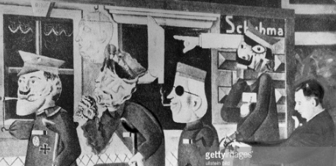

Guidance
The sources B and C have both strengths and limitations for an enquiry into X

Source B is useful in its content and NOP. 3 main points supported by K. However it is limited also because..supported by K.

Source C is useful in its content and NOP. 3 main points supported by K.

However it is limited also because.supported by K..

3 (b) Study Interpretations 1 and 2.
They give different views about the attitudes of Nazis towards the German Arts. What is the main difference between these views? Explain your answer, using details from both interpretations. 4 marks

Interpretation 1 Camilla Evans 2017  Regulation of the media and the arts was central to the in controlling public opinion. The Ministry of Propaganda insured that the Newspapers,Radio, Film and Literature reflected and spread widely Nazi ideals. In addition the Reich Chamber of Culture promoted Nazi ideals through paintings, buildings and plays. In 1937 the Nazis opened the House of German Art to showcase this officially approved art as opposed to what the Nazis referred to as the Degenerate Art of the Weimar era. | Interpretation 2 Leigh Dobson  Whilst the artistic styles of Weimar were driven underground by the Ministries of the Nazi state there remained an appetite for arts that did not receive official support. In 1937 the Nazis put on an exhibition of unacceptable “Degenerate Art” which had been banned by the Reich Chamber of Culture. The pieces were often hung without frames and labelled with crude explanations. However the exhibition was very popular with the German public and it attracted five times as many visitors as the approved German Art exhibition.

Guidance
Interpretation 1 views the attitudes of X towards Y as……….. This is supported by the quotes “a” and “b”.

On the other hand Interpretation 2 views the attitudes of X towards Y as…… …...This is supported by the quotes “a” and “b”.

3 (c) Suggest one reason why Interpretations 1 and 2 give different views about the attitudes of Nazis towards the German Arts. You may use Sources B and C to help explain your answer. 4 marks

Guidance
Note: There are 2 possible reasons why the Interpretations differ and you only need to explain 1! Use either of the following plans. p38

Reason 1
The interpretations differ because they have given different weight to two different sources. Identify the views given in the two sources and show how the views match the two interpretations.

Reason 2
The interpretations may differ because the author emphasises and focuses on different aspects of the problem. Identify the different focuses and emphasis given and show how these match the two sources.

3 (d) How far do you agree with Interpretation 1 about the attitudes of Nazis towards the German Arts?
Explain your answer, using both interpretations and your knowledge of the historical context. 20 marks

Up to 4 marks of the total for part (d) will be awarded for spelling, punctuation, grammar and use of specialist terminology.

Guidance
I mainly agree/disagree with the view given in interpretation 1 which supports the view that

Part 1
There is evidence to support Interpretation 1. Expand the paragraph using 3 main points from your own Knowledge.

Part 2
However Interpretation 2 challenges this view because it suggests that….Expand the paragraph using 3 main points from Interpretation 2.

Part 3
Furthermore Interpretation 1 does not take account of other factors involved. Expand the paragraph using 3 main points from your own Knowledge.

Overall I mainly agree/disagree primarily because the evidence which supports/challenges it is more convincing. I think this because

Focus 4. Opposition, resistance and conformity.
The extent of support for the Nazi regime.
Opposition from the Churches, including the role of Pastor Niemöller.
Opposition from the young, including the Swing Youth and the Edelweiss Pirates.

Activity 1:
The extent of support for the Nazi regime.
The extent of support for the Nazi regime.

The extent of support for the Nazi regime
The army
Assassination attempts

Activity 2:
Opposition from the Churches, including the role of Pastor Niemöller.

Opposition from the Churches, including the role of Pastor Niemöller.

The Protestant Church
The Catholic Church

Activity 3:
Opposition from the young, including the Swing Youth and the Edelweiss Pirates.
Opposition from the young, including the Swing Youth and the Edelweiss Pirates.

Opposition from young people to the Nazis
The Edelweiss Pirates
The Swing Youth

Exam Practise KT3 F4
SECTION A
Answer both questions.
Study Source A and then answer Question 1
1 Give two things you can infer from source A about attitudes of members of the Hitler Youth. 4 marks

Source A From memoirs, written in the 1960’s of a member of the Hitler Youth.

No one in our class ever read Mein Kampf. I myself only ever used the book for quotations. In general we did not do much about Nazi ideals. Anti-Semitism wasn’t mentioned much by our teachers except through Richard wagner’s essay “The Jews in Music”. We did however, do a lot of physical education and cookery.

Guidance
Source A suggests that

I know this because the source says that..

Source A also suggests that

I know this because the source says that..

2 Explain why there was some opposition to the Nazi’s 1933-39.
You may use the following in your answer:
- Christian Church
- Nazi Authoritarian State
You must also use information of your own. 12 marks

Guidance
There are three main reasons which link together that explain why X occurred including a, b and c.

The first reason is a. Give three points to support the reason.

The second reason is b. Give three points to support the reason.

The third reason is c. Give three points to support the reason.

Conclusion. Comment on how the reasons link together

Exam Practise KT3 F4
SECTION B
For this section, you will need to use the sources and interpretations in the Sources/Interpretations Booklet.

3 (a) Study Sources B and C.
How useful are Sources B and C for an enquiry into the attitudes of young people toward the Hitler Youth?
Explain your answer, using Sources B and C and your knowledge of the historical context. 8 marks

Source B From a British magazine 1938  There seems little enthusiasm for the Hitler youth, with membership falling. Many no longer want to be commanded, but wish to do as they like. Usually only a third of a group appears for roll call. At evening meetings it is a great event if 20 turn up out of 80, but usually there are only 10 or 12. | Source C The memoirs of a Hitler Youth leader  What i liked about the Hitler Youth was the comradeship. I was full of enthusiasm when i joined the Young people at the age of 10. I was deeply moved by the club motoes “Young people are hard. They can keep a secret. They are loyal. They are comrades”. And then there were the trips. Is anything nicer than enjoying the splendours of the homeland in the company of one’s comrades?

Guidance
The sources B and C have both strengths and limitations for an enquiry into X

Source B is useful in its content and NOP. 3 main points supported by K. However it is limited also because..supported by K.

Source C is useful in its content and NOP. 3 main points supported by K.

However it is limited also because.supported by K..

3 (b) Study Interpretations 1 and 2.
They give different views about the attitudes of young people toward the Hitler Youth. What is the main difference between these views? Explain your answer, using details from both interpretations. 4 marks

Interpretation 1 Wright 2016  The Nazis wanted to control the young in their spare time. This was to be achieved through the Hitler Youth for boys and girls and all other youth organisations were banned. By 1939 there were 7 million members. Many enjoyed the comradeship and the activities. | Interpretation 2 Waugh 2016  Although many of the young joined the Hitler youth, it was not popular with some of its members and not all young people accepted the Nazi ideas. Indeed by the mid 30’s gangs began to appear on street corners. They played their own music and boys and girls were free to be together. Many grew their hair long and wore their own choice of clothes as a rebellion against the regimentation of Nazi ideas.

Guidance
Interpretation 1 views the attitudes of X towards Y as……….. This is supported by the quotes “a” and “b”.

On the other hand Interpretation 2 views the attitudes of X towards Y as…… …...This is supported by the quotes “a” and “b”.

3 (c) Suggest one reason why Interpretations 1 and 2 give different views about the attitudes of young people toward the Hitler Youth. You may use Sources B and C to help explain your answer. 4 marks

Guidance
Note: There are 2 possible reasons why the Interpretations differ and you only need to explain 1! Use either of the following plans. p38

Reason 1
The interpretations differ because they have given different weight to two different sources. Identify the views given in the two sources and show how the views match the two interpretations.

Reason 2
The interpretations may differ because the author emphasises and focuses on different aspects of the problem. Identify the different focuses and emphasis given and show how these match the two sources.

3 (d) How far do you agree with Interpretation 2 about the attitudes of young people toward the Hitler Youth?
Explain your answer, using both interpretations and your knowledge of the historical context. 20 marks

Up to 4 marks of the total for part (d) will be awarded for spelling, punctuation, grammar and use of specialist terminology.

Guidance
I mainly agree/disagree with the view given in interpretation 2 which supports the view that

Part 1
There is evidence to support Interpretation 2. Expand the paragraph using 3 main points from your own Knowledge.

Part 2
However Interpretation 1 challenges this view because it suggests that….Expand the paragraph using 3 main points from Interpretation 1.

Part 3
Furthermore Interpretation 2 does not take account of other factors involved. Expand the paragraph using 3 main points from your own Knowledge.

Overall I mainly agree/disagree primarily because the evidence which supports/challenges it is more convincing. I think this because

(III) Assessment for Learning
Puzzle practise : X
In the puzzle there will be 3 compulsory questions 1,2 and 3a b c and d. The content will come from either one or a combination of the key themes covered in each of the key questions;

The following examples are focussed on content from ..

Exam Practise
SECTION A
Answer both questions.
Study Source A and then answer Question 1
1 Give two things you can infer from source A about X. 4 marks

Source A

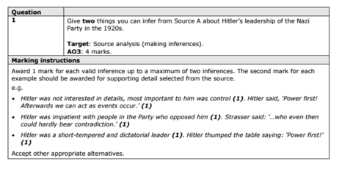

2 Explain why X.
You may use the following in your answer:

You must also use information of your own. 12 marks

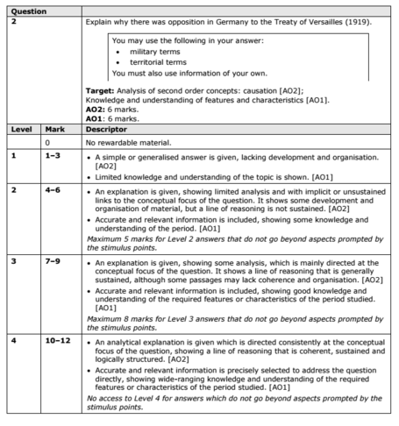

SECTION B
For this section, you will need to use the sources and interpretations in the Sources/Interpretations Booklet.

3
(a)
Study Sources B and C.
How useful are Sources B and C for an enquiry into the attitudes of X towards Y?
Explain your answer, using Sources B and C and your knowledge of the historical context. 8 marks

Source B | Source C

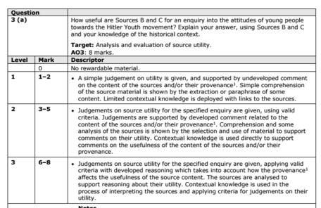

(b)
Study Interpretations 1 and 2. They give different views about the attitudes of X towardsY.
What is the main difference between these views?
Explain your answer, using details from both interpretations. 4 marks

Interpretation 1 | Interpretation 2

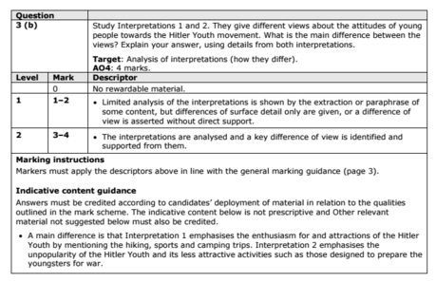

c) Suggest one reason why Interpretations 1 and 2 give different views about the attitudes of X towards Y.
You may use Sources B and C to help explain your answer.4 marks

Up to 4 marks of the total for part (d) will be awarded for spelling, punctuation, grammar and use of specialist terminology.

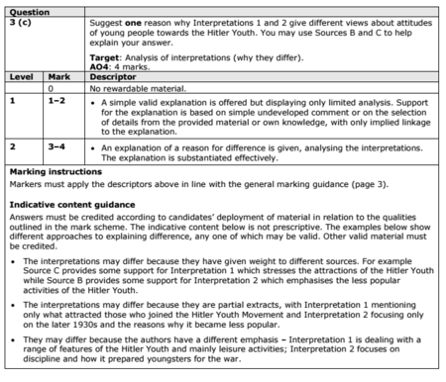

(d) How far do you agree with Interpretation 2 about the attitudes of X towards Y?
Explain your answer, using both interpretations and your knowledge of the historical context. 20 marks

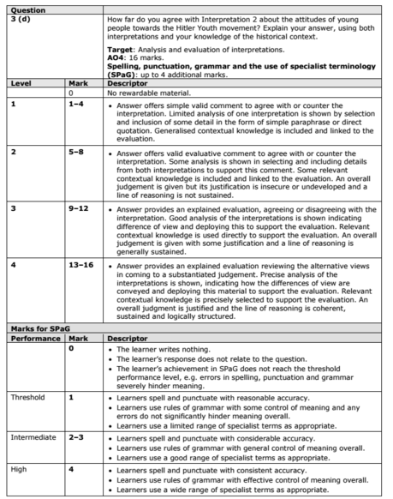

KT3 TMA Germany 1918-39
Focus Points and Elements | Sub-elements | Key Picture | Key Narrative
1 The creation  of a dictatorship,  1933–34 | - The Reichstag Fire.  - The Enabling Act  - The banning of other parties and trade unions. | 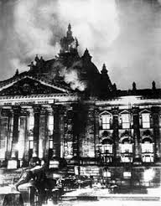 | One week before the election, on 27 February, the Reichstag building was set on fire. On the day following the fire, Hitler persuaded President Hindenburg to sign the 'Decree for the Protection of People and State'. The decree replaced the constitutional government by a permanent state of emergency and suspended basic civil rights. Hitler's next step was to pass the Enabling Act. This would give him and his government full powers for the next four years and would mean that the Reichstag would become a rubber stamp for Nazi activities.
1 The creation  of a dictatorship,  1933–34 | - The threat from Röhm and the SA,  - The Night of the Long Knives  - The death of von Hindenburg.  - Hitler becomes Führer, the army and oath of allegiance. | 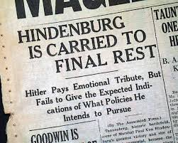 | The Night of the Long Knives (also known as 'Operation Hummingbird' or the 'Blood Purge') was the purging of Hitler's political and military rivals in the SA (Sturmabteilung). One cause of the removal of the leaders of the SA was the need to win the support of the army. On the death of Hindenburg in August 1934, the army swore allegiance to Hitler who, having combined the posts of Chancellor and President, was now their Fuhrer. Hitler decided he needed to seek the approval of the German people when he combined the posts.
2 The police state | - The role of the Gestapo, the SS, the SD and concentration camps. | 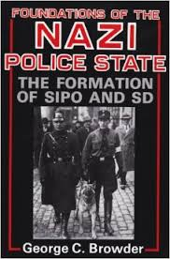 | A key element in maintaining a Nazi dictatorship was to create a climate of fear- make people too frightened to actively oppose the Nazi state. This was achieved through the establishment of a police state, including a secret police (the Gestapo), the SS, an intelligence agency (the Sicherheitsdienst, Security Service), Nazi control of the law courts and the setting up of concentration camps.
2 The police state | - Nazi control of the legal system, judges and law courts. | 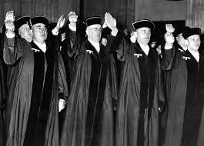 | The law courts had to experience Gleichschaltung , just as any other part of society. Some judges were removed and all had to become members of the National Socialist League for the Maintenance of Law ( NSRB). This meant that Nazi views were upheld in the courts. In October 1933, the German Lawyers Front was established and there were more than 10,000 members by the end of the year. The lawyers had to swear that they would 'strive as German jurists to follow the course of our Fuhrer to the end of our days'.
2 The police state | - Nazi policies towards the Catholic and Protestant Churches, including the Reich Church and the Concordat. | 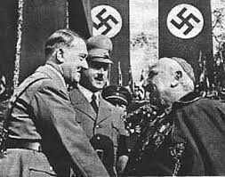 | Hitler could not immediately persecute Christianity as Germany was essentially a Christian country. Almost two-thirds of the population was Protestant, most of whom lived in the north; almost one­ third was Catholic, most of whom lived in the south. A Concordat (understanding) with the Catholic Church was agreed and the Reich Church established to unite Protestants. Hitler set up a Ministry of Church Affairs in 1935 in an attempt to weaken the hold the Catholic and Protestant Churches had on the people.
3 Controlling  and influencing  attitudes | - Goebbels and the Ministry of Propaganda: censorship  - Nazi use of media, rallies and sport, including the Berlin Olympics of 1936. | 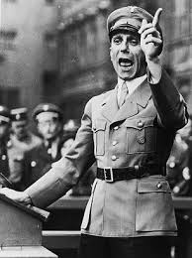 | Goebbels used his Ministry of Public Propaganda and Enlightenment and the Reich Chamber of Culture to control the thoughts, beliefs and opinions of the German people. Musicians, writers and actors had to be members of the Chamber. It was important for the long-term future of the Third Reich that the majority of the population believed in the ideals of the Nazi Party. All aspects of the media were censored and skilfully manipulated by Goebbels. He used a variety of methods to ensure that even the fine arts, music, theatre and literature were controlled
3 Controlling  and influencing  attitudes | - Nazi control of culture and the arts, including art, architecture, literature and film. | 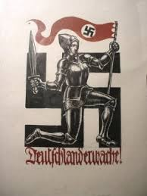 | Just as it was important to control the media, Hitler realised that other aspects of everyday life could be controlled in order to re-inforce the ideology of Nazism. Thus, the Arts were controlled and people became used to seeing Nazi imagery in paintings, buildings and plays. It became impossible to avoid the message of the Nazis in art, architecture, literature and film.
4 Opposition,  resistance and  conformity | - The extent of support for the Nazi regime. | 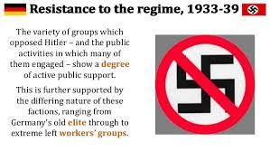 | In the years 1933-39, there were about 1.3 million people sent to concentration camps in Germany and this would see m to be an indication of quite widespread opposition to the regime. Nevertheless, many Germans gained much from Hitler's successes after 1933 and consequently Hitler was readily able to maintain support. There were economic successes which began to erase the Depression. Germany's international standing grew and this seemed to remove the shame of defeat in the war and the Treaty of Versailles (the Saar was returned in 1935, the army was built up after 1935, and in 1936 the Rhineland was reoccupied). Some Germans were happy to see the Communists, Socialists and SA leaders removed.
4 Opposition,  resistance and  conformity | - Opposition from the Churches, including the role of Pastor Niemöller. | 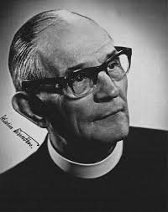 | Pastor Martin Niemoller opposed Nazi control of the Church and became leader of the Confessional Church, which followed traditional German Protestantism. He established the Pastors' Emergency League, which opposed Nazi attempts to control the Protestant Church and saw membership rise co 7,000 by 1934. However, many pastors left when they were persecuted by the Nazis. Niemoller was arrested in 1937 after having preached that people must obey God and not man. He was tried and kept in prison and concentration camps until 1945.
4 Opposition,  resistance and  conformity | - Opposition from the young, including the Swing Youth and the Edelweiss Pirates. | 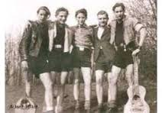 | Although many of che young joined the Hider Youth (see page 92), it was not popular with some of its members and not all young people accepted the Nazi ideas. Indeed by the mid-1930s gangs began to appear on street corners. They played their own music and boys and girls were free robe together. Many grew their hair long and wore their own choice of clothes as a rebellion against the regimentation of Nazi ideas. Some went looking for members of the Hitler Youth and beat them up.

Trigger Memory Story Medicine 50-1350

The story must be very imaginative. It must involve you seeing, talking and doing things. It must link the ten trigger words together in the form of a continuous story. You should then rehearse the story and commit it too your long term memory to be recalled when necessary. This will take some effort but will be very useful! Use different colours to write the trigger words in your story.

I was...

