Key Topic 2. Hitler’s rise to power 1918-33.

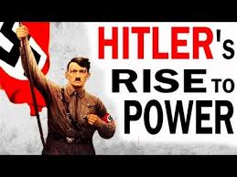

Content
In a Nutshell: Overview of developments

Focus 1 Early development of the Nazi Party, 1920–22

Focus 2 The Munich Putsch and the lean years, 1923–29

Focus 3 The growth in support for the Nazis, 1929–32

Focus 4 How Hitler became Chancellor, 1932–33

Cracking the Puzzle – Preparing for assessment.

Content
In a Nutshell: Overview of developments

Causes and Analysis including:

Focus 1 Early development of the Nazi Party, 1920–22
Hitler’s early career: joining the German Workers’ Party and setting up the Nazi Party, 1919–20.
The early growth and features of the Party. The Twenty-Five Point Programme. The role of the SA.

Focus 2 The Munich Putsch and the lean years, 1923–29
The reasons for, events and consequences of the Munich Putsch.
Reasons for limited support for the Nazi Party, 1924–28. Party reorganisation and Mein Kampf. The Bamberg Conference of 1926.

Focus 3 The growth in support for the Nazis, 1929–32
The growth of unemployment – its causes and impact. The failure of successive Weimar governments to deal with unemployment from 1929 to January 1933. The growth of support for the Communist Party.
Reasons for the growth in support for the Nazi Party, including the appeal of Hitler and the Nazis, the effects of propaganda and the work of the SA.

Focus 4 How Hitler became Chancellor, 1932–33
Political developments in 1932. The roles of Hindenburg, Brüning, von Papen and von Schleicher.
The part played by Hindenburg and von Papen in Hitler becoming Chancellor in 1933.

Thematic Analysis of Wider context through a Mystery game;
Why did ?

Cracking the Puzzle – Preparing for assessment.

Language and Literacy
Key Terms and their meanings in Medicine 1250-1500.

(I) In a Nutshell: Overview of Hitler’s rise to power 1918-33.
Content overview
Focus 1 Early development of the Nazi Party, 1920–22
Hitler’s early career: joining the German Workers’ Party and setting up the Nazi Party, 1919–20.
The early growth and features of the Party. The Twenty-Five Point Programme. The role of the SA.

Focus 2 The Munich Putsch and the lean years, 1923–29
The reasons for, events and consequences of the Munich Putsch.
Reasons for limited support for the Nazi Party, 1924–28. Party reorganisation and Mein Kampf. The Bamberg Conference of 1926.

Focus 3 The growth in support for the Nazis, 1929–32
The growth of unemployment – its causes and impact. The failure of successive Weimar governments to deal with unemployment from 1929 to January 1933. The growth of support for the Communist Party.
Reasons for the growth in support for the Nazi Party, including the appeal of Hitler and the Nazis, the effects of propaganda and the work of the SA.

Focus 4 How Hitler became Chancellor, 1932–33
Political developments in 1932. The roles of Hindenburg, Brüning, von Papen and von Schleicher.
The part played by Hindenburg and von Papen in Hitler becoming Chancellor in 1933.

(II) Causes and Analysis of developments:
Activity 1 – On your marks…..
The timeline grid sums up developments between 1919-1933. It covers economic developments, changes for the weimar government, and developments in the Nazi Party. For each area colour code each box; stable/successful (green), becoming unstable/some difficulties (yellow) or significant problems/unsuccessful (red).

Activity 2 – Get set…..
Your teacher will give you an A3 copy of a concept map. Stick it in your book. You will fill sections in at the end of each key focus area. As well as adding information to your concept map you can add a colour scheme to identify key themes.

Activity 3 – Go…..
As well as the lesson work and activities, read your book independently and visit the library. There are also many excellent websites listed in the back of this booklet to check out. Try to develop your own individual interest in this area of focus .

Focus 1. Early development of the Nazi Party, 1920–22.
Hitler’s early career: joining the German Workers’ Party and setting up the Nazi Party, 1919–20.The early growth and features of the Party. The Twenty-Five Point Programme. The role of the SA.

Activity 1: 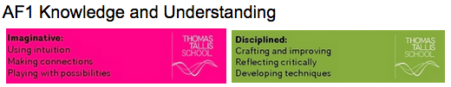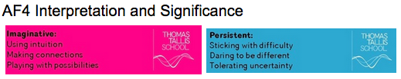
Hitler’s early career: joining the German Workers’ Party and setting up the Nazi Party, 1919–20.The early growth and features of the Party. The Twenty-Five Point Programme. The role of the SA.

Hitler’s early career: joining the German Workers’ Party and setting up the Nazi Party, 1919–20.The early growth and features of the Party. The Twenty-Five Point Programme. The role of the SA.
Hitler’s early career
The early growth of the Nazi Party
Hitler and the German Workers Party
The NSDAP 1920-23
The role of the Sturmabteilung SA

Exam Practise KT2 F1
SECTION A
Answer both questions.
Study Source A and then answer Question 1
1 Give two things you can infer from source A about Hitler’s early career. 4 marks

Source A Mein Kampf Adolf Hitler 1924. Here he is describing his time in Vienna

My life was a continual struggle with hunger. I had but one pleasure, my books. At that time I read enormously and thoroughly. In this way I forged in a few years time the foundation of my knowledge. From which I still draw nourishment today. In this period there took shape within me a world picture and philosophy which became the granite foundation of all my acts.

Guidance
Source A suggests that

I know this because the source says that..

Source A also suggests that

I know this because the source says that..

2 Explain why Nazi Party began to attract support in Munich 1919-22.
You may use the following in your answer:
- The role of Hitler
- The role of the SA
You must also use information of your own. 12 marks

Guidance
There are three main reasons which link together that explain why X occurred including a, b and c.

The first reason is a. Give three points to support the reason.

The second reason is b. Give three points to support the reason.

The third reason is c. Give three points to support the reason.

Conclusion. Comment on how the reasons link together

Exam Practise KT2 F1
SECTION B
For this section, you will need to use the sources and interpretations in the Sources/Interpretations Booklet.

3 (a) Study Sources B and C.
How useful are Sources B and C for an enquiry into reasons why the Nazi party grew in Munich in the early years to 1922?
Explain your answer, using Sources B and C and your knowledge of the historical context. 8 marks

Source B The pledge of loyalty and obedience taken by members of the SA  As a member of the NSDAP I pledge myself by its storm flag to;  1 be always ready to stake life and limb in the struggle for the aims of the movement.  2 give absolute military obedience to my military superiors and leaders.  3 bear myself honourably in and out of service. | Source C A member of the Nazi party describing one of Hitler’s speeches in 1922  My critical faculty was swept away. Leaning forward as if he was trying to force his inner self into the consciousness of al these thousands., he was holding the masses and me with them, under a hypnotic spell by the sheer force of his belief...I forgot everything but the man. Looking around I saw that this magnetism was similarly holding the masses.

Guidance
The sources B and C have both strengths and limitations for an enquiry into X

Source B is useful in its content and NOP. 3 main points supported by K. However it is limited also because..supported by K.

Source C is useful in its content and NOP. 3 main points supported by K.

However it is limited also because.supported by K..

3 (b) Study Interpretations 1 and 2.
They give different views about the reasons why the Nazi party grew in Munich in the early years to 1922. What is the main difference between these views? Explain your answer, using details from both interpretations. 4 marks

Interpretation 1 From Weimar and Nazi Germany by Stephen Lee 1996  The 25 point programme contained policies which maybe described as either nationalist or socialist, or both. The nationalist policies emphasised race, expansion, the army, power and relations with other countries. The socialist policies were to do with state controls over the living conditions of the people and the economy. | Interpretation 2 An extract from the Weimar republic by John Hiden 1996  The NSDAP was built on protest and resentment. Hitler incorporated in his own person many of the main features on which the movement thrived, the deep sense of frustration, hatred of the Jews and Marxists (Communists) and dislike of parliamentary democracy. To build up a mass movement from such beginnings and keep it together required unique personal qualities. It was clear that the movement depended heavily on Hitler’s spectacular speaking skills.

Guidance
Interpretation 1 views the attitudes of X towards Y as……….. This is supported by the quotes “a” and “b”.

On the other hand Interpretation 2 views the attitudes of X towards Y as…… …...This is supported by the quotes “a” and “b”.

3 (c) Suggest one reason why Interpretations 1 and 2 give different views about the reasons why the Nazi party grew in Munich in the early years to 1922. You may use Sources B and C to help explain your answer. 4 marks

Guidance
Note: There are 2 possible reasons why the Interpretations differ and you only need to explain 1! Use either of the following plans. p38

Reason 1
The interpretations differ because they have given different weight to two different sources. Identify the views given in the two sources and show how the views match the two interpretations.

Reason 2
The interpretations may differ because the author emphasises and focuses on different aspects of the problem. Identify the different focuses and emphasis given and show how these match the two sources.

3 (d) How far do you agree with Interpretation 2 about thereasons why the Nazi party grew in Munich in the early years to 1922?
Explain your answer, using both interpretations and your knowledge of the historical context. 20 marks

Up to 4 marks of the total for part (d) will be awarded for spelling, punctuation, grammar and use of specialist terminology.

Guidance
I mainly agree/disagree with the view given in interpretation 2 which supports the view that

Part 1
There is evidence to support Interpretation 2. Expand the paragraph using 3 main points from your own Knowledge.

Part 2
However Interpretation 1 challenges this view because it suggests that….Expand the paragraph using 3 main points from Interpretation 1.

Part 3
Furthermore Interpretation 2 does not take account of other factors involved. Expand the paragraph using 3 main points from your own Knowledge.

Overall I mainly agree/disagree primarily because the evidence which supports/challenges it is more convincing. I think this because

Focus 2. The Munich Putsch and the lean years, 1923–29.
The reasons for, events and consequences of the Munich Putsch.Reasons for limited support for the Nazi Party, 1924–28. Party reorganisation and Mein Kampf. The Bamberg Conference of 1926.

Activity 1:
The reasons for, events and consequences of the Munich Putsch.Reasons for limited support for the Nazi Party, 1924–28. Party reorganisation and Mein Kampf. The Bamberg Conference of 1926.

The reasons for, events and consequences of the Munich Putsch.Reasons for limited support for the Nazi Party, 1924–28. Party reorganisation and Mein Kampf. The Bamberg Conference of 1926.
The Munich Putsch
Key features of the Munich Putsch
The importance of the Munich Putsch
The impact of the Putsch on the Nazi Party
Reorganisation of the Nazi Party
Progress

Exam Practise KT2 F2
SECTION A
Answer both questions.
Study Source A and then answer Question 1
1 Give two things you can infer from source A about Hitler’s views on politics. 4 marks

Source A Comments made by Hitler in Landsberg prison 1924. He was speaking to a fellow Nazi inmate.

When I resume active work, it will be necessary to follow a new policy. Instead of working to achieve power by armed conspiracy, we shall have to hold our noses and enter the parliament against the Catholic and Communist members. If outvoting them takes longer than outshooting them, at least the results will be guaranteed by their own constitution. Sooner or later we shall have a majority in parliament.

Guidance
Source A suggests that

I know this because the source says that..

Source A also suggests that

I know this because the source says that..

2 Explain why Hitler carried out the Munich Putsch.
You may use the following in your answer:
- Ludendorff
- French occupation of the Ruhr
You must also use information of your own. 12 marks

Guidance
There are three main reasons which link together that explain why X occurred including a, b and c.

The first reason is a. Give three points to support the reason.

The second reason is b. Give three points to support the reason.

The third reason is c. Give three points to support the reason.

Conclusion. Comment on how the reasons link together

Exam Practise KT2 F2
SECTION B
For this section, you will need to use the sources and interpretations in the Sources/Interpretations Booklet.

3 (a) Study Sources B and C.
How useful are Sources B and C for an enquiry into the the development of the Nazi Party 1924-29?
Explain your answer, using Sources B and C and your knowledge of the historical context. 8 marks

Source B Comments made by Hitler in Landsberg prison 1924. He was speaking to a fellow Nazi inmate.  When I resume active work, it will be necessary to follow a new policy. Instead of working to achieve power by armed conspiracy, we shall have to hold our noses and enter the parliament against the Catholic and Communist members. If outvoting them takes longer than outshooting them, at least the results will be guaranteed by their own constitution. Sooner or later we shall have a majority in parliament. | Source C Hitler with members of the SA at a Nazi Party rally in Nuremberg 1927. The SA were a Nazi paramilitary body used for his protection and to intimidate and use violence against his opponents.  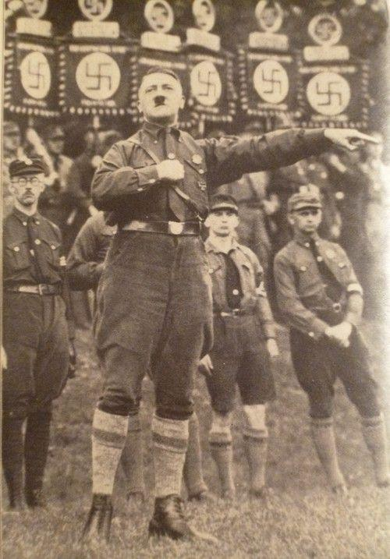

Guidance
The sources B and C have both strengths and limitations for an enquiry into X

Source B is useful in its content and NOP. 3 main points supported by K. However it is limited also because..supported by K.

Source C is useful in its content and NOP. 3 main points supported by K.

However it is limited also because.supported by K..

3 (b) Study Interpretations 1 and 2.
They give different views about the the development of the Nazi Party 1924-29. What is the main difference between these views? Explain your answer, using details from both interpretations. 4 marks

Interpretation 1 Heather Odd 2017  From 1925 Hitler began the process of making the NSDAP a much better organised political party. He reorganised Nazi Party headquaters in Munich to resemble the organisation of a government, appointed a local Nazi Party leader divided in each of Germany’s 35 regions called Gaue and paid for this by raising money from wealthy industrialists who shared some of his nationalist views. In this way Hitler began to prepare his Party to engage in the democratic process in order to win power in the Reichstag through participation in elections. Although the strategy was largely unsuccessful by 1928, it meant his Party were much better able of take advantage of the economic crises of 1929-32. His route to power was primarily through winning support in elections, a strategy that was planned through Party reorganisation 1924-29. | Interpretation 2 Nikki Collins 2017  In 1924 Hitler had attempted to win power via an armed coup using his SA paramilitary organisation. Although he engaged in the democratic path to power after his release from prison ne was still committed to using his SA as an instrument of political intimidation and violence in order to defeat his opponents. Furthermore he set up a special SS unit in 1925 to act as his personal bodyguard. By 1930 the SS had 3,000 members and the SA had 400,000 members routinely prepared to take the law into their own hands. This introduced great political instability in which Hitler and the NSDAP were to claim that only their Party could provide a stable future for Germany. His route to power was primarily through violence and intimidation through the expansion of his paramilitary organisations 1924-29.

Guidance
Interpretation 1 views the attitudes of X towards Y as……….. This is supported by the quotes “a” and “b”.

On the other hand Interpretation 2 views the attitudes of X towards Y as…… …...This is supported by the quotes “a” and “b”.

3 (c) Suggest one reason why Interpretations 1 and 2 give different views about the development of the Nazi Party 1924-29. You may use Sources B and C to help explain your answer. 4 marks

Guidance
Note: There are 2 possible reasons why the Interpretations differ and you only need to explain 1! Use either of the following plans. p38

Reason 1
The interpretations differ because they have given different weight to two different sources. Identify the views given in the two sources and show how the views match the two interpretations.

Reason 2
The interpretations may differ because the author emphasises and focuses on different aspects of the problem. Identify the different focuses and emphasis given and show how these match the two sources.

3 (d) How far do you agree with Interpretation 2 about the development of the Nazi Party 1924-29?
Explain your answer, using both interpretations and your knowledge of the historical context. 20 marks

Up to 4 marks of the total for part (d) will be awarded for spelling, punctuation, grammar and use of specialist terminology.

Guidance
I mainly agree/disagree with the view given in interpretation 2 which supports the view that

Part 1
There is evidence to support Interpretation 2. Expand the paragraph using 3 main points from your own Knowledge.

Part 2
However Interpretation 1 challenges this view because it suggests that….Expand the paragraph using 3 main points from Interpretation 1.

Part 3
Furthermore Interpretation 2 does not take account of other factors involved. Expand the paragraph using 3 main points from your own Knowledge.

Overall I mainly agree/disagree primarily because the evidence which supports/challenges it is more convincing. I think this because

Focus 3. The growth in support for the Nazis, 1929–32.
The growth of unemployment – its causes and impact. The failure of successive Weimar governments to deal with unemployment from 1929 to January 1933.
The growth of support for the Communist Party.
Reasons for the growth in support for the Nazi Party, including the appeal of Hitler and the Nazis, the effects of propaganda and the work of the SA.

Activity 1:
The growth of unemployment – its causes and impact. The failure of successive Weimar governments to deal with unemployment from 1929 to January 1933.
The growth of unemployment – its causes and impact. The failure of successive Weimar governments to deal with unemployment from 1929 to January 1933.

Unemployment and its impact
Impact on the Weimar government

Activity 2:
The growth of support for the Communist Party.
The growth of support for the Communist Party.

The German Communist Party

Activity 3:
Reasons for the growth in support for the Nazi Party, including the appeal of Hitler and the Nazis, the effects of propaganda and the work of the SA.
Reasons for the growth in support for the Nazi Party, including the appeal of Hitler and the Nazis, the effects of propaganda and the work of the SA.
Growth in support of the Nazi’s
The role of Joseph Goebbels
Nazi electoral success
The presidential election of 1932
Financial support for the Nazis
The SA and the Communists
The role of Hitler and his charisma

Exam Practise KT2 F3
SECTION A
Answer both questions.
Study Source A and then answer Question 1
1 Give two things you can infer from source A about the effects of unemployment. 4 marks

Source A from “A fairytale of Christmas” a short story written in 1931 by Rudolf Leonhard. He was writing about the effects of unemployment on German people 1929-31

No one knew how many of them there were. They completely filled the streets. They stood or lay about in the streets as if they had completely taken root there. The streets were grey, their faces were grey and even the hair on their heads and the stubble on their cheeks of the youngest there were grey with dust and their adversity.

Guidance
Source A suggests that

I know this because the source says that..

Source A also suggests that

I know this because the source says that..

2 Explain why there was increasing support for the Nazis in the years 1929-32.
You may use the following in your answer:
- Unemployment
- Goebbels
You must also use information of your own. 12 marks

Guidance
There are three main reasons which link together that explain why X occurred including a, b and c.

The first reason is a. Give three points to support the reason.

The second reason is b. Give three points to support the reason.

The third reason is c. Give three points to support the reason.

Conclusion. Comment on how the reasons link together

Exam Practise KT2 F3
3 (a) Study Sources B and C.
How useful are Sources B and C for an enquiry into the reasons for the growth in support for the Nazi Party in the years 1929–32?
Explain your answer, using Sources B and C and your knowledge of the historical context. 8 marks

Source B A photograph published in 1932 in a German newspaper. It shows people  from Hanover queuing for their unemployment benefits. The writing on the  wall of the building says ‘Vote Hitler’.  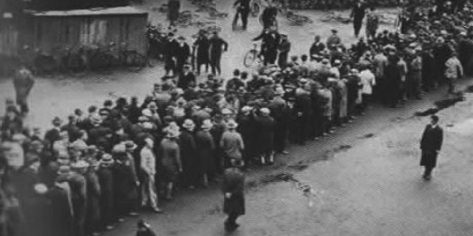 | Source C From Inside the Third Reich  by Albert Speer, published in 1970. Here Speer is remembering hearing a speech made by Hitler in 1931. Speer later became the official Nazi architect and a Nazi minister.  I was carried away on a wave of enthusiasm by the speech. Here, it seemed to me, was new hope. Here were new ideals, a new understanding and new tasks for Germany. The dangers of Communism, which seemed to be growing, could be stopped. Hitler persuaded us that Germany could recover from all of its problems. It must have been during this time that my mother saw an SA parade. The sight  of discipline in a time of chaos, the impression of energy in an atmosphere of hopelessness, seems to have won her over to the Nazis as well

Guidance
The sources B and C have both strengths and limitations for an enquiry into X

Source B is useful in its content and NOP. 3 main points supported by K. However it is limited also because..supported by K.

Source C is useful in its content and NOP. 3 main points supported by K.

However it is limited also because.supported by K..

3 (b) Study Interpretations 1 and 2.
They give different views about reasons for the growth in support for the Nazi Party in the years 1929–32 .What is the main difference between these views? Explain your answer, using details from both interpretations. 4 marks

Interpretation 1 From Weimar and Nazi Germany by J Hite and C Hinton, published  in 2000.  Hitler himself was central to the success of the Nazis in the years 1929–32. He provided charismatic leadership with his powerful message to build a new Germany. He was a powerful speaker with his timing, expression and the content of his speeches impressing listeners. He was able to identify with their emotions and gave people hope. Along with Goebbels, he realised the importance of propaganda. He used propaganda to target the specific grievances of many Germans | Interpretation 2 From Hitler 1889–1936  by I Kershaw, published in 1998  There was nothing inevitable about Hitler becoming Chancellor of Germany in January 1933. Five years earlier the Nazis had been a small party in German politics with little support. Events such as the Wall Street Crash, which led to depression in Germany, brought increased support for the Nazis in the years 1929–32. Chance events, such as the depression and unemployment, played a much larger role than  any actions of the Nazi leader himself in bringing Hitler to power

Guidance
Interpretation 1 views the attitudes of X towards Y as……….. This is supported by the quotes “a” and “b”.

On the other hand Interpretation 2 views the attitudes of X towards Y as…… …...This is supported by the quotes “a” and “b”.

3 (c) Suggest one reason why Interpretations 1 and 2 give different views about reasons for the growth in support for the Nazi Party in the years 1929–32. You may use Sources B and C to help explain your answer. 4 marks

Guidance
Note: There are 2 possible reasons why the Interpretations differ and you only need to explain 1! Use either of the following plans. p38

Reason 1
The interpretations differ because they have given different weight to two different sources. Identify the views given in the two sources and show how the views match the two interpretations.

Reason 2
The interpretations may differ because the author emphasises and focuses on different aspects of the problem. Identify the different focuses and emphasis given and show how these match the two sources.

3 (d)
How far do you agree with Interpretation 2 about the reasons for the growth in
support for the Nazi Party in the years 1929–32?
Explain your answer, using both interpretations and your knowledge of the historical context. 20 marks

Up to 4 marks of the total for part (d) will be awarded for spelling, punctuation, grammar and use of specialist terminology.

Guidance
I mainly agree/disagree with the view given in interpretation 2 which supports the view that

Part 1
There is evidence to support Interpretation 2. Expand the paragraph using 3 main points from your own Knowledge.

Part 2
However Interpretation 1 challenges this view because it suggests that….Expand the paragraph using 3 main points from Interpretation 1.

Part 3
Furthermore Interpretation 2 does not take account of other factors involved. Expand the paragraph using 3 main points from your own Knowledge.

Overall I mainly agree/disagree primarily because the evidence which supports/challenges it is more convincing. I think this because

Focus 4. How Hitler became Chancellor, 1932–33.
Political developments in 1932. The roles of Hindenburg, Brüning, von Papen and von Schleicher.
The part played by Hindenburg and von Papen in Hitler becoming Chancellor in 1933.

Activity 1:
Political developments in 1932. The roles of Hindenburg, Brüning, von Papen and von Schleicher.
Political developments in 1932. The roles of Hindenburg, Brüning, von Papen and von Schleicher.

Political developments in 1932

Activity 2:
The part played by Hindenburg and von Papen in Hitler becoming Chancellor in 1933.
The part played by Hindenburg and von Papen in Hitler becoming Chancellor in 1933.
Political intrigue

Exam Practise KT2 F4
SECTION A
Answer both questions.
Study Source A and then answer Question 1
1 Give two things you can infer from source A about X. 4 marks

Source A From Berlin Stories by Christopher Isherwood 1945. He was a British journalist living in Berlin 1932-33

Each week there were new Emergency decrees. Brunings weary voice issued commands..and were not obeyed...Berlin was in a state of civil war. Hate exploded out of nowhere; at street corners, in restaurants, cinemas...at midnight...in the middle of the afternoon. Knives were whipped out, blows were dealt with spiked rings, bullets slashed the advertisements. “Bruning is weak” they said “What these swine need is a man with hair on his chest”. People said that the Nazis would be in power by Christmas.

Guidance
Source A suggests that

I know this because the source says that..

Source A also suggests that

I know this because the source says that..

2 Explain why Hindenburg appointed Hitler Chancellor between 1932 and January 33.
You may use the following in your answer:
- Failure of Bruning, Schleicher and von Papen as Chancellors
- The Reichstag was not functioning
You must also use information of your own. 12 marks

Guidance
There are three main reasons which link together that explain why X occurred including a, b and c.

The first reason is a. Give three points to support the reason.

The second reason is b. Give three points to support the reason.

The third reason is c. Give three points to support the reason.

Conclusion. Comment on how the reasons link together

Exam Practise KT2 F4
SECTION B
For this section, you will need to use the sources and interpretations in the Sources/Interpretations Booklet.

3 (a) Study Sources B and C.
How useful are Sources B and C for an enquiry into the reasons why Hindenburg appointed Hitler as Chancellor in January 1933?
Explain your answer, using Sources B and C and your knowledge of the historical context. 8 marks

Source B The results of the July 1932 elections which caused von Papen to begin to reconsider how he might persuade the president to consider appointing Hitler Chancellor in January 1933.  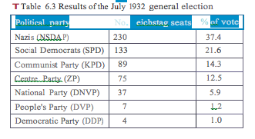 | Source C Adapted from a diary of Luise Solmitz 23rd March 1932. He was attending a meeting in Hamburg at which Hitler spoke  There stood Hitler in a simple black coat looking over the crowd of 120,000 people of all ages and classes. A forest of swastika flags unfurled and the joy of this moment showed itself in a roaring salute. The crowd looked up to Hitler with touching faith as their helper, their saviour, their deliverer from unbearable distress. He is the rescuer of the scholar, the farmer, the worker and the unemployed.

Guidance
The sources B and C have both strengths and limitations for an enquiry into X

Source B is useful in its content and NOP. 3 main points supported by K. However it is limited also because..supported by K.

Source C is useful in its content and NOP. 3 main points supported by K.

However it is limited also because.supported by K..

3 (b) Study Interpretations 1 and 2.
They give different views about the reasons why Hindenburg appointed Hitler as Chancellor in January 1933.What is the main difference between these views? Explain your answer, using details from both interpretations. 4 marks

Interpretation 1 Ashley Tomlin 2017  The wall street crash of 1929 had crippled the German economy 1929-32 and with it the trust of all classes of people that the traditional political parties held the solutions to these circumstances. The Reichstag parties could not find agreement and with the failure of Bruning, von Papen and Schleicher as Chancellors to find a solution people of all classes began to consider alternatives to the mainstream political parties. This is why the Nazi party grew spectacularly in the period 1929-32, assisted by clever propaganda that made promises to all classes of people and above all by the extraordinary charisma and speaking of Adolf Hitler who appeared to offer hope where there seemed to be nothing but despair. | Interpretation 2 Steve Waugh and John Wright 2016  Papen was determined to regain power and to this end he met Hitler in early January 1933 and they agreed that Hitler should lead a Nazi-Nationalist government with Papen as the Vice-Chancellor. Intrigue and trickery now took the place of considered, open political debate. The army, major landowners and leaders of industry were convinced that Papen and Hitler were saving Germany from Schleicher's plans and a possible communist takeover. Papen was able to convince President Hindenburg that a coalition government with Hitler as Chancellor would save Germany and bring stability to the country. Papen said that he would be able to control Hitler - he would 'make Hider squeak'.

Guidance
Interpretation 1 views the attitudes of X towards Y as……….. This is supported by the quotes “a” and “b”.

On the other hand Interpretation 2 views the attitudes of X towards Y as…… …...This is supported by the quotes “a” and “b”.

3 (c) Suggest one reason why Interpretations 1 and 2 give different views about the reasons why Hindenburg appointed Hitler as Chancellor in January 1933. You may use Sources B and C to help explain your answer. 4 marks

Guidance
Note: There are 2 possible reasons why the Interpretations differ and you only need to explain 1! Use either of the following plans. p38

Reason 1
The interpretations differ because they have given different weight to two different sources. Identify the views given in the two sources and show how the views match the two interpretations.

Reason 2
The interpretations may differ because the author emphasises and focuses on different aspects of the problem. Identify the different focuses and emphasis given and show how these match the two sources.

3 (d) How far do you agree with Interpretation 2 about the reasons why Hindenburg appointed Hitler as Chancellor in January 1933?
Explain your answer, using both interpretations and your knowledge of the historical context. 20 marks

Up to 4 marks of the total for part (d) will be awarded for spelling, punctuation, grammar and use of specialist terminology.

Guidance
I mainly agree/disagree with the view given in interpretation 2 which supports the view that

Part 1
There is evidence to support Interpretation 2. Expand the paragraph using 3 main points from your own Knowledge.

Part 2
However Interpretation 1 challenges this view because it suggests that….Expand the paragraph using 3 main points from Interpretation 1.

Part 3
Furthermore Interpretation 2 does not take account of other factors involved. Expand the paragraph using 3 main points from your own Knowledge.

Overall I mainly agree/disagree primarily because the evidence which supports/challenges it is more convincing. I think this because

(III) Assessment for Learning
Puzzle practise : X

In the puzzle there will be 3 compulsory questions 1,2 and 3a b c and d. The content will come from either one or a combination of the key themes covered in each of the key questions;

The following examples are focussed on content from ..

Exam Practise
SECTION A
Answer both questions.
Study Source A and then answer Question 1
1 Give two things you can infer from source A about X. 4 marks

Source A

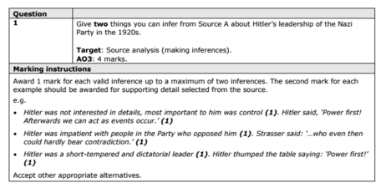

2 Explain why X.
You may use the following in your answer:

You must also use information of your own. 12 marks

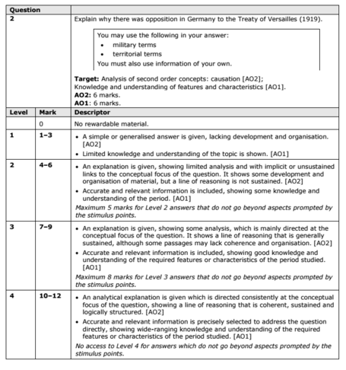

SECTION B
For this section, you will need to use the sources and interpretations in the Sources/Interpretations Booklet.

3
(a)
Study Sources B and C.
How useful are Sources B and C for an enquiry into the attitudes of X towards Y?
Explain your answer, using Sources B and C and your knowledge of the historical context. 8 marks

Source B | Source C

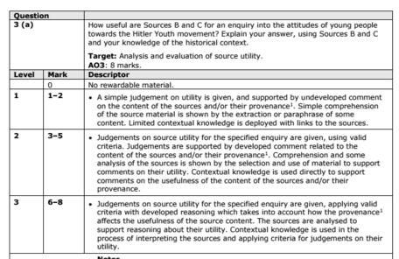

(b)
Study Interpretations 1 and 2. They give different views about the attitudes of X towards Y.
What is the main difference between these views?
Explain your answer, using details from both interpretations. 4 marks

Interpretation 1 | Interpretation 2

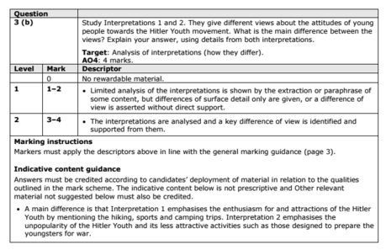

c) Suggest one reason why Interpretations 1 and 2 give different views about the attitudes of X towards Y.
You may use Sources B and C to help explain your answer.4 marks

Up to 4 marks of the total for part (d) will be awarded for spelling, punctuation, grammar and use of specialist terminology.

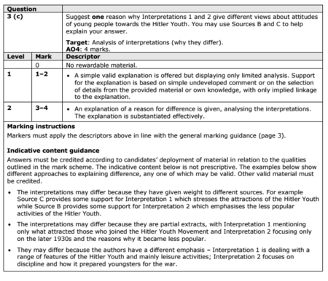

(d) How far do you agree with Interpretation 2 about the attitudes of X towards Y?
Explain your answer, using both interpretations and your knowledge of the historical context. 20 marks

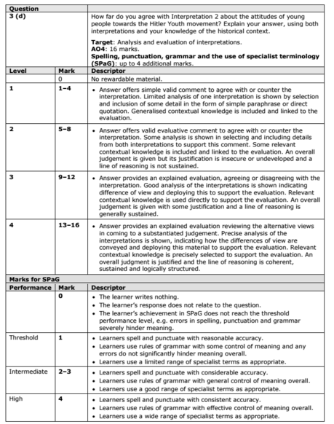

KT2 TMA Germany 1918-39
Focus Points and Elements | Sub-elements | Key Picture | Key Narrative
1 Early  development  of the Nazi  Party, 1920–22 | Hitler’s early career:  Joining the German Workers’ Party and setting  up the Nazi Party, 1919–20. | 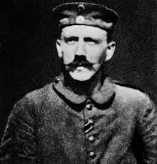 | When the First World War ended, Germany experienced tremendous social and political upheaval. During the five years after the war, several new parties emerged and there were communist and right-wing uprisings. One of the new parties was the DAP (Deutsche Arbeiterpartei). As it grew, it added the words 'national' and 'socialist' to become the NSDAP and during its transformation it acquired a new leader, Adolf Hitler. Hitler changed the DAP from a small number of malcontents to a party which tried to take over the Bavarian state government in 1923.
1 Early  development  of the Nazi  Party, 1920–22 | The early growth and features of the Party.  The Twenty-Five Point Programme.  The role of the SA. | 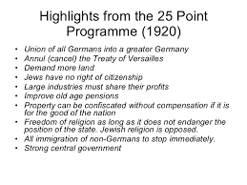 | In February 1920, Hitler and Drexler wrote what became known as the Twenty-Five Point Program me (Table 5.1). It was a political manifesto and Hitler kept to most of the ideas throughout the rest of his life. The programme was announced at a key meeting in Munich a nd shortly after 'national socialist' was added to the party's name. The party grew rapidly in 1920 and Hitler was largely responsible for this - his public speaking attracted hundreds to meetings of the NSDAP. During the period 1921-23, the SA was used to disrupt the meetings of the Social Democratic Party and the Communist Party.
2 The Munich  Putsch and  the lean years,  1923 –29 | The reasons for, events and consequences of the Munich Putsch. | 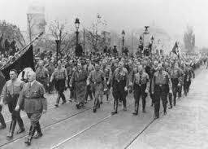 | On the evening of8 November 1923, Hitler and 600 Nazis seized the Biirgerbraukeller (a huge beer hall in Munich), where Kahr, Seisser and Lossow were attending a political meeting. Hitler placed the three leaders in a room and won promises of support for his planned takeover from them after they had been held at gunpoint. Hitler was arrested along with his main supporter, Erich Ludendorff, and was tried for treason. The trial began in February 1924 and lasted almost one month. The trial gave Hitler nationwide publicity and introduced him to the German public via the national press.
2 The Munich  Putsch and  the lean years,  1923 –29 | Reasons for limited support for the Nazi Party, 1924–28.  Party  reorganisation and Mein Kampf.  The Bamberg Conference of 1926. | 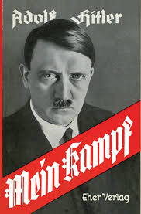 | Hitler's leadership and reorganisation of the party achieved results. The party had only 27,000 members in 1925 bur exceeded 100,000 by the end of 1928. It was a nationwide party that had begun to attract all classes. Yet, despite the changes, the Nazis won only 12 seats i n parliament in the 1928 elections, having held 32 in 1924. There were further changes within the Nazi Party in the late 1920s when Hitler began to target the peasants as a key electoral group. He also replaced Strasser as head of party propaganda with Josef Goebbels.The political and economic events of 1929 (see pages 39-40) helped the Nazi Party rise from relative obscurity to become one of the leading parties in the country. The 'lean years' were at an end.
3 The growth in support for  the Nazis, 1929–32 | The growth of unemployment – its causes and impact.  The failure of  successive Weimar governments to deal with unemployment from 1929 to January 1933.  The growth of support for the Communist Party. | 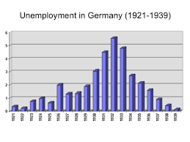 | When its stock market collapsed in October  1929 - the Wall Street Crash - the problems created had huge consequences for the German economy. The death of Stresemann also added to the crisis. Successive Weimar governments, more especially the Bruning government of 1930-32, failed to deal with the problem of unemployment. The economic crisis created problems for the Weimar government and there was little agreement about how to tackle unemployment and poverty. During the years of the Weimar Republic the KPD was the largest communist party in Europe, and was seen as the 'leading party' of the communist movement outside the Soviet Union. It maintained a solid electoral performance, usually polling more than 10 per cent of the vote, and gained 100 deputies in the November 1932 elections.
3 The growth in support for  the Nazis, 1929–32 | Reasons for the growth in support for the Nazi Party, The appeal of Hitler and the Nazis  The effects of propaganda  The work of the SA. | 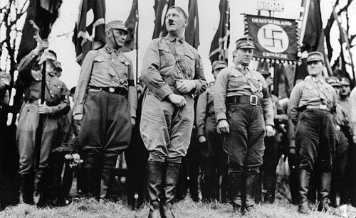 | The economic problems led to political discontent and meant extreme parties were able to secure increasing support of the electorate in elections as opposed to the established pro democratic political parties in Germany. Hitler was able to appeal to all classes of society; his simple messages and slogans could be understood by all.
4 How Hitler  became  Chancellor, 1932–33 | Political developments in 1932.  The roles of Hindenburg, Brüning, von Papen and von Schleicher. | 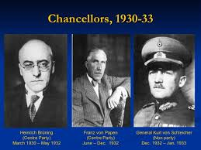 | However, Papen could not secure a majority in the Reichstag and, at the same time, Hitler continued to demand the post of Chancellor. Papen suggested abolishing the Weimar constitution and at this, Kurt von Schleicher, the Minister of Defence, persuaded Hindenburg that if this happened there might be civil war. Papen lost Hindenburg's confidence and resigned. He was succeeded by Schleicher (translated, his name means 'sneaky', 'furtive' or 'intriguer'), who hoped to attain a majority in the Reichstag by forming a Que1" front, meaning 'cross-front', whereby he would bring together different strands from left and right parties. Papen was determined to regain power and to this end he met Hitler in early January 1933 and they agreed that Hitler should lead a Nazi-Nationalist government with Papen as the Vice-Chancellor. Intrigue and trickery now took the place of considered, open political debate.
4 How Hitler  became  Chancellor, 1932–33 | The part played by Hindenburg and von Papen in Hitler becoming Chancellor in 1933. | 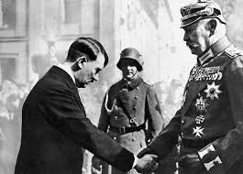 | The army, major landowners and leaders of industry were convinced that Papen and Hitler were saving Germany from Schleicher's plans and a possible communist takeover. Papen was able to convince President Hindenburg that a coalition government with Hitler as Chancellor would save Germany and bring stability to the country. Papen said that he would be able to control Hitler - he would 'make Hider squeak'.  On 30 January 1933, Adolf Hider became Chancellor of Germany.

Trigger Memory Story Medicine 50-1350

The story must be very imaginative. It must involve you seeing, talking and doing things. It must link the ten trigger words together in the form of a continuous story. You should then rehearse the story and commit it too your long term memory to be recalled when necessary. This will take some effort but will be very useful! Use different colours to write the trigger words in your story.

I was...

