Key Topic 1. The Weimar Republic 1918–29

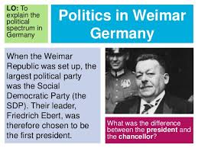

Content
In a Nutshell: Overview of developments

Focus 1 The legacy of the First World War.

Focus 2 The early challenges to the Weimar Republic, 1919–23

Focus 3 The recovery of the Republic, 1924–29

Focus 4 Changes in society, 1924–29

Cracking the Puzzle – Preparing for assessment.

Content
In a Nutshell: Overview of developments

Causes and Analysis including:

Focus 1 The legacy of the First World War.
The abdication of the Kaiser, the armistice and revolution, 1918–19.
The setting up of the Weimar Republic. The strengths and weaknesses of the new Constitution.

Focus 2 The early challenges to the Weimar Republic, 1919–23
Reasons for the early unpopularity of the Republic, including the ‘stab in the back’ theory and the key terms of the Treaty of Versailles.
Challenges to the Republic from Left and Right: Spartacists, Freikorps, the Kapp Putsch.
The challenges of 1923: hyperinflation; the reasons for, and effects of, the French occupation of the Ruhr.

Focus 3 The recovery of the Republic, 1924–29
Reasons for economic recovery, including the work of Stresemann, the Rentenmark, the Dawes and Young Plans and American loans and investment.
The impact on domestic policies of Stresemann’s achievements abroad: the Locarno Pact, joining the League of Nations and the Kellogg-Briand Pact

Focus 4 Changes in society, 1924–29
Changes in the standard of living, including wages, housing, unemployment insurance.
Changes in the position of women in work, politics and leisure.
Cultural changes: developments in architecture, art and the cinema.

Cracking the Puzzle – Preparing for assessment.

Language and Literacy
Key Terms and their meanings in the Weimar Republic 1918-29.

(I) In a Nutshell: Overview of
Content overview
Focus 1 The legacy of the First World War.
The abdication of the Kaiser, the armistice and revolution, 1918–19.
The setting up of the Weimar Republic. The strengths and weaknesses of the new Constitution.

Focus 2 The early challenges to the Weimar Republic, 1919–23
Reasons for the early unpopularity of the Republic, including the ‘stab in the back’ theory and the key terms of the Treaty of Versailles.
Challenges to the Republic from Left and Right: Spartacists, Freikorps, the Kapp Putsch.
The challenges of 1923: hyperinflation; the reasons for, and effects of, the French occupation of the Ruhr.

Focus 3 The recovery of the Republic, 1924–29
Reasons for economic recovery, including the work of Stresemann, the Rentenmark, the Dawes and Young Plans and American loans and investment.
The impact on domestic policies of Stresemann’s achievements abroad: the Locarno Pact, joining the League of Nations and the Kellogg-Briand Pact

Focus 4 Changes in society, 1924–29
Changes in the standard of living, including wages, housing, unemployment insurance.
Changes in the position of women in work, politics and leisure.
Cultural changes: developments in architecture, art and the cinema.

(II) Causes and Analysis of developments:
Activity 1 – On your marks…..
The timeline grid sums up developments between 1919-1933. It covers economic developments, changes for the weimar government, and developments in the Nazi Party. For each area colour code each box; stable/successful (green), becoming unstable/some difficulties (yellow) or significant problems/unsuccessful (red).
Activity 2 – Get set…..
Your teacher will give you an A3 copy of a concept map. Stick it in your book. You will fill sections in at the end of each key focus area. As well as adding information to your concept map you can add a colour scheme to identify key themes.
Activity 3 – Go…..
As well as the lesson work and activities, read your book independently and visit the library. There are also many excellent websites listed in the back of this booklet to check out. Try to develop your own individual interest in this area of focus .

Focus 1. The legacy of the First World War.
The abdication of the Kaiser, the armistice and revolution, 1918–19.
The setting up of the Weimar Republic. The strengths and weaknesses of the new Constitution.

Activity 1: 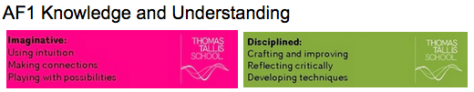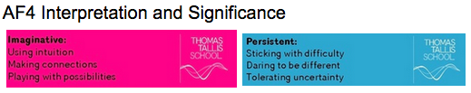
The abdication of the Kaiser, the armistice and revolution, 1918–19.
The abdication of the Kaiser, the armistice and revolution, 1918–19.

Legacy of the FWW
Revolution 1918-19

Activity 2:
The setting up of the Weimar Republic. The strengths and weaknesses of the new Constitution.
The setting up of the Weimar Republic. The strengths and weaknesses of the new Constitution.

Setting up of the Weimar Republic
The Weimar Constitution
Strengths of the Constitution
Weaknesses of the Constitution

Exam Practise KT1 F1
SECTION A
Answer both questions.
Study Source A and then answer Question 1
1 Give two things you can infer from source A about the difficulties in setting up the Weimar Constitution. 4 marks

Source A From a speech to the new Constituent Assembly by Hugo Preuss, Head of the commission that drew up the Weimar Constitution in 1919.

I have often listened to the debates with real concern, glancing at the gentlemen of the Right, fearful in case they say to me “Do you hope to give a parliamentary system to a nation like this, one that resists it with every sinew in its body?” One finds suspicion everywhere; Germans cannot shake off their old political timidity and their deference to the authoritarian state.

Guidance
Source A suggests that

I know this because the source says that..

Source A also suggests that

I know this because the source says that..

2 Explain why it was difficult to agree on the new Weimar Constitution.
You may use the following in your answer:
- German Revolution 1918-19
- Article 48 of the Weimar Constitution
You must also use information of your own. 12 marks

Guidance
There are three main reasons which link together that explain why X occurred including a, b and c.

The first reason is a. Give three points to support the reason.

The second reason is b. Give three points to support the reason.

The third reason is c. Give three points to support the reason.

Conclusion. Comment on how the reasons link together

Exam Practise KT1 F1
SECTION B
For this section, you will need to use the sources and interpretations in the Sources/Interpretations Booklet.

3 (a) Study Sources B and C.
How useful are Sources B and C for an enquiry into the attitudes of Germans towards the German Constitution? Explain your answer, using Sources B and C and your knowledge of the historical context. 8 marks

Source B From a speech to the new Constituent Assembly by Hugo Preuss, head of the commission that drew up the Weimar Constitution in 1919.  I have often listened to the debates with real concern, glancing at the gentlemen of the Right, fearful in case they say to me “Do you hope to give a parliamentary system to a nation like this, one that resists it with every sinew in its body?” One finds suspicion everywhere; Germans cannot shake off their old political timidity and their deference to the authoritarian state. | Source C Ebert, the President of the Weimar Republic 1919-25  The new constitution is the result of careful consideration about how best to represent the opinions of all Germans in the new constitutional arrangements. A democratically elected Reichstag where all political parties were represented proportionate to the percentage of the electorate that voted for them is considered the most appropriate system to replace the Kaiser’s authoritarian state. The parties will work closely together and work out their differences to form coalition governments.

Guidance
The sources B and C have both strengths and limitations for an enquiry into X

Source B is useful in its content and NOP. 3 main points supported by K. However it is limited also because..supported by K.

Source C is useful in its content and NOP. 3 main points supported by K.

However it is limited also because.supported by K..

3 (b) Study Interpretations 1 and 2.
They give different views about the attitudes of Germans towards the new Constitution. What is the main difference between these views? Explain your answer, using details from both interpretations. 4 marks

Interpretation 1 Camilla Evans 2017  The new constitution had several strengths and clearly represented a cross section of support from across German political parties. It was very democratic with all men and women having the right to vote aged 20. Elections resulted in a Reichstag forming with each party receiving the same proportion of representatives as the percentage of voters that voted for them. The Chancellor (Head of Government) had to have the support of the majority of representatives in the Reichstag. | Interpretation 2 Leigh Dobson 2017  The new constitution had many weaknesses and was not welcomed by most germans. Proportional Representation for the parties in the Reichstag resulted in a large number of parties without one having a single majority. This resulted in coalition governments that found it difficult to win support from the Reichstag. Furthermore the government could be easily dismissed by the special powers given to the President in Article 48 and the army, judges and civil servants did support it

Guidance
Interpretation 1 views the attitudes of X towards Y as……….. This is supported by the quotes “a” and “b”.

On the other hand Interpretation 2 views the attitudes of X towards Y as…… …...This is supported by the quotes “a” and “b”.

3 (c) Suggest one reason why Interpretations 1 and 2 give different views about the attitudes of Germans towards the new Constitution. You may use Sources B and C to help explain your answer. 4 marks

Guidance
Note: There are 2 possible reasons why the Interpretations differ and you only need to explain 1! Use either of the following plans. p38

Reason 1
The interpretations differ because they have given different weight to two different sources.
Identify the views given in the two sources and show how the views match the two interpretations.

Reason 2
The interpretations may differ because the author emphasises and focuses on different aspects of the problem. Identify the different focuses and emphasis given and show how these match the two sources.

3 (d) How far do you agree with Interpretation 2 about the attitudes of Germans towards the new Constitution?
Explain your answer, using both interpretations and your knowledge of the historical context. 20 marks

Up to 4 marks of the total for part (d) will be awarded for spelling, punctuation, grammar and use of specialist terminology.

Guidance
I mainly agree/disagree with the view given in interpretation 2 which supports the view that

Part 1
There is evidence to support Interpretation 2. Expand the paragraph using 3 main points from your own Knowledge.

Part 2
However Interpretation 1 challenges this view because it suggests that….Expand the paragraph using 3 main points from Interpretation 1.

Part 3
Furthermore Interpretation 2 does not take account of other factors involved. Expand the paragraph using 3 main points from your own Knowledge.

Overall I mainly agree/disagree primarily because the evidence which supports/challenges it is more convincing. I think this because

Focus 2. The early challenges to the Weimar Republic, 1919–23.
Reasons for the early unpopularity of the Republic, including the ‘stab in the back’ theory and the key terms of the Treaty of Versailles.
Challenges to the Republic from Left and Right: Spartacists, Freikorps, the Kapp Putsch.
The challenges of 1923: hyperinflation; the reasons for, and effects of, the French occupation of the Ruhr.

Activity 1:
Reasons for the early unpopularity of the Republic, including the ‘stab in the back’ theory and the key terms of the Treaty of Versailles.
Reasons for the early unpopularity of the Republic, including the ‘stab in the back’ theory and the key terms of the Treaty of Versailles.

Treaty of Versailles
Territorial terms
Military terms
Financial terms
The ‘stab in the back” theory

Activity 2:
Challenges to the Republic from Left and Right: Spartacists, Freikorps, the Kapp Putsch.
Challenges to the Republic from Left and Right: Spartacists, Freikorps, the Kapp Putsch.

Challenges
Threat from the left
The Spartacist Uprising
The Kapp Putsch
Further Uprisings

Activity 3:
The challenges of 1923: hyperinflation; the reasons for, and effects of, the French occupation of the Ruhr.
The challenges of 1923: hyperinflation; the reasons for, and effects of, the French occupation of the Ruhr.
Problems get worse
French occupation of the Ruhr 1923
Hyperinflation

Exam Practise KT1 F2
SECTION A
Answer both questions.
Study Source A and then answer Question 1
1 Give two things you can infer from source A about German reactions to the Treaty of Versailles. 4 marks

Source A From a German Newspaper Deutsche Zeitung 29th June 1919

Vengeance! German nation! Today in the Hall of Mirrors (Versailles) the disgraceful treaty is being signed. Do not forget it. The German people will, with unceasing work press forward to reconquer the place among nations to which it is entitled. Then will come vengeance for the shame of 1919.

Guidance
Source A suggests that

I know this because the source says that..

Source A also suggests that

I know this because the source says that..

2 Explain why the Weimar republic faced many challenges 1919-23.
You may use the following in your answer:
- Spartacist uprising 1919
- Hyperinflation 1923
You must also use information of your own. 12 marks

Guidance
There are three main reasons which link together that explain why X occurred including a, b and c.

The first reason is a. Give three points to support the reason.

The second reason is b. Give three points to support the reason.

The third reason is c. Give three points to support the reason.

Conclusion. Comment on how the reasons link together

Exam Practise KT1 F2
SECTION B
For this section, you will need to use the sources and interpretations in the Sources/Interpretations Booklet.

3 (a) Study Sources B and C.
How useful are Sources B and C for an enquiry into the attitudes of in Germany towards the Treaty of Versailles?
Explain your answer, using Sources B and C and your knowledge of the historical context. 8 marks

Source B John Child 2017  On 11th November 1918 just two days after the Kaiser abdicated, Erzberger representing the new German republic signed the agreement to stop fighting. Once the armistice was signed the Allied leaders decided the rems of the peace. Peace was popular with the German people, as they had suffered during the war. The terms of the Treaty could have been much harsher had some of Germany’s harsher critics had their way. Both America and Britain were keen to moderate excessive French demands for revenge and compensation as they wanted some stability for the newly created German republic. There was little alternative. | Source C A cartoon entitled “Clemenceau the Vampire” From the German right wing satirical magazine Kladderdatsch July 1919 Clemenceau was the leader of France  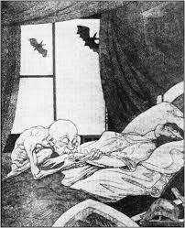

Guidance
The sources B and C have both strengths and limitations for an enquiry into X

Source B is useful in its content and NOP. 3 main points supported by K. However it is limited also because..supported by K.

Source C is useful in its content and NOP. 3 main points supported by K.

However it is limited also because.supported by K..

3 (b) Study Interpretations 1 and 2.
They give different views about the attitudes of German towards the Treaty of Versailles. What is the main difference between these views? Explain your answer, using details from both interpretations. 4 marks

Interpretation 1 From “Versailles and After 1919-33 Dr Ruth Henig 1995  Compared to the treaties which Germany had imposed on defeated Russia and Romania in 1918, the Treaty of Versailles was quite moderate. The Treaty of Versailles was not excessively harsh on Germany, either territorially or economically. However the German people were expecting victory and not defeat. It was the acknowledgment of defeat as much as the treaty terms themselves, which they found so hard to accept. | Interpretation 2 From “The Treaty of Versailles - the peace to end all peace” Alan Woods 2009  The Versailles Treaty of 1919 was one of the most outrageous treaties in history. It was a blatant act of plunder perpetrated by a gang of robbers against a helpless, prostrate and bleeding Germany. Amongst its numerous provisions it required Germany and its allies to accept full responsibility for causing the war and under the terms of articles 231-48, to disarm, make substantial territorial concessions and pay reparations to the Entente powers.

Guidance
Interpretation 1 views the attitudes of X towards Y as……….. This is supported by the quotes “a” and “b”.

On the other hand Interpretation 2 views the attitudes of X towards Y as…… …...This is supported by the quotes “a” and “b”.

3 (c) Suggest one reason why Interpretations 1 and 2 give different views about the attitudes of X towards Y. You may use Sources B and C to help explain your answer. 4 marks

Guidance
Note: There are 2 possible reasons why the Interpretations differ and you only need to explain 1! Use either of the following plans. p38

Reason 1
The interpretations differ because they have given different weight to two different sources. Identify the views given in the two sources and show how the views match the two interpretations.

Reason 2
The interpretations may differ because the author emphasises and focuses on different aspects of the problem. Identify the different focuses and emphasis given and show how these match the two sources.

3 (d) How far do you agree with Interpretation 2 about the attitudes of Germans towards the Treaty of Versailles?
Explain your answer, using both interpretations and your knowledge of the historical context. 20 marks

Up to 4 marks of the total for part (d) will be awarded for spelling, punctuation, grammar and use of specialist terminology.

Guidance
I mainly agree/disagree with the view given in interpretation 2 which supports the view that

Part 1
There is evidence to support Interpretation 2. Expand the paragraph using 3 main points from your own Knowledge.

2
However Interpretation 1 challenges this view because it suggests that….Expand the paragraph using 3 main points from Interpretation 1.

Part 3
Furthermore Interpretation 2 does not take account of other factors involved. Expand the paragraph using 3 main points from your own Knowledge.

Overall I mainly agree/disagree primarily because the evidence which supports/challenges it is more convincing. I think this because

Focus 3. The recovery of the Republic, 1924–29.
Reasons for economic recovery, including the work of Stresemann, the Rentenmark, the Dawes and Young Plans and American loans and investment.
The impact on domestic policies of Stresemann’s achievements abroad: the Locarno Pact, joining the League of Nations and the Kellogg-Briand Pact

Activity 1:
Reasons for economic recovery, including the work of Stresemann, the Rentenmark, the Dawes and Young Plans and American loans and investment.
Reasons for economic recovery, including the work of Stresemann, the Rentenmark, the Dawes and Young Plans and American loans and investment.

Reasons
The Dawes Plan
US loans
The Rentenmark
The Young Plan
Political stability
Extent of recovery

Activity 2:
The impact on domestic policies of Stresemann’s achievements abroad: the Locarno Pact, joining the League of Nations and the Kellogg-Briand Pact
The impact on domestic policies of Stresemann’s achievements abroad: the Locarno Pact, joining the League of Nations and the Kellogg-Briand Pact

The Locarno Pact
The League of Nations
The Kellogg Briand Pact
The impact on domestic policies

Exam Practise KT1 F3
SECTION A
Answer both questions.
Study Source A and then answer Question 1
1 Give two things you can infer from source A about the German recovery 1924-28. 4 marks

Source A From a German journalist, written in 1930

In comparison with what we expected after Versailles, Germany had raised herself up to shoulder the terrific burden of this peace in a way we would have never thought possible. So that today after 10 years we can say with some certainty “Even so, it might have been worse” The stage of convalescence from Versailles is a very long road to go and we have travelled it surprisingly quickly.

Guidance
Source A suggests that

I know this because the source says that..

Source A also suggests that

I know this because the source says that..

2 Explain why Weimar recovered in the years 1924-29.
You may use the following in your answer:
- The Dawes plan
- Achievements abroad
You must also use information of your own. 12 marks

Guidance
There are three main reasons which link together that explain why X occurred including a, b and c.

The first reason is a. Give three points to support the reason.

The second reason is b. Give three points to support the reason.

The third reason is c. Give three points to support the reason.

Conclusion. Comment on how the reasons link together

Exam Practise KT1 F3
SECTION B
For this section, you will need to use the sources and interpretations in the Sources/Interpretations Booklet.

3 (a) Study Sources B and C.
How useful are Sources B and C for an enquiry into the extent of German recovery 1924-29?
Explain your answer, using Sources B and C and your knowledge of the historical context. 8 marks

Source B From a German journalist, written in 1930  In comparison with what we expected after Versailles, Germany had raised herself up to shoulder the terrific burden of this peace in a way we would have never thought possible. So that today after 10 years we can say with some certainty “Even so, it might have been worse” The stage of convalescence from Versailles is a very long road to go and we have travelled it surprisingly quickly. | Source C From a speech by Stresemann 1929  The economic position is only flourishing on the surface. Germany is in fact dancing on a volcano. If the short term loans are called in by America, a large section of our economy would collapse.

Guidance
The sources B and C have both strengths and limitations for an enquiry into X

Source B is useful in its content and NOP. 3 main points supported by K. However it is limited also because..supported by K.

Source C is useful in its content and NOP. 3 main points supported by K.

However it is limited also because.supported by K..

3 (b) Study Interpretations 1 and 2.
They give different views about the extent of German recovery 1924-29. What is the main difference between these views? Explain your answer, using details from both interpretations. 4 marks

Interpretation 1 From weimar and Nazi Germany F Reynoldson 1996  From 1924-1929 the Weimar Republic was much stronger than it had been just after the war. Led by Stresemann in the Reichstag, the different parties managed to work together. The extreme parties such as the Nazis gained fewer seats in the elections. The German people were better off and more contented and the weimar republic looked safe. | Interpretation 2 From Weimar and Nazi Germany E Wimlott 1997  German prosperity was built on quicksand foundations. The German economy was dependent on high interest American loans, which usually had to be repaid or renewed within three months. In times of depression, American moneylenders could demand rapid repayment. Moreover unemployment never fell below 1.3 million. Although big business grew in the 1920’s, small firms struggled and many went bankrupt.

Guidance
Interpretation 1 views the attitudes of X towards Y as……….. This is supported by the quotes “a” and “b”.

On the other hand Interpretation 2 views the attitudes of X towards Y as…… …...This is supported by the quotes “a” and “b”.

3 (c) Suggest one reason why Interpretations 1 and 2 give different views about the extent of German recovery 1924-29. You may use Sources B and C to help explain your answer. 4 marks

Guidance
Note: There are 2 possible reasons why the Interpretations differ and you only need to explain 1! Use either of the following plans. p38

Reason 1
The interpretations differ because they have given different weight to two different sources. Identify the views given in the two sources and show how the views match the two interpretations.

Reason 2
The interpretations may differ because the author emphasises and focuses on different aspects of the problem. Identify the different focuses and emphasis given and show how these match the two sources.

3 (d) How far do you agree with Interpretation 2 about the extent of German recovery 1924-29?
Explain your answer, using both interpretations and your knowledge of the historical context. 20 marks

Up to 4 marks of the total for part (d) will be awarded for spelling, punctuation, grammar and use of specialist terminology.

Guidance
I mainly agree/disagree with the view given in interpretation 2 which supports the view that

Part 1
There is evidence to support Interpretation 2. Expand the paragraph using 3 main points from your own Knowledge.

Part 2
However Interpretation 1 challenges this view because it suggests that….Expand the paragraph using 3 main points from Interpretation 1.

Part 3
Furthermore Interpretation 2 does not take account of other factors involved. Expand the paragraph using 3 main points from your own Knowledge.

Overall I mainly agree/disagree primarily because the evidence which supports/challenges it is more convincing. I think this because

Focus 4. Changes in society, 1924–29.
Changes in the standard of living, including wages, housing, unemployment insurance.
Changes in the position of women in work, politics and leisure.
Cultural changes: developments in architecture, art and the cinema.
Activity 1:
Changes in the standard of living, including wages, housing, unemployment insurance.
Changes in the standard of living, including wages, housing, unemployment insurance.

Wages
Housing
Unemployment insurance

Activity 2:
Changes in the position of women in work, politics and leisure.
Changes in the position of women in work, politics and leisure.

Politics
Employment
Leisure

Activity 3:
Cultural changes: developments in architecture, art and the cinema.
Cultural changes: developments in architecture, art and the cinema.
Art
Architecture
Cinema
Literature
Theatre

Exam Practise KT1 F4
SECTION A
Answer both questions.
Study Source A and then answer Question 1
1 Give two things you can infer from source A about German society in the Weimar period. 4 marks
Source A  A painting by Otto Dix showing a Berlin street scene from 1927. It is expressionist in style and shows the harsh life of war veterans and falling standards of behaviour in Germany’s nightlife during the Weimar Republic. | 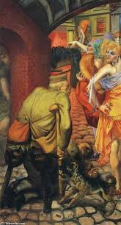

Guidance
Source A suggests that………….I know this because the source says that..

Source A also suggests that…….I know this because the source says that..

2 Explain why 1924-29 was a golden age in the Weimar Republic.
You may use the following in your answer:
- Women
- Culture
You must also use information of your own. 12 marks

Guidance
There are three main reasons which link together that explain why X occurred including a, b and c.

The first reason is a. Give three points to support the reason.

The second reason is b. Give three points to support the reason.

The third reason is c. Give three points to support the reason.

Conclusion. Comment on how the reasons link together

Exam Practise KT1 F4
SECTION B
For this section, you will need to use the sources and interpretations in the Sources/Interpretations Booklet.

3 (a) Study Sources B and C.
How useful are Sources B and C for an enquiry into the attitudes towards Women in Weimar Germany?
Explain your answer, using Sources B and C and your knowledge of the historical context. 8 marks

Source B  A very famous photograph from Weimar Germany. The "El Dorado" was situated at 29, Lutherstraße, and mainly attracted members of Berlin's high society, adventurous foreign tourists and provincial artists and writers. It had a lavish floor show. It was closed down in about 1932  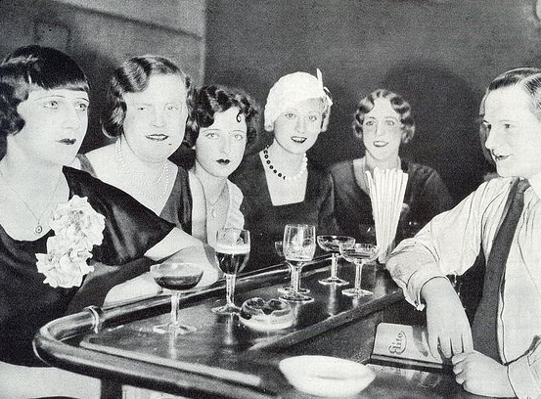 | Source C  A photograph of a woman serving soup in a street scene in Germany in the 1920’s. The image portrays not only the level of poverty but also the traditional role of women as guadians of the family whose work tended to focus around a domestic and nurturing role.  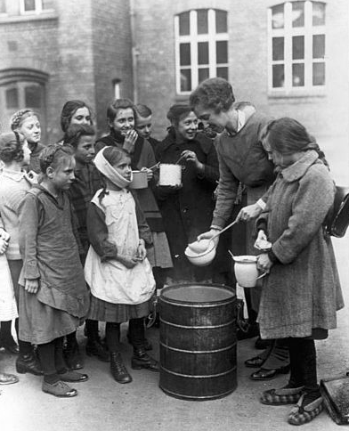

Guidance
The sources B and C have both strengths and limitations for an enquiry into X

Source B is useful in its content and NOP. 3 main points supported by K. However it is limited also because..supported by K.

Source C is useful in its content and NOP. 3 main points supported by K.

However it is limited also because.supported by K..

3 (b) Study Interpretations 1 and 2.
They give different views about the attitudes towards Women in Weimar Germany. What is the main difference between these views? Explain your answer, using details from both interpretations. 4 marks

Interpretation 1 From an article on women in Weimar Germany by Rudiger Grafin 2009  Because of women’s improved position in the workforce and their newly acquired rights as citizens, women themselves seemed to have changed. Magazines presented a new generation of women that differed fundamentally from their mothers generation. | Interpretation 2 From weimar and Nazi Germany by Stephen Lee published in 1996  The 1920’s saw a huge cultural revival in Germany. Indeed these years have been seen as the greatest period of experimentation in German history. As things settled down politically, writers and artists had more of a chance to try out new ideas. However these changes were short lived and any perceived change in the role of German women was about to be severely challenged on the economic downturn. The extent of change in women’s changing role and status in Weimar Germany were not deep rooted.

Guidance
Interpretation 1 views the attitudes of X towards Y as……….. This is supported by the quotes “a” and “b”.

On the other hand Interpretation 2 views the attitudes of X towards Y as…… …...This is supported by the quotes “a” and “b”.

3 (c) Suggest one reason why Interpretations 1 and 2 give different views about the attitudes towards women in Weimar Germany. You may use Sources B and C to help explain your answer. 4 marks

Guidance
Note: There are 2 possible reasons why the Interpretations differ and you only need to explain 1! Use either of the following plans. p38

Reason 1
The interpretations differ because they have given different weight to two different sources. Identify the views given in the two sources and show how the views match the two interpretations.

Reason 2
The interpretations may differ because the author emphasises and focuses on different aspects of the problem. Identify the different focuses and emphasis given and show how these match the two sources.

3 (d) How far do you agree with Interpretation 2 about the attitudes towards Women in Weimar Germany? Explain your answer, using both interpretations and your knowledge of the historical context. 20 marks

Up to 4 marks of the total for part (d) will be awarded for spelling, punctuation, grammar and use of specialist terminology.

Guidance
I mainly agree/disagree with the view given in interpretation 2 which supports the view that

Part 1
There is evidence to support Interpretation 2. Expand the paragraph using 3 main points from your own Knowledge.

Part 2
However Interpretation 1 challenges this view because it suggests that….Expand the paragraph using 3 main points from Interpretation 1.

Part 3
Furthermore Interpretation 2 does not take account of other factors involved. Expand the paragraph using 3 main points from your own Knowledge.

Overall I mainly agree/disagree primarily because the evidence which supports/challenges it is more convincing. I think this because

(III) Assessment for Learning
Puzzle practise : Key Topic 1 The Weimar Republic 1918-29

In the puzzle there will be 3 compulsory questions 1,2 and 3a b c and d. The content will come from either one or a combination of the key themes covered in each of the key questions;

The following examples are focussed on content from ..

Exam Practise
SECTION A
Answer both questions.
Study Source A and then answer Question 1
1 Give two things you can infer from source A about X. 4 marks

Source A

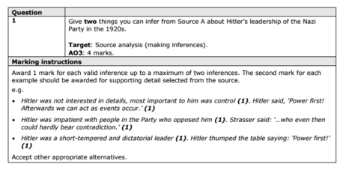

2 Explain why X.
You may use the following in your answer:

You must also use information of your own. 12 marks

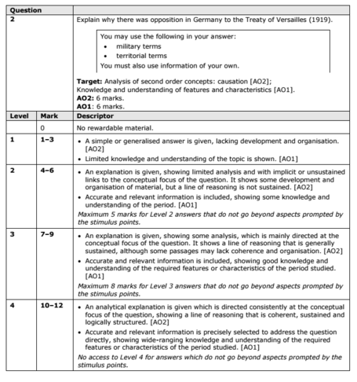

SECTION B
For this section, you will need to use the sources and interpretations in the Sources/Interpretations Booklet.

3
(a)
Study Sources B and C.
How useful are Sources B and C for an enquiry into the attitudes of X towards Y?
Explain your answer, using Sources B and C and your knowledge of the historical context. 8 marks

Source B | Source C

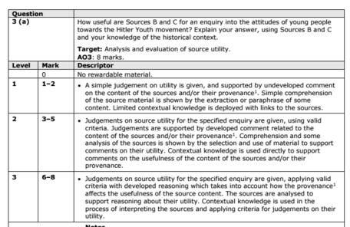

(b)
Study Interpretations 1 and 2. They give different views about the attitudes of X towards Y .
What is the main difference between these views?
Explain your answer, using details from both interpretations. 4 marks

Interpretation 1 | Interpretation 2

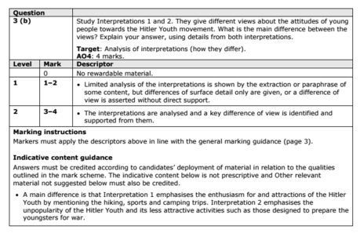

c) Suggest one reason why Interpretations 1 and 2 give different views about the attitudes of X towards Y.
You may use Sources B and C to help explain your answer.4 marks

Up to 4 marks of the total for part (d) will be awarded for spelling, punctuation, grammar and use of specialist terminology.

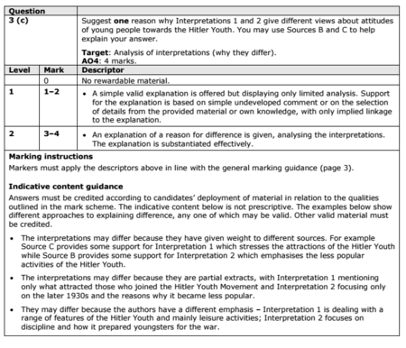

(d) How far do you agree with Interpretation 2 about the attitudes of X towards Y?
Explain your answer, using both interpretations and your knowledge of the historical context. 20 marks

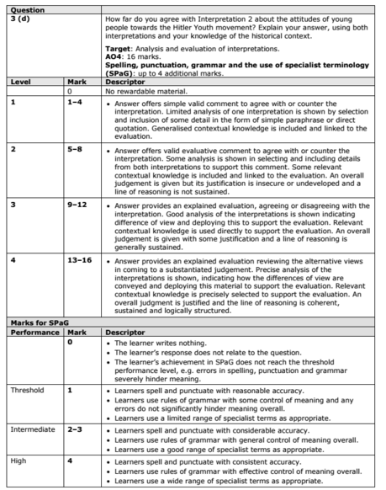

KT1 TMA Germany 1918-39
Focus Points and Elements | Sub-elements | Key Picture | Key Narrative
1 The origins of  the Republic, 1918–19 | - The legacy of the First World War.  - The abdication of the Kaiser  - The armistice  - The revolution, 1918–19. | 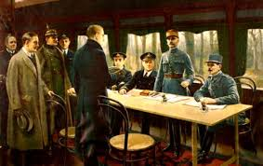 | On 9 November 1918, Kaiser Wilhelm II abdicated the German throne and fled to Holland. Germany became a republic and, two days later, the Armistice was signed bringing an end to fighting in the First World War (1914-18).
1 The origins of  the Republic, 1918–19 | - The setting up of the Weimar Republic.  - The strengths and weaknesses of the new Constitution. | 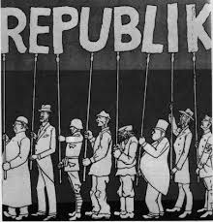 | Within a few months a new republic with a new constitution was set up. This new constitution was in many respects one of the most democratic in the world with a president as the head of state. However, it also included several features which were to contribute to the instability, weakness and eventual downfall of the Weimar Republic, particularly proportional representation and Article 48 which gave powers to the president in an emergency.
2 The early  challenges to  the Weimar  Republic,  1919–23 | - Reasons for the early unpopularity of the Republic, including the ‘stab in the back’ theory  - The key terms of the Treaty of Versailles. | 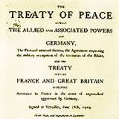 | The Treaty of Versailles imposed extremely severe terms on Germany. Germany lost 13 per cent of its land, 48 per cent of its iron production and more than 6 million citizens were absorbed into other countries. Perhaps the harshest term for Germany was Article 231- the War Guilt Clause. This stated that Germany had to accept blame for starting the war in 1914. This was compounded when the treaty denied Germany entry to the league of Nations, thus showing that Germany was a pariah.For most Germans, the Treaty stoked the fire of shame and humiliation. Versailles was nothing more than a dictated peace (Diluat). A scapegoat was needed - and Ebert, the Weimar Government and its politicians fitted the bill and people began to call them the November Criminals.
2 The early  challenges to  the Weimar  Republic,  1919–23 | - Challenges to the Republic from Left and Right: Spartacists,  - Freikorps, the Kapp Putsch. | 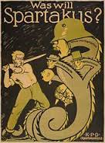 | At the same time that Ebert and Scheidemann were trying to establish a new government in Germany, there was political turmoil across the country. In its early years, the Weimar Republic faced constant threats from the left and right and there were several uprisings across Germany that threatened the existence of the Government. It seemed that the Weimar Government could not win. Its politicians were criticised for ending the war, accepting the Treaty of Versailles and then introducing high taxes for the better off in society in order to meet the Allied reparations.
2 The early  challenges to  the Weimar  Republic,  1919–23 | - The challenges of 1923: hyperinflation;  - the reasons for, and effects of, the French occupation of the Ruhr. | 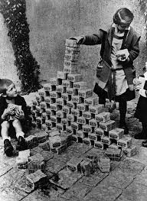 | The problems facing the Weimar Republic worsened in 1923 due to the French occupation of the Ruhr and the effects of hyperinflation. When the reparations figure was announced - £6,600 million at £100 million per year- the Weimar Government claimed that it could not pay. The value of the German currency started to fall rapidly and, because no reparations were paid, France sent troops into the Ruhr.
3 The recovery  of the Republic,  1924–29 | - Reasons for economic recovery, including the work of Stresemann, the Rentenmark,  - The Dawes Plan 1924  - The Young Plan 1929 and American loans and investment. | 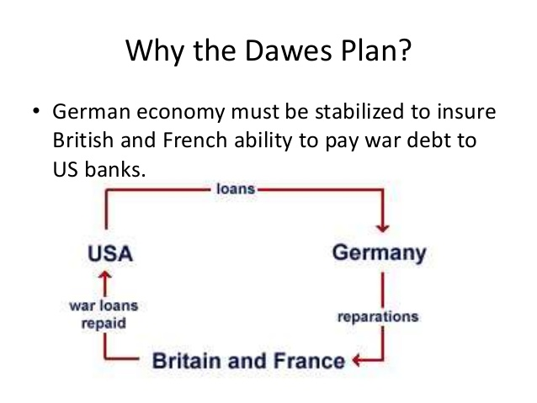 | Following the crises of 1923, including the French occupation of the Ruhr and hyperinflation, Germany seemed to experience a period of recovery at home and abroad under the direction of Gustav Stresemann and with the assistance of American loans. This, in turn, seemed to encourage greater support for the Weimar Republic and less support for extremist parties such as the Nazis and Communists.German recovery was largely due to the work of Gustav Stresemann, who was able co work successfully with Britain, France and the USA co improve Germany's economic and international position
3 The recovery  of the Republic,  1924–29 | - The impact on domestic policies of Stresemann’s achievements abroad:  - The Locarno Pact  - Joining the League of Nations  - The Kellogg-Briand Pact. | 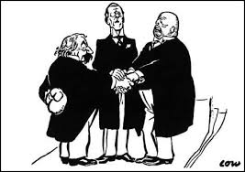 | Stresemann realised that France needed to feel secure in order to co-operate over changes in the Versailles peace treaty. Therefore, in 1925 Germany signed the Locarno Pact with Britain, France, Belgium and Italy. In 1928 Germany signed the Kellogg-Briand Pact along with 64 other nations. It was agreed that they would keep their armies for self-defence and solve all international disputes 'by peaceful means'.
4 Changes in society, 1924–29 | - Changes in the standard of living, including wages, housing,  - Unemployment insurance. | 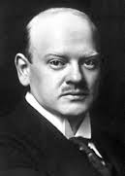 | During this period, German workers did, to a certain extent, benefit from increases in the value of real wages. By 1928 there had been an increase in real wages of over ten per cent which meant Germany had workers some of the best-paid workers in Europe. However, many of the middle class did not share in this increased prosperity. These changes in real wages were of little benefit to the middle classes, many of who had been bankrupted by the hyperinflation of 1923.
4 Changes in society, 1924–29 | - Changes in the position of women in work, politics and leisure. |  | In 1919, women over 20 years old were given the vote and took an increasing interest in politics. The Weimar Constitution also introduced equality in education for the sexes, equal opportunity in civil service appointments and equal pay in the professions. By the end of this period, German women had some of the most advanced legal rights of any country in Europe. Furthermore, by 1926 there were 32 women deputies in the Reichstag, which was a higher proportion than the number in Britain and the USA. The proportion of women who took up work outside the home remained much the same during the Weimar Republic. Women enjoyed much more freedom socially than had been the case before the Weimar Republic. They went out unescorted, drank and smoked in public, were fashion conscious, often wearing relatively short skirts, had their hair cut short and wore make-up.
4 Changes in society, 1924–29 | - Cultural changes: developments in architecture, art and the cinema. | 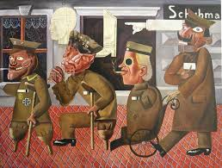 | This period saw the emergence of some of the most exciting art and culture in Europe. The strict p re-war censorship was removed. Throughout the 1920s, Berlin challenged Paris as the cultural capital of Europe, with new and significant developments in painting, cinema, architecture, literature and theatre. However, this led to criticism that artists were undermining traditional German values, especially from right-wing politicians such as Hitler. They said these cultural changes were un-German and immoral.

Trigger Memory Story Medicine 50-1350

The story must be very imaginative. It must involve you seeing, talking and doing things. It must link the ten trigger words together in the form of a continuous story. You should then rehearse the story and commit it too your long term memory to be recalled when necessary. This will take some effort but will be very useful! Use different colours to write the trigger words in your story.

I was...

