Key Topic 3. The end of the Cold War, 1970–91

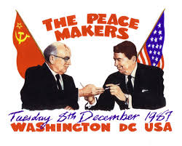

In a Nutshell: Overview of developments The end of the Cold War, 1970–91

Causes and Analysis including:
Focus 1 Attempts to reduce tension between East and West
Détente in the 1970s, SALT 1, Helsinki, and SALT 2. The significance of Reagan and Gorbachev’s changing attitudes. Gorbachev’s ‘new thinking’ and the Intermediate-Range Nuclear Force (INF) Treaty 1987.

Focus 2 Flashpoints
The significance of the Soviet invasion of Afghanistan, the Carter Doctrine and the Olympic boycotts. Reagan and the ‘Second Cold War’, the Strategic Defence Initiative.

Focus 3 The collapse of Soviet control of Eastern Europe
The impact of Gorbachev’s ‘new thinking’ on Eastern Europe: the loosening Soviet grip on Eastern Europe. The significance of the fall of the Berlin Wall. The collapse of the Soviet Union and its significance in bringing about the end of the Warsaw Pact.

Cracking the Puzzle – Preparing for assessment.
Language and Literacy
Key Terms and their meanings in Cold War 1970-91.

(I) In a Nutshell: Overview of Cold War 1970-91

Content overview
Focus 1 Attempts to reduce tension between East and West
Détente in the 1970s, SALT 1, Helsinki, and SALT 2. The significance of Reagan and Gorbachev’s changing attitudes. Gorbachev’s ‘new thinking’ and the Intermediate-Range Nuclear Force (INF) Treaty 1987.

Focus 2 Flashpoints
The significance of the Soviet invasion of Afghanistan, the Carter Doctrine and the Olympic boycotts. Reagan and the ‘Second Cold War’, the Strategic Defence Initiative.

Focus 3 The collapse of Soviet control of Eastern Europe
The impact of Gorbachev’s ‘new thinking’ on Eastern Europe: the loosening Soviet grip on Eastern Europe. The significance of the fall of the Berlin Wall. The collapse of the Soviet Union and its significance in bringing about the end of the Warsaw Pact.

(II) Causes and Analysis of developments:
Activity 1 – On your marks…..
The timeline grid sums up developments in the Cold War 1970-91. For each area colour code each box; stable/successful (green), becoming unstable/some difficulties (yellow) or significant problems/unsuccessful (red).

Activity 2 – Get set…..
Your teacher will give you an A3 copy of a concept map. Stick it in your book. You will fill sections in at the end of each key focus area. As well as adding information to your concept map you can add a colour scheme to identify key themes.

Activity 3 – Go…..
As well as the lesson work and activities, read your book independently and visit the library. There are also many excellent websites listed in the back of this booklet to check out. Try to develop your own individual interest in this area of focus .

Focus 1.Attempts to reduce tension between East and West
Détente in the 1970s, SALT 1, Helsinki, and SALT 2. The significance of Reagan and Gorbachev’s changing attitudes. Gorbachev’s ‘new thinking’ and the Intermediate-Range Nuclear Force (INF) Treaty 1987.
Activity 1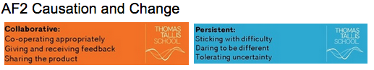
Détente in the 1970s, SALT 1, Helsinki, and SALT 2. p64-71
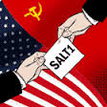 | Détente in the 1970s, SALT 1, Helsinki, and SALT 2.
Reasons for Detente
Vietnam War
Nixon’s visit to Moscow
SALT I 1972
The Middle East Yom Kippur War 1973
Nixon’s visit to Moscow 1974
Space link-up
Helsinki Agreements
Superpower relations after Helsinki
SALT II 1974

Activity 2
The significance of Reagan and Gorbachev’s changing attitudes. p72-73
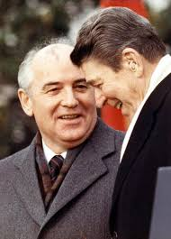 | The significance of Reagan and Gorbachev’s changing attitudes
Gorbachev becomes leader
New thinking
Other developments

Activity 3
Gorbachev’s ‘new thinking’.The summit conferences p72-73
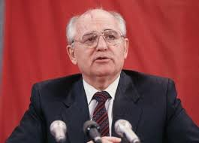 | Gorbachev’s ‘new thinking’.The summit conferences
The summit conferences 1985-86
The 1986 summit meeting in Reykjavik

Activity 4
The Intermediate-Range Nuclear Force (INF) Treaty 1987.p74-75

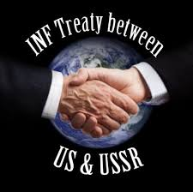 | The Intermediate-Range Nuclear Force (INF) Treaty 1987
Intermediate Range Nuclear Forces Treaty (INF) 1987
Further Agreements

Activity 5

SECTION A: Superpower relations and the Cold War, 1941–91

Answer ALL questions in this section.

1 Explain two consequences of the Helsinki Agreements 1975 (1962).
8 marks

2 Write an account that explains the developments in the SALT Agreements.
You may use the following in your answer:
- SALT I
- SALT II
You must also use information of your own. 8 marks

3 Explain two of the following:
- The importance of the agreements in Helsinki 1975 for the development of the Cold War. (8 marks)
- The importance of the SALT Agreements for relations between the US and the Soviet Union. (8 marks)
- The importance of Gorbachev’s ‘new thinking’ for Summit Conferences and INF Treaty 1985-87. (8 marks)
(Total for Question 3 = 16 marks)

Focus 2. Flashpoints
The significance of the Soviet invasion of Afghanistan, the Carter Doctrine and the Olympic boycotts. Reagan and the ‘Second Cold War’, the Strategic Defence Initiative.
Activity 1
The significance of the Soviet invasion of Afghanistan p76-77

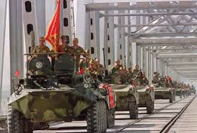 | The significance of the Soviet invasion of Afghanistan
Soviet invasion 1979
Background to Soviet involvement in Afghanistan
The issue of Islamic fundamentalism
The invasion

Activity 2
The Carter Doctrine and the Olympic boycotts. p78-79
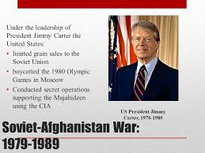 | The Carter Doctrine and the Olympic boycotts.
Significance of the invasion
The Carter Doctrine
Moscow Olympics boycott 1980
End of detente

Activity 3
Reagan and the ‘Second Cold War’. p80-82

Reagan and the ‘Second Cold War’
Reagan’s attitude to foreign policy
Reagan’s defence policy
Impact of Reagan’s policy
The Zero option
Polish Solidarity

Activity 4
The Strategic Defence Initiative p83
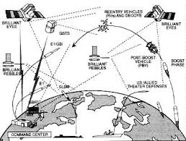 | The Strategic Defence Initiative
SDI
Soviet response to SDI

Activity 5

SECTION A: Superpower relations and the Cold War, 1941–91

Answer ALL questions in this section.

1 Explain two consequences of the Soviet invasion of Afghanistan (1979).
8 marks

2 Write an account that explains the key impacts of the Soviet invasion of Afghanistan.
You may use the following in your answer:
- Carter Doctrine
- End of detente
You must also use information of your own. 8 marks

3 Explain two of the following:
- The importance of the events in Afghanistan 1979 for the development of the Cold War. (8 marks)
- The importance of Reagan’s election as President for relations between the US and the Soviet Union. (8 marks)
- The importance of the SDI for Cold War relations. (8 marks)
(Total for Question 3 = 16 marks)

Focus 3. The collapse of Soviet control of Eastern Europe
The impact of Gorbachev’s ‘new thinking’ on Eastern Europe: the loosening Soviet grip on Eastern Europe. The significance of the fall of the Berlin Wall. The collapse of the Soviet Union and its significance in bringing about the end of the Warsaw Pact.

Activity 1
The impact of Gorbachev’s ‘new thinking’ on Eastern Europe: the loosening Soviet grip on Eastern Europe. p84-85
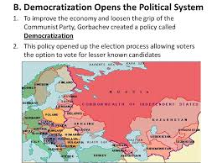 | The impact of Gorbachev’s ‘new thinking’ on Eastern Europe: the loosening Soviet grip on Eastern Europe
Impact of Gorbachev’s new thinking on eastern Europe
Changes in eastern Europe | Poland  East Germany  Czechoslovakia  Hungary  Romania  Bulgaria

Activity 2
The significance of the fall of the Berlin Wall. p86-87

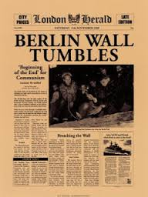 | The significance of the fall of the Berlin Wall.
Developments in East Germany

Activity 3
The collapse of the Soviet Union. p88

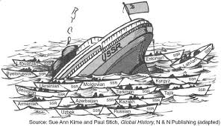 | The collapse of the Soviet Union.
Collapse of the Soviet Union

Activity 4
The collapse of the Soviet Union and its significance in bringing about the end of the Warsaw Pact. p89
The collapse of the Soviet Union and its significance in bringing about the end of the Warsaw Pact.
End of the Warsaw Pact and the Cold War.

Activity 5
SECTION A: Superpower relations and the Cold War, 1941–91

Answer ALL questions in this section.

1 Explain two consequences of Gorbachev’s new thinking on eastern Europe to 1989.
8 marks

2 Write an account that explains the key events of the fall of the Berlin Wall 1989.
You may use the following in your answer:
- The impact of Gorbachev’s new thinking
- Developments in East Germany
You must also use information of your own. 8 marks

3 Explain two of the following:
- The importance of the events in Hungary in 1956 for the development of the Cold War. (8 marks)
- The importance of the Soviet invasion of Czechoslovakia (1968) for relations between the US and the Soviet Union. (8 marks)
- The importance of Gorbachev’s ‘new thinking’ for Soviet control of Eastern Europe. (8 marks)
(Total for Question 3 = 16 marks)

(III) Assessment for Learning
Puzzle practise :Cold War 1970-91
In the puzzle there will be three compulsory questions covering the core content. The content will come from either one or a combination of the key themes covered in each of the key questions;

The following examples are focussed on content from ..

Exam Practise
SECTION A: Superpower relations and the Cold War, 1941–91
Answer ALL questions in this section.
1 Explain two consequences of the Cuban Missile Crisis (1962).
8 marks

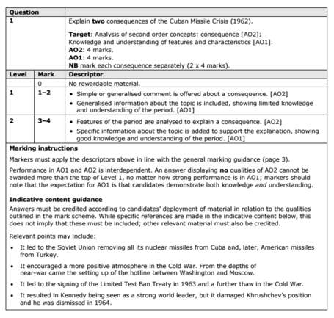

2 Write an account that explains the key events of the Berlin Crisis, 1948–49.
You may use the following in your answer:
- Stalin’s fears
- the Airlift
You must also use information of your own. 8 marks

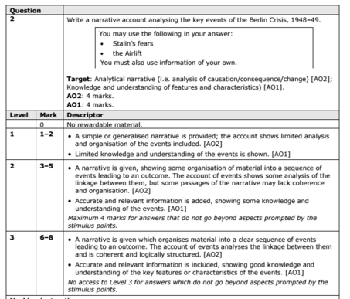

3 Explain two of the following:
- The importance of the events in Hungary in 1956 for the development of the Cold War. (8 marks)
- The importance of the Soviet invasion of Czechoslovakia (1968) for relations between the US and the Soviet Union. (8 marks)
- The importance of Gorbachev’s ‘new thinking’ for Soviet control of Eastern Europe. (8 marks)
(Total for Question 3 = 16 marks)

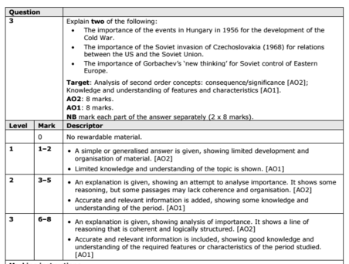

Trigger Memory Activity for Cold War 1970-91

Trigger Words | Trigger Picture | Add Trigger  Points from your notes
Focus 1 Attempts to reduce tension between East and West
Détente in the 1970s, SALT 1, Helsinki, and SALT 2.
The significance of Reagan and Gorbachev’s changing attitudes.
Gorbachev’s ‘new thinking’ and the Intermediate-Range Nuclear Force (INF) Treaty 1987.
Focus 2 Flashpoints
The significance of the Soviet invasion of Afghanistan,
The Carter Doctrine and the Olympic boycotts.
Reagan and the ‘Second Cold War’
The Strategic Defence Initiative.

Focus 3 The collapse of Soviet control of Eastern Europe
The impact of Gorbachev’s ‘new thinking’ on Eastern Europe:
The loosening Soviet grip on Eastern Europe.
The significance of the fall of the Berlin Wall.
The collapse of the Soviet Union and its significance in bringing about the end of the Warsaw Pact.
Trigger Memory Story Cold War 1970-91

The story must be very imaginative. It must involve you seeing, talking and doing things. It must link the ten trigger words together in the form of a continuous story. You should then rehearse the story and commit it to your long term memory to be recalled when necessary. This will take some effort but will be very useful! Use different colours to write the trigger words in your story.

I was on my way to a history lesson and on entering the room the clock began to go backwards, minutes, hours, days, months, years coming to a halt in 1970. There was a relaxation of tension in the Cold War called Detente

