Key Topic 2. Cold War crises 1958-70

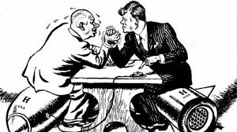

Content
In a Nutshell: Overview of developments Cold War crises 1958-70

Causes and Analysis of Cold War crises 1958-70 including:
Focus 1 Increased tension between East and West
The refugee problem in Berlin, Khrushchev’s Berlin ultimatum (1958), and the summit meetings of 1959–61. Soviet relations with Cuba, the Cuban Revolution and the refusal of the USA to recognise Castro’s government. The significance of the Bay of Pigs incident. Opposition in Czechoslovakia to Soviet control: the Prague Spring.

Focus 2 Cold War crises
The construction of the Berlin Wall, 1961. The events of the Cuban Missile Crisis. The Brezhnev Doctrine and the re-establishment of Soviet control in Czechoslovakia.

Focus 3 Reaction to crisis
Impact of the construction of the Berlin Wall on US-Soviet relations. Kennedy’s visit to Berlin in 1963. The consequences of the Cuban Missile Crisis: the ‘hotline’, the Limited Test Ban Treaty 1963; the Outer Space Treaty 1967; and the Nuclear Non-Proliferation Treaty 1968. International reaction to Soviet measures in Czechoslovakia.

Cracking the Puzzle – Preparing for assessment.

Language and Literacy
Key Terms and their meanings in Cold War 1958-70.

(I) In a Nutshell: Overview of old War 1958-70

Content overview
Focus 1 Increased tension between East and West
The refugee problem in Berlin, Khrushchev’s Berlin ultimatum (1958), and the summit meetings of 1959–61. Soviet relations with Cuba, the Cuban Revolution and the refusal of the USA to recognise Castro’s government. The significance of the Bay of Pigs incident. Opposition in Czechoslovakia to Soviet control: the Prague Spring.

Focus 2 Cold War crises
The construction of the Berlin Wall, 1961. The events of the Cuban Missile Crisis. The Brezhnev Doctrine and the re-establishment of Soviet control in Czechoslovakia.

Focus 3 Reaction to crisis
Impact of the construction of the Berlin Wall on US-Soviet relations. Kennedy’s visit to Berlin in 1963. The consequences of the Cuban Missile Crisis: the ‘hotline’, the Limited Test Ban Treaty 1963; the Outer Space Treaty 1967; and the Nuclear Non-Proliferation Treaty 1968. International reaction to Soviet measures in Czechoslovakia.

(II) Causes and Analysis of developments:
Activity 1 – On your marks…..
The timeline grid sums up developments in the Cold War 1958-70. For each area colour code each box; stable/successful (green), becoming unstable/some difficulties (yellow) or significant problems/unsuccessful (red).

Activity 2 – Get set…..
Your teacher will give you an A3 copy of a concept map. Stick it in your book. You will fill sections in at the end of each key focus area. As well as adding information to your concept map you can add a colour scheme to identify key themes.

Activity 3 – Go…..
As well as the lesson work and activities, read your book independently and visit the library. There are also many excellent websites listed in the back of this booklet to check out. Try to develop your own individual interest in this area of focus .

Focus 1. Increased tension between East and West
The refugee problem in Berlin, Khrushchev’s Berlin ultimatum (1958), and the summit meetings of 1959–61. Soviet relations with Cuba, the Cuban Revolution and the refusal of the USA to recognise Castro’s government. The significance of the Bay of Pigs incident. Opposition in Czechoslovakia to Soviet control: the Prague Spring.

Activity 1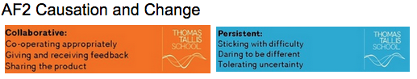
The refugee problem in Berlin, Khrushchev’s Berlin ultimatum (1958), and the summit meetings of 1959–61.p40-41
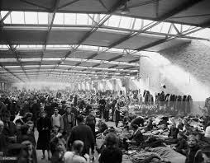 | The refugee problem in Berlin, Khrushchev’s Berlin ultimatum (1958), and the summit meetings of 1959–61.
Anxieties for Khrushchev.
The refugee problem in Berlin
Khrushchev’s Berlin ultimatum
Paris summit 1960
Vienna summit 1961

Activity 2
Soviet relations with Cuba, the Cuban Revolution and the refusal of the USA to recognise Castro’s government. p46

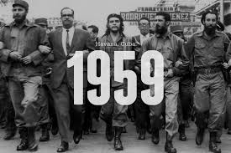 | Soviet relations with Cuba, the Cuban Revolution and the refusal of the USA to recognise Castro’s government.
Increased tension over Cuba
The Cuban revolution
Soviet relations with Cuba

Activity 3
The significance of the Bay of Pigs incident. P 47-49
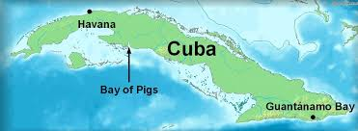 | The significance of the Bay of Pigs incident.
Bay of Pigs April 1961
Reasons the invasion failed
Significance of the invasion
Military build up in Cuba

Activity 4
Opposition in Czechoslovakia to Soviet control: the Prague Spring. p54-57

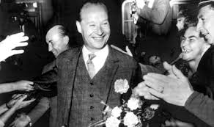 | Opposition in Czechoslovakia to Soviet control: the Prague Spring.
Increased tension over Czechoslovakia
Novotny’s fall from power
Novotny’s replacement Dubcek
The Prague Spring Reforms
Reactions to the reforms
Other reasons for the invasion

Activity 5
SECTION A: Superpower relations and the Cold War, 1941–91

Answer ALL questions in this section.

1 Explain two consequences of the Berlin refugee problem by 1961.
8 marks

2 Write an account that explains the key events of the Cuba’s relation with America 1959-61.
You may use the following in your answer:
- Soviet relations with Cuba
- Bay of Pigs April 1961
You must also use information of your own. 8 marks

3 Explain two of the following:
- The importance of the events in Berlin by 1961 for the development of the Cold War. (8 marks)
- The importance of the Soviet invasion of Czechoslovakia (1968) for relations between the US and the Soviet Union. (8 marks)
- The importance of the Cuban revolution for the development of the Cold War. (8 marks)
(Total for Question 3 = 16 marks)

Focus 2. Cold War crises
The construction of the Berlin Wall, 1961. The events of the Cuban Missile Crisis. The Brezhnev Doctrine and the re-establishment of Soviet control in Czechoslovakia.
Activity 1
The construction of the Berlin Wall 1961. p42

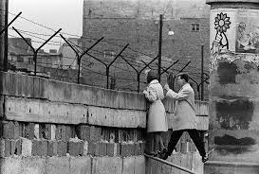 | The construction of the Berlin Wall 1961
Construction of the Wall

Activity 2
The events of the Cuban Missile Crisis. p50-51
 | The events of the Cuban Missile Crisis.
The photographs
Kennedy’s reaction
The October crisis | 22nd October  24th October  26th October  27th October  28th October

Activity 3
The Brezhnev Doctrine. p59

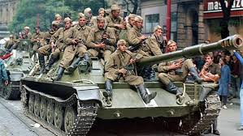 | The Brezhnev Doctrine
The Brezhnev Doctrine

Activity 4
The re-establishment of Soviet control in Czechoslovakia p58-59
The re-establishment of Soviet control in Czechoslovakia
Soviet invasion

Activity 5
SECTION A: Superpower relations and the Cold War, 1941–91

Answer ALL questions in this section.

1 Explain two consequences of the Cuban Missile Crisis (1962).
8 marks

2 Write an account that explains the key events of the Berlin Crisis, 1948–49.
You may use the following in your answer:
- Stalin’s fears
- the Airlift
You must also use information of your own. 8 marks

3 Explain two of the following:
- The importance of the events in Berlin 1959-61 for the development of the Cold War. (8 marks)
- The importance of the Soviet invasion of Czechoslovakia (1968) for relations between the US and the Soviet Union. (8 marks)
- The importance of the Cuban Missile Crisis 1962 for relations between US and the Soviet Union. (8 marks)
(Total for Question 3 = 16 marks)

Focus 3. Reaction to crisis
Impact of the construction of the Berlin Wall on US-Soviet relations. Kennedy’s visit to Berlin in 1963. The consequences of the Cuban Missile Crisis: the ‘hotline’, the Limited Test Ban Treaty 1963; the Outer Space Treaty 1967; and the Nuclear Non-Proliferation Treaty 1968. International reaction to Soviet measures in Czechoslovakia.

Activity 1
Impact of the construction of the Berlin Wall on US-Soviet relations. p43
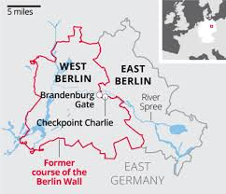 | Impact of the construction of the Berlin Wall on US-Soviet relations
Impact of the Berlin Wall for US Soviet relations
Impact of the Berlin Wall for Germans

Activity 2
Kennedy’s visit to Berlin in 1963. p44
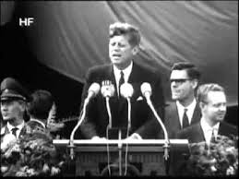 | Kennedy’s visit to Berlin in 1963.
The end of the Berlin crisis
Kennedy’s visit to Berlin 1963

Activity 3
The consequences of the Cuban Missile Crisis: the ‘hotline’, the Limited Test Ban Treaty 1963. p52
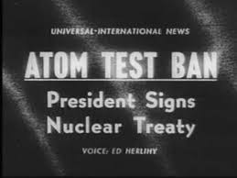 | The consequences of the Cuban Missile Crisis: the ‘hotline’, the Limited Test Ban Treaty 1963.
The consequences
Increased rivalry
The hotline
Treaties

Activity 4
The Outer Space Treaty 1967; and the Nuclear Non-Proliferation Treaty 1968. p52
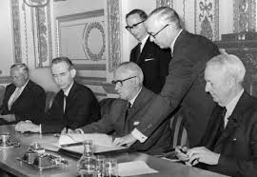 | The Outer Space Treaty 1967; and the Nuclear Non-Proliferation Treaty 1968
Treaties

Activity 5
International reaction to Soviet measures in Czechoslovakia.p60-61

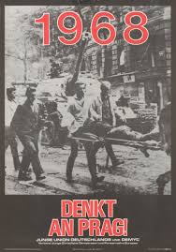 | International reaction to Soviet measures in Czechoslovakia.
Czechoslovakia
Soviet and USA relations
Western Europe
Communist countries

Activity 6
SECTION A: Superpower relations and the Cold War, 1941–91

Answer ALL questions in this section.

1 Explain two consequences of the Cuban Missile Crisis (1962).
8 marks

2 Write an account that explains the key events of the Berlin Crisis, 1959-61.
You may use the following in your answer:
- The refugee problem
- The Vienna summit
You must also use information of your own. 8 marks

3 Explain two of the following:
- The importance of the events in Berlin 1959-61 for the development of the Cold War. (8 marks)
- The importance of the Soviet invasion of Czechoslovakia (1968) for relations between the US and the Soviet Union. (8 marks)
- The importance of Cuban Revolution for US and Soviet relations. (8 marks)
(Total for Question 3 = 16 marks)

(III) Assessment for Learning
Puzzle practise : Cold War 1958-70

In the puzzle there will be three compulsory questions covering the core content. The content will come from either one or a combination of the key themes covered in each of the key questions;

The following examples are focussed on content from ..

Exam Practise
SECTION A: Superpower relations and the Cold War, 1941–91
Answer ALL questions in this section.
1 Explain two consequences of the Cuban Missile Crisis (1962).
8 marks

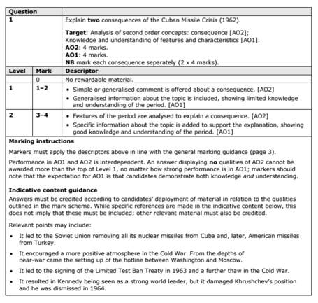

2 Write an account that explains the key events of the Berlin Crisis, 1948–49.
You may use the following in your answer:
- Stalin’s fears
- the Airlift
You must also use information of your own. 8 marks

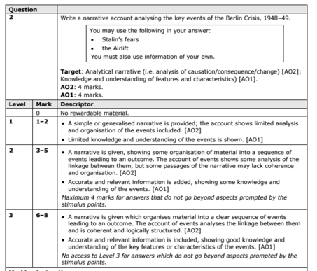

3 Explain two of the following:
- The importance of the events in Hungary in 1956 for the development of the Cold War. (8 marks)
- The importance of the Soviet invasion of Czechoslovakia (1968) for relations between the US and the Soviet Union. (8 marks)
- The importance of Gorbachev’s ‘new thinking’ for Soviet control of Eastern Europe. (8 marks)
(Total for Question 3 = 16 marks)

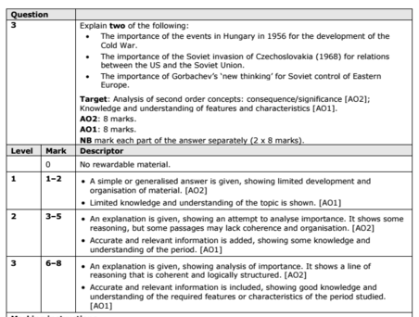

Trigger Memory Activity for Cold War 1958-70

Trigger Words | Trigger Picture | Add Trigger  Points from your notes
Focus 1 Increased tension between East and West
The refugee problem in Berlin.
Khrushchev’s Berlin ultimatum (1958), | 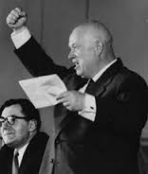
The summit meetings of 1959–61. | 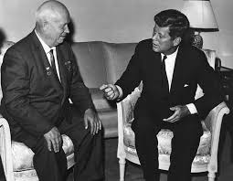
Soviet relations with Cuba, the Cuban Revolution and the refusal of the USA to recognise Castro’s government.
The significance of the Bay of Pigs incident.

Opposition in Czechoslovakia to Soviet control: the Prague Spring.
Focus 2 Cold War crises
The construction of the Berlin Wall, 1961.
The events of the Cuban Missile Crisis.
The Brezhnev Doctrine and the re-establishment of Soviet control in Czechoslovakia.
Focus 3 Reaction to crisis
Impact of the construction of the Berlin Wall on US-Soviet relations.
Kennedy’s visit to Berlin in 1963.
The consequences of the Cuban Missile Crisis: the ‘hotline’, the Limited Test Ban Treaty 1963;
The Outer Space Treaty 1967; and the Nuclear Non-Proliferation Treaty 1968.
International reaction to Soviet measures in Czechoslovakia.

Trigger Memory Story Cold War 1958-70

The story must be very imaginative. It must involve you seeing, talking and doing things. It must link the ten trigger words together in the form of a continuous story. You should then rehearse the story and commit it too your long term memory to be recalled when necessary. This will take some effort but will be very useful! Use different colours to write the trigger words in your story.

I was on my way to a history lesson and on entering the room the clock began to go backwards, minutes, hours, days, months, years coming to a halt in 1958. There was a relaxation of tension in the Cold War called Detente

