Key Topic 1. The origins of the Cold War, 1941–58

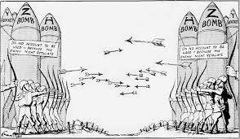

Content
In a Nutshell: Overview of developments The origins of the Cold War, 1941–58

Causes and Analysis of the origins of the Cold War, 1941–58 , including:
Focus 1 Early tension between East and West
The Grand Alliance. The outcomes of the Tehran, Yalta and Potsdam conferences. The ideological differences between the superpowers and the attitudes of Stalin, Truman and Churchill. The impact on US-Soviet relations of the development of the atomic bomb, the Long and Novikov telegrams and the creation of Soviet satellite states in Eastern Europe.

Focus 2 The development of the Cold War
The impact on US-Soviet relations of the Truman Doctrine and the Marshall Plan, 1947. The significance of Cominform (1947), Comecon (1949) and the formation of NATO (1949). Berlin: its division into zones. The Berlin Crisis (blockade and airlift) and its impact. The formation of the Federal Republic of Germany and German Democratic Republic.

Focus 3 The Cold War intensifies
The significance of the arms race and the formation of the Warsaw Pact. Events in 1956 leading to the Hungarian Uprising, and Khrushchev’s response. The international reaction to the Soviet invasion of Hungary.

Cracking the Puzzle – Preparing for assessment.

Language and Literacy
Key Terms and their meanings in Cold War 1941-58.
(I) In a Nutshell: Overview of Cold War 1941-58

Content overview
Focus 1 Early tension between East and West
The Grand Alliance. The outcomes of the Tehran, Yalta and Potsdam conferences. The ideological differences between the superpowers and the attitudes of Stalin, Truman and Churchill. The impact on US-Soviet relations of the development of the atomic bomb, the Long and Novikov telegrams and the creation of Soviet satellite states in Eastern Europe.

Focus 2 The development of the Cold War
The impact on US-Soviet relations of the Truman Doctrine and the Marshall Plan, 1947. The significance of Cominform (1947), Comecon (1949) and the formation of NATO (1949). Berlin: its division into zones. The Berlin Crisis (blockade and airlift) and its impact. The formation of the Federal Republic of Germany and German Democratic Republic.

Focus 3 The Cold War intensifies
The significance of the arms race and the formation of the Warsaw Pact. Events in 1956 leading to the Hungarian Uprising, and Khrushchev’s response. The international reaction to the Soviet invasion of Hungary.

(II) Causes and Analysis of developments:
Activity 1 – On your marks…..
The timeline grid sums up developments in the Cold War 1941-58. For each area colour code each box; stable/successful (green), becoming unstable/some difficulties (yellow) or significant problems/unsuccessful (red).

Activity 2 – Get set…..
Your teacher will give you an A3 copy of a concept map. Stick it in your book. You will fill sections in at the end of each key focus area. As well as adding information to your concept map you can add a colour scheme to identify key themes.

Activity 3 – Go…..
As well as the lesson work and activities, read your book independently and visit the library. There are also many excellent websites listed in the back of this booklet to check out. Try to develop your own individual interest in this area of focus .

Focus 1. Early tension between East and West
The Grand Alliance. The outcomes of the Tehran, Yalta and Potsdam conferences. The ideological differences between the superpowers and the attitudes of Stalin, Truman and Churchill. The impact on US-Soviet relations of the development of the atomic bomb, the Long and Novikov telegrams and the creation of Soviet satellite states in Eastern Europe.
Activity 1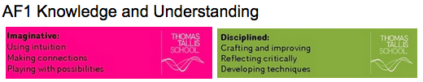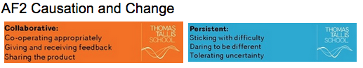
The Grand Alliance and the Tehran Conference November 1943. p10
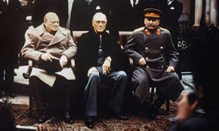 | The Grand Alliance and the Tehran Conference November 1943.
Allies
Stalin, Roosevelt and Churchill
The Tehran Conference November 1943

Activity 2
The outcomes of the Yalta and Potsdam Conferences. p11-12
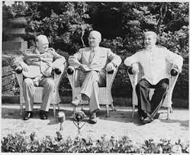 | The outcomes of the Yalta and Potsdam Conferences.
The Yalta Conference February 1945
The Potsdam Conference July 1945
Agreements made at Potsdam
Disagreements made at Potsdam

Activity 3
The ideological differences between the superpowers and the attitudes of Stalin, Truman and Churchill. p7-9
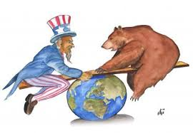 | The ideological differences between the superpowers and the attitudes of Stalin, Truman and Churchill.
What was the Cold War?
Main features of the Cold War | Spying  Propaganda  Arms Race  Space Race  Loans and aid
Ideological differences - Communist countries | Politics  Economy  Beliefs
Ideological differences - Capitalist countries | Politics  Economy  Beliefs

Activity 4
The impact on US-Soviet relations of the development of the atomic bomb, the Long and Novikov telegrams. P15, p18
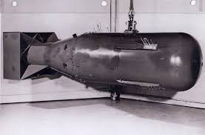 | The impact on US-Soviet relations of the development of the atomic bomb, the Long and Novikov telegrams.
Arms race and Space race | Impact on US Soviet relations
The Long Telegram | Impact on US Soviet relations
The Novikov Telegram | Impact on US Soviet relations
The impact on US-Soviet relations and the Iron Curtain speech

Activity 5
The creation of Soviet satellite states in Eastern Europe p14-16
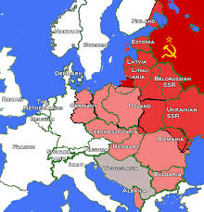 | The creation of Soviet satellite states in Eastern Europe
Soviet Expansion | Memory of what happened 1918-39  Percentages Deal  Strategic importance of Poland  Security.
The pattern of establishing satellite states
Poland
Romania
Hungary
Bulgaria
Czechoslovakia
Yugoslavia

Activity 6
SECTION A: Superpower relations and the Cold War, 1941–91

Answer ALL questions in this section.

1 Explain two consequences of the Potsdam Conference (1945).
8 marks

2 Write an account that explains the key events of the Berlin Crisis, 1948–49.
You may use the following in your answer:
- Stalin’s fears
- the Airlift
You must also use information of your own. 8 marks

3 Explain two of the following:
- The importance of the events in Eastern Europe 1945-48 for the development of the Cold War. (8 marks)
- The importance of ideological divisions for relations between the US and the Soviet Union. (8 marks)
- The importance of the Tehran and Yalta conferences in failing to reconcile differences amongst the allies. (8 marks)
(Total for Question 3 = 16 marks)

Focus 2. The development of the Cold War
The impact on US-Soviet relations of the Truman Doctrine and the Marshall Plan, 1947. The significance of Cominform (1947), Comecon (1949) and the formation of NATO (1949). Berlin: its division into zones. The Berlin Crisis (blockade and airlift) and its impact. The formation of the Federal Republic of Germany and German Democratic Republic.

Activity 1
The impact on US-Soviet relations of the Truman Doctrine and the Marshall Plan, 1947. p20-23
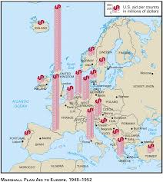 | The impact on US-Soviet relations of the Truman Doctrine and the Marshall Plan, 1947.
The Truman Doctrine 1947
The Truman Doctrine. The consequences
Marshall Aid. Why was it introduced?
Marshall Aid. The consequences
Marshall Aid. Soviet reaction.

Activity 2
The significance of Cominform (1947), Comecon (1949) and the formation of NATO (1949). p24,29
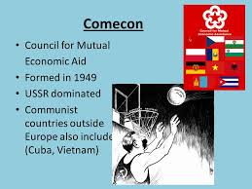 | The significance of Cominform (1947), Comecon (1949) and the formation of NATO (1949).
Cominform 1947
Comecon 1949
NATO and consequences

Activity 3
Berlin: its division into zones and the Berlin Crisis (blockade and airlift) and its impact. p25-27
.
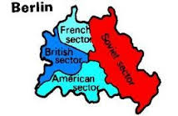 | Berlin: its division into zones and the Berlin Crisis (blockade and airlift) and its impact.
Long term causes of the crises
Short term causes of the crises
Stages of the crises 1948 | January  March  April  June  24 June
The Berlin airlift

Activity 4
The formation of the Federal Republic of Germany and German Democratic Republic. p28
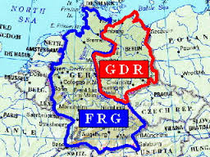 | The formation of the Federal Republic of Germany and German Democratic Republic.
Results of the crisis
A divided Germany
East West rivalry

Activity 5
SECTION A: Superpower relations and the Cold War, 1941–91

Answer ALL questions in this section.

1 Explain two consequences of the Marshall Plan(1947).
8 marks

2 Write an account that explains the key events of the Berlin Crisis, 1948–49.
You may use the following in your answer:
- Stalin’s fears
- the Airlift
You must also use information of your own. 8 marks

3 Explain two of the following:
- The importance of the Truman Doctrine for the development of the Cold War. (8 marks)
- The importance of the Soviet formation of Cominform 1947 and Comecon 1949 for the development of the Cold War. (8 marks)
- The importance of the Berlin crisis in the development of the Cold War. (8 marks)
(Total for Question 3 = 16 marks)

Focus 3. The Cold War intensifies
The significance of the arms race and the formation of the Warsaw Pact. Events in 1956 leading to the Hungarian Uprising, and Khrushchev’s response. The international reaction to the Soviet invasion of Hungary.
Activity 1
The significance of the arms race and the formation of the Warsaw Pact. p31-33
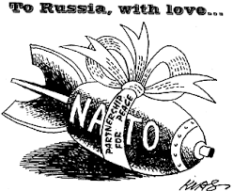 | The significance of the arms race and the formation of the Warsaw Pact.
The Warsaw Pact 1955
The arms race
Superpowers arms spending | 1949 1950 1951 1952 1953  US spending on arms $bn  Soviet Union spending on arms $bn
Weaponry by 1961 | Weapon USA Soviet Union  ICBM  SLBM  MRBM/IRBM  Long range bombers  Aircraft carriers  Nuclear submarines  Conventional submarines  Active military manpower
The impact of sputnik

Activity 2
Events in 1956 leading to the Hungarian Uprising. p34-35
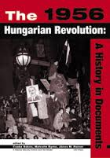 | Events in 1956 leading to the Hungarian Uprising.
Hungary after 1945
Impact of Soviet control
The rule of Rakosi
Key events of the Hungarian uprising

Activity 3
The Hungarian Uprising and Khrushchev’s response. p36-37
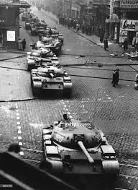 | The Hungarian Uprising and Khrushchev’s response.
The demands of Nagy and the rebels
Krushchev’s response to the uprising
Events of the invasion
Results of the uprising

Activity 4
The international reaction to the Soviet invasion of Hungary. p38

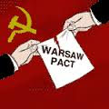 | The international reaction to the Soviet invasion of Hungary.
The West’s response
UN response
Soviet response

Activity 5
SECTION A: Superpower relations and the Cold War, 1941–91

Answer ALL questions in this section.

1 Explain two consequences of the arms race.
8 marks

2 Write an account that explains the key events of the Hungarian Uprising 1956.
You may use the following in your answer:
- Hungary after WW2
- The rule of Rakosi
You must also use information of your own. 8 marks

3 Explain two of the following:
- The importance of the events in Hungary in 1956 for the development of the Cold War. (8 marks)
- The importance of the arms race for relations between the US and the Soviet Union. (8 marks)
(Total for Question 3 = 16 marks)

(III) Assessment for Learning
Puzzle practise : Cold War 1941-58

In the puzzle there will be three compulsory questions covering the core content. The content will come from either one or a combination of the key themes covered in each of the key questions;

The following examples are focussed on content from ..

Exam Practise
SECTION A: Superpower relations and the Cold War, 1941–91
Answer ALL questions in this section.
1 Explain two consequences of the Cuban Missile Crisis (1962).
8 marks

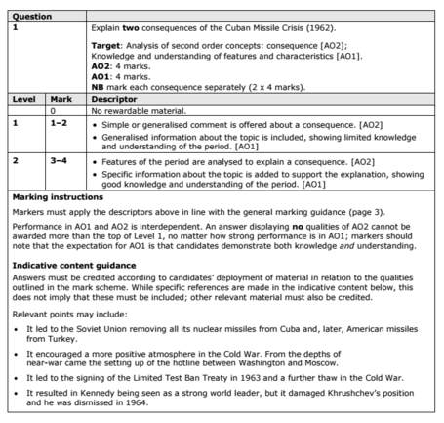

2 Write an account that explains the key events of the Berlin Crisis, 1948–49.
You may use the following in your answer:
- Stalin’s fears
- the Airlift
You must also use information of your own. 8 marks

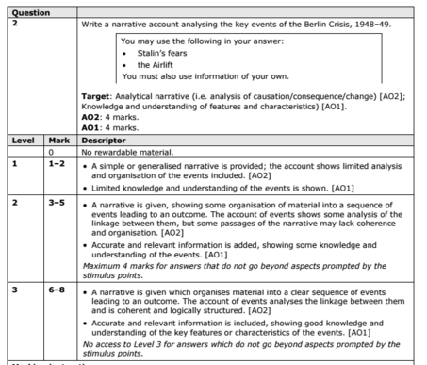

3 Explain two of the following:
- The importance of the events in Hungary in 1956 for the development of the Cold War. (8 marks)
- The importance of the Soviet invasion of Czechoslovakia (1968) for relations between the US and the Soviet Union. (8 marks)
- The importance of Gorbachev’s ‘new thinking’ for Soviet control of Eastern Europe. (8 marks)
(Total for Question 3 = 16 marks)

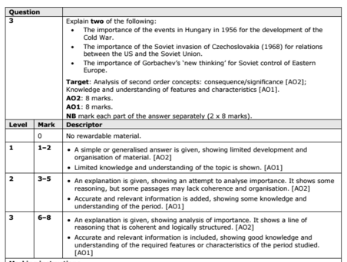

Trigger Memory Activity for Cold War 1941-58

Trigger Words | Trigger Picture | Add Trigger  Points from your notes
Focus 1 Early tension between East and West. The Grand Alliance.
The outcomes of the Tehran, Yalta and Potsdam conferences.
The ideological differences between the superpowers and the attitudes of Stalin, Truman and Churchill.
The impact on US-Soviet relations of the development of the atomic bomb,
The Long and Novikov telegrams | 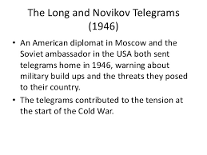
The creation of Soviet satellite states in Eastern Europe.
Focus 2 The development of the Cold War
The impact on US-Soviet relations of the Truman Doctrine and the Marshall Plan, 1947.
The significance of Cominform (1947), Comecon (1949) and the formation of NATO (1949).
Berlin: its division into zones. The Berlin Crisis (blockade and airlift) and its impact.
The formation of the Federal Republic of Germany and German Democratic Republic.

Focus 3 The Cold War intensifies
The significance of the arms race and the formation of the Warsaw Pact.
Events in 1956 leading to the Hungarian Uprising.
Khrushchev’s response to the uprising.
The international reaction to the Soviet invasion of Hungary.

Trigger Memory Story Cold War 1941-58

The story must be very imaginative. It must involve you seeing, talking and doing things. It must link the ten trigger words together in the form of a continuous story. You should then rehearse the story and commit it to your long term memory to be recalled when necessary. This will take some effort but will be very useful! Use different colours to write the trigger words in your story.

I was on my way to a history lesson and on entering the room the clock began to go backwards, minutes, hours, days, months, years coming to a halt in 1941. There was a Grand Alliance of America, Russia and britain to combat the threat of Nazi Germany who had invaded much of mainland Europe. As time passed they met at a variety of Conferences in Tehran, Yalta and Potsdam

