Challenge 1 – War with Makkah
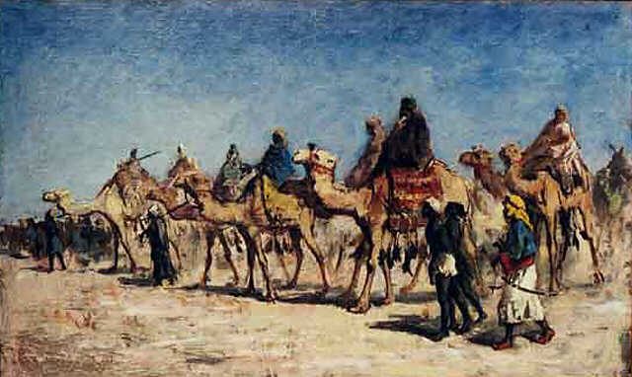
The Quraysh tribe in Makkah that Muhammad had once been a part of made life very difficult for Medina, and before long they were preparing for war. In 624, Muslim spies were sent to report on the caravans, and 350 warriors were sent out to attack the camels. However, the Quraysh had spies too, and sent an army out to meet the Muslim warriors. The Makkans outnumbered them three to one. In the fierce battle, the Muslims’ discipline paid off, and the Makkans were defeated. There were other battles with Makkah and also with some Jewish Arab tribes in the area. In 628, Muhammad visited Makkah and made a truce with the Quraysh. Some people weren’t happy about this, and Muhammad had to work hard to maintain support, but gradually he regained their trust. His Muslim followers swore an oath: ‘O Messenger of God, I pledge my allegiance to that which is in your soul.’

Challenge 2 – Death of Muhammad
In 632 Muhammad died, and the Muslims were left with no leader. They tried to choose a caliph, which means ‘successor’ or ‘deputy’. They would not replace Muhammad, but would lead the Muslim community. There was a lot of discussion and argument over who it should be. Some people thought it should be someone in Muhammad’s family, or a member of the Quraysh tribe. Some people thought the Quraysh was too powerful, and it should be someone else, perhaps a good warrior. It was very difficult to decide.
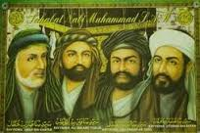
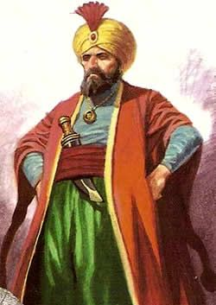
The first four caliphs were considered to be good leaders: (Muhammad’s father-in-law), Umar, Uthman (wrote the Quran), and Ali (Muhammad’s cousin). Ali was murdered by his enemy Mu’awiya, who made himself caliph and moved the Muslim capital to Damascus in Syria. Mu’awiya was from the Umayya clan, which ruled the Muslims from 661-750. However, the debates about who should lead continued.

Challenge 3 – War with the Umayyads
Ali’s family believed that, as Muhammad’s cousin, the caliph should be one of Ali’s sons and it should remain within the family. In 680 they encouraged Ali’s son al-Husayn to challenge the Umayyads. Al-Husayn and 200 followers went out to meet several thousand Umayyad troops, who eventually cut off the water supply. Al-Husayn’s troops fought on but there was no hope, they were very thirsty. The Umayyad general cut off Al-Husayn’s head and gave it to the caliph in Damascus. This day is mourned every year by Shi’ite Muslims – this is what Ali’s supporters called themselves.
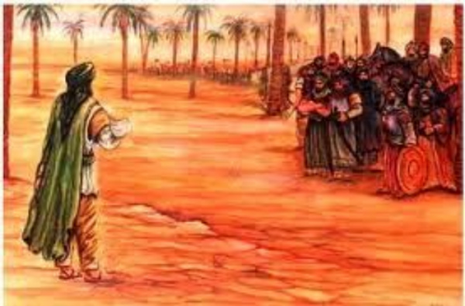
Many people were unhappy with the Umayyads, including the main rebels, the Abbasids. They were descended from Muhammad’s uncle, and didn’t see the Umayyads as the true caliphs. Between 747 and 750, the Abbasids killed all but one of the Umayyads.

Challenge 4 – Berber Attacks
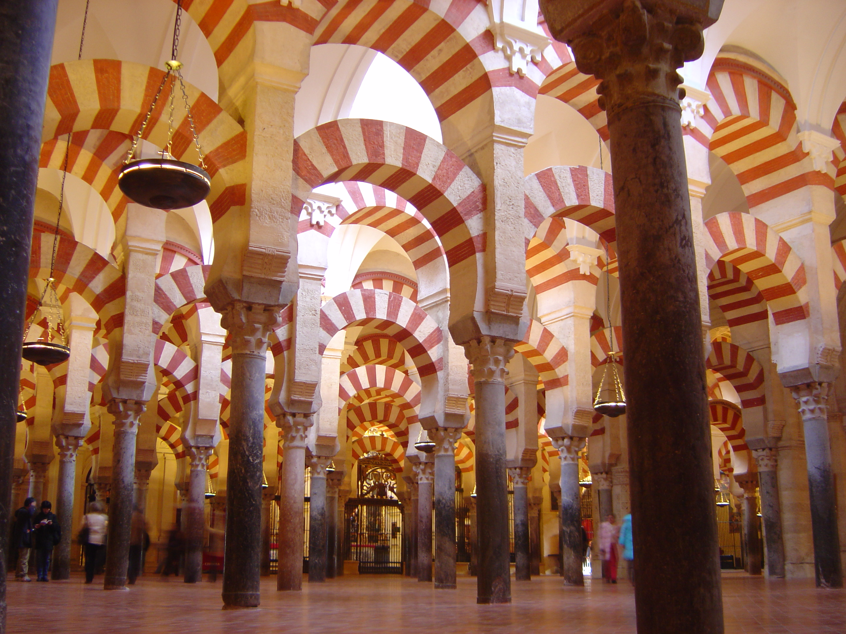
In 750 the Emir (Prince) of the Spanish city of Cordoba in al-Andalus was Abd al-Rahman, the last surviving Umayyad! His first task was to build a mosque so that Muslims could pray. This mosque was incredibly beautiful, and was extended over the next 300 years by different emirs. In 1013, Cordoba was attacked by the Berber tribe of North Africa, who broke through the city walls and massacred 20,000 people. After this, the leaders lost their authority, the population shrunk, and the size and wealth of the city fell.

Challenge 5 – Seljuk Attacks
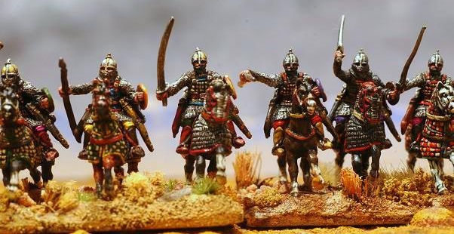
For Jews, Christians and Muslims, the city of Jerusalem in the area known as the Holy Land is very special. A great Jewish temple once stood in the centre, it is where Jesus Christ died, and where Muslims believe the prophet Muhammad was taken to Heaven to meet God. From 395 it was ruled by Greek Christians, but Arab Muslims took over in 638. Christians and Jews were allowed to stay, but had to pay a special tax to the Muslims. In 1077, Turkish Muslims called Seljuks took over the Holy Land, moving west from central Asia. The caliph lost most of his power, and the Muslim world lost its unity.

Challenge 6 – Frank Attacks
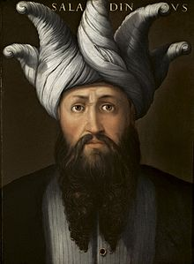
In 1099 European Christians called Franks invaded the Holy Land and captured Jerusalem. These Franks were from France, Germany and Italy. This was called a crusade (Holy War). The Muslims refused to surrender but the battle was very bloody. One person described ‘wading through blood up to our ankles’. No help came from other Muslims, and the Franks occupied large parts of the Holy Land, and ruled there for a long time. By 1176, a powerful new leader called Salah al-Din (Saladin) united large parts of Syria, Palestine and Egypt. Saladin was ashamed that the Muslim world had lost its power, and called for a jihad (war against enemies of Islam). In 1187 he crushed a Christian army in battle at Hattin and went on to recapture Jerusalem.

Challenge 7 – Mongol Attacks
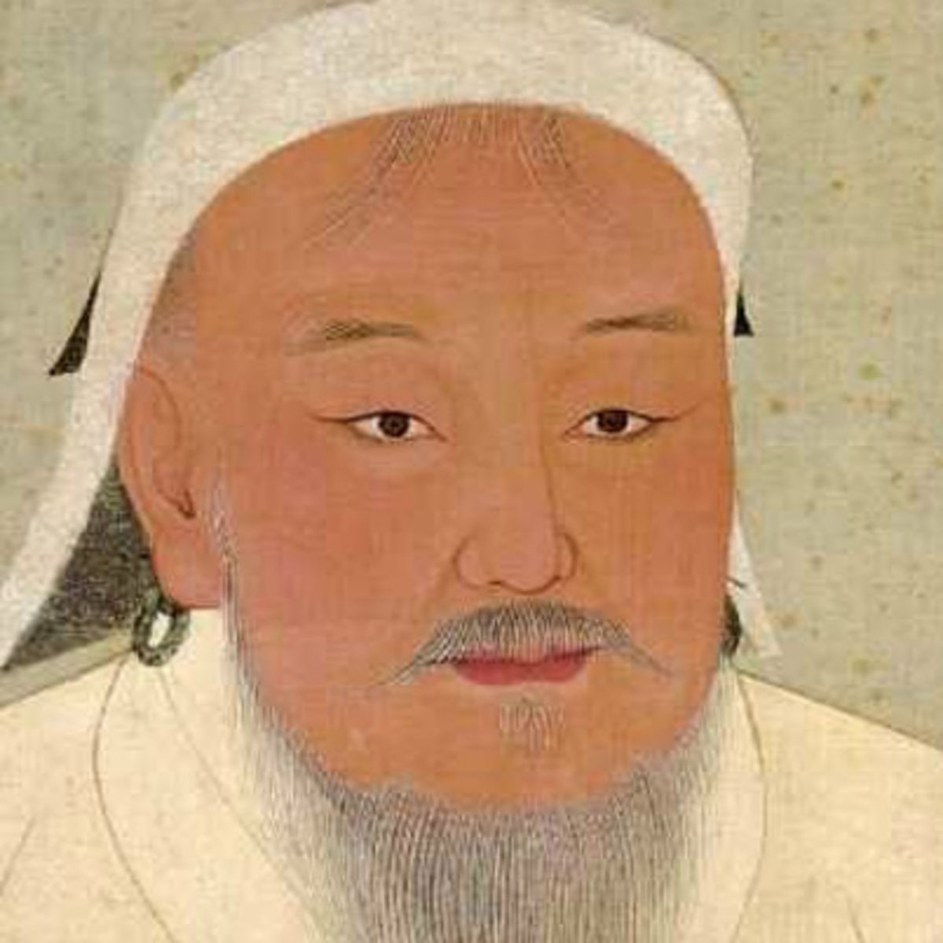
In 1218 Muslim lands were attacked by the Mongol armies of Genghis Khan, who called himself the ‘World Conqueror’. They had swept across most of Asia, into China and through Russia into Eastern Europe. Genghis Khan conquered more than twice as much land as any other person in history, bringing Eastern and Western civilizations into contact in the process, massacring many people during his invasions. He died in 1227, but in 1258 a new leader, Hulego, launched an attack on Iraq. He destroyed Baghdad and killed the caliph along with 800,000 Muslims. Iraq never fully recovered from the destruction of its canals and farming system.

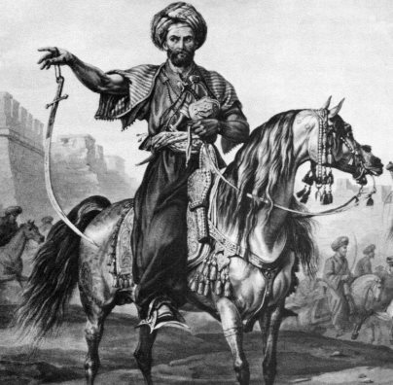
In 1260, the Mongols were defeated for the first time, by a Muslim army called the Mamluks. Their general was called Baybars, and soon after winning the battle he killed his leader and made himself the sultan (ruler) of Egypt. His greatest victory was against the Mongols and Christians together – Baybar seized the Turkish city of Antioch. In 1291 the Mamluks finally expelled the last Franks. The Muslim victory was complete.

Challenge 8 – Christian Attacks in Cordoba
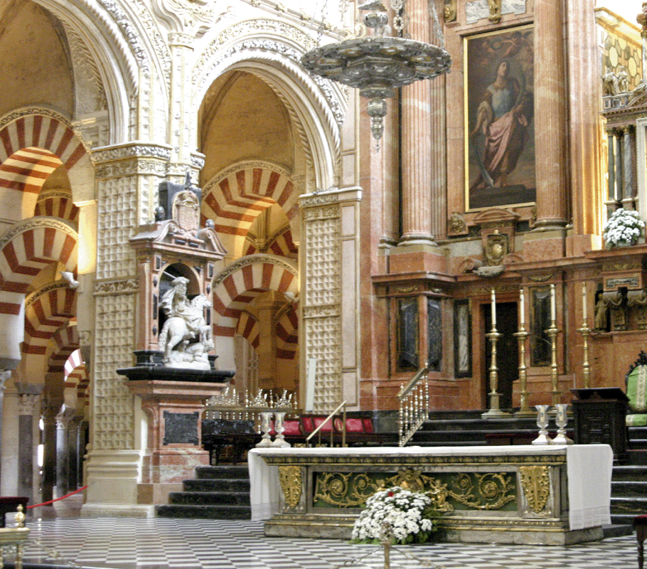
In 1236, after many attempts to take over Cordoba, Christians finally defeated the Muslims, who were then expelled from the city. Some Muslims were allowed to stay so that the Christians could get them to decorate their churches, but they had to wear special marks on their clothes. At the beginning of the 16th century the Archbishop of Cordoba decided to build an enormous cathedral in the middle of the beautiful mosque. There was a big argument, but the Christian Emperor said he was allowed to build it. When he eventually saw what had been built, the Emperor realised what a mistake he had made, and was horrified at having ruined such a beautiful building.

