C2 Britain, c1860-1930. The Changing Position of Women and the Suffrage Question.

KQ3 attitudes of politicians, Parliament and public to the suffrage question; the Liberal government 1906-14; the Parliament Act 1918, the Equal franchise Act 1928 and their immediate impact.

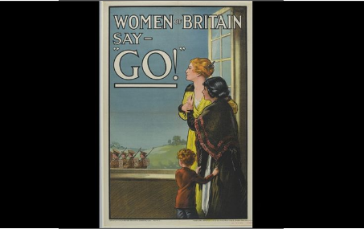

- In a Nutshell: attitudes towards women’s suffrage and the nature of the political establishment
- Key developments and conceptual understanding : the Liberal government 1906-14; the Parliament Act 1918, the Equal franchise Act 1928 and their immediate impact.
- Thinking about viewpoints : Exploring and analysing evidence and interpretations.

- Cracking the Puzzle – preparing for assessment

(I)In a Nutshell: How did the attitudes of politicians, Parliament and public to the suffrage question change?

Activity 1 – Intriguing images
You will be given a collection of images. You will be asked to examine these images in groups. For each consider what is in the image, what you can infer from it about attitudes towards and responses to the women’s suffrage campaign and what it does not reveal.

Activity 2 – Defining moment
Before we study the reaction of the political system it is important that we understand the nature of the political system in the period. Using the Rees handout briefly record the role of the following:
i)the House of Commons, ii)House of Lords, iii)the Crown iv) political parties

Activity 3-On your marks…..
As you work through this unit plot how supportive the political system was towards the suffrage campaign onto your copy of the living graph. You will need to plot several lines:
- The reaction of the Liberals
- The reaction of the Conservatives
- The reaction of the Labour Party
- The reaction of the House of Lords
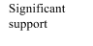
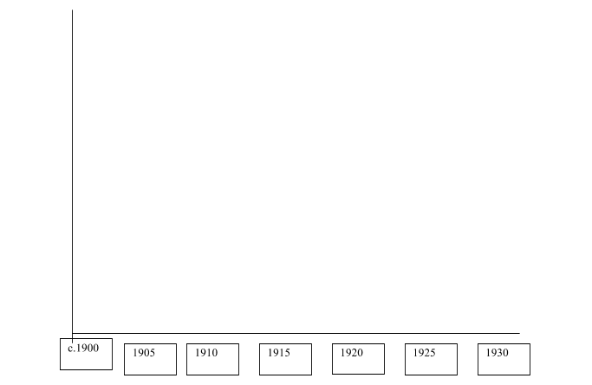
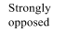

(II)Dramatic episodes in the spotlight: Depth studies illustrating the nature of the reaction to the Suffrage Campaign

Students should know about
- The different reactions to the suffrage campaigns by the main political parties and how and why these change over time.
- The attitude of the Liberal government and Asquith.
- The reaction of the trade unions, religious groups and the media is expected.
- The importance of the First World War in changing the focus of the debate about votes for women.
- The reasons why the Representation of the People Act 1918 was passed and its impact and the Equal Franchise Act 1928 and its impact.

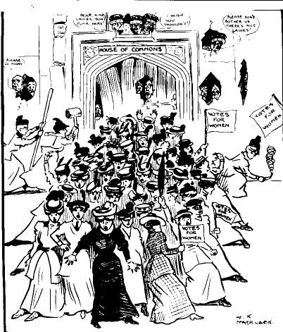
No political party supported the campaign of Votes for Women. This meant that all the suffrage bills that were forwarded by sympathetic MP’s, as private members bills had little chance of success, despite the work of the Cross Party Conciliation Committee from 1910 onwards. Use Bartley to complete the following notes. You may wish to work in groups and share the work.

Political Party | Response to the Votes for Women campaign
The Conservative Party  (page 80-82) | Although the Conservatives tended to dislike any extension to the franchise, such a clear cut party interpretation underestimates the variety of opinions within the Conservative Party from 1880-1914.  To some extent the leadership of the Conservative Party lent their support to the campaign during the period…..  However there was no evidence of a great commitment toward the campaign…..  The House of Lords….
The Liberal Party  (page 82-83 and  86) | Although it has been pointed out that the Liberals opposed Votes for Women because they feared that the property owning qualification would give the Conservatives a clear majority, a clear cut party interpretation underestimates the variety of opinions within the Liberal Party 1880-1914.  There was opposition to the campaign from the Liberal leadership…  However the campaign drew the support of some leading Liberal MP’s..  There is certainly evidence of grass roots support for the campaign in the Liberal Party….  Despite the large majority in 1906 the Liberals were reluctant to enfranchise women for four key reasons…  In 1910 the First Conciliation Bill failed because…. In 1911 the second Conciliation Bill failed because…  However these could be seen as excuses…
The Labour Party  (page 83-85) | Although Labour was cautious in its support for the extension of a property based qualification extension of the suffrage to women because of its preference for universal suffrage, such a clear cut party interpretation underestimates the variety of opinions within the Labour Party 1880-1914.  The Labour Party was more committed to Universal suffrage than the extension of a property based qualification to women..  However the campaign drew the support of some leading labour MP’s..  There was much support for the WSPU and NUWSS inside the Labour Party….  From 1912 onwards…..
Summary  p.100-101 | By 1914

Activity 5- The reaction of the trade unions, religious groups and the media

The male alternative establishment (trade unions, religious groups and the press) were as divided as the political parties over the suffrage issue.

Group | The response to the women’s suffrage campaign.
The Trade Unions  Note: More research is  needed by historians  in this area.  (page 91-92) | The leadership of the majority of the trade unions seemed to be  indifferent to women’s suffrage, but a number of other lent their  support.  The Trade Union movement was split over the issue of women’s  suffrage….  However trade unionists were not always antagonistic to the cause as  some local trade union branches and members supported the cause….
Religious groups  Note: More research is  needed by historians  in this area.  (page 92-93) | The official Anglican church was unresponsive, but some individual  clergy campaigned vigorously for the cause.  The response of the Church of England was…  A number of Church of England clergy responded positively…  The connections between the for women’s suffrage campaign and  non-conformism were stronger….
The Press  Note: More research is  needed by historians  in this area.  (page 93-94) | Increasingly the Press began to focus on the campaign from 1908  onwards. The response depended on the political allegiances of  newspaper proprietors.  The press often reported militancy in a condemnatory style…  However not all newspapers were unsympathetic…

Activity 6- The reaction of men to the campaign

Form of response | Positive Response | Negative Response
The creation of organisations  p.94-97 | Men’s League for Women’s Suffrage….  The Men’s Federation for Women’s Suffrage (later the Men’s Political Union)……. | The Men’s League for Opposing Women’s Suffrage……
The reaction of key individuals  p.98, 100 | Specific middle Class individual responses… | Specific Arisocratic and Upper Class responses…
Indicators of general public perceptions  p.99-100 | Many businesses…. | Popular Cultural expression….

Activity7-The response of the Liberal government and Asquith to the suffrage campaign.
Divide into groups. Each group will research a different case study in the government’s response to the Suffrage Campaign

- Denying democratic forms of protest 1905-1908 (Bartley p64-5, 87)
- Black Friday 1910 (Bartley p87-88)
- Reaction to violent illegal protest (Bartley p67-73, 88)
- Blocking the Conciliation Bills (Collier p86-89)
- Dealing with Hunger Strikers (Bartley p73-4, 89-90)

For each you many wish to include the following;

- Describe the actions of the Suffragettes
- Explain why the Suffragettes had initiated these actions
- Describe the response of the government
- Explain the impact of this reaction on the campaign

Activity 7- The importance of the First World War in changing the focus of the debate about votes for women.

WWI had a profound affect on society and the political landscape. Women played a crucial role in the War Effort and the major suffrage organisations refocused their campaigns. The war also stimulated political debate and action over franchise reform.

Use Bartley chapter 6 and Collier p.105-114 to complete the concept map which provides evidence of the importance of WWI in the enfranchisement of women.
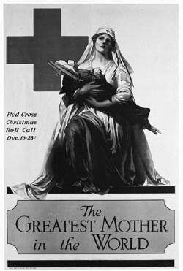

Activity 8- The reasons why the Representation of the People Act 1918 was passed and its impact.

i) In Activity 7 you completed a concept map which provides evidence for the argument for the importance of WWI in the enfranchisement of women. Now you need to complete the concept map which provided evidence for the counter argument, that other factors were more important.

ii) There is evidence that the Representation of the People Act had a significant impact on the political position of women. However, there is also evidence of limitations to its positive impact. Complete the following notes using Collier p.115-120
The impact of the Representation of the People Act 1918
 | Evidence of a positive impact | Evidence of limitations to impact
Degree of enfranch-isement  (p115) | All women over 30 who….  8,400,000… | Most munitions workers…  Most Middle-Class single women…  22%....
Numbers of women in political roles  (p117-118) | Several women candidates…  Constance Gore-Booth…  The first women to be elected…  By 1922…….But by 1929… | However Gore-Booth refused…  In 1922 the treatment of female MPs was…  Christabel’s all-woman party..
The response of political parties  (p118-120) | In 1918 the Labour Party…  The Labour Party elected Dr Marion Philips… | Many Labour policies and Bills focused on male interests such as..  In 1924 the Labour Government resisted..
 | Women played a range of roles within the Conservative Party. | The roles for women in the party were…  The Conservatives were glad of the limited franchise as..
Impact on legal position of women | A range of legislation addressed inequalities in employment, education and within marriage….. | These legal changes did little to bring true social and economic equality to women.
Impact on Parliamentary politics |  | The House of Commons remained……
Overall impact?

Activity 9- The Equal Franchise Act 1928
Complete the following diagram using source evidence on pages 120-122 of Collier

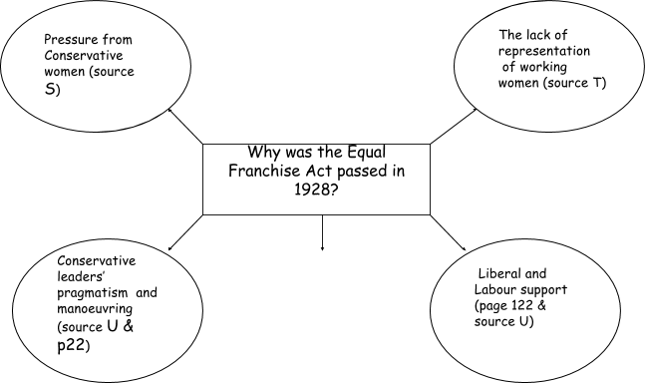
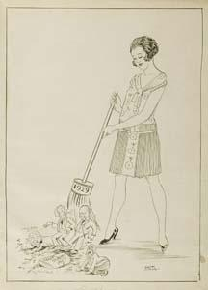

(III) Identifying thematic developments -

Activity 10 – Consolidate those concepts

Create a mind map or complete the concept map to consolidate your understanding. Include five key points on each of the following:
- The reactions to the suffrage campaigns by the main political parties (Liberal Party, Labour Party, Conservative Party) and their change over time.
- The response of the Liberal government and Asquith.
- The reaction of men; trade unions, religious groups, the media and public
- The importance of the First World War in changing the focus of the debate about votes for women.
- The reasons for and impact of the Representation of the People Act 1918.
- The Equal Franchise Act 1928 and its impact.

b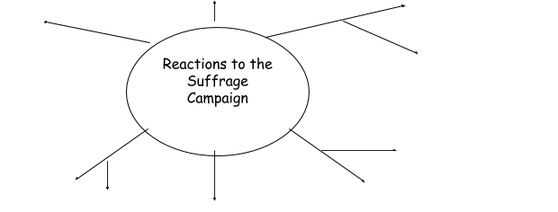B)Return to task two and ensure that you have completed your analysis of the extent of change in each of these areas.
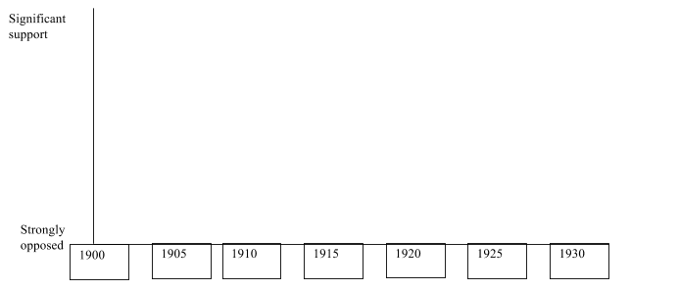

(IV)Spinning History: What are the different explanations?
Activity 11

(a)Use sources F(p.86), G (p.87) and J (p.88) in Chapter 6, Collier Edexcel GCE to consider the following question.

How far do these sources support the view that the Liberal party positively supported the idea of enfranchising women in 1910-11? Use sources to respond

- Examine each source carefully. Identify any points which support the view expressed in the question and any points which challenge it.
- Consider the provenance of each source (authorship, purpose and nature of the source) to evaluate the weight of the evidence for investigating the view of the Liberal Party on enfranchisement in 1910-11?

(b) Use sources D(p.107), O(p.116) and P(p117) in Chapters 7, Collier Edexcel GCE to considering the following question:

Do you agree with the view that some women were given the vote in 1918 because of women’s contribution to the war effort? Use sources and own knowledge

- Examine the sources carefully. Identify any points which support the view and any points which challenge it.
- Consider the provenance of each source (authorship, date, purpose and nature of the source) to evaluate the weight of its evidence for investigating extent of division and unity in the movement.
- Go back over your notes for the chapter to find further evidence to support and challenge the viewpoint
- Look over the sources work and own knowledge evidence to reach a judgement

Cracking the Puzzle- Preparing for Assessment

- Complete Trigger Memory Activity Reactions to the Suffrage using your notes.

- There are many excellent Suffrage websites which can be used to revisit the material covered so far. These include -

www.spartacus.schoolnet.co.uk

www.historylearningsite.co.uk

www. learningcurve.gov.uk/britain1906to1918/g4/cs4/g4cs4.htm

www.guardian.co.uk/world/1918/feb/07/gender

www.history.ac.uk/reviews

Use these websites to gather contemporary documents for the period.

- As a class, play the Game Show Presenter Game called 12womenKQ3

- Revisit the examination criteria and advice on tackling the examination questions given in the guidance booklet.

- Apply these techniques to the specimen examination. You may be asked to work individually, in pairs or in groups.

Key Figures in the response to the Suffrage campaign

Figure | Image | Explanation
Balfour and Bonar Law
Lord Lytton
Lord Curzon
Campbell Bannerman
Asquith

Lloyd George

Churchill
Keir Hardie
Philip Snowden

George Lansbury
Nancy Astor

Trigger Memory Activity – Women KQ3

Word | Image | Explanation
Conservatives views

Liberal views

Labour views

Trade Unions

Religious groups

The Press

MLWS and MFWS

MLOWS

Black Friday

Force-Feeding
Conciliation Bill

Cat and Mouse

Act

Conciliation Bills

Election Fighting Fund

Government Franchise Bill
1913

WWI

Speaker’s Conference

Representation of the People Act 1918

Equal Franchise Act 1928

