C2 Britain, c1860-1930. The Changing Position of Women
and the Suffrage Question.

KQ4 Changing educational opportunities for women and girls and the impact of these for workplace opportunities; the opening of the universities and professions to women.

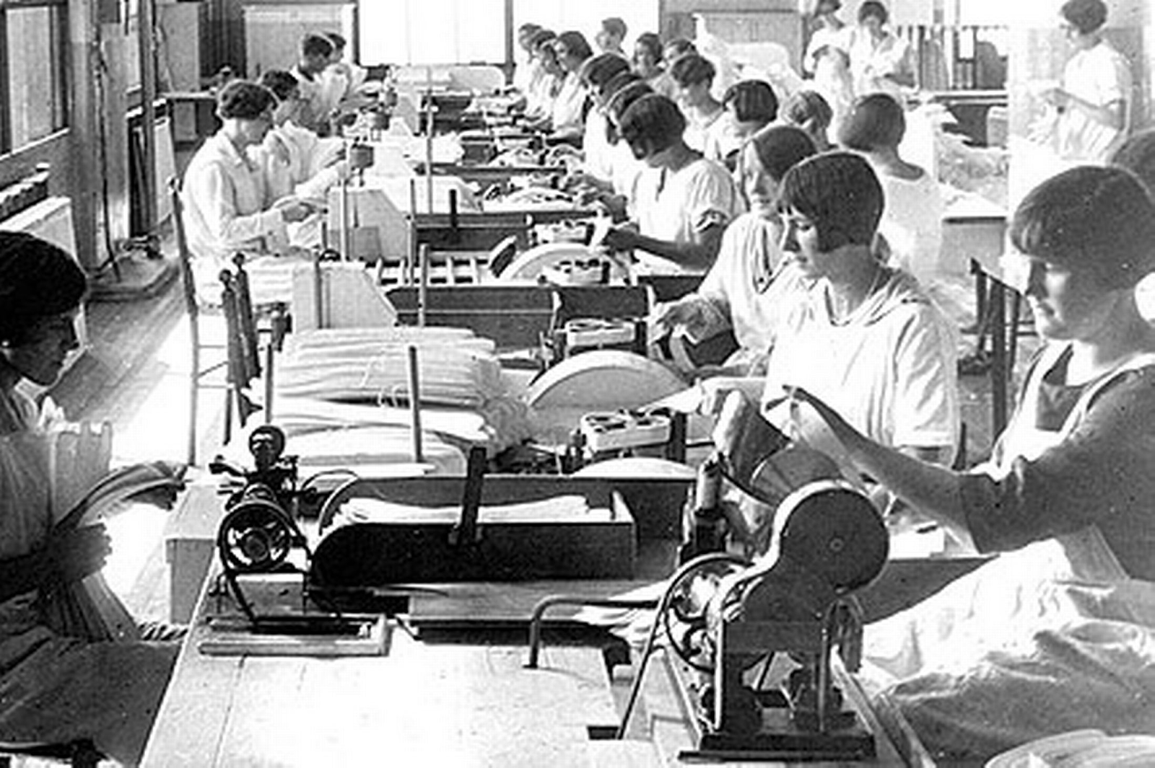

- · In a Nutshell: changing educational and employment opportunities for girls and women

- · Key developments and conceptual understanding: changing educational opportunities for girls and women and the impact of these on the workplace

- · Thinking about viewpoints: Exploring and analysing evidence and interpretations.

- · Cracking the Puzzle – preparing for assessment

(I)In a Nutshell: How did education opportunities for girls and women change and what was the impact on the workplace?

Activity 1 – Intriguing images

You will be given a collection of images. You will be asked to examine these images in groups. For each consider what is in the image, what you can infer from it about attitudes towards and responses to the women’s suffrage campaign and what it does not reveal.

Activity 2-On your marks…..

As you work through this unit plot the degree of progress onto your copy of the living graph. You will need to plot several lines:
- Educational opportunities of working class females
- Educational opportunities of upper and middle class females
- Employment opportunities for upper and middle class women
- Employment opportunities for working class women

(II)Dramatic episodes in the spotlight: Depth studies illustrating the nature of educational and employment opportunities for girls and women through the period

Students should understand
- The importance of relevant legislation, particularly the education act of 1870 in educating working class girls.
- The work of Dorothy Beale, Francis Mary Buss and about the Girls Day School Trust (GPDST) in educating girls from the more privileged
- The gradual opening of higher education to women and the impact this had on entry to the professions, in particular to teaching, the law and medicine.
- How legislation impacted on the working lives of girls and women.
- How technology (telephone and typewriter) increased job opportunities for women and girls, and why trade unions reacted as they did to increasing numbers of women in the workforce.
- The impact of the First World War on creating job opportunities for women and the ways in which these were both developed and eroded in the 1920’s.

Activity 3 – Why did educational opportunities improve for working class girls and how significant was progress 1860-1930? Complete notes using p.126-131 of Collier & p.*of Bartley

How significant was progress in education for working class girls 1860-1918?
Education before 1870  Collier p128, Bartley p2 | Types of school provider-  - Nature of provision-  - Girls’ attendance-  - Extent of educational opportunity for girls-
1870 Elementary Ed. Act (Foster’s Act)  Collier p128-9 | Reasons for legislation-  - Features of the Act-  - Impact-
1878 Curriculum rules Bartley p2 | Features of change-
1880 Mundella’s Act  Collier p129 | Features of the Act-  - Impact-
1891 Government Grant  Collier p129,130 | Features of change-  - Impact-
1902 Ed Act (Balfour’s Act)  Collier p130 | Features of the Act-  - Impact-
1906 Ed (meals) Act & 1907 Ed (Admin procedures) Act  Collier p130 | Reasons for legislation-  Features of the Acts-  - Impact-
Amendment to Balfour’s Act Collier p130 | Features of change-  - Impact-
Education 1870-1914  Collier p131 | Nature of provision-  - Girl’s attendance-

Extent of progress by 1918/1930

Collier p126-7 130, Bartley p2

Activity 4 Why did educational opportunities for middle class girls improve and how significant was progress?

How significant was progress in education for middle &upper class girls 1860-1918?
Education before 1850  Collier p132-3, Bartley2-3 | Types of school provider-  - Nature of provision-  - Girls’ attendance-  - Extent of educational opportunity for girls-
1850 North London Collegiate School  Collier p133-5, 139, 145 | Reasons for founding-  - Nature of provision-  - Impact-
1854 Cheltenham Ladies College  Collier p136-7 | Reasons for founding-  Nature of provision-  - Impact-
1867 Public Examinations  Collier p135 | - Reasons for development-  - Features of change-
1873 the Girls’ Public School Company (from 1905 Trust) Collier p138-9 | - Reasons for development-  Features of change-  - Impact-
1902 Education Act (Balfour’s Act)  Collier p130, 139 | Features of the Act-  - Impact-

Extent of progress by 1918
Collier p139, Bartley p3

Activity 5 – The contribution of key figures

Summarise the roles of individuals onto your Key Figures in developments in Education and Employment of Women 1860-1930 sheet. Use notes from Activity 4, wider research and relevant pages from Collier.

a)The contribution of W.E.Forster -Collier, p128
b)The contribution of Frances Mary Buss- Collier, p132-5, 145
c)The contribution of Dorothea Beale- Collier p136-7, 145
d)The contribution of Maria & Emily Shirreff & Mary Gurney - Collier p138

Activity 6 – What were the differences between Frances Buss and Dorothea Beale?

Although they both contributed significantly to the development of education for girls in the same period, the women were markedly different in background, and outlook. Work in pairs. Each revisit the work of one of the women, record your findings on the appropriate side of the handout then discuss the differences with your partner. Record your partner’s findings, then together conclude on the nature and extent of their differences. Use Collier Unit 8 and wider research for this activity.
 | Frances Buss | Dorothea Beale
What was her family background?
How was she educated?

What teaching experience did she have prior to setting up her school?
How selective was her school?
How did she manage finances?
What other work did she do in promoting education?
Nature of impact?

Activity 6 The degree of opening of higher education to women by 1900

The class will divide into two. One side should adopt the position that significant progress had been achieved in terms of women’s access to higher education by 1900. The other side should adopt the position that progress in terms of women’s access to higher education was limited by 1900. Use Collier p.139-143

Include arguments on the following points:
· Examples of institutions entry rules
· Arguments used at the time to justify the viewpoint
· Subject/course access
· Factors (Individuals/organisations/government that helped or hindered progress
· Impact on access to professions, teaching, law and medicine

Your teacher will either ask you to use this work to enter into a debate on the degree of progress, or to prepare a presentation for the other half of the class.

Following this, use Collier p143 and Bartley p3 to consider how much further access had opened by the 1930s and the situation of changes for working class women.

Activity 7 - The contribution of key figures

Summarise the roles of individuals onto your Key Figures in developments in Education and Employment of Women 1860-1930 sheet. Use notes from Activity 6, wider research and relevant pages from Collier.

a)The contribution of Elizabeth Garrett Anderson -Collier, p141-3

b)The contribution of Sophia Jex-Blake - Collier, p143

Activity 8 The nature of work opportunities for women
Between 1860 and 1890 there were many changes for women in the world of work, but the most marked contrasts were due to the different socio-economic classes of women.
Use Collier p147155 to identify the nature of and extent of types of employment.

Work opportunities for women | Socio-economic group | Positive appeal | Negative elements | Changes in numbers employed? | Factors impacting on change
Domestic  service  p149-152 | Working class
Factory  Work  P149, 152-3 | Working class
‘sweated labour’ at home  P149, 160 | Working class
Clerical work  P149, 153 | Lower middle class
Shop work  P149, 153 | Lower middle class
Teaching  P149, 154 | Upper middle & lower middle class
Nursing  P149, 154 | Upper middle & lower middle class
Medicine  P149, 154-5 | Upper middle class
Law

Activity 9 How far did government and trade unions improve conditions of service for working women?
By 1910 job opportunities for women had increased dramatically. However, in the 1860s women were paid considerably less than men, many worked very long hours and had poor working conditions. Government and Union action did have some impact on these issues, but how much?

a)Use Collier pages155-161 to identify the extent of impact of government and union action. Identify how one dev linked to another by using causal link arrows and explanations.

b) What influenced the government and unions to respond in the way they did between 1860-1914? Use pages 155-161 to consider the significance of i)attitudes and beliefs, ii)party political concerns, iii)economic motivations.

Activity 10 - The contribution of key figures
Summarise the roles of individuals onto your Key Figures in developments in Education and Employment of Women 1860-1930 sheet. Use notes from Activities 8 & 9, wider research and relevant pages from Collier.

a)The contribution of Florence Nightingale -Collier, p154
b)The contribution of D.Merrick & H.R.King - Collier, p159
c) The contribution of Emma (Smith) Paterson – Collier p159, 161
d) The contribution of Clementia Black - Collier p161

Activity 11 The impact of the First World War on women’s work and on the ways in which these were both developed and eroded in the 1920’s
a)What initial impact did the First World War have on women’s work and why?
b)What was done to try to address these problems?

c) Use Bartley p112-114 to complete the following notes:
The Impact of the war on job opportunities for women 1915-1918
Social Class | Jobs | What these women did
Upper and  Middle Class  (pages 112-  113) | Government
 | Land Army
 | Armed Forces | The WAACS….  The WRENS…  The WRAFS…
 | VAD’s
Working  Class  (pages 113-  114) | Domestic Service
 | Transport
 | Munitions Factories
 | Armed Forces | The WAACS….  The WRENS…  The WRAFS…

d) Use pages p162-165 to evaluate how far the government and trade unions supported women’s work during the War.

e) What influenced the government and unions to respond in the way they did during the War? Use pages 162-5 to consider the significance of i)attitudes and beliefs, ii)party political concerns, iii)economic motivations.

f) Use pages p162-165 to evaluate how far the government and trade unions supported women’s work after the War.

g) What influenced the government and unions to respond in the way they did after the War? Use pages 166- 168to consider the significance of i)attitudes and beliefs, ii)party political concerns, iii)economic motivations.

(III) Identifying thematic developments -

Activity 13 – Consolidate those concepts
Complete the concept map or create a mind map to consolidate your understanding of each factor. Include five key points on each of the following:
- The importance of relevant legislation educating working class girls.
- The impact of individuals in developing the education of girls from more privileged sections of society.
- The opening of higher education to women and the impact this had on entry to the professions, in particular to teaching, the law and medicine.
- How legislation impacted on the working lives of girls and women.
- How technology increased job opportunities for women, and why trade unions reacted as they did to increasing numbers of women in the workforce.
- The impact of WWI on creating job opportunities for women and on the ways in which these were both developed and eroded in the 1920’s.
b)Return to task two and ensure that you have completed your analysis of the extent of change in each of these areas.

(IV)Spinning History: What are the different explanations?

Activity 14

(a)Use sources S(p.140), T (p.141) and U (p.142) in Chapter 8, Collier Edexcel GCE to consider the following question.

How far does source U support the views expressed in Source S and the actions portrayed in source T? Use sources to respond

- Begin by examining source S identify 3-4 main points that the source suggests about education for women
- Examine source T identify 3-4 main points that the source suggests about education for women. Identify points which are suggested by both sources S and T. Also consider the provenance of sources S and T in terms of what they reveal about attitudes towards education for women

- Examine source U carefully. Identify any points which support those identified in sources S and T and any points which challenge source S and T.
- Consider the provenance of source U (authorship, purpose and nature of the source) to evaluate the weight of the evidence for investigating arguments about education for women.

- As a class, return to the question. Your teacher will lead a discussion on how to bring these ideas together to reach a judgement on ‘how far’.

(b) Use sources T(p.165) and U(p.165) in Chapter 9, Collier Edexcel GCE to considering the following question:

Do you agree with the view that women gained nothing from their wartime experiences? Use sources and own knowledge

- Examine the sources carefully. Identify any points which support the view and any points which challenge it.
- Consider the provenance of each source (authorship, date, purpose and nature of the source) to evaluate the weight of its evidence for investigating extent of division and unity in the movement.
- Go back over your notes for the chapter to find further evidence to support and challenge the viewpoint
- Look over the sources work and own knowledge evidence to reach a judgement

Cracking the Puzzle- Preparing for Assessment

1. Complete Trigger Memory Activity Female Education and Employment 1860-1930 using your notes.

2. There are many excellent women’s history websites which can be used to revisit the material covered so far. These include -

www.bbc.co.uk/history/historic_figures/butler_josephine.shtml

www. spartacus.schoolnet.co.uk

www. victorianweb.org/history/education/publicschool2.html

www. .iwm.org.uk/upload/package/30/women/womanswork.htm

www. http://www.bbc.co.uk/history/british/britain_wwone/women

Use these websites to gather contemporary documents for the period.

3. As a class, play the Game Show Presenter Game called 12WomenKQ4.

4. Revisit the examination criteria and advice on tackling the examination questions given in the guidance booklet.

5. Apply these techniques to the specimen examination. You may be asked to work individually, in pairs or in groups.

