C2 Britain, c1860-1930. The Changing Position of Women and the Suffrage Question.

KQ1 How far did the personal status of women change 1860-1930?; challenges to the “angel in the house” concept.
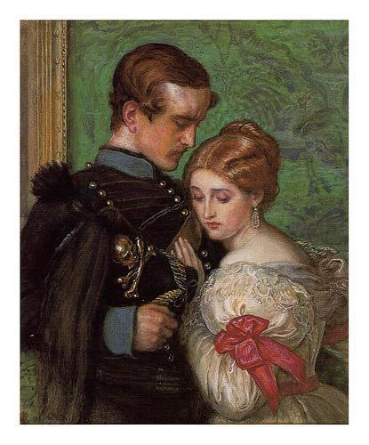

- In a Nutshell: What was the “angel of the house”?
- Dramatic episodes in the spotlight: the changing personal status of women? : marriage, divorce, children and property, evidence of challenges to the “angel in the house” concept.

- Identifying thematic developments?

- Spinning History: In what different ways are these events interpreted?

- Cracking the Puzzle – Preparing for assessment

(I)In a Nutshell: the changing personal status of women? : marriage, divorce, children and property; challenges to the “angel in the house” concept.?

Activity 1 – Intriguing images
You will be given a collection of images. You will be asked to examine these images in groups. For each consider what is in the image, what you can infer from it about the Victorian ideal for women and it does not reveal.

Activity 2 – On your marks…..
As you work through this unit plot changes in the position of women onto your copy of the living graph. You will need to plot several lines:
- Legal position in marriage
- Property ownership rights
- Degree of Involvement in public life

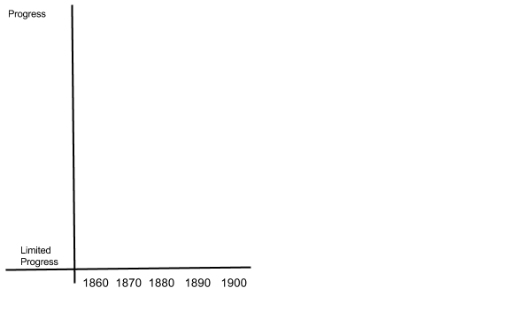

(II)Dramatic episodes in the spotlight: Depth studies illustrating the nature of the changing personal status of women.

Activity 3 - Changes in womens personal status
There are many developments which help to reveal changes in the personal status of women.

Students will be expected to know about
- The importance of relevant legislation in both reflecting and forming attitudes to the status of women, in particular the Married Women’s Property Acts of 1870 and 1882.
- The ways in which divorce could be obtained after the 1857 Divorce Act.
- The impact of the Matrimonial Causes Act of 1884.
- The importance of the 1891 Jackson marriage case.
- The sexual double standards that pertained at the time and about the successful campaign led by Josephine Butler in bringing about the repeal of the Contagious Diseases Acts.

Activity 4 - The importance of relevant legislation in both reflecting and forming attitudes to the status of women, in particular the Married Women’s Property Acts of 1870 and 1882.

During the period 1860-1890 Parliament was persuaded to make a number of significant changes in the legal position of women. Women experienced inequality in terms of property rights, marital rights, divorce and custody of children.

Aspects of law | Changes in women’s legal position.
Property rights for  Women  (pages 4-5) | In 1860 women  The Norton case  The Married Women’s Property Acts of 1870 and 1882  Had women achieved equality in this aspect of the law?
Marital Rights for  women.  (page 5) | Many women were concerned by  The matrimonial causes Act 1884  The Jackson case  Had women achieved equality in this aspect of the law?
Divorce Rights for  Women.  (page 5) | Before 1867  The 1867 Divorce Act  However this benefited men rather than women  Had women achieved equality in this aspect of the law?
Custody of children  Rights for women.  (page 5) | Once divorced women found it difficult to get custody of children  In the 1870’s and 1880’s  Had women achieved equality in this aspect of the law?

Activity 5 - The ways in which divorce could be obtained after the 1857 Divorce Act.

Covered currently in Activity 4

Activity 6 - The impact of the Matrimonial Causes Act of 1884.

Currently covered in Activity 4

Activity 7 - The importance of the 1891 Jackson marriage case.!

Activity 8 - The sexual double standards that pertained at the time and about the successful campaign led by Josephine Butler in bringing about the repeal of the Contagious Diseases Acts.

During the period 1860-1890 there were some achievements in regulating some aspects of male sexuality.

Development in laws of  Sexual morality | The way in which these developments affected women.
The Repeal of the  Contagious Diseases  Act (page 6) | In 1864  In 1886  Equality
The Criminal Law  Ammendment Act  (page 6) | Before 1885  After 1885
 | Had women achieved greater equality in sexual standards during this

(III) Identifying thematic developments -

Activity 9 – Consolidate those concepts

Create a concept map or mind map to consolidate your understanding of
The importance of relevant legislation in both reflecting and forming attitudes to the status of women, in particular the married women’s property Acts of 1870 and 1882.
The ways in which divorce could be obtained after the 1857 Divorce Act.
The impact of the Matrimonial Causes Act of 1884.
The importance of the 1891 Jackson marriage case.
The sexual double standards that pertained at the time and about the successful campaign led by Josephine Butler in bringing about the repeal of the Contagious Diseases Acts.

(IV)Spinning History: What are the different explanations?

Activity 7 Cracking the Puzzle- Preparing for Assessment

- Complete Trigger Memory Activity for KQ1, using your background notes. An explanation on how to complete this is in your guidance booklet.

- There are many excellent websites about the changing role of women which can be used to revisit the material covered so far. These include -

www.

www.

www.

www.

www.

Use these websites to gather further information for the period.

- As a class, play the Game Show Presenter Game called 12womenKQ1.

- Revisit the examination criteria and advice on tackling the examination questions given in the guidance booklet.

- Apply these techniques to the specimen examination. You may be asked to work individually, in pairs or in groups.

Trigger Memory Activity - Women KQ1

Word | Image | Explanation
Angel of the house

Separate sphere

Domestic service

Caroline Norton

Custody of Children

Divorce

Matrimonial Causes Act

Married Property Acts

Sexual morality
Contagious Diseases Acts

Ladies National Association

Josephine Butler

Legal status by 1900?

Schools boards

Poor Law Adminisration

Workhouse Visiting Society

Municipal Elections

Public involvement by 1900?

