Key Topic 1: The British sector of the Western Front, 1914–18: surgery and treatment ?
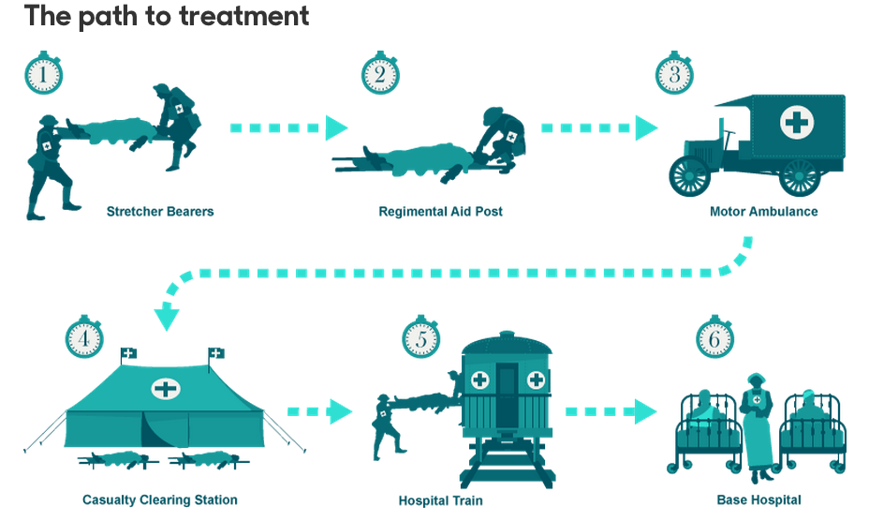

In a Nutshell: Overview of developments

Causes and Analysis of the developments in surgery during the First World War, including:
Focus 1. The British sector of the Western Front, 1914–18: surgery and treatment
Focus 2. Knowledge, selection and use of sources for historical enquiries.

Cracking the Puzzle – Preparing for assessment.

Language and Literacy
Key Terms and their meanings in Medicine 1250-1500.

(I) In a Nutshell: Overview of

Content overview
1 The British sector of the Western Front, 1914–18: surgery and treatment

● The context of the British sector of Western Front and the theatre of war, including the rural landscape, the battle front, the trench system and the medical facilities behind the lines.
● Conditions requiring medical treatment on the Western Front, including the problems of ill health caused by conditions in the trenches and the nature of wounds from rifles used by snipers and in battle and from explosives. The problem of shrapnel and wound infection. The effects of gas attacks, including the use of chlorine gas at Loos (1915), chlorine-phosgene at Ypres (1915) and mustard gas at Ypres (1917).
● Recovery and treatment of the wounded. The problem in dealing with the high number of casualties, including in the Battle of the Somme. The RAMC. The RAMC and system of transport, treatment and facilities at various stages: aid post and field ambulance, dressing station, casualty clearing station and base hospital.
● Developments in surgery and medicine, including: new techniques in the treatment of wounds and infection, the search for effective treatment after a gas attack, the attempts to deal with increased numbers of head injuries.
● The historical context of medicine in the early twentieth century: the understanding of infection and moves towards aseptic surgery; Geoffrey Marshall’s work on anaesthetics; the development of x-rays and use of mobile x-ray units to detect shrapnel; blood transfusions – limitations caused by the need for donor-to-patient transfusions, developments in storing blood and blood banks.

2 Knowledge, selection and use of sources for historical enquiries

● Knowledge of national sources relevant to the period and issue, e.g. army records, national newspapers, government reports, medical articles.
● Knowledge of local sources relevant to the period and issue, e.g. personal accounts, photographs, hospital records, army statistics.
● Recognition of the strengths and weaknesses of different types of source for specific enquiries.
● Framing of questions relevant to the pursuit of a specific enquiry.
● Selection of appropriate sources for specific investigations.

(II) Causes and Analysis of developments:
Activity 1 – On your marks…..
The timeline grid sums up developments between………………….. For each area colour code each box; ………….. (green), …………………….. (yellow) or ……………………. (red).

Activity 2 – Get set…..
Your teacher will give you an A3 copy of a concept map. Stick it in your book. You will fill sections in at the end of each key focus area. As well as adding information to your concept map you can add a colour scheme to identify key themes.

Activity 3 – Go…..
As well as the lesson work and activities, read your book independently and visit the library. There are also many excellent websites listed in the back of this booklet to check out. Try to develop your own individual interest in this area of focus .

Online Resources
BBC iWonder How did WW1 change the way in which we treat war injuries?
BBC WW1 Uncut World of the Trenches Infections Machine Guns Women Medics Medical Equipment
World War 1 Field Hospitals 220462-01 221694-07 220930-01
British Pathe News Dressing Station
Nursing FWW Nursing
Harold Gillies The man who fixes faces

Overview. Knowledge, selection and use of sources for historical enquiries. What sources have survived for historians of surgery in the First World War to use in their studies?

Activity 1 Knowledge of national sources relevant to the period and issue, e.g. army records, national newspapers, government reports, medical articles.
National Sources on Surgery in the FWW | Describe this type of source and the circumstances of it survival
Royal Army Medical Corps records
National newspapers
Government reports
Medical articles

Activity 2 Knowledge of local sources relevant to the period and issue, e.g. personal accounts, photographs, hospital records, army statistics.
Local Sources on Surgery in the FWW | Describe this type of source and the circumstances of it survival
Personal accounts
Photographs
Hospital records
Royal Army Medical Corps statistics

Activity 3 Recognition of the strengths and weaknesses of different types of source for specific enquiries.

Examples of types of sources of evidence | Strengths of the sources of evidence | Weaknesses of the sources of evidence
Choose a National source. | 1  2 | 1  2
Choose a National source. | 1  2 | 1  2
Choose a Local source. | 1  2 | 1  2
Choose a Local source. | 1  2 | 1  2

Activity 4 Framing of questions relevant to the pursuit of a specific enquiry.

Types of questions | Question framing
1 Comprehension | What can you learn from source X about...?
2 Representation | How does source X portray...?
3 Utility | How useful is source X for an historian investigating…?
4 Reliability | How reliable is source X for an historian investigating…?

Activity 5 Selection of appropriate sources for specific investigations.

Types of Specific investigations | What sources of evidence might help with these specific investigations?
1 The context of the British sector of Western Front and the theatre of war.
2 Conditions requiring medical treatment on the Western Front.
3 Recovery and treatment of the wounded.

4 Developments in surgery and medicine.

5 The historical context of medicine in the early twentieth century.

How could you follow up Source B to find out more about the problems involved in performing operations on the Western Front? In your answer, you must give the question you would ask and the type of source you could use. Complete the table below. 4 marks

Detail in Source B that I would follow up:

Question I would ask:

What type of source I could use:

How this might help answer my question:

Focus 1. The context of the British sector of Western Front and the theatre of war, including the rural landscape, the battle front, the trench system and the medical facilities behind the lines.

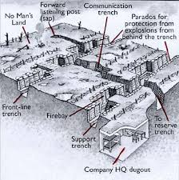

Remember to consider
2 Knowledge, selection and use of sources for historical enquiries
● Knowledge of national sources relevant to the period and issue, e.g. army records, national newspapers, government reports, medical articles.
● Knowledge of local sources relevant to the period and issue, e.g. personal accounts, photographs, hospital records, army statistics.
● Recognition of the strengths and weaknesses of different types of source for specific enquiries.
● Framing of questions relevant to the pursuit of a specific enquiry.
● Selection of appropriate sources for specific investigations.

Activity 1: The Trench system.

What were the trenches?  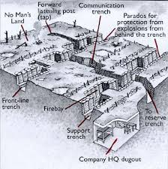 | Although most of us think primarily of the Great War in terms of life and death in the trenches, only a relatively small proportion of the army actually served there. The trenches were the front lines, the most dangerous places. But behind them was a mass of supply lines, training establishments, stores, workshops, headquarters and all the other elements of the 1914-1918 system of war, in which the majority of troops were employed. The trenches were the domain of the infantry, with the supporting arms of the mortars and machine-guns, the engineers and the forward positions of the artillery observers.
Why were the trenches there?  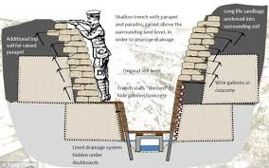 | The idea of digging into the ground to give some protection from powerful enemy artillery and small arms fire was not a new idea or unique to the Great War. It had been widely practiced in the US Civil War, the Russian-Japanese war and other fairly recent wars. Trench warfare can be said to have begun in September 1914 and ended when the Allies made a breakthrough attack in August 1918. Before and after those dates were wars of movement: in between it was a war of entrenchment. The massive armies of 1914 initially fought a war of movement, and any trenches dug were only for temporary cover. But from the Battle of the Aisne onwards, both sides dug in to take cover and hold their ground. By the end of 1914 there was a continuous line of trenches covering some 400 miles from Switzerland to the North Sea. There was no way round.
What were the trenches like?  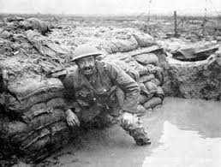 | The type and nature of the trench positions varied a lot, depending on the local conditions. For example, in the area of the River Somme on the Western Front, the ground is chalky and is easily dug. The trench sides will crumble easily after rain, so would be built up ('revetted') with wood, sandbags or any other suitable material. At Ypres, the ground is naturally boggy and the water table very high, so trenches were not really dug, more built up using sandbags and wood (these were called 'breastworks').. In the major offensives of 1915, 1916 and 1917 many trench positions were only held for a few days at a time before the next advance moved them on into what had been no man's land or the enemy position. These trenches were scratch affairs, created as the advancing troops dug in, and were sometimes little more than 18 inches deep.Behind it is another line, similarly made, called a support line. In this would be found 'dugouts' cut into the side of the trench wall, often very small but with room for perhaps three or four men to squeeze in for shelter, or for a telephone position for a signaller, or for a Platoon or Company HQ. Communication trenches linked the rear areas with both lines, and it was along these that all men, equipment and supplies had to be fetched, by hand. Probing out from the front line were trenches usually called 'saps', which often went beyond the protective belts of barbed wire, terminating somewhere in 'no man's land' between the two opposing front lines in a listening post, manned by one or two infantrymen. The cross-section shows how the front and rear of the trench was ideally protected and built up using sandbags at the front and rear, or 'parapet' and 'parados'.
Living conditions  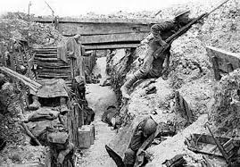 | Trench conditions varied widely between different theatres of war, different sectors within a theatre, and with the time of year and weather. Trench life was however always one of considerable squalor, with so many men living in a very constrained space. Scraps of discarded food, empty tins and other waste, the nearby presence of the latrine, the general dirt of living half underground and being unable to wash or change for days or weeks at a time created conditions of severe health risk (and that is not counting the military risks). Vermin including rats and lice were very numerous; disease was spread both by them, and by the maggots and flies that thrived on the nearby remains of decomposing human and animal corpses. Troops in the trenches were also subjected to the weather: the winter of 1916-1917 in France and Flanders was the coldest in living memory; the trenches flooded in the wet, sometimes to waist height, whenever it rained. Men suffered from exposure, frostbite, trench foot (a wasting disease of the flesh caused by the foot being wet and cold, constrained into boots and puttees, for days on end, that would cripple a man), and many diseases brought on or made worse by living in such a way.
How long would a man have to be in a trench?  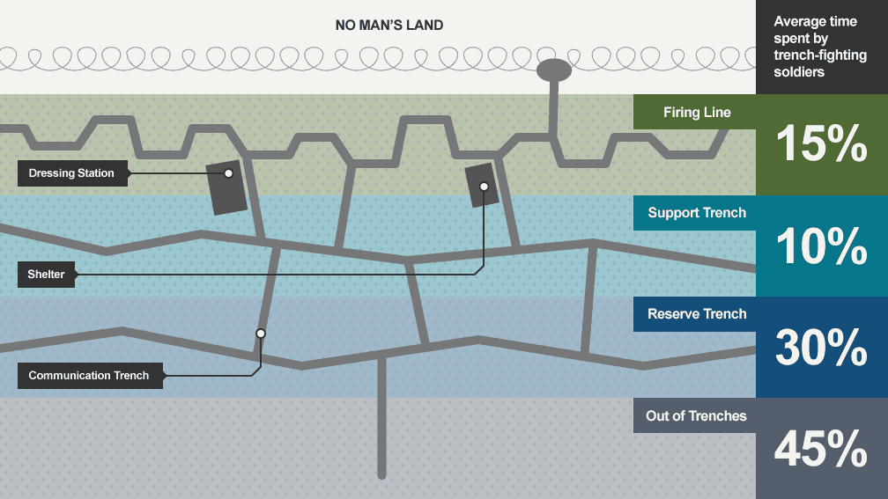 | A general pattern for trench routine was 4 days in the front line, then 4 days in close reserve and finally 4 at rest, although this varied enormously depending on conditions, the weather and the availability of enough reserve troops to be able to rotate them in this way. In close reserve, men had to be ready to reinforce the line at very short notice. They may have been in a trench system just behind the front system or in the dubious shelter of a ruined village or wood. The relief of a unit after its time in the front by a fresh one was always an anxious time, as the noise and obvious activity increased the risk of attracting enemy attention in the form of shelling, machine-gun fire or even a raid at the very time when the manning of the position was changing. Once the incoming unit had relieved the outgoing one, various precautionary actions would be taken. At least one man in four (at night, and perhaps one in ten by day) were posted as sentries on look-out duty, often in saps dug a little way ahead of the main fire trench. They would listen for sounds that might indicate enemy activity, and try to observe such activity across no man's land. The other men would be posted into the fire trench or support trench, in sections. Unless they were a specialist such as a signaller or machine-gunner, men would inevitably be assigned to carrying, repair or digging parties, or sent under cover of dark to put out or repair barbed wire defences.

SECTION A: The British sector of the Western Front, 1914–18: surgery and treatment
Look carefully at Sources A and B in the Sources Booklet and then answer all parts of Question 1.

Source A From an account by Reverend Leonard Pearson, who was the army chaplain at
Casualty Clearing Station 44 during the Battle of the Somme (1916).

I spent most of my time giving anaesthetics. I had no right to be doing this because I had no medical qualifications, but we were simply so rushed. We couldn’t get the wounded into the hospital quickly enough and the journey from the battlefield was simply terrible for these poor lads. It was a question of operating as quickly as possible. If they had to wait their turn in the normal way, until the surgeon was able to perform the operation with a doctor giving the anaesthetic, it would have been too late for many of them. As it was, many died. We all simply had to help and do anything that was needed.

Source From the diary of Oswald Robertson, written on 30 November 1917. He was an
army surgeon working on the Western Front during the First World War.

Men were horribly mutilated – many were dying when brought into the ward. All
the beds were full and we began putting stretchers on the floor. Blood everywhere – clothes soaked in blood, pools of blood in the stretchers, streams of blood dropping from the stretchers to the floor. My rubber apron was one solid red smear. All we could do was try to stop the bleeding and get the patients as comfortable as possible. I could only transfuse an occasional patient. The majority had to take their chance and go through the operation as best they could.

1 (a) Study Source A.
Give two things that you can infer from Source A about this X.
Complete the table below. 4 marks.

What I can infer.

Details in the source that tell me this.

What I can infer.

Details in the source that tell me this

(b) Study Sources A and B.
How useful are Sources A and B for an enquiry into the problems involved in X on the Western Front? Explain your answer, using Sources A and B and your knowledge of the historical context. 8 marks.

(c) Study Source B.
How could you follow up Source B to find out more about the problems involved in performing operations on the Western Front? In your answer, you must give the question you would ask and the type of source you could use. Complete the table below. 4 marks

Detail in Source B that I would follow up:

Question I would ask:

What type of source I could use:

How this might help answer my question:

Focus 2. How Conditions requiring medical treatment on the Western Front, including the problems of ill health caused by conditions in the trenches and the nature of wounds from rifles used by snipers and in battle and from explosives. The problem of shrapnel and wound infection. The effects of gas attacks, including the use of chlorine gas at Loos (1915), chlorine-phosgene at Ypres (1915) and mustard gas at Ypres (1917).

Advanced dressing stations | Casualty clearing stations | Base hospitals
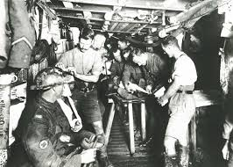 | 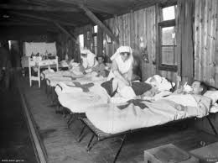 | 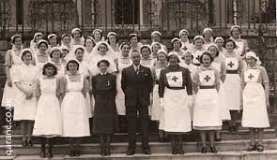

Remember to consider
2 Knowledge, selection and use of sources for historical enquiries

● Knowledge of national sources relevant to the period and issue, e.g. army records, national newspapers, government reports, medical articles.
● Knowledge of local sources relevant to the period and issue, e.g. personal accounts, photographs, hospital records, army statistics.
● Recognition of the strengths and weaknesses of different types of source for specific enquiries.
● Framing of questions relevant to the pursuit of a specific enquiry.
● Selection of appropriate sources for specific investigations.

Activity 1: Statistics, wounds and gas.
Statistics  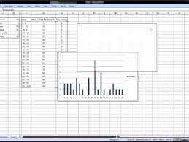 | Between 1914 and 1918 the British Army in France and Flanders sustained no fewer than 2.7 million battle casualties. Of the 2.7 million just over a quarter were never seen by the medical services. Those were the men who had been killed, were missing or were prisoners of war. Just under three quarters of the total number of casualties were seen by the medical services, of whom 5.6 per cent of the total - 151,356 - died of their wounds. In an assessment of nearly a quarter of a million casualties admitted to the casualty clearing stations in France and Flanders the majority were caused by high explosives or shrapnel. When men went over the top, then rifle and particularly machine-gun bullets took their toll. Hand-to-hand fighting within the trenches, moving from one segment of a trench to another, resulted in wounds caused by handheld bombs and grenades. Bayonet wounds were conspicuous by their absence, either because they didn't occur at all or because when inflicted they were almost invariably fatal.
Evacuation pathway  Advanced dressing stations  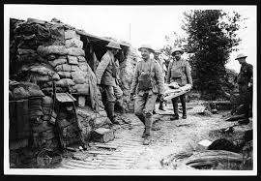 | With that in mind, here is the evacuation pathway. The top of the slide is the front line. The bottom of the slide is the base hospitals in Calais, Boulogne and Étaples. When the wounded arrived at the advanced dressing station they were assessed. They were divided into one of three groups: minor wounds, hopeless cases and severe but survivables. The minor wounds would go back to the main dressing station, the hopeless cases were put aside to die - there was no point in wasting any time on a hopeless case because you might deprive someone with a severe but survivable wound the opportunity to live. There was a very limited place for surgery in the early years of the war at the advanced dressing station. Amputation was encouraged in the completely mangled limb. (Rather like the limb that you saw in the slide.) If you removed a mangled limb from a badly wounded soldier his general condition improved. These legs were removed without anaesthetic or with a local anaesthetic infiltration into nerves to remove the totally mangled extremity. Arrest of haemorrhage was another thing that they had to do. Haemorrhage is what kills people fastest. It's an easier said thing than done sometimes to do. Bad conditions, deep hole, blood welling up. Sometimes it's very difficult to do that. In appropriate cases, where the wound is more distal in the limb, further down, you might be able to get a tourniquet above it. But it took a long time to get these casualties back and there was a high risk - 80 per cent of these patients ended up with an amputation. By 1918 teams of experienced surgeons with an anaesthetist would go forward to advanced dressing stations, so by 1918 they were taking the medical services further forward to do more major stuff.
Evacuation pathway  Casualty clearing stations  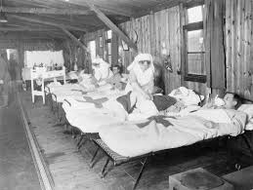 | Then from the advanced dressing station into an ambulance wagon which was heated. Very, very important. For the first time a soldier who had lain in a wet shell hole, who was hypothermic, began to feel warm. And as he warmed up, so his condition improved. Then he arrived at the casualty clearing station. The casualty clearing stations had accommodation for 800 to 1,200 wounded. They were grouped together in groups of two or three, admitting 150 to 300 cases at a time before passing the on call to the adjacent station with a similar area of interest. Those casualty clearing stations, treating abdominal wounds, chest wounds and compound fractures of the femur were closer to the front line at a range of around 10,000 yards. They were closer because these wounds above all others needed early surgery.  Casualty clearing stations fulfilled three important roles, depending on the severity of the wound. Minor wounds were treated in a minor operations theatre and the casualty kept in the forward area and then sent back to the front line. Wounds which were severe but safe to send back were immediately transferred to a train and put on a hospital train to the base. Those wounds which threatened limb and life and needed immediate surgery were kept in the casualty clearing station The inside of an operating theatre in a casualty clearing station was pretty standard. Twin operating tables, three teams of surgeons and anaesthetists working 16 hours on, eight hours off. They kept two operating tables working round the clock until the backlog was cleared. During the Third Battle of Ypres, which raged between 31 July 1917 and 10 November, there were 24 casualty clearing stations which dealt with the wounded from two British armies - the Second and the Fifth. Each army had about 150,000 men.
Bacterial infection  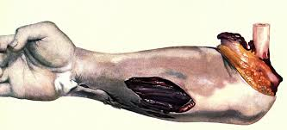 | The most important thing about war wounds on the Western Front was that they were absolutely filthy. And the heavy bacterial contamination of the soil, with organisms responsible for tetanus and gas gangrene, meant that these were particularly serious problems in 1914. So much so that consulting surgeon to the Expeditionary Force, Sir Anthony Bowlby, said: 'It is absolutely essential for success that wound excision should be done as soon as possible after the infliction of an extensive wound because in such cases gas gangrene may become widely spread within 24 hours. It is therefore necessary to operate on such cases before the patient is sent by train to the base.'
Wound excision  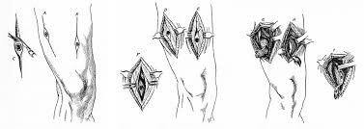 | Wound excision meant removal of all dead, devitalised tissue. It meant removal of all foreign material - shell fragments, clothing driven into the wound at the time the wound was inflicted, and all the filth and debris from the battlefield that goes deep into the body tissues. Only healthy, bleeding tissue is left behind and only then, only when you've got healthy, bleeding tissue will the organisms responsible for gangrene be deprived of the opportunity to grow because they only grow in the absence of oxygen. The top-right slide shows a very nasty wound in the right leg with much dead muscle. That dead muscle has been completely excised That is the basic principle of war surgery as it is the basic principle of civilian trauma surgery.
Effect of Gas  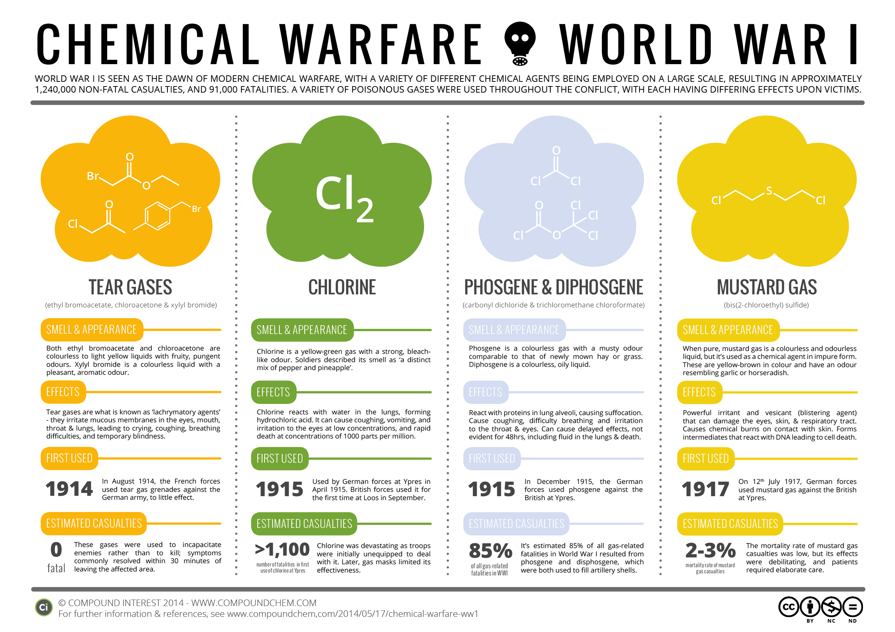 | Gas in its various manifestations was responsible for 18 per cent of admissions to casualty clearing stations by 1918. Mustard gas caused blistering and problems arose with mustard gas when those blisters became secondarily infected by bacterial. The most deadly of the three was phosgene which caused asphyxiation. It was always almost odourless. There was a slight whiff of musty hay and once you'd smelled that it was too late. This [slide shows] post mortem changes in the lungs of a soldier dying from phosgene gas poisoning. The empty looking spaces are in fact air sacs, or alveoli. This is where gas exchange occurs. This is where oxygen diffuses into the bloodstream and carbon dioxide comes out. The pink area below the clear space - these are also alveoli but they are filled with inflammatory exudate. This patient essentially drowned in his own secretions.

SECTION A: The British sector of the Western Front, 1914–18: surgery and treatment
Look carefully at Sources A and B in the Sources Booklet and then answer all parts of Question 1.

Source A From an account by Reverend Leonard Pearson, who was the army chaplain at
Casualty Clearing Station 44 during the Battle of the Somme (1916).

I spent most of my time giving anaesthetics. I had no right to be doing this because I had no medical qualifications, but we were simply so rushed. We couldn’t get the wounded into the hospital quickly enough and the journey from the battlefield was simply terrible for these poor lads. It was a question of operating as quickly as possible. If they had to wait their turn in the normal way, until the surgeon was able to perform the operation with a doctor giving the anaesthetic, it would have been too late for many of them. As it was, many died. We all simply had to help and do anything that was needed.

Source From the diary of Oswald Robertson, written on 30 November 1917. He was an
army surgeon working on the Western Front during the First World War.

Men were horribly mutilated – many were dying when brought into the ward. All
the beds were full and we began putting stretchers on the floor. Blood everywhere – clothes soaked in blood, pools of blood in the stretchers, streams of blood dropping from the stretchers to the floor. My rubber apron was one solid red smear. All we could do was try to stop the bleeding and get the patients as comfortable as possible. I could only transfuse an occasional patient. The majority had to take their chance and go through the operation as best they could.
1 (a) Study Source A.
Give two things that you can infer from Source A about this X.
Complete the table below. 4 marks.

What I can infer.

Details in the source that tell me this.

What I can infer.

Details in the source that tell me this

(b) Study Sources A and B.
How useful are Sources A and B for an enquiry into the problems involved in X on the Western Front? Explain your answer, using Sources A and B and your knowledge of the historical context. 8 marks.

(c) Study Source B.
How could you follow up Source B to find out more about the problems involved in X on the Western Front? In your answer, you must give the question you would ask and the type of source you could use. Complete the table below. 4 marks

Detail in Source B that I would follow up:

Question I would ask:

What type of source I could use:

How this might help answer my question:

Focus 3. Recovery and treatment of the wounded. The problem in dealing with the high number of casualties, including in the Battle of the Somme. The RAMC. The RAMC and system of transport, treatment and facilities at various stages: aid post and field ambulance, dressing station, casualty clearing station and base hospital.

Remember to consider
2 Knowledge, selection and use of sources for historical enquiries

● Knowledge of national sources relevant to the period and issue, e.g. army records, national newspapers, government reports, medical articles.
● Knowledge of local sources relevant to the period and issue, e.g. personal accounts, photographs, hospital records, army statistics.
● Recognition of the strengths and weaknesses of different types of source for specific enquiries.
● Framing of questions relevant to the pursuit of a specific enquiry.
● Selection of appropriate sources for specific investigations.
Activity 1: The chain of medical intervention.

 | The main medical functions in a complex chain that processed the casualty from the front line back to hospitals at home. It is in a simplified format. Many men missed stages altogether, and of course many wounded soldiers were in no condition to know which of these units was caring for them.
Aid and Bearer Relay Posts  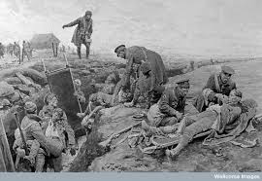 | The casualty is likely to have received first medical attention at aid posts situated in or close behind the front line position. Units in the trenches provided such posts and generally had a Medical Officer, orderlies and men trained as stretcher bearers who would provide this support. The Field Ambulance (see below) would provide relays of stretcher bearers and men skilled in first aid, at a series of "bearer posts" along the route of evacuation from the trenches. All involved were well within the zone where they could be under fire.
Field Ambulance and Advanced dressing stations  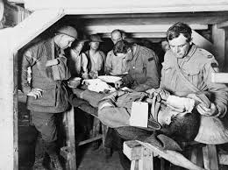 | This was a mobile medical unit, not a vehicle. Each British division had three such units, as well as a specialist medical sanitary unit. The Field Ambulances provided the bearer posts but also estabished Main and Advanced (that is, forward) Dressing Stations where a casualty could receive further treatment and be got into a condition where he could be evacuated to a Casualty Clearing Station. Men who were ill or injured would also be sent to the Dressing Stations and in many cases returned to their unit after first aid or some primary care.  There was no hard and fast rule regarding the location of a Dressing Station: existing buildings and underground dug-outs and bunkers were most common, simply because they afforded some protection from enemy shell fire and aerial attack. The Dressing Stations were generally manned by the Field Ambulances of the Royal Army Medical Corps.  Once treated at a Dressing Station, casualties would be moved rearward several miles to the Casualty Clearing Station. This might be on foot; or on a horse drawn wagon or motor ambulance or lorry; or in some cases by light railway.
Casualty Clearing Station | The CCS was the first large, well-equipped and static medical facility that the wounded man would visit. Its role was to retain all serious cases that were unfit for further travel; to treat and return slight cases to their unit; and evacuate all others to Base Hospitals. It was often a tented camp, although when possible the accommodation would be in huts. CCS's were often grouped into clusters of two or three in a small area, usually a few miles behind the lines and on a railway line. A typical CCS could hold 1,000 casualties at any time, and each would admit 15-300 cases, in rotation. At peak times of battle, even the CCS's were overflowing. Serious operations such as limb amputations were carried out here. Some CCS's were specialist unit, for nervous disorders, skin diseases, infectious diseases, certain types of wounds, etc. CCS's did not move location very often, and the transport infrastructure of railways usually dictated their location. Most evacuated casualties came away from the CCS by rail, although motor ambulances and canal barges also carried casualties to Base Hospitals, or directly to a port of embarkation if the man had been identified as a "Blighty" case. (In 1916, 734,000 wounded men were evacuated from CCS's by train and another 17,000 by barge, on the Western Front alone. There were 4 ambulance trains in 1914 and 28 by July 1916). The serious nature of many wounds defied the medical facilities and skills of a CCS, and many CCS positions are today marked by large military cemeteries. CCS's also catered for sick men. Generally, considering the conditions, the troops were kept in good health. Great care was taken in reporting sickness and infection, and early preventive measures were taken. The largest percentage of sick men were venereal disease cases at 18.1 per 1000 casualties; trench foot was next with 12.7. Until mid 1915, the CCS was known as a Clearing Hospital. Generally there was one provided for each Division. From the CCS, the casualty would be evacuated to a Base Hospital.
Base Hospital  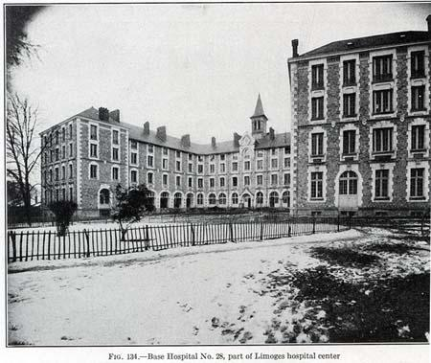 | Once admitted to a Base Hospital, the soldier stood a reasonable chance of survival. More than half were evacuated from a General or Stationary Hospital for further treatment or convalescence in the United Kingdom. The Stationary Hospitals, two per Division, could hold 400 casualties each. The General Hospital could hold 1040 patients. They were located near the army's principal bases at Boulogne, Le Havre, Rouen, Le Touquet and Etaples. The establishment of a General Hospital included 32 Medical Officers of the RAMC, 3 Chaplains, 73 female Nurses and 206 RAMC troops acting as orderlies, etc. The hospitals were enlarged in 1917, to as many as 2,500 beds.

SECTION A: The British sector of the Western Front, 1914–18: surgery and treatment
Look carefully at Sources A and B in the Sources Booklet and then answer all parts of Question 1.

Source A From an account by Reverend Leonard Pearson, who was the army chaplain at
Casualty Clearing Station 44 during the Battle of the Somme (1916).

I spent most of my time giving anaesthetics. I had no right to be doing this because I had no medical qualifications, but we were simply so rushed. We couldn’t get the wounded into the hospital quickly enough and the journey from the battlefield was simply terrible for these poor lads. It was a question of operating as quickly as possible. If they had to wait their turn in the normal way, until the surgeon was able to perform the operation with a doctor giving the anaesthetic, it would have been too late for many of them. As it was, many died. We all simply had to help and do anything that was needed.

Source From the diary of Oswald Robertson, written on 30 November 1917. He was an
army surgeon working on the Western Front during the First World War.

Men were horribly mutilated – many were dying when brought into the ward. All
the beds were full and we began putting stretchers on the floor. Blood everywhere – clothes soaked in blood, pools of blood in the stretchers, streams of blood dropping from the stretchers to the floor. My rubber apron was one solid red smear. All we could do was try to stop the bleeding and get the patients as comfortable as possible. I could only transfuse an occasional patient. The majority had to take their chance and go through the operation as best they could.

1 (a) Study Source A.
Give two things that you can infer from Source A about this X.
Complete the table below. 4 marks.

What I can infer.

Details in the source that tell me this.

What I can infer.

Details in the source that tell me this

(b) Study Sources A and B.
How useful are Sources A and B for an enquiry into the problems involved in X on the Western Front? Explain your answer, using Sources A and B and your knowledge of the historical context. 8 marks.

(c) Study Source B.
How could you follow up Source B to find out more about the problems involved in X on the Western Front? In your answer, you must give the question you would ask and the type of source you could use. Complete the table below. 4 marks

Detail in Source B that I would follow up:

Question I would ask:

What type of source I could use:

How this might help answer my question:

Focus 4. Developments in surgery and medicine, including: new techniques in the treatment of wounds and infection, the search for effective treatment after a gas attack, the attempts to deal with increased numbers of head injuries.

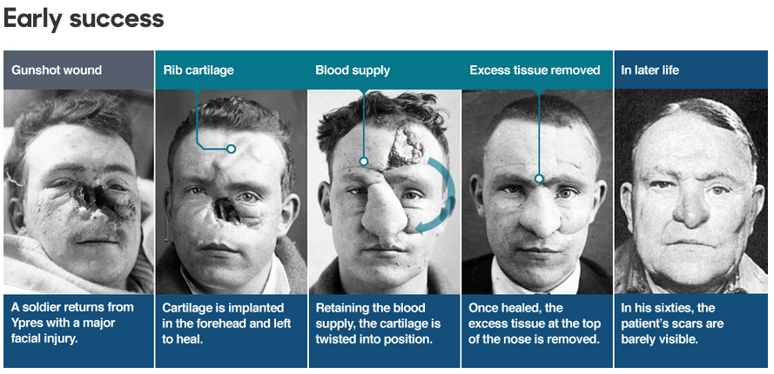

Remember to consider
2 Knowledge, selection and use of sources for historical enquiries

● Knowledge of national sources relevant to the period and issue, e.g. army records, national newspapers, government reports, medical articles.
● Knowledge of local sources relevant to the period and issue, e.g. personal accounts, photographs, hospital records, army statistics.
● Recognition of the strengths and weaknesses of different types of source for specific enquiries.
● Framing of questions relevant to the pursuit of a specific enquiry.
● Selection of appropriate sources for specific investigations.

Activity 1: Head injuries and gas.

Dealing with increased number of Head injuries  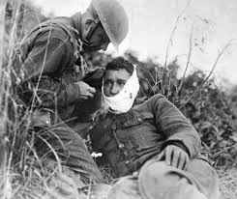 | The biggest killer on the battlefield and the cause of many facial injuries was shrapnel. Unlike the straight-line wounds inflicted by bullets, the twisted metal shards produced from a shrapnel blast could rip a face off. Not only that, but the shrapnel's shape would often drag clothing and dirt into the wound. Improved medical care meant that more injured soldiers could be kept alive, but urgently dealing with such devastating injuries was a new challenge.  Harold Gillies was the man the British Army tasked with fixing these grisly wounds. Born in New Zealand, he studied medicine at Cambridge before joining the British Army Medical Corps at the outset of World War One.  Gillies was shocked by the injuries he saw in the field, and requested that the army set up their own plastic surgery unit.  Soon after, a specifically-designed hospital was opened in Sidcup. It treated 2,000 patients after the Battle of the Somme alone. Here Gillies would do some of his finest work.  Previously viewed with suspicion, facial reconstruction became an integral part of the post-war healing process. However, in a world before antibiotics, going under the knife for an experimental form of surgery posed as many risks as the trenches themselves.
Search for dealing with effective treatment after a gas attack.  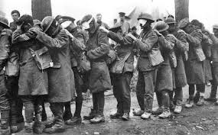 | None of the First World War's combatants was prepared for the introduction of poison gas as a weapon. Once gas had appeared, development of gas protection began and the process continued for much of the war producing a series of increasingly effective gas masks.  Even at Second Ypres, Germany, still unsure of the weapon's effectiveness, only issued breathing masks to the engineers handling the gas. At Ypres a Canadian medical officer, who was also a chemist, quickly identified the gas as chlorine and recommended that the troops urinate on a cloth and hold it over their mouth and nose. The first official equipment issued was similarly crude; a pad of material, usually impregnated with a chemical, tied over the lower face. To protect the eyes from tear gas, soldiers were issued with gas goggles.  The next advance was the introduction of the gas helmet — basically a bag placed over the head. The fabric of the bag was impregnated with a chemical to neutralize the gas — however, the chemical would wash out into the soldier's eyes whenever it rained. Eye-pieces, which were prone to fog up, were initially made from talc. When going into combat, gas helmets were typically worn rolled up on top of the head, to be pulled down and secured about the neck when the gas alarm was given. The first British version was the Hypo helmet, the fabric of which was soaked in sodium hyposulfite(commonly known as "hypo"). The British P gas helmet, partially effective against phosgene and with which all infantry were equipped with at Loos, was impregnated with sodium phenolate. A mouthpiece was added through which the wearer would breathe out to prevent carbon dioxide build-up. The adjutant of the 1/23rd Battalion, The London Regiment, recalled his experience of the P helmet at Loos:  The goggles rapidly dimmed over, and the air came through in such suffocatingly small quantities as to demand a continuous exercise of will-power on the part of the wearers.  Self-contained box respirators represented the culmination of gas mask development during the First World War. Box respirators used a two-piece design; a mouthpiece connected via a hose to a box filter. The box filter contained granules of chemicals that neutralised the gas, delivering clean air to the wearer. Separating the filter from the mask enabled a bulky but efficient filter to be supplied. Nevertheless, the first version, known as the Large Box Respirator(LBR) or "Harrison's Tower", was deemed too bulky — the box canister needed to be carried on the back. The LBR had no mask, just a mouthpiece and nose clip; separate gas goggles had to be worn. It continued to be issued to the artillery gun crews but the infantry were supplied with the "Small Box Respirator" (SBR).  The Small Box Respirator featured a single-piece, close-fitting rubberized mask with eye-pieces. The box filter was compact and could be worn around the neck. The SBR could be readily upgraded as more effective filter technology was developed. The British-designed SBR was also adopted for use by the American Expeditionary Force. The SBR was the prized possession of the ordinary infantryman; when the British were forced to retreat during the GermanSpring Offensive of 1918, it was found that while some troops had discarded their rifles, hardly any had left behind their respirators.  Humans were not the only ones that needed protection from gas clouds. Horses and mules were important methods of transportation that could be endangered if they came into close contact with gas. This was not so much of a problem until it became common to launch gas great distances. This caused many researchers to develop masks that could be used on animals such as dogs, horses, mules, and even carrier pigeons.

SECTION A: The British sector of the Western Front, 1914–18: surgery and treatment
Look carefully at Sources A and B in the Sources Booklet and then answer all parts of Question 1.

Source A From an account by Reverend Leonard Pearson, who was the army chaplain at
Casualty Clearing Station 44 during the Battle of the Somme (1916).

I spent most of my time giving anaesthetics. I had no right to be doing this because I had no medical qualifications, but we were simply so rushed. We couldn’t get the wounded into the hospital quickly enough and the journey from the battlefield was simply terrible for these poor lads. It was a question of operating as quickly as possible. If they had to wait their turn in the normal way, until the surgeon was able to perform the operation with a doctor giving the anaesthetic, it would have been too late for many of them. As it was, many died. We all simply had to help and do anything that was needed.

Source From the diary of Oswald Robertson, written on 30 November 1917. He was an
army surgeon working on the Western Front during the First World War.

Men were horribly mutilated – many were dying when brought into the ward. All
the beds were full and we began putting stretchers on the floor. Blood everywhere – clothes soaked in blood, pools of blood in the stretchers, streams of blood dropping from the stretchers to the floor. My rubber apron was one solid red smear. All we could do was try to stop the bleeding and get the patients as comfortable as possible. I could only transfuse an occasional patient. The majority had to take their chance and go through the operation as best they could.

1 (a) Study Source A.
Give two things that you can infer from Source A about this X.
Complete the table below. 4 marks.

What I can infer.

Details in the source that tell me this.

What I can infer.

Details in the source that tell me this

(b) Study Sources A and B.
How useful are Sources A and B for an enquiry into the problems involved in X on the Western Front? Explain your answer, using Sources A and B and your knowledge of the historical context. 8 marks.

(c) Study Source B.
How could you follow up Source B to find out more about the problems involved in performing operations on the Western Front? In your answer, you must give the question you would ask and the type of source you could use. Complete the table below. 4 marks

Detail in Source B that I would follow up:

Question I would ask:

What type of source I could use:

How this might help answer my question:

Focus 5. The historical context of medicine in the early twentieth century: the understanding of infection and moves towards aseptic surgery; Geoffrey Marshall’s work on anaesthetics; the development of x-rays and use of mobile x-ray units to detect shrapnel; blood transfusions – limitations caused by the need for donor-to-patient transfusions, developments in storing blood and blood banks.

Development of Aseptic surgery | Geoffrey Marshall  Development of Anaesthetics | Development of mobile X Ray units | Development of storing blood
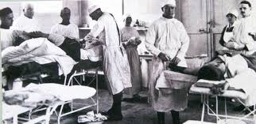 | 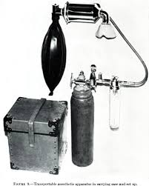 | 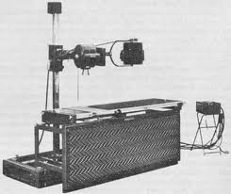 | 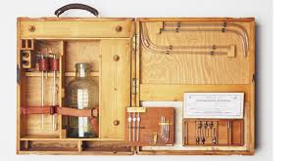

Remember to consider
2 Knowledge, selection and use of sources for historical enquiries

● Knowledge of national sources relevant to the period and issue, e.g. army records, national newspapers, government reports, medical articles.
● Knowledge of local sources relevant to the period and issue, e.g. personal accounts, photographs, hospital records, army statistics.
● Recognition of the strengths and weaknesses of different types of source for specific enquiries.
● Framing of questions relevant to the pursuit of a specific enquiry.
● Selection of appropriate sources for specific investigations.

Activity 1: Aseptics, Anaesthetics, X Ray & Blood

 | Aseptics, Anaesthetics, X Ray & Blood Transfusion
Henry Gray  Development of Aseptic surgery in the FWW | By October 1914, Gray realised the importance of removing all devitalised and contaminated tissues from wounds. In 1915, the technique of wound excision became firmly established. The anaerobic conditions predisposing to gas gangrene were thereby eliminated. Sometimes wounds looked innocuous and there was a temptation to transfer patients with such wounds to base hospitals for surgery. This was a mistake, because tissue contamination was always worse than first appearances sometimes suggested. The field dressing and splint were removed under general anaesthesia in an operating theatre in the CCS. Entrance and exit wounds were extended widely. There was invariably a huge amount of dead muscle which was excised until only healthy bleeding muscle remained. Bone ends were cleansed of filth, and loose fragments of bone with no soft tissue attachments were removed. All foreign bodies were removed. At the completion of the procedure only healthy, viable tissue remained. This systematic aggressive excision of all devitalised tissue was the fundamental principle of war surgery. In favourable cases, operated on before infection was established, Gray advocated primary closure of the wound.11 If there was doubt about the completeness of the surgical excision, delayed primary closure was employed, taking a ‘second look’ two or three days after the wound excision and closing the wound if all was well. The second look was usually performed at a base hospital, the primary excision having been carried out at a CCS. Gray used hypertonic salt dressings packed into the wound after primary wound excision. The pack was removed at the time of delayed primary closure.  In cases where wounds were already infected on admission to CCSs, patients first underwent excision of the wound, before it was either packed with hypertonic salt dressings or irrigated with antiseptic agents such as flavine, iodoform, boric acid or Dakin’s solution, which used sodium hypochlorite as its active ingredient. Antiseptics were sometimes helpful but were no substitute for surgical removal of dead, contaminated tissue. Granulation tissue gradually covered the wound surfaces, provided those surfaces had a blood supply. The wound could usually be closed secondarily after two to three weeks. In hopelessly infected cases, amputation was the best initial option
Geoffrey Marshall  Development of Anaesthetic in the FWW | The anaesthesia that was being practiced at the outbreak of the First World War had not drastically altered from that of the mid-nineteenth century. Old anaesthetics given via basic facemasks could be performed by many doctors; specialists were rare. This situation, however, altered during the First World War. This is because the vast number of wounded in the war demanded the introduction of casualty clearing stations to help triage and treat the wounded quickly and efficiently. The workload of these 'mini hospitals' created specialist anaesthetist posts within the military. Once in place, the anaesthetists were able to help develop the relatively new concepts of blood transfusion and resuscitation. These were recognized to be vital against shock, something that had previously not been well researched or understood. While at the casualty clearing stations, Geoffrey Marshall readdressed this by studying the effects of different anaesthetic agents in varying amounts of shock. This work led to the popularity of nitrous oxide, ether and oxygen, which in turn stimulated interest in anaesthesia machines. Finally, the treating of facial wounds in casualties at the Queen's Hospital for facial and jaw injuries at Sidcup, highlighted the possibility of endotracheal intubation, a technique that had a drastic effect on the administration of anaesthetics.
Development of mobile X Ray Units in the FWW | Curie was a brilliant scientist who also had humanitarian leanings. Disheartened by the trauma brought on by war she became determined to do what she could to lessen the suffering. Curie launched a project to establish a radiological service for the French army and bring x-ray machines nearer to the battlefield. She obtained vehicles that could be converted into mobile x-ray units and worked with x-ray equipment manufacturers to get suitable machines. She also worked with electrical manufacturers to obtain portable electric generators. From these materials she was able to make effective field radiological units.  Curie directed the work in the field herself. She trained people in the use of the machines and constantly made improvements to the equipment and procedures. By the end of the war she had built twenty mobile radiological units and some two hundred permanent posts. In 1917 and 1918 these mobile facilities took more than a million x-rays. Having x-rays near the battlefield meant that doctors could locate and treat wounds more quickly and save more lives.  Curie’s mobile units gave people a chance to help. As director of the army’s radiological service Curie had to recruit large numbers of people. Hundreds of them—drivers, technicians, and radiologists—were women. Working in the field x-ray unit provided these women with an active way of supporting the war effort and helping those in need. Curie’s efforts during the war saved thousands of lives and set an example in the humane use of technology
Developments in storing blood and blood banks during the FWW | The British Army began the routine use of blood transfusion in treating wounded soldiers. Blood was transferred directly from one person to another. But it was a US Army doctor, Captain Oswald Robertson, who realised the need to stockpile blood before casualties arrived. He established the first blood bank on the Western Front in 1917, using sodium citrate to prevent the blood from coagulating and becoming unusable. Blood was kept on ice for up to 28 days and then transported to casualty clearing stations for use in life-saving surgery where it was needed most.

SECTION A: The British sector of the Western Front, 1914–18: surgery and treatment
Look carefully at Sources A and B in the Sources Booklet and then answer all parts of Question 1.

Source A From an account by Reverend Leonard Pearson, who was the army chaplain at
Casualty Clearing Station 44 during the Battle of the Somme (1916).

I spent most of my time giving anaesthetics. I had no right to be doing this because I had no medical qualifications, but we were simply so rushed. We couldn’t get the wounded into the hospital quickly enough and the journey from the battlefield was simply terrible for these poor lads. It was a question of operating as quickly as possible. If they had to wait their turn in the normal way, until the surgeon was able to perform the operation with a doctor giving the anaesthetic, it would have been too late for many of them. As it was, many died. We all simply had to help and do anything that was needed.

Source From the diary of Oswald Robertson, written on 30 November 1917. He was an
army surgeon working on the Western Front during the First World War.

Men were horribly mutilated – many were dying when brought into the ward. All
the beds were full and we began putting stretchers on the floor. Blood everywhere – clothes soaked in blood, pools of blood in the stretchers, streams of blood dropping from the stretchers to the floor. My rubber apron was one solid red smear. All we could do was try to stop the bleeding and get the patients as comfortable as possible. I could only transfuse an occasional patient. The majority had to take their chance and go through the operation as best they could.
1 (a) Study Source A.
Give two things that you can infer from Source A about this X.
Complete the table below. 4 marks.

What I can infer.

Details in the source that tell me this.

What I can infer.

Details in the source that tell me this

(b) Study Sources A and B.
How useful are Sources A and B for an enquiry into the problems involved in X on the Western Front? Explain your answer, using Sources A and B and your knowledge of the historical context. 8 marks.

(c) Study Source B.
How could you follow up Source B to find out more about the problems involved in performing operations on the Western Front? In your answer, you must give the question you would ask and the type of source you could use. Complete the table below. 4 marks

Detail in Source B that I would follow up:

Question I would ask:

What type of source I could use:

How this might help answer my question:

(III) Assessment for Learning
Puzzle practise : X

In the puzzle Section A will have three compulsory questions, 1a, b and c. The content will come from either one or a combination of the key themes;

Exam Practise

1 (a) Study Source A.
Give two things that you can infer from Source A about this X. Complete the table below. 4 marks.
What I can infer.

Details in the source that tell me this.

What I can infer.

Details in the source that tell me this

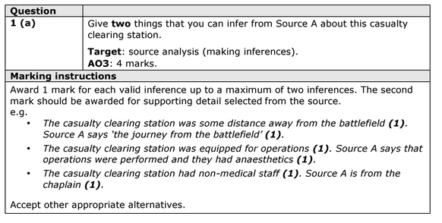
(b) Study Sources A and B.
How useful are Sources A and B for an enquiry into the problems involved in X on the Western Front? Explain your answer, using Sources A and B and your knowledge of the historical context. 8 marks.

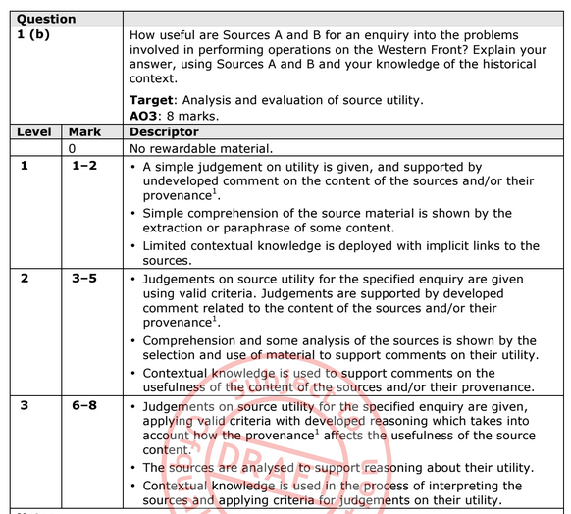

(c) Study Source B.
How could you follow up Source B to find out more about the problems involved in performing operations on the Western Front? In your answer, you must give the question you would ask and the type of source you could use. Complete the table below. 4 marks

Detail in Source B that I would follow up:

Question I would ask:

What type of source I could use:

How this might help answer my question:

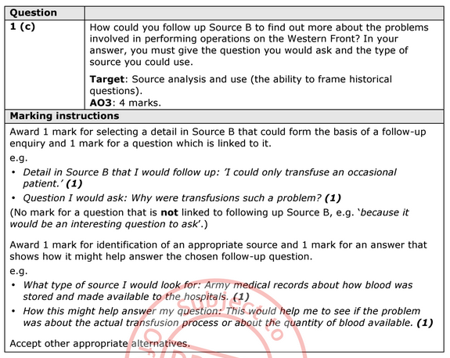

Trigger Memory Activity for FWW Surgery 1914-18

Trigger Words | Trigger Picture | Add Trigger  Points from your notes

Trigger Memory Story FWW Surgery 1914-18

The story must be very imaginative. It must involve you seeing, talking and doing things. It must link the ten trigger words together in the form of a continuous story. You should then rehearse the story and commit it too your long term memory to be recalled when necessary. This will take some effort but will be very useful! Use different colours to write the trigger words in your story.

I was...

