Why did Hitler rise to power in Germany by 1933 and what was his downfall?

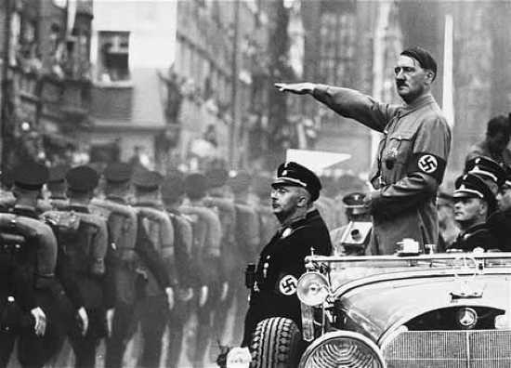

What was the impact of the Treaty of Versailles on Germany?
Why was Hitler appointed Chancellor of Germany in January 1933?
Did life improve for German people under Hitlers government?
Why did Hitlers government collapse by 1945?

A list of Key Terms and their meanings in the topic.

Background Causes | Things that contribute to an event happening, which exist for a long time before the event. They build up over many years, but are not enough on their own to make it happen.
bankrupt | Completely out of money and unable to pay debts.
Chancellor | Head of the government
Colonies | An area or country controlled by another.
Communists | A supporter of a system where everything is owned by the government and people are paid according to their needs.
Concentration camps | Places where people are kept prisoners, often forced to work for nothing. Some camps systematically murdered people.
constitution | A list of rules for how a country should be governed.
Contributed to | Helped to make something
democracy | Countries with a system of government where everyone has the right to vote for representatives from several political parties. The party with the most votes forms the government.
depression | Things becoming very bad or low, often lots of people do not have enough money to feed their families.
dictatorship | A country with a system of government where one person or party runs the country, without holding free elections and where no opposition is allowed
economic | To do with the money of a country.
elections | When people vote for an individual or political party.
Hindenburg | The president of Germany, when Hitler became the Chancellor.
Hitler | The Chancellor of Germany from 1933 who set up a Dictatorship. He fell from power in 1945.
Immediate causes | Things that contribute to an event happening, which only occurred just before the event. These often affect the timing of when the event happens.
majority | More than half the people.
ministers | Members of a government.
opposition | When people are against an idea or event.
Nazi Party | Short for the National Socialist Party, led by Hitler. They believed in having one powerful leader, wanted Germany to be powerful and held racist views.
political | To do with the governing of a country.
propaganda | The presentation of information in a specific way to influence people’s opinions.
quote | Copy out part of a text, placing between punctuation marks like these; ‘………………….’
Reichstag | The elected parliament of the German government.
reparations | To compensate or make up for something.
social | To do with the way people live.
Trade Union | An organisation of people who do a certain type of work, set up to talk to their employers about pay and conditions.
treaty | An agreement made between people or countries. They promise to do certain things.

“The Treaty of Versailles was fair in the way it dealt with Germany” How far do you agree with this view?

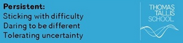
Getting started with the Mystery! Background contextual information

The First World War ended in November 1918. Germany and Austria had lost and Britain, France and the USA had won. In 1919, ‘The Big Three’; the leaders of Britain (Lloyd George), France (Clemenceau) and the USA (Wilson,) met at Versailles, near Paris in France. They spent four months talking about the peace treaty they were to draw up. The Germans were not included in the talks.

Think about this image in pairs and share your thoughts with another pair.
Headlines of Boston Telegraph June 1919
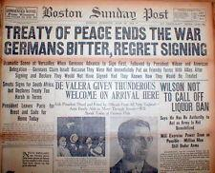
Content: The letter tells us..
Treatment: The author presents the content as..
Knowledge: This view can be both confirmed and challenged..
Nature : This is a..
Origins: This was produced by....in place..at a time when..
Purpose: The purpose of this image was too...

Piece together the background contextual information to the mystery in pairs and check your thinking with another pair.
Heads | Tails
Britain, France and the USA | …..‘The Big Three’.
Germany and Austria | …..won World War One.
The peacemakers met | …..lost World War One.
These leaders of Britain, France and the USA have been called | …..decide what went in to the Peace Treaty.
Germany was not allowed to | …...at Versailles, near Paris.

At Versailles the leaders had to agree the answers to a number of questions:
1. Who was to blame for the war?
2. What should happen to countries’ armies?
3. Who should pay for the war damage?
4. Should Germany and other defeated countries lose some of their lands, and how should these areas be organised?
5. How was the peace going to be kept in future?

Terms of the Treaty of Versailles | Fair | Harsh

1)Germany was forced to accept all the blame for starting the War.

2)Germany’s army was cut to 100,000 men. They could not put troops in the area nearest France and was not allowed to build any tanks planes or submarines.

3)In 1921 the Allies decided Germany should pay £6600 million reparations in gold and goods.

4)All Germany’s colonies were given to the Allies and land around the edges of Germany was given to France, Belgium, Denmark and Poland.

5)The League of Nations was set up. It was designed to get countries to discuss their disagreements instead of to fight.

Development Activity 1. Thinking through change and continuity of the Mystery. In pairs think through the categories that help explain the terms of the Versailles Treaty. Share your thinking with another pair sticking with difficulty and tolerating differences of view.

Some people would argue that the terms of the Versailles Treaty were fair on Germany, others would argue that they were too harsh and led to resentment and problems later on. Below are a number of statements about the terms of Treaty. For each one work out which term it is talking about and whether the person thinks it was fair on Germany or too harsh. Write the letter of that statement into the correct box on your table.

1 Germany was not the only country responsible, other countries were also trying to take over territory to become more powerful. |  | 5 Some of the land taken contained German speaking people. Germany would want it back and it led to the potential for further war.
2 Germany should be made to compensate for all the suffering and loss caused by the War. |  | 6 By being made to pay Germany would not be able to look after its people. Other countries also caused the damages in fighting.
3 Germany was the main cause. It gave Austria permission to attack Serbia and sent its’ army to invade .France. |  | 7 All countries have the right to keep up the same level of military power as its neighbours as protection
4 It was essential to reduce Germany’s military power so it could no longer be a threat to her surrounding countries. |  | 8 Taking land away from Germany created a barrier which was supposed to protect Germany’s neighbour from the threat of invasion.

Statements
Treaty of Versailles was fair
Treaty of Versailles was harsh

Development Activity 4. Independent Enquiry on the Mystery. You are building an analysis and evaluation of a viewpoint or interpretation and should be written in 18 mins. This will involve looking at evidence to support the view and evidence to challenge the view and these may involve factors to be addressed e.g. P, E, S. Two main parts.. one and half pages.

“The Treaty of Versailles was fair in the way it dealt with Germany” How far do you agree with this view?

Introduction. There is evidence to support and challenge this view. It is argued that

· There is evidence to support/challenge the view…. Point, Evidence, Explanation
· However there is evidence to challenge/support the view. Point, Evidence, Explanation

In conclusion whilst there is evidence to both support and challenge the view, the view that is most convincing is X. Point, Evidence, Explanation

“The despair of unemployment and economic depression was the main reason for Hitlers’ rise to power”. How far do you agree with this view?

Getting started with the Mystery! Background contextual information

Think about this image in pairs and share your thoughts with another pair.
Source A Nazi election poster pre 1933. It communicates, vote for Hitler..our last hope.
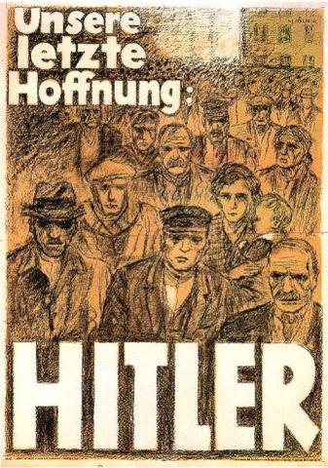
Content: The letter tells us..
Treatment: The author presents the content as..
Knowledge: This view can be both confirmed and challenged..
Nature : This is a..
Origins: This was produced by....in place..at a time when..
Purpose: The purpose of this image was too...

Development Activity 1. Thinking through change and continuity of the Mystery.
In January 1933 Adolf Hitler became the Chancellor of Germany. Germany was a democratic country, whose ruler were made by a Parliament called the Reichstag. In the elections of March 1933, Adolf Hitler’s political party (the NSDAP) won a majority in the Reichstag, and he directed them to pass an Enabling Law. This allowed Hitler to make laws and decisions for Germany without getting the permission if the Reichstag. In effect the Reichstag had it greatest power taken away, the right to make Germany’s laws. Adolf Hitler became a dictator. Why did so many Germans welcome Hitler?

In pairs think through the sources that help explain the attraction of Hitler and the Nazis. Share your thinking with another pair sticking with difficulty and tolerating differences of view.

1THE NAZI’S CHANCE FOR POWER:  In 1929 came a crisis from which the Weimar Republic never recovered. A world trade slump prevented the Germans from selling their exports. The factories closed down and many unemployed workers joined the extreme political parties – the Nazis and the Communists – who offered help. Between 1929 and 1931 Hitler’s brownshirts fought their Communist rivals in the streets and clamoured for political power. In the 1932 election, the Nazis emerged as the biggest single party in the Reichstag.  Brian Catchpole, Map History of the Modern World (1974) |  | 6 WHY BE A NAZI?  For five years I remained unemployed and I was broken in body and spirit and I learned how stupid were all my dreams in those hard days at university. I was not wanted by Germany…then I was introduced to Hitler. You won’t understand and I cannot explain either, because I don’t know what happened, but life took on a tremendous new significance…I have since committed myself, body, soul, and spirit, to this movement…I can only tell you that I cannot go back. I cannot question, I am pledged.  Interview with an un-named member of the Nazi party (1936)
2 EXTRACTS FROM THE NAZI PROGRAMME:  1. We demand the union of all Germans, on the basis of the right of self-determination, to form a great Germany.  2. We demand equality of rights of the German people, and the abolition of the peace treaties of Versailles and St. Germain…  4. Only those of German blood may be citizens of the state…  11. We demand abolition of all incomes not earned by work…  13. We demand the nationalisation of all large businesses…  15. We demand generous provision for old ages pensioners.  Nazi Party Programme (24 Feb 1920) |  | 7 UNEMPLOYMENT AND POLITICS 1928 –1933:  DATE NUMBER UNEMPLOYED REICHSTAG SEATS  1928 1,862,000 12  1930 2,850,000 107  1932 (Jul) 3,217,000 230  1932 (Nov) 4,886,000 196  1933 6,042,000 288  Think of these figures in terms of men standing hopelessly on the street corners every industrial town in Germany.  Alan Bullock, historian, explains the figures.
3 ATTRACTION OF THE NAZI PARTY:  I am not a follower of every new group that comes along. I joined the NSDAP because it was run by men who, above all, know what they want. Our educated classes are not good at organisation even though their theories may be well meant. Hitler and Drexler are men of action, although they have not been to university.  Gustav Seifart, Letter (6 January 1922) |  | 8 WHY WAS HITLER POPULAR?  At one of the early congresses I was sitting surrounded by thousands of S.A men and as Hitler spoke I was most interested at the shouts and more often the muttered exclamations of the men around me, who were mainly workmen of lower middle class types. “He speaks foe me, he speaks for me”, “He knows how I feel”. Many of them seemed lost to the world around them and were probably unsure of what they were saying.  Amy Buller, ‘Darkness over Germany’ (1946)
4 THE GREAT INFLATION:  People coming from the bank with millions of paper marks in suitcases or wheelbarrows. People paying for seats at the theatre with eggs or pats of butter… Money what lost half its value in 12 hours. People who had been wealthy trying to sell watches or jewelry for food instead of that hated money. A woman I knew had saved, year by year, to assure her son’s welfare. Her capital would have bought a houseful of furniture. Three months later it would not pay her tram fare. The middle class was wiped out in a matter of weeks.  Vernon Bartlett, Nazi Germany Explained (1932) |  | 9 THE GREAT INFLATION:  Date Marks to the pound  Jul 1914 16  Jan 1921 260  Jan 1922 770  Jul 1922 1,970  Jan 1923 72,000  Jul 1923 150,000  Nov 1923 16,800,000,000
5THE APPEAL OF THE NAZIS:  Here it seemed to me was hope. Here were new ideals, a new understanding, new tasks. The perils of Communism could be checked, Hitler persuaded us, and instead of hopeless unemployment, Germany could move towards economic recovery. It must have been during these months that my mother saw a Storm Trooper parade in the streets of Heidelberg. The sight of discipline in a time of chaos, the impression of energy in an atmosphere of universal hopelessness, seems to have won her over also.  Albert Speer (1931). A leading Nazi describes how he felt after hearing Hitler speak. |  | 10 THE APPEAL OF NAZISM:  The nazi appeal to young people was characterised by a mixture of reason and emotion…the job situation for new graduates in the early 1930s was appalling and the Nazi party and its programme of a new order offered – apart from anything else – prospects for future employment.  Jeremy Noakes, ‘The Rise of the Nazis’ (History Today, January 1983)

Development Activity 2. Thinking through change and continuity of the Mystery. In pairs identify and think through the categories that help explain the mystery. Share your thinking with another pair sticking with difficulty and tolerating differences of view.

Causal Factors | Statements
A Political

B Economic

C Social

D Any other factors?

Development Activity 2.
In your pair think about which of the types of cause you have researched is the most important one, and how it is connected with the other two. Go and discuss your viewpoint with another pair. Do they agree with your interpretation or not? Discuss what they think and why.

Go back to your work and think about a final paragraph. You should explain the following:

Which type of cause if the most important and why.
How this type of cause is linked to the other types.
Which cause you think is the most important and why.
How this cause is linked to the others.

Development Activity 4. Independent Enquiry on the Mystery. You are building an analysis and evaluation of a viewpoint or interpretation and should be written in 18 mins. This will involve looking at evidence to support the view and evidence to challenge the view and these may involve factors to be addressed e.g. P, E, S. Two main parts.. one and half pages.

“The despair of unemployment and economic depression was the main reason for Hitlers’ rise to power”. How far do you agree with this view?

Introduction There are many reasons that explain how the Nazis were able to take power in 1933. These causes can be categorised as political, economic, or social; sometimes a cause can be a combination of these three. Also, these causes are often linked together in different ways.

Paragraph 1: Political causes
A political cause is -------------. This is mentioned in source -----, for example it says –(insert your selection here)-. Another cause is --------, as mentioned in source ------, it says --- (insert selection).

Paragraph 2: Economic causes
An economic cause is ----. This is mentioned in source ---, for example it says that (insert selection)--. Another cause is ---, as mentioned in source ---. It says --(insert selection).

Paragraph 3: Social causes
A social cause is ---. This is mentioned in source ---, for example it says that (insert selection). Another cause is ---, as mentioned in source ---. It says (insert selection).

Paragraph 4: Links between sources and causes
Many of these types of causes are linked together, for example source --- is about ----. This can be a ----- and ---- cause, for example (insert selection). Source --- is about --- cause, this can be linked to source --- which mentions --- cause. The causes themselves can also be linked, for example, source --- is about ---- which can be connected to source --- which is about ----.

“Life improved for German people under Hitler’s government.” How far do you agree?

Getting started with the Mystery! Background contextual information

Think about this image in pairs and share your thoughts with another pair.
Source A 1932 Nazi election poster entitled “Our last Hope: Hitler”
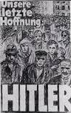
Nature : This is a
Origins: This was produced by....in X.
Purpose: The purpose of this image was too...
Content: The image shows
Knowledge: There were a range of views about..

Development Activity 1. Thinking through change and continuity of the Mystery. In pairs think through the categories that help explain the mystery. Share your thinking with another pair sticking with difficulty and tolerating differences of view.

1 This picture shows unemployment levels in Hitler’s Germany. The Great Depression, which began in 1929, led to very high levels of unemployment. Millions of people lost their jobs and could not afford to feed their families. One of the reasons why Hitler came to power was because he promised ‘Work and Bread’ for everyone. After he came to power, Hitler set up work creation schemes, such as road building and digging ditches on farms. All men aged 18-25 had to spend 6 months in this National Labour Service. Also, from 1935 onwards, all men between 18 and 25 had to serve in the Army for two years. These schemes reduced the number of people who needed jobs. | 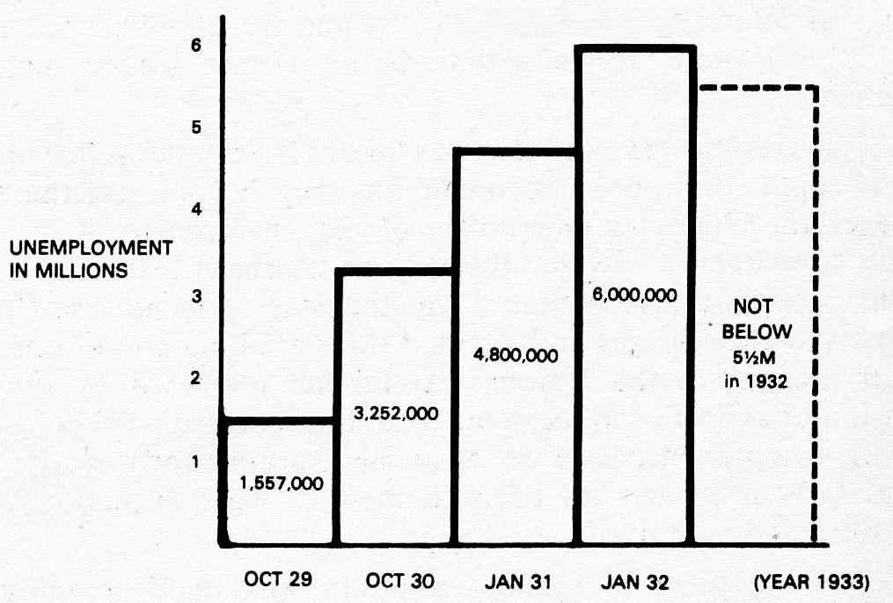
2 This picture shows a newly built motorway from Hitler’s Germany. From 1933, Hitler built up the Autobahn (motorway) network across Germany. He planned 7,00 kilometres of motorway. By 1938, 3000 kilometres had been built. The improved transport system helped industry to grow, because goods from factories could reach markets more easily. This meant that industries needed more workers so this helped to reduce unemployment. | 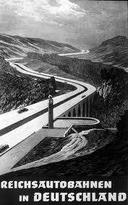
3 This picture shows judges making an oath of loyalty to Hitler. Hitler did not replace the existing law courts. However, if judges wanted to keep their jobs, they were not allowed to hold different views to those of the government. From then on the German people could not count on a fair trial. The law could be ignored if it was decided that it was ‘in the interests of the country’. New laws were made by Hitler to reflect his ideas, such as anti-Semitic (anti-Jewish) laws. The judges had to accept these new laws and to make sure that the people who broke these laws were found guilty and imprisoned. | 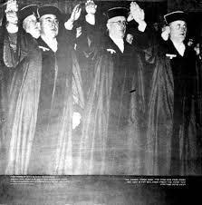
4 This picture shows the new people’s car designed in Hitler’s Germany – The Volkswagen. The poster says “Save 5 marks a week and drive your own car.” The aim was to give more people the opportunity to own a car by making the design simple, keeping the cost of production low and the price cheap. During the 1930’s the total car ownership trebled in Germany. | 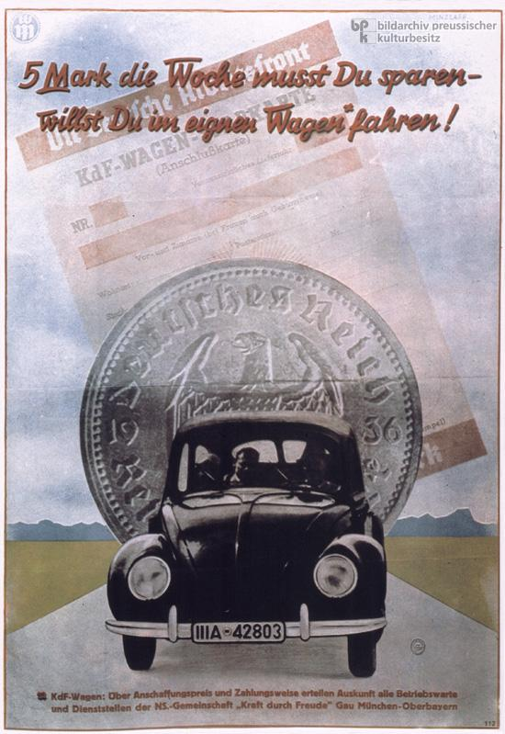
5 This picture is a poster advertising a Cruise. An organisation called ‘Strength through Joy’ was set up by when Hitler became leader of Germany. It was set up to keep workers happy by providing leisure activities, such as concerts, films, sports and holidays. German workers were also constantly told they were much better off than workers in other countries. The most loyal and hardest working workers could qualify for a holiday on a Strength through Joy cruiser. | 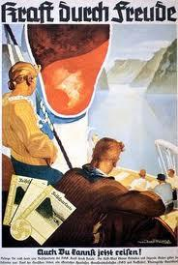
6 This picture shows the public burning of banned books by the SA (Hitler’s private army in 1934. Hitler’s government controlled what was said in newspapers, films, plays and books and on the radio. They made sure they only put across their ideas. This is called Censorship. Anything that criticised the government, or put forward different ideas, was banned and could be destroyed. The works of over 2,500 writers were officially banned. Officials attacked libraries and burned millions of books on huge bonfires. | 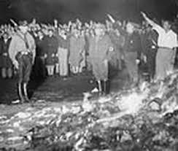
7 This picture shows political opponents of Hitler’s Nazi Party being rounded up by the SA (Hitler’s Private Army). These people did not want Hitler to be leader of Germany any more. After Hitler became Chancellor of Germany there was an Election. Hitler wanted to make sure his party got more votes than the last time. The SS (Secret Police) was set up to deal with any opposition to Hitler. They were allowed to use any means necessary. Hitler’s Private Army and this new Secret Police used violence and intimidation, making it impossible for other parties to put forward their ideas at elections. Many of these people were arrested and sentenced to death. Later in 1933, Hitler banned all other political parties completely. | 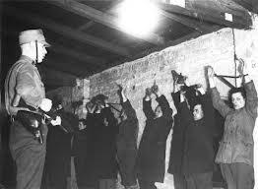
8 This picture shows Jewish men being transported to a concentration camp, where they could be killed or worked to death. Hitler believed that the German people (Aryans) were superior to (better than) other races. Other races like the Jews were blamed for any problems that Germany had.  Once Hitler became Chancellor, people were encouraged not to use Jewish shops or businesses. Non-Aryans were sacked from government jobs. Jews were banned from public places such as parks, shops and cafes. From 1935, laws were made which took away Jewish people’s basic human rights; they could not marry non-Jews, go to German schools, or travel freely. Then they had to wear a yellow star on their clothes and were made to live in walled parts of cities, called Ghettos, were they could starve to death. In 1942, Work Camps and Death Camps were set up and Jews and other people that Hitler’s government did not like, such as political opponents, Gypsies, Black people and Homosexuals, were transported to them in trains. They had no food or water. When the train arrived at the camps, some were sent to work, others were killed in gas chambers. | 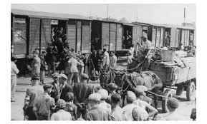

Development Activity 2. Thinking through change and continuity of the Mystery. In pairs identify and think through the categories that help explain the mystery. Share your thinking with another pair sticking with difficulty and tolerating differences of view. Complete the following table into your books so that it fills a whole page. Write in the numbers of the photograph under the interpretation of life in Hitler’s Germany that it supports. For each photograph, give one sentence to explain why it supports that view.

Life improved | Life did not improve
Photograph.. This shows that.. | Photograph.. This shows that..
Photograph.. This shows that.. | Photograph.. This shows that..
Photograph.. This shows that.. | Photograph.. This shows that..
Photograph.. This shows that.. | Photograph.. This shows that..

Development Activity 3. Independent Enquiry on the Mystery. You are building an analysis and evaluation of a viewpoint or interpretation and should be written in 18 mins.

“Life improved for German people under Hitler’s government.” How far do you agree?
There is evidence to support the view that life improved for German people under Hitler’s government. For example, ….

However, there is also evidence to support the view that life did not improve, or got worse. For example, …

In conclusion whilst there is evidence to both support and challenge the view, the view that is most convincing is X. Point, Evidence, Explanation.
“Hitler fell from power by May 1945 largely because of internal opposition” How far do you agree with this view?

Getting started with the Mystery! Background contextual information

Think about this image in pairs and share your thoughts with another pair.
Source A A photograph of Berlin in 1945
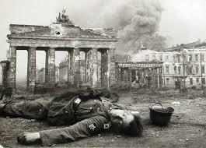
Nature : This is a
Origins: This was produced by....in X.
Purpose: The purpose of this image was too...
Content: The image shows
Knowledge: There were a range of views about..

Piece together the background contextual information to the mystery in pairs and check your thinking with another pair.

Heads | Tails
1Adolf Hitler was determined to | and Adolf Hitler had committed suicide.
2 From 1936 Hitler’s army took over | make his country larger and more powerful.
3 By 1942 controlled much of Europe and was fighting an | other areas and countries.
4 However, by May 1945 Germany had surrendered | aggressive war against Britain, France, Russia and the USA.

Your teacher will give you a timeline of Hitler’s foreign policy from 1936 and the events of the Second World War. In groups of four, study it carefully and think about how successful Germany was at each point.

Below are three headings. Decide when on your timelines they best describe. For each one you should be able to explain why it could apply to that period of time.
‘Heading for Victory’
‘The tide turns’
‘Darker days for the Germany’

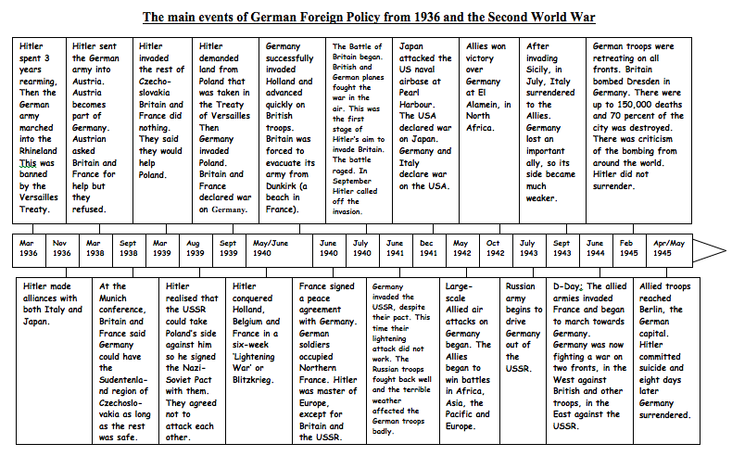

Now you need to concentrate on the period 1939-1945. Use the timeline to complete your copy of the progress graph for Germany in the war.

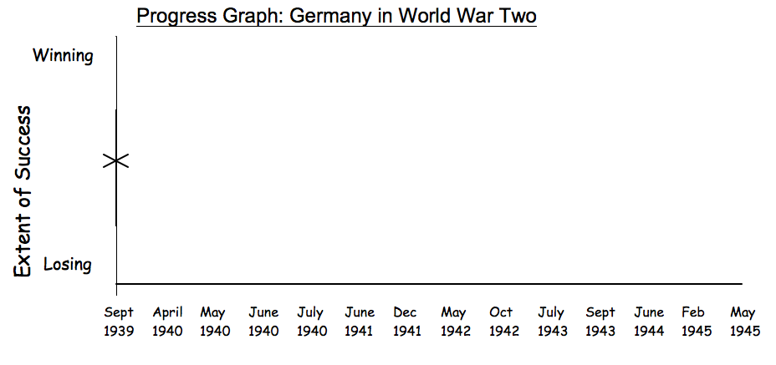

Development Activity 1. Thinking through change and continuity of the Mystery. In pairs think through the categories that help explain the decline of Hitlers Germany. Share your thinking with another pair sticking with difficulty and tolerating differences of view. Whilst how Germany performed in the Second World War is crucial to understanding why Hitler fell, it is also important to recognise that other factors also contributed.
Evidence to show that opposition to Hitler was growing in Germany |  | Evidence to show that Germans were disillusioned with the war

1 People who supported other political parties (Socialists and Communists) continued to try to fight Hitler and the Nazis, although most were imprisoned or killed. |  | 6 The Edelweiss Pirates were groups of teenagers, mainly 14-17. They held activities just like the Hitler Youth movement, but they mocked the Nazis and sometimes attacked the Hitler Youth. They helped army deserters, stole weapons and helped an attack on the Gestapo (the secret police).
2 People’s lives became more and more difficult, with longer hours at work, less heating and food. This did not seem worth putting up with when the war was not going well: |  | 7 In 1944 there was an assassination attempt on Hitler, which failed.
3 Some scientists passed on secrets about new weapons to Britain. Other individuals helped Jews and others to escape. |  | 8 By the last years of war, there were no entertainments or postal service. This meant that people found it hard to escape their everyday lives and to raise their morale.
4 In the last year of the war, ordinary people stayed away from Nazi rallies and refused to give ‘Heil Hitler’ salutes when asked to do so. |  | 9 Many individual churchmen resisted Hitler, giving sermons against Nazi ideas. Many were sent to concentration camps and killed or worked to death.
5 In 1941, Hitler decided to invade the Soviet Union (Russia). This was a massive risk, as he was now fighting a war on two fronts - Britain and France to the West, and Russia to the East. At first, the invasion went well. However as the Russian army retreated into Russia it destroyed anything that might be useful to the Germans such as railways, food supplies and factories. |  | 10 The Japanese attack on Pearl Harbor was supposed to knock America out of the war before they even entered it. However the attack failed to cripple America as it was supposed to and it brought America into the war. Because of the terms of their treaties, when Japan declared war on America so did Germany. This meant that America was also at war with Germany. America brought more troops and weapons into the war.

Development Activity 4. Independent Enquiry on the Mystery. You are building an analysis and evaluation of a viewpoint or interpretation and should be written in 18 mins.

“Hitler fell from power mainly due to internal opposition” Do you agree?

Introduction. There is evidence to support and challenge this view. It is argued that

· There is evidence to support/challenge the view…. Point, Evidence, Explanation
· However there is evidence to challenge/support the view. Point, Evidence, Explanation

In conclusion whilst there is evidence to both support and challenge the view, the view that is most convincing is X. Point, Evidence, Explanation

Here’s what the students do for their GCSE Paper for Causation
Question Number 6 or 7. Co-operate, share, stick with difficulty and tolerate uncertainty.
Why was X so important in Y across the period….? How important was X for Y? ‘X was more important during the period Y than Z’ Do you agree? Why did X occur? How far did X change over the period?

Target: Analysis of significance/ causation/change (AO 1 & 2: 16 marks)

Level | Mark | Descriptor
1 | 1-4 | Simple or generalised comment is offered, supported by some knowledge. Candidate makes generalised statements or describes one aspect in limited detail.  Writing communicates ideas using everyday language and showing some selection of material but the response lacks clarity and organisation. The candidate spells, punctuates and uses the rules of grammar with limited accuracy
2 | 5-8 | Statements are developed with support from material which is mostly relevant and accurate. Candidate states that there was some continuity or change and provides detailed descriptions of aspects of each period.  Maximum 7 marks for answers that do not describe an aspect in addition to those prompted by the stimulus material.  Writing communicates ideas using a limited range of historical terminology and showing some skills of selection and organisation of material, but passages lack clarity and organisation. The candidate spells, punctuates and uses some of the rules of grammar with general accuracy.
3 | 9-12 | The response shows understanding of the focus of the question and deploys sufficient accurate and relevant material to support the points made. Candidate provides an analysis of each period and makes comparisons between periods.Maximum 10 marks for answers that do not explore aspects beyond those prompted by the stimulus material.  Writing communicates ideas using historical terms accurately and showing some direction and control in the organising of material. The candidate uses some of the rules of grammar appropriately and spells and punctuates with considerable accuracy, although some spelling errors may still be found.
4 | 13-16 | A sustained analysis, supported by precisely-selected and accurate material and with sharply focused development of points made. Answer as a whole focuses well on the question. Candidate recognises the need to compare aspects of progress with areas of stagnation, in order to make a judgement.NB: No access to Level 4 for answers which do not explore aspects beyond those prompted by the stimulus material,  Writing communicates ideas effectively, using a range of precisely- selected historical terms and organising information clearly and coherently. The candidate spells, punctuates and uses the rules of grammar with considerable accuracy, although some spelling errors may still be found.
Marks for SPaG
 | 0 | Errors severely hinder the meaning of the response or candidates do not spell, punctuate or use the rules of grammar within the context of the demands of the question.
 | 1 | Candidates spell, punctuate and use the rules of grammar with reasonable accuracy in the context of the demands of the question. Any errors do not hinder meaning in the response. Where required, they use a limited range of specialist terms appropriately.
 | 2 | Candidates spell, punctuate and use the rules of grammar with considerable accuracy and general control of meaning in the context of the demands of the question. Where required, they use a good range of specialist terms with facility.
 | 3 | Candidates spell, punctuate and use the rules of grammar with consistent accuracy and effective control of meaning in the context of the demands of the question. Where required, they use a wide range of specialist terms adeptly and with precision.

Q5b You are building an analysis and evaluation of a viewpoint or interpretation and should be written in 24 mins. This will involve looking at evidence to support the view and evidence to challenge the view and these may involve factors to be addressed e.g. P, E, S. Two main parts.. one and half pages.

Introduction. There is evidence to support and challenge this view. It is argued that

· There is evidence to support the view. For example PEEx
· However there is evidence to challenge this view and suggest other factors were more significant. For example PEEx

In conclusion whilst there is evidence to both support and challenge the view, the view that is most convincing is X.

KS3/4 | Progress  Chart  History | AO1 Recall select and communicate Knowledge and understanding of history. | AO2 Describe, explain, analyse and evaluate causes, consequences, changes, continuities and their significance. | AO3a) Describe, explain, analyse and evaluate  a) a range of source material. | AO3b) Describe, explain, analyse and evaluate  b) how different historical events have been interpreted and represented.
 |  | Imaginative  Using intuition  Making connections  Playing with possibilities | Collaborative  Co-operating appropriately  Giving and receiving feedback  Sharing the product | Inquisitive  Wondering and questioning  Exploring and investigating  Challenging assumptions | Imaginative  Using intuition  Making connections  Playing with possibilities
 |  | Disciplined  Crafting and improving  Reflecting critically  Developing techniques | Persistent  Sticking with difficulty  Daring to be different  Tolerating uncertainty | Disciplined  Crafting and improving  Reflecting critically  Developing techniques | Persistent  Sticking with difficulty  Daring to be different  Tolerating uncertainty
9  A**  Creator | a. I am confident  b. I am secure in  c. I am beginning | I can go beyond excelling in all of the qualities of this Assessment Objective, which are thoroughly explained in the Grade A descriptor.I craft and refine my work selecting a wide range of sophisticated techniques with skill and flair. I critically reflect on my strengths and weaknesses, taking control of my learning. | I can go beyond excelling in all of the qualities of this Assessment Objective, which are thoroughly explained in the Grade A descriptor.  I collaborate creatively, regularly giving intelligent feedback and making excellent use of advice and guidance.I thrive on challenge and can manage uncertainty in the knowledge that this is essential for my creativity. | I can go beyond excelling in all of the qualities of this Assessment Objective, which are thoroughly explained in the Grade A descriptor.I can creatively explore a range of ideas independently. I ask challenging questions that help me to generate my own investigations informed by detailed and imaginative research and analysis. | I can go beyond excelling in all of the qualities of this Assessment Objective, which are thoroughly explained in the Grade A descriptor.I rely on my instincts to help me play with new ideas and create inventive connections in my learning.I thrive on challenge and can manage uncertainty in the knowledge that this is essential for my creativity.
8  A*  Creator | a. I am confident  b. I am secure in  c. I am beginning | I craft and refine my work selecting a wide range of sophisticated techniques with skill and flair. I critically reflect on my strengths and weaknesses, taking control of my learning.I can go beyond excelling in all of the qualities of this Assessment Objective, which are thoroughly explained in the Grade A descriptor. | I collaborate creatively, regularly giving intelligent feedback and making excellent use of advice and guidance.I thrive on challenge and can manage uncertainty in the knowledge that this is essential for my creativity.I can go beyond excelling in all of the qualities of this Assessment Objective, which are thoroughly explained in the Grade A descriptor. | I can creatively explore a range of ideas independently. I ask challenging questions that help me to generate my own investigations informed by detailed and imaginative research and analysis.  I can go beyond excelling in all of the qualities of this Assessment Objective, which are thoroughly explained in the Grade A descriptor. | I rely on my instincts to help me play with new ideas and create inventive connections in my learning.I thrive on challenge and can manage uncertainty in the knowledge that this is essential for my creativity. I can go beyond excelling in all of the qualities of this Assessment Objective, which are thoroughly explained in the Grade A descriptor.
7  A  Creator | a. I am confident  b. I am secure in  c. I am beginning | I craft and refine my work selecting a wide range of sophisticated techniques with skill and flair. I critically reflect on my strengths and weaknesses, taking control of my learning.I can recall, select, organise and deploy detailed historical knowledge effectively and with consistency. I show thorough understanding of the historical periods, themes and topics studied. I communicate ideas using historical terms accurately and appropriately. | I collaborate creatively, regularly giving intelligent feedback and making excellent use of advice and guidance.I thrive on challenge and can manage uncertainty in the knowledge that this is essential for my creativity.I can demonstrate understanding of the past through developed, reasoned and well-substantiated explanations. I make perceptive analyses of the key concepts, features and characteristics of the periods studied, and the interrelationships between them. | I can creatively explore a range of ideas independently. I ask challenging questions that help me to generate my own investigations informed by detailed and imaginative research and analysis.I can evaluate and use critically a wide range of sources of information in an historical context to investigate historical questions, problems or issues independently, and reach reasoned and substantiated conclusions. | I rely on my instincts to help me play with new ideas and create inventive connections in my learning. I thrive on challenge and can manage uncertainty in the knowledge that this is essential for my creativity.I can recognise and comment on how and why events, people and issues have been interpreted and represented in a wide range of different ways, and provide a thorough consideration of their value in the historical context.
6  B  Constructor | a. I am confident  b. I am secure in  c. I am beginning | I can confidently craft and refine my work. I can skilfully select and use a range of techniques. I am able to reflect on my strengths and weaknesses in detail.I can recall, select, organise and deploy historical knowledge with increasing accuracy and relevance. I show good understanding of the historical periods, themes and topics studied. I communicate ideas using historical terminology confidently. | I collaborate effectively. I enjoy giving thoughtful feedback and I make good use of advice and guidance to improve my work.I can confidently manage to keep going when things are difficult. I understand that not knowing is part of the process of being creative and I enjoy taking risks.I can demonstrate understanding of the past through structured descriptions and explanations of the main concepts, features and characteristics of the periods studied with confidence. My descriptions are accurate and my explanations show good understanding of relevant causes, consequences and changes. | I can confidently explore a range of ideas independently and ask challenging questions based on my careful research. I can carry out skilful analysis.I can confidently evaluate and use critically a range of sources of information in an historical context to investigate historical questions, problems or issues, and reach reasoned conclusions, which are well supported. | I am confident in trusting my instincts. I enjoy playing with ideas and making thoughtful connections in my learning.  I can confidently manage to keep going when things are difficult. I understand that not knowing is part of the process of being creative and I enjoy taking risks.I can confidently recognise and comment on how and why events, people and issues have been interpreted and represented in different ways, and provide reasoned consideration of their value in the historical context.
5  C  Constructor | a. I am confident  b. I am secure in  c. I am beginning | I can confidently craft and refine my work. I can skilfully select and use a range of techniques. I am able to reflect on my strengths and weaknesses in detail.I can recall, select, organise and deploy historical knowledge with accuracy and relevance. I show sound understanding of the historical periods, themes and topics studied. I communicate ideas using historical terminology appropriately. | I collaborate effectively. I enjoy giving thoughtful feedback and I make good use of advice and guidance to improve my work.  I can confidently manage to keep going when things are difficult. I understand that not knowing is part of the process of being creative and I enjoy taking risks.I can demonstrate understanding of the past through structured descriptions and explanations of the main concepts, features and characteristics of the periods studied. My descriptions are accurate and my explanations show understanding of relevant causes, consequences and changes. | I can confidently explore a range of ideas independently and ask challenging questions based on my careful research. I can carry out skilful analysis.I can evaluate and use critically a range of sources of information in an historical context to investigate historical questions, problems or issues, and with some limited guidance, to reach reasoned conclusions.  I can confidently explore a range of ideas independently and ask challenging questions based on my careful research. I can carry out skilful analysis. | I am confident in trusting my instincts. I enjoy playing with ideas and making thoughtful connections in my learning.  I can confidently manage to keep going when things are difficult. I understand that not knowing is part of the process of being creative and I enjoy taking risks.I can recognise and comment on how and why events, people and issues have been interpreted and represented in different ways, and provide an appropriate consideration of their value in the historical context.
4  D  Experimenter | a. I am confident  b. I am secure in  c. I am beginning | I can craft and refine my work with increasing skill. I can competently use a range of techniques. I can reflect on my strengths and weaknesses with growing confidence.I can nearly always recall, select, organise and deploy historical knowledge with accuracy and relevance. I show mainly sound understanding of the historical periods, themes and topics studied. I communicate ideas using historical terminology appropriately. | I often work well with others. I enjoy giving and receiving feedback which I use to improve my work. I am experimenting with a variety of ways to share my work.I am developing a range of ways to keep going when things are difficult. I am able to cope with not knowing and I try to take risksI can nearly always demonstrate understanding of the past through structured descriptions and explanations of the main concepts, features and characteristics of the periods studied. My descriptions are mainly accurate and my explanations show understanding of relevant causes, consequences and changes. | I am developing the ability to explore a range of ideas independently and ask interesting questions that help me carry out more developed research and analysis.I am developing a range of ways to keep going when things are difficult. I am able to cope with not knowing and I try to take risks. I can nearly always evaluate and use critically a range of sources of information in an historical context to investigate historical questions, problems or issues, and with some limited guidance, to reach reasoned conclusions. | I am able to trust my instincts. I can play with ideas and make some interesting connections in my learning.  I am developing a range of ways to keep going when things are difficult. I am able to cope with not knowing and I try to take risks. I can nearly always recognise and comment on how and why events, people and issues have been interpreted and represented in different ways, and provide an appropriate consideration of their value in the historical context.
3  E  Experimenter | a. I am confident  b. I am secure in  c. I am beginning | I can craft and refine my work with increasing skill. I can competently use a range of techniques. I can reflect on my strengths and weaknesses with growing confidence.I can confidently recall, select and organise some relevant historical knowledge to show some basic understanding of historical periods, themes and topics studied. I can confidently communicate ideas using everyday language. | I often work well with others. I enjoy giving and receiving feedback which I use to improve my work. I am experimenting with a variety of ways to share my work.I am developing a range of ways to keep going when things are difficult. I am able to cope with not knowing and I try to take risks.I can confidently demonstrate understanding of the past through description of reasons, results and changes in relation to the events, people and issues studied. I can confidently provide limited descriptions of events, issues or periods, including characteristic ideas, beliefs and attitudes. | I am developing the ability to explore a range of ideas independently and ask interesting questions that help me carry out more developed research and analysis.I can confidently understand sources of information and, taking them at their face value, begin to consider their usefulness for investigating historical issues and draw simple conclusions. | I am able to trust my instincts. I can play with ideas and make some interesting connections in my learning.  I am developing a range of ways to keep going when things are difficult. I am able to cope with not knowing and I try to take risks.I can confidently identify some differences between ways in which events, people or issues have been represented and interpreted, and may identify some of the reasons for these.
2  F  Apprentice | a. I am confident  b. I am secure in  c. I am beginning | I am beginning to learn how to craft and refine my work. I am trying to use new techniques and reflect on my strengths and weaknesses.I can recall, select and organise some relevant historical knowledge to show some basic understanding of historical periods, themes and topics studied. I can communicate ideas using everyday language. | I can work well with others. I can give and receive feedback with support which I sometimes use to improve my work. I am beginning to share my work.I am beginning to stick at things when they are difficult and I am getting better at coping with not knowing.I can demonstrate understanding of the past through description of reasons, results and changes in relation to the events, people and issues studied. I can provide limited descriptions of events, issues or periods, including characteristic ideas, beliefs and attitudes. | I am beginning to explore ideas and ask questions. I have attempted some simple research and analysis.I can understand sources of information and, taking them at their face value, begin to consider their usefulness for investigating historical issues and draw simple conclusions. | I am learning how to trust my instincts, I try to make connections in my learning.I am beginning to stick at things when they are difficult and I am getting better at coping with not knowing. I can identify some differences between ways in which events, people or issues have been represented and interpreted, and may identify some of the reasons for these.
1  G  Apprentice | a. I am confident  b. I am secure in  c. I am beginning | I am beginning to learn how to craft and refine my work. I am trying to use new techniques and reflect on my strengths and weaknesses.  I can sometimes recall, select and organise some relevant historical knowledge to show some basic understanding of historical periods, themes and topics studied. I can sometimes communicate ideas using everyday language. | I can work well with others. I can give and receive feedback with support which I sometimes use to improve my work. I am beginning to share my work.I am beginning to stick at things when they are difficult and I am getting better at coping with not knowing.I can sometimes demonstrate understanding of the past through description of reasons, results and changes in relation to the events, people and issues studied. I can sometimes provide limited descriptions of events, issues or periods, including characteristic ideas, beliefs and attitudes. | I am beginning to explore ideas and ask questions. I have attempted some simple research and analysis. I can sometimes understand sources of information and, taking them at their face value, begin to consider their usefulness for investigating historical issues and sometimes draw simple conclusions. | I am learning how to trust my instincts, I try to make connections in my learning. I am beginning to stick at things when they are difficult and I am getting better at coping with not knowing. I can sometimes identify some differences between ways in which events, people or issues have been represented and interpreted, and may occasionally identify some of the reasons for these.
Working  Towards |  | I have produced very few ideas. I have attempted to some research. | I have occasionally attempted to describe past events and developments. | I have attempted to record very few of my ideas from thinking about sources.. | I am working towards understanding that the past has been represented in different ways.

