What were the causes and consequences of the First World War 1914-18?
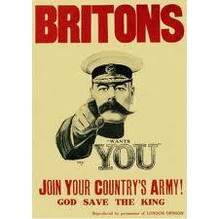

On the outbreak of the First World War, Prime Minister of the United Kingdom Herbert Asquithappointed Kitchener as Secretary of State for War.^{[1]} Kitchener was the first member of the military to hold the post and was given the task of recruiting a large army to fight Germany.Britain declared war on the German Empire on 4 August 1914. The poster was designed by Alfred Leete and had first appeared as a cover illustration for London Opinion, one of the most influential magazines in the world, on 5 September 1914.

Overview
- What were the immediate causes of the First World War?
- What were the deep rooted causes of the First World War in 1914?
- Who fought for Britain on the western front during the First World War 1914-1918?
- What were the main developments during the period of the First World War 1914-918?
- What were the effects of the First World War on Germany?

1 What were the immediate causes of the First World War?
Activity 1.
Put a sub title “International Alliances in 1914”
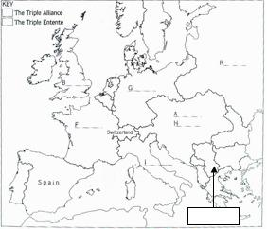

Using the data in Peace and War p112-113 source 5 and source 6 colour in your own copy of the above map using one colour for the Triple Alliance and one colour for the Triple Entente. Also find out the name of the country with the arrow pointing to it and fill it in.

In best summarise who belonged to these alliances and when they joined by completing the chart below using information from Peace and War p112.

The formation of the Triple Alliance | The formation of the Triple Entente
In 1879 | In 1893
In 1882 | In 1904
 | In 1907
The Germans thought that Britain  had formed the Triple Entente to | The British said that they had  formed the Triple Entente to

Activity 2. Put a sub title “The Assassination of Archduke Frank Ferdinand”.
Put the following statements in chronological order and write them out into best.
Since 1878 Serbia had gained independence and wished to unite all serbs in the area some of whom were in the Austrian Empire. | From 1878 onwards Austria was very suspicious of Serbia. Serbia won the friendship of Russia to help her achieve her aims.
As the Archdukes car drove along the riverside in Sarajevo, Princep climbed aboard and shot him and his wife. | From 1908 onwards some serbs in Bosnia began to oppose Austrian control.
Gavrilo Princep was one Serb determined to resist Austrian control and he and some fellow supporters planned to kill Franz Ferdinand. | On the 28th June the heir to the Austrian throne Franz Ferdinand went to visit the Austrian Army based in the capital of Bosnia, Sarajevo.
In 1908 Austria gained control of Bosnia, which was a province with many Serbs in it. Serbians and Serbs were disappointed about this. | Since 1867 Austria Hungary had been a multi ethnic Empire determined to stop different ethnic groups gain independence.
Activity 3. Put a sub title “International reaction to Franz Ferdinand’s assassination”.
Below are 9 statements of what happened from the 28th June to the 6th August 1914. You need to select a statement to go with each of the pictures that you have been given. Stick the picture in your book and write the statement that goes with it next to it.
1st August:  Germany declared war on Russia. It also began to move its army towards  France and Belgium. | 28th June:  Austria Hungary declared war on Serbia. Belgrade the capital of Serbia was attacked. | 2nd August:  The French  army was put on war  alert, ready to fight  any German invasion.
6th August:  to complete the picture,  Austria Hungary  declared war on Russia. | 28th June:  The heir to the Austrian  throne Archduke Franz  Ferdinand was  assassinated in Sarajevo  by a Bosnian Serb. | 23rd July:  Austria Hungary blamed  Serbia for the  assassination of Archduke  Franz Ferdinand.
30th July:  Germany sent a  message to Russia  ordering it not  to help Serbia. | 3rd and 4th August:  Germany declared war on  France and invaded  Belgium. Britain ordered Germany to withdraw and  when Germany refused,  Britain declared war. | 29th July:  The Russian  army got ready to help  Serbia defend itself  against the Austrian  attack.

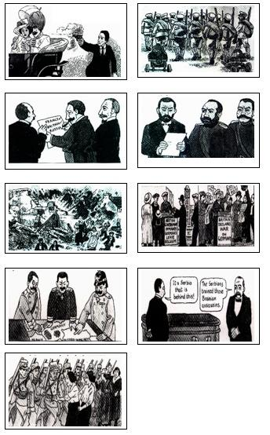

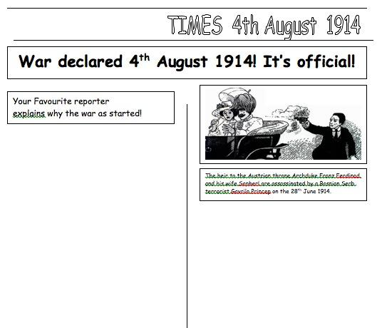

Target: recall; understanding/analysis of key features/consequences (AO1 and AO2: 9 marks)
Level | Mark | Descriptor
 | 0 | No rewardable material
1 | 1-3 | Simple statement(s) offered, showing some relevant knowledge on immediate causes of FWW.  Student makes valid point(s) without development.  Reserve top of level for answers which offer several valid points.
2 | 4-6 | Statements are developed with support from material which is mostly relevant and accurate on immediate causes of FWW.  Student describes or narrates examples/points/ reasons. Links to question focus remain implicit. Reserve top of level for depth and range of evidence.
3 | 7-9 | The answer shows understanding of the focus of the question and is able to support the points made with sufficient accurate and relevant detail on immediate causes of FWW.  Student explains key points. Reserve top of level for depth of answer and historical context.

2 What were the deep rooted causes of the First World War in 1914?
Although the assassination of Archduke Franz Ferdinand and the response of the Great Powers to this in July 1914 were a very significant triggering factor to the start of the First World War, it is not the only explanation. It should be noted that many historians argue that there are much deeper underlying factors which explain why this event in the Balkans erupted into a world war.

Activity 1
Complete the table below which offers a number of different explanations for the beginning of the First World War in August 1914. You will need to select evidence from the text boxes to help support the explanations.
Causal factors of the  First World War | Evidence to support this causal factor
Reason 1  The alliance system,  FF assassination and  Great Powers response. | During the period 1879-1914 Europe split into two main alliance  systems, the Triple Alliance (Germany, Austria, Italy) and the  Triple Entente (France, Russia and Britain). The assassination of  FF provoked conflict between Austria and Russia and the  response of the Great Powers in August 1914 was to support  their alliance partners and this led to the outbreak of the FWW.
Reason 2
The Arms race between
the powers and military
planning.
Reason 3
Tension between the
powers as a result of the race to gain influence in different parts of the world.
Reason 4
Germany was alone
responsible for the
outbreak of the FWW.

All of the Great Powers were keen to expand their Empires and influence. Britain had 27 million square km of overseas colonies, France 11 and Germany 2.5. There was a race for colonies and this caused tension, particularly between Germany on one side and Britain and France on the other. Examples of this conflict can be seen in the First and Second Morocco crises of 1906 and 1911. | German army staff faced a major problem. They knew that if war broke out they would probably have to fight a war in the East against Russia as well as in the West against France. In order to solve this problem they developed the Schlieffen Plan. The aim of this plan was to respond so quickly to any crises that they would attack and defeat France within six weeks and then turn and deal with Russia afterwards. This plan reduced the time for the Great Powers to talk to try and solve any crises.
There was a great naval rivalry between Britain and Germany during the period 1897-1914. Britain is an island and needed a strong Navy to protect herself from invasion and to look after her Empire. Germany was keen to build up her Navy because German trade was increasing and she to wished to build up an Empire. Britain felt very threatened by this and an naval race between the two powers. Between 1906-1914 Britain built 29 Dreadnoughts and Germany 17 Dreadnoughts. | The German army generals believed that war in Europe was unavoidable and they actually planned for this war in advance. The German General Von Moltke said in December 1912, “I believe war is unavoidable. War the sooner the better because our enemies are arming more strongly than we are”. This is why a world war emerged in 1914, the assassination of Archduke Franz Ferdinand was the excuse for it.
Both Russia and Austria were more interested in gaining influence over developments in the Balkans. In 1908 Austria took over the province of Bosnia which had many Serbs in it. This angered not only Serbia but more importantly Russia. Russia was very keen to support Serbian independence and gain influence in the Balkans herself. | The major powers of mainland Europe were building up their permanent armies (excluding reserves).  Country 1900 1910 1914  France 0.7m 0.8m 0.9m  Britain 0.6m 0.55m 0.5m  Russia 1.1m 1.3m 1.35m  Austria 0.25m 0.3m 0.35m  Germany 0.5m 0.7m 0.9m  Italy 0.25m 0.3m 0.35m  Figures are in millions of men.

Activity 2
You now have to deal with eight witness statements. You need to decide what each witness thinks is the main cause of the war by ticking the appropriate reason.
Witness | Reason 1 | Reason 2 | Reason 3 | Reason 4
1
2
3
4
5
6
7
8

Witness 1. W. Hines US Ambassador in 1914  German militarism had been working for this for the last 50 years. | Witness 2. Prince von Bulow in 1918.  The German Bethmann Hollwegg said in 1914 that he had no idea how the war had come about.
Witness 3. LCF Turner 1983  The rulers of the Great Powers acted in accordance with the demands of military planning of their General Staffs. | Witness 4. Count Szogyeny, Austrian.  The Kaiser gave Austria German approval to take warlike action against Serbia after Franz Ferdinands assassination
Witness 5. Encyclopaedia Britannica 1926  It was the actions of international powers in August 1914, along with the alliance systems which caused the FWW. | Witness 6. D E Marshall 1988  It was the German military plans which lad directly to the war. It reduced the German governments ability to act.
Witness 7. Hungarian woman 1914  The murder of the Archduke is provoking a storm in Austria and this might lead to war with Serbia. | Witness 8. French PM Clemanceau 1914  German: I wonder what history will say?  Clemanceau: History will not say that Belgium invaded Germany.

Activity 3 The year is 1914. Billy Brown is 18 years old and is training to be a mechanic in an engineering factory in Glasgow. On October 2nd he returned to the family home late one evening looking very pleased and excited. “I’ve joined up” he announced, “four of us went down after work”. Why did Billy go to war in October 1914? Read the Following statements and decide which support each cause.
1 Billy was a very proud young man who was healthy and fit. He had developed some good engineering skills and felt that it was his duty to serve his country with them. | 2 On August 1st Germany put the Schlieffen plan into action. In order to attack France they needed to go through Belgium. This caused Britain to declare war on Germany on the 4th August 1914. | 3 The assassination of Franz Ferdinand provoked conflict between Austria and Russia and the response of the Great Powers in August 1914 was to support their alliance partners and this led to the outbreak of FWW.
4 Since 1878 Serbia had gained independence and wished to unite all Serbs in the area some of whom were in the Austrian Empire. | 5 The aim of the Schleiffen plan was to respond so quickly to any crises that they would attack and defeat France within six weeks and then turn and deal with Russia afterwards. This plan reduced the time to talk and try and solve any crises. | 6 In 1908 Austria gained control of Bosnia, which was a province with many Serbs in it. Gavrilo Princep was one Serb terrorist determined to resist Austrian control and he and some fellow supporters planned to kill Franz Ferdinand.
7 There was a great naval rivalry between Britain and Germany during the period 1897-1914. Britain is an island and needed a strong Navy to protect herself from invasion and to look after her Empire. Germany was keen to build up her Navy because German trade was increasing and she to wished to build up an Empire. | 8 From 1878 onwards Austria was very suspicious of Serbia. Serbia won the friendship of Russia to help her achieve her aims. | 9 Since war with Germany broke out on August 4th Billy and his friends had discussed the situation. His friends talked about how they would be able to look after each other if they joined up together.
10 German army staff faced a major problem. They knew that if war broke out they would probably have to fight a war in the East against Russia as well as in the West against France. In order to solve this problem they developed the Schlieffen Plan. | 11 In August 1914 Lord Kitchener the Minister for War made an appeal for volunteers to join the British Army. By the middle of September 1914 almost half a million had joined up. | 12 All of the Great Powers were keen to expand their Empires and influence. Britain had 27 million square km of overseas colonies, France 11 and Germany 2.5. There was a race for colonies and this caused tension between countries.
13 During the period 1879-1914 Europe split into two main alliance  systems, the Triple Alliance (Germany, Austria, Italy) and the  Triple Entente (France, Russia and Britain). | 14 The German army generals believed that war in Europe was unavoidable and they actually planned for this war in advance. The German General Von Moltke said in December 1912, “I believe war is unavoidable.” | 15 All the main powers of Europe were building up the size of their armies during the period 1900-1914.This included Germany, Russia, France and Austria.
16 Britain felt very threatened by the growth of the German navy and a naval race between the two powers developed. Between 1906-1914 Britain built 29 Dreadnoughts and Germany 17 Dreadnoughts. | 17 Both Russia and Austria were more interested in gaining influence over developments in the Balkans. In 1908 Austria took over the province of Bosnia which had many Serbs in it. This angered not only Serbia but more importantly Russia. Russia was very keen to support Serbian independence and gain influence in the Balkans.

The four big reasons | Statement numbers 1-17.
Reason 1  The alliance system,  FF assassination and  Great Powers response. | 1  2  3
Reason 2  The Arms race between  the powers and military  planning. | 1  2  3
Reason 3  Tension between the  powers as a result of the race to gain influence in different parts of the world. | 1  2  3
Reason 4  Germany was alone  responsible for the  outbreak of the FWW. | 1  2  3

Activity 4
“The most significant factor in why Billy went to war in October 1914 was the immediate circumstances of FF assassination and the response of the Great Powers.” How far do you agree with this view?

Totally agree with some minor qualifications regarding the utility of soldiers letters. | Mostly agree with some major qualifications regarding the utility of soldiers letters. | Mostly disagree with some major qualifications regarding the utility of soldiers letters. | Totally agree with some minor qualifications regarding the utility of soldiers letters.

Introduction
There were many factors that help to explain why Billy went to war in October 1914. I agree/partly agree/disagree with the view that the triggering factors and immediate circumstances of the assassination of FF and the response of the Great Powers was the most significant factor. I think this because..

· The immediate circumstances of the assassination of FF and the response of the Great Powers was certainly important in the decision of Billy to go to war in October 1914. This is because..

· However there are other reasons including background conditions and Billy’s situation, which help to explain Billy’s decision to go to war in October 1914. For example..

· Overall it is important to recognise that all the factors are interlinked. For example..

Conclusion
The key to understanding the causes of the Billy’s decision are the context in which he made the decision. Therefore the most important factors were..

Assessment for Learning using Level Ladders in Causation and Interpretation at KS3

Level | Sub Level | Level Descriptor
Level 8 | a I am confident at  b I am secure in  c I am beginning to | Pupils use their factual knowledge and understanding of the history of Britain and the wider world to analyse the relationships between events, people and changes, and between the features of different past societies and cultures. Their explanations of reasons for, and results of, events and changes are set in a wider historical context.  They analyse and explain different historical interpretations and are beginning to evaluate them.
Level 7 | a I am confident at  b I am secure in  c I am beginning to | Pupils make links between their factual knowledge and understanding of the history of Britain and the wider world. They use links between factual knowledge and understanding to analyse relationships between features of a particular period or society, and to analyse reasons for, and results of, events and changes  They explain how and why different historical interpretations have been produced.
Level 6 | a I am confident at  b I am secure in  c I am beginning to | They examine and explain the reasons for, and results of, events and changes.  Pupils describe, and begin to analyse, why there are different historical interpretations of events, people and changes.
Level 5 | a I am confident at  b I am secure in  c I am beginning to | They describe events, people and changes. They describe and make links between events and changes and give reasons for, and results of, these events and changes.  They know that some events, people and changes have been interpreted in different ways and suggest possible reasons for this.
Level 4 | a I am confident at  b I am secure in  c I am beginning to | They give some reasons for, and results of, the main events and changes.  They show some understanding that aspects of the past have been represented and interpreted in different ways.
Level 3 | a I am confident at  b I am secure in  c I am beginning to | They are beginning to give a few reasons for, and results of, the main events and changes.  They identify some of the different ways in which the past is represented.

3 Who fought for Britain on the western front during the First World War 1914-1918?
Activity 1
Your teacher will give you an A4 sheet, which will show a picture of the different groups of people within the British Empire who contributed to the fighting for Britain on the western front 1914-1918. You will need to select five facts from the following data grids that help you to understand the role of the Empire troops in the British war effort during the First World War.

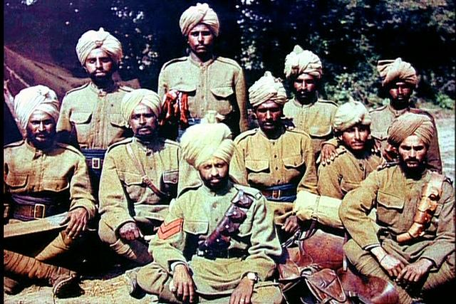

Indian Sikh troops on the Western front in service of the British Empire forces in the First World War against Germany

The contribution of the British Empire to the FWW | Top two points
The contribution of the Australians  The Australian Imperial Force reached France in March 1916. They were a wholly volunteer army. Over 300,000 Australians fought on all war fronts, the majority in France where 175,000 were killed or wounded. They fought in many battles including the Somme, Ypres and Passchendaele. | 1  2
The contribution of the Indians  The Indian soldiers and cavalry were in action on the western front as early as October 1914. They played a key role in British sectors of the front during early German attacks when the British were very stretched. Over 138,000 Indian troops fought, and 5,000 were killed in France. Many were withdrawn in 1915 to fight on other fronts, particularly Egypt and Mesopotamia. Around a million Indian soldiers fought on all fronts. | 1  2
The contribution of the Canadians  The Canadians were the first to respond to the call for forces. Canadian troops arrived in the trenches in April 1915. Around 400,000 Canadians fought on the Western front and 60,000 died. When the Germans launched their last main offensive in March 1918, they avoided the parts of the trench where the Canadians were: many Canadians considered that this was an acknowledgement of their reputation as tough fighters. | 1  2
The contribution of the West Indians  The eleven battalions of West Indian troops were recruited from across the islands. They wanted to fight as soldiers but when they reached France they found that they were to be used to unload ships and supply the front line troops. They resented this and over 1,000 died in the poor housing conditions on the western Front. Later, two battalions did see action in Palestine where they fought in the Jordan Valley. They were highly praised for their bravery and caused the Generals to change their plans when it came to the Second World War. | 1  2
The contribution of the New Zealander’s  The New Zealander’s Division was one of the most highly regarded fighting divisions on the western Front. Around 100,000 came to France, 13,500 being killed and 35,000 being wounded. | 1  2

Activity 2
In this task you have been commissioned to design a recruitment poster to appeal to the people of the Empire to come and fight for Britain on the Western Front. Think carefully about the words and images you will use in your poster. Design it in draft first and show your teacher before you do it in best.

Activity 3
In this task you have been asked to complete two bar charts.
i) To show the number of Australians, Indians, Canadians, West Indians and New Zealanders who participated in the First World War on behalf of Britain.
ii) To show the number of Australians, Indians, Canadians, West Indians and New Zealanders who died in the First World war fighting for Britain.

Activity 4 Discuss the following question in pairs.
Why do you think it is important to recognise the contribution of the people of the Empire to the British War effort although it is rarely mentioned in history books?

4 What were the main developments during the period of the First World War 1914-918?
Activity 1
On a double page spread of your best books, design a timeline like the one below. You need to label on your timeline some of the main developments in the war by using the information from the textboxes. Some of the developments relate only to the Western Front, whilst others look at the bigger picture. You may wish to find some pictures to stick on your timeline.
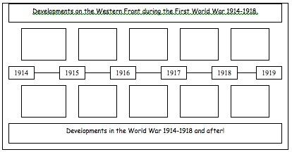

In April 1915 the Germans used Chlorine Gas for the first time on the Western Front. | In June 1919 the Treaty of Versailles provided the terms for the peace settlement at the end of the war.
In November 1918 the German leader Wilhem II resigned and Germany surrendered. The fighting stopped. | In September 1918 the Allied troops broke through the last line of German defences on the Western Front.
In 1914 at the Battle of Marne the Schleiffen plan fails when Britain and France stop the German advance. | In November 1917 the Russians withdraw from the war after the Communists take over the country.
In April 1917 the Americans decide to join the war on the side of Britain, Russia, France and Italy | The Third Battle of Ypres in 1917 reduced the battleground to a vast mud swamp in which soldiers drowned.
From June to November 1916 at the Battle of the Somme over 1 million men were killed or wounded. | From 1915 onwards the war was fought on three main fronts: The Western, Eastern , Balkan Fronts

Activity 2
Put a sub tile “The Western Front 1914-1918” and complete activities a, b and c.

a) Summarise the following piece of writing.
By the end of 1914 the lines of Trenches that formed the Western Front had been dug. They stretched from the Channel coast to Switzerland, over 370 miles! In time communications trenches were added to supply the front line. In front of the trench was stretched a barrier of barbed wire, up to 15 metres thick. In between the trenches was "No Man's Land", the area being fought over with the two front lines being between 20 to 800 metres apart. The aim was to capture the enemies trenches, but this was difficult because they were so well defended by machine guns. When either side succeeded in capturing the enemies trench, the loser could simply retreat into the communications trenches. The situation became a deadlock. In the next four years they rarely moved more than either 10 miles east or west.

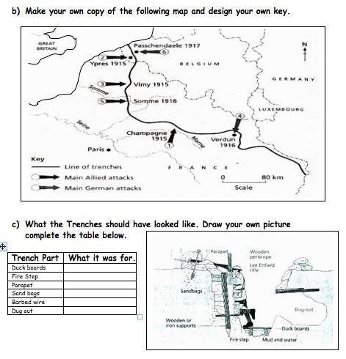

5 What were the effects of the First World War on Germany?

Activity 1 Put a side heading "The Versailles Treaty 1919 and its effects on Germany". Using "Peace and War" p116-117 summarise each of the terms of the Peace Treaty and their effects (consequences) on Germany.
The Nature of the problem to be resolved. | The Terms of the Treaty to  resolve the problem. | The consequences of the Terms on Germany.
1 Who was to blame for the war?
2 What should be done about Germany military strength?

3 What to do about Germany's overseas Empire?
4 Should land be taken away from Germany?
5 Who will pay for the war damage?

Activity 2
Put a side heading "The effects of the First World War on Europe". Using the textboxes summarise the main effects of the First World War on Europe into the table below.
The effects of the FWW  on Europe. | A description of the effect.
1 Death and destruction.
2 Debt and depression.
3 Bitterness and blame.
4 Political chaos.

Many French and British people blamed Germany for the war and they wanted to make Germany pay. | Many countries owed the USA an awful lot of money which they had borrowed to pay for war materials.
The war had brought a lot of political disruption and left many smaller unstable governments. | The war had resulted in over 10 million deaths and 20 million wounded soldiers.
Many Germans felt bitterness to their new government for signing the Versailles Treaty in 1919. | World trade slumped which meant high unemployment and returning soldiers could not get jobs.
The war had caused a revolution in Russia and brought about the worlds first Communist government in 1917. | In 1918-20 Europe was hit by a devastating Flu epidemic that killed a further 20 million people.
Activity 3 Answer the following question using the writing frame suggested."The Treaty of Versailles and the effects of the First World War made Europe a much safer place after 1919." How far do you agree with this statement?

· To some extent it could be argued that the Treaty of Versailles and the effects of the First World War made Europe a safer place after 1919. For example..

· However it could be argued that the Treaty of Versailles and the effects of the First World War made Europe unstable and dangerous after 1919. For example..

Activity 4
Turn to p137 of "Peace and War" and look at sources 5 and 6. Choose to study one of them closer and answer the following questions about it.
i) What type of source is it?
ii) Who made the source and when was it made?
iii) Describe what the source shows in detail.
iv) What does the cartoonist want you to believe about the Peace Treaty?
v) How useful to the historian is this source to an historian studying the effects of the Peace Treaty on Europe?

GCSE Marking schemes

Question Number 3/4
Why did Z occur? or In what ways did X contribute to Y?
Target: recall, cause and consequence or analysis of significance or importance (AO1 and AO2: 12 marks)
 | Mark | Descriptor
 | 0 | No rewardable material
1 | 1-4 | Simple statement(s) offered, showing some relevant knowledge. Student states example(s)/point(s)/reason(s) without development  Reserve top of level for answers which state more than one example/point /reason.  N.B Do not credit repetition of the bullet points without  Development.
2 | 5-8 | Statements are developed with support from material which is mostly relevant and accurate.  Student descriptive or narrative answer, which includes relevant examples/points/ reasons. Links to question focus remain implicit.  Reserve top of level for quality of supporting detail used.
3 | 9-12 | The answer shows understanding of the focus of the question and is able to support the factors/points identified with sufficient accurate and relevant detail.  Student identifies and explains range of factors or points. Reserve top of level for detail and links explored.

Question Number 5 (b)/ 6 (b)
‘Z.’ Do you agree? Explain your answer.
Target: recall; analysis of factors or extent of change or analysis of consequence within an historical context (AO1 and AO2: 16 marks)
Level | Mark | Descriptor
 | 0 | No rewardable material
1  QWC  i-ii-iii | 1-4 | Simple statement(s) offered, showing some relevant knowledge.  Student offers simple detail(s) on topic or asserts judgement unsupported  Reserve top of level for answers which offer several valid points.  Writing communicates ideas using everyday language and showing some selection of material, but the response lacks clarity and organisation. The student spells, punctuates and uses the rules of grammar with limited accuracy.
2  QWC  i-ii-iii | 5-8 | Statements are developed with support from material which is mostly relevant and accurate.Student provides narrative/description. Links to judgment remain implicit Reserve top of level for depth and range of supporting detail.Writing communicates ideas using a limited range of historical terminology and showing some skills of selection and organisation of material, but passages lack clarity and organisation. The student spells, punctuates and uses some of the rules of grammar with accuracy.
3  QWC  i-ii-iii | 9-12 | The answer shows understanding of the focus of the question and is able to support points made with sufficient accurate and relevant detail.  Student provides explanations to support and/or challenge viewpoint or explains reasons why. Reserve top of level for answers depth and range of material and covering both viewpoints, or range of reasons.Writing communicates ideas using historical terms accurately and showing some direction and control in the organising of material. The student uses some of the rules of grammar appropriately and spells and punctuates with considerable accuracy, although some spelling errors.
4  QWC  i-ii-iii | 13-16 | The answer has sustained focus on the question. It offers an analysis supported by precisely selected and accurate material.  Student attempts to assess extent of importance of one factor weighed against other factors, or extent of agreement with viewpoint, to make a judgement. Reserve top of level for answers which can make and support a judgement on the proposition in the question.Writing communicates ideas effectively, using a range of precisely selected historical terms and organising information clearly and coherently. The student spells, punctuates and uses the rules of grammar with considerable accuracy, although some spelling errors may still be found.

